Harold WASHINGTON College Virtual dual enrollment orientation schedule Spring 2024 |  | ORIENTATION  DATES:  Tues, Nov 14th 3:30pm  Tues, Nov 21st 3:30pm  Tues, Nov 28th 3:30pm  Tues, Dec 5th 3:30pm  Tues, Dec 12th 3:30pm  Tues, Dec 19th 3:30pm  Wed, Jan 3rd 12:00pm  Thurs, Jan 4th 12:00pm  Fri, Jan 5th 12:00 pm  Sat, Jan 6th 10:00am  Tues, Jan 9th 3:30pm  Sat, Jan 13th 10:00am  Tues, Jan 30th 3:30pm  Tues Feb 6th 3:30pm  Zoom Link:  https://cccedu.zoom.us/meeting/register/tZwodu2qrzMiHtRNsrn3wXUPl55zrJyCpvU0  After registering, you will receive a confirmation email containing information about joining the Zoom meeting.    Zoom Link:  https://cccedu.zoom.us/meeting/register/tZIpf-6upjkrGNdvbv64VhfiBynDbpBP9UsV  After registering, you will receive a confirmation email containing information about joining the Zoom meeting.
  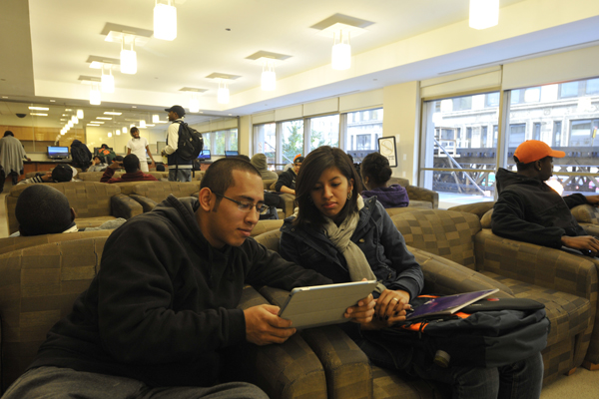
  Join us for one of the sessions to complete your registration for the Spring, 2024 Semester.
  Please complete the following and send to Latisha Williams via
  email lwilliams584@ccc.edu
  - Dual Enrollment Permission & SAP Forms
  - Copy Of SAT, ACT or the CCC Placement Test results
  - Copy of High School Photo ID
  - Copy of High School Transcripts
  Make sure you have applied online at https://applyearly.ccc.edu/ and completed the CCC placement test (if required) before the orientation. This is a Virtual Interactive Session! Make sure you can log into the student portal at my.ccc.edu.

