PeopleSoft Travel Authorizations
Created on 2/26/2016 03:57:00 PM
Table of Contents
PeopleSoft Expenses 1
PeopleSoft Expenses 9.2 1
Preparing Travel Authorizations 1
Creating Travel Authorizations 2
Adding Multiple Travel Authorization Expense Lines 38
Viewing and Modifying Travel Authorizations 69
Attaching a Document to a Travel Authorization 87
Copying Travel Authorization Expense Lines 94
Deleting Travel Authorizations 106

PeopleSoft Expenses


PeopleSoft Enterprise Expense Management allows your employees to capture and submit time and expenses in online, disconnected, or wireless mode. Employees save time and you save on processing costs. This module reviews the fundamentals you will need to use PeopleSoft Expenses.

Upon completion of this module, you will be able to:

- Prepare travel authorizations.
- Prepare cash advances.
- Prepare expense reports.
- Process expense report exceptions.
- Use commitment control with Expenses.
- Manage approvals in Expenses.
- Process expense payments.
- View accounting transactions in Expenses.
- Run reports.

Preparing Travel Authorizations

Expenses provides a travel authorization system to manage the pre-trip approval of estimated travel costs. If you use Commitment Control, Expenses supports budget checking of travel authorizations. From the Travel and Expense Center, you can create, modify, view, cancel, delete, and print travel authorizations. As you prepare a travel authorization request, Expenses provides the options to create cash advances, modify the default accounting, or change the general information. You can save travel authorizations for more input at a later time—with invalid or missing information—or you can submit them for approval. Expenses provides functionality to decrease the time that you spend entering travel authorizations. You can:
- Create travel authorizations populated with information from user defaults.
- Copy expense transaction lines from another travel authorization.
- Copy multiple expense transaction lines at one time on a travel authorization.

Upon completion of this lesson, you will be able to:
- Create a travel authorization.
- Copy expense lines.
- Add multiple expense lines.
- Modify default accounting.
- Review accounting detail information.
- View and modify travel authorizations.
- Delete a travel authorization.
- Cancel an approved travel authorization.
- Attach a document to a travel authorization.

Creating Travel Authorizations
Creating Travel Authorizations

When you create a travel authorization, you have options on which to base the new document, and the selection that you make triggers other choices that prompt you for details about the travel authorization. You can start with a blank document or populate one with data from another source.
Procedure

In this topic you will learn the following:

- How to create a travel authorization
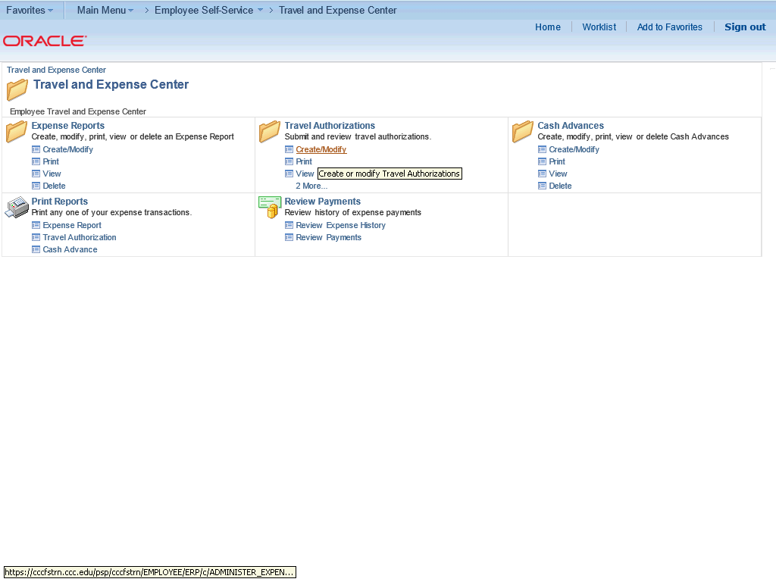

Step | Action
 | From the Travel and Expense Center, click the Create/Modify link under the Travel Authorizations heading.

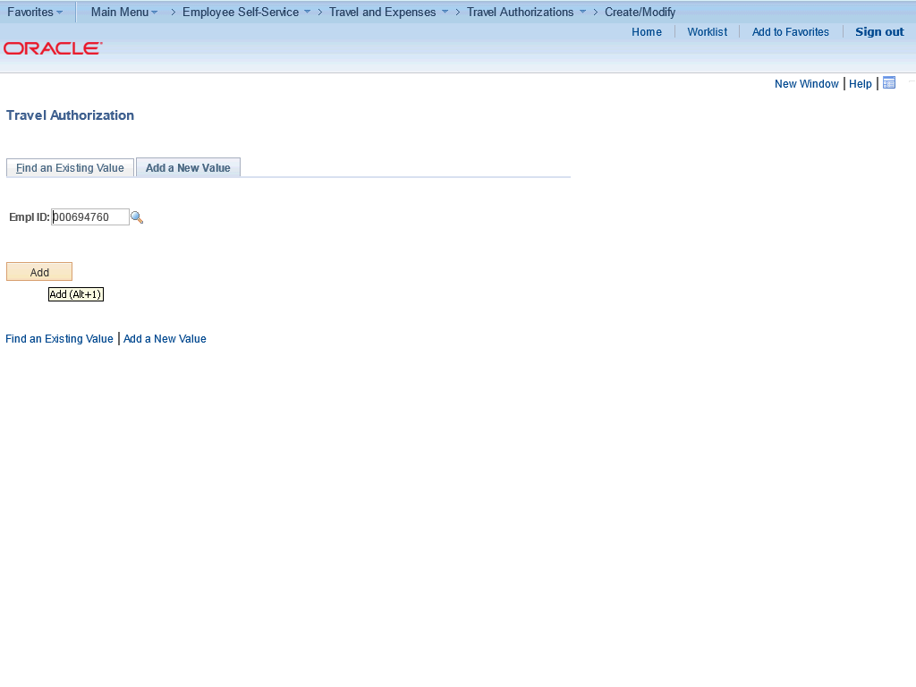

Step | Action
 | Click the Add button.

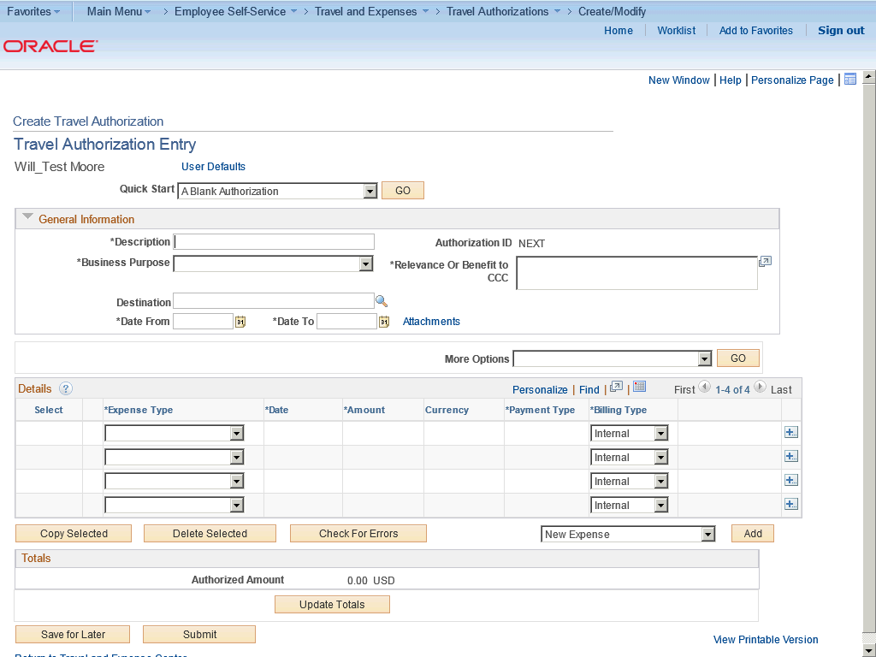

Step | Action
Enter the desired information into the Description field.

Enter "Training in Dallas".

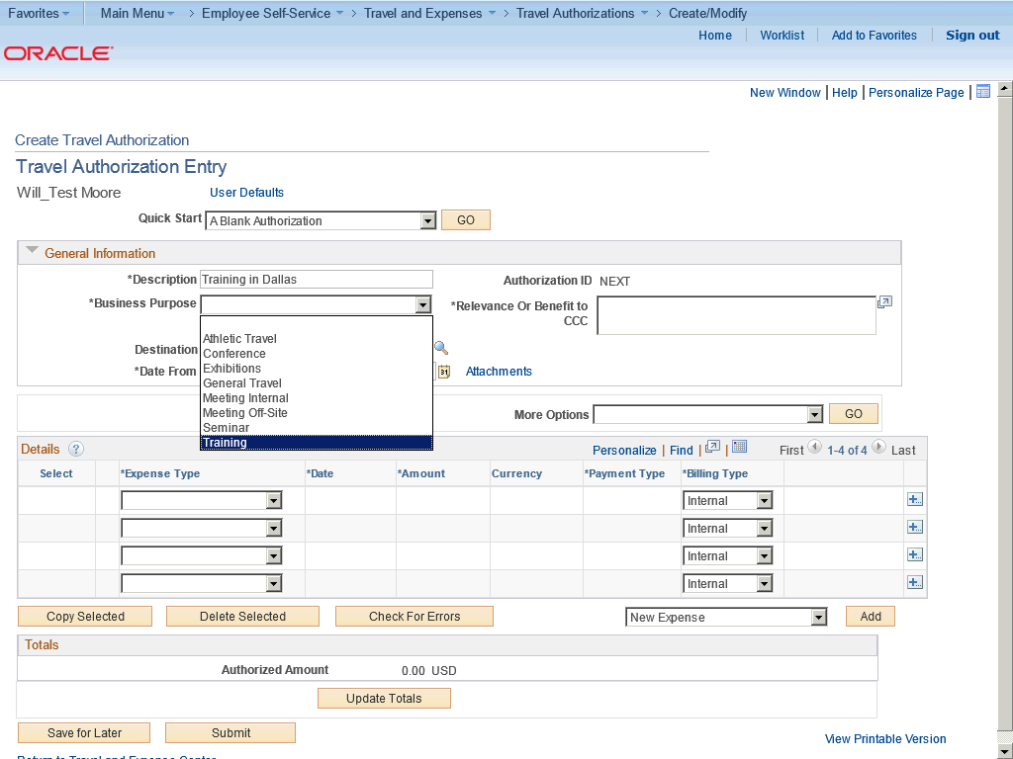

Step | Action
 | Click the Training list item.

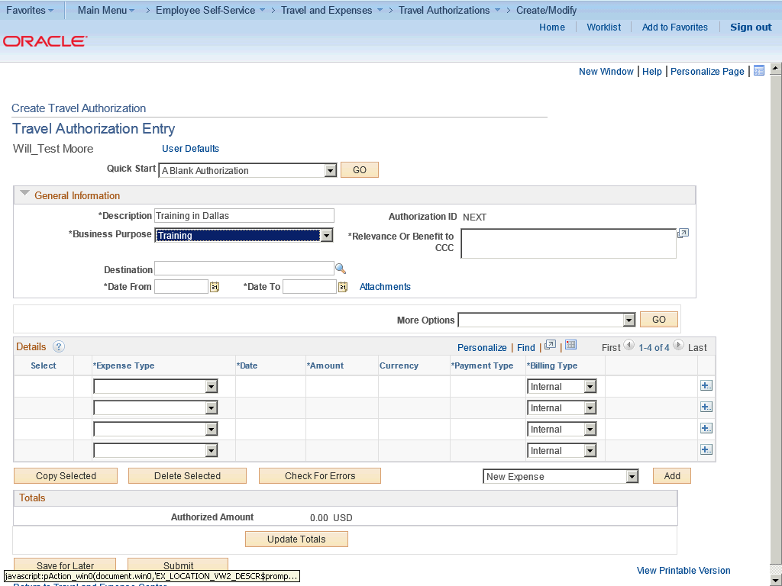

Step | Action
 | Click the Look up Destination (Alt+5) button.

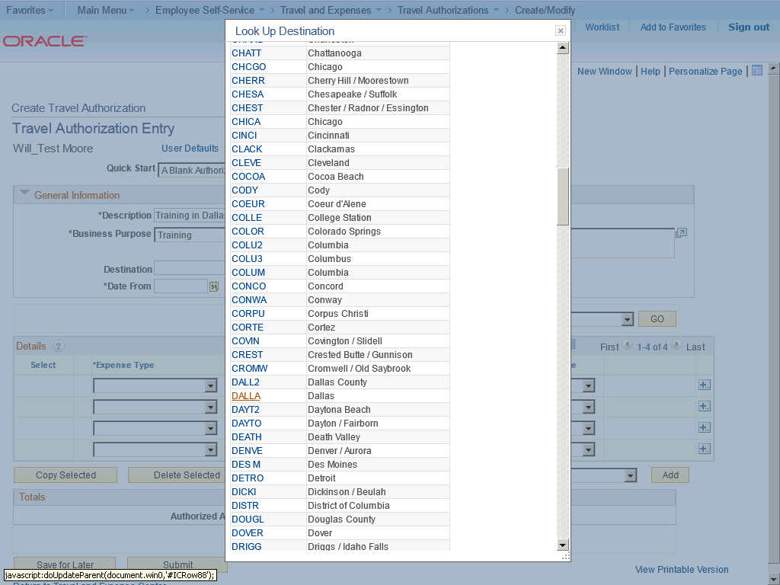

Step | Action
 | Click the DALLA link.

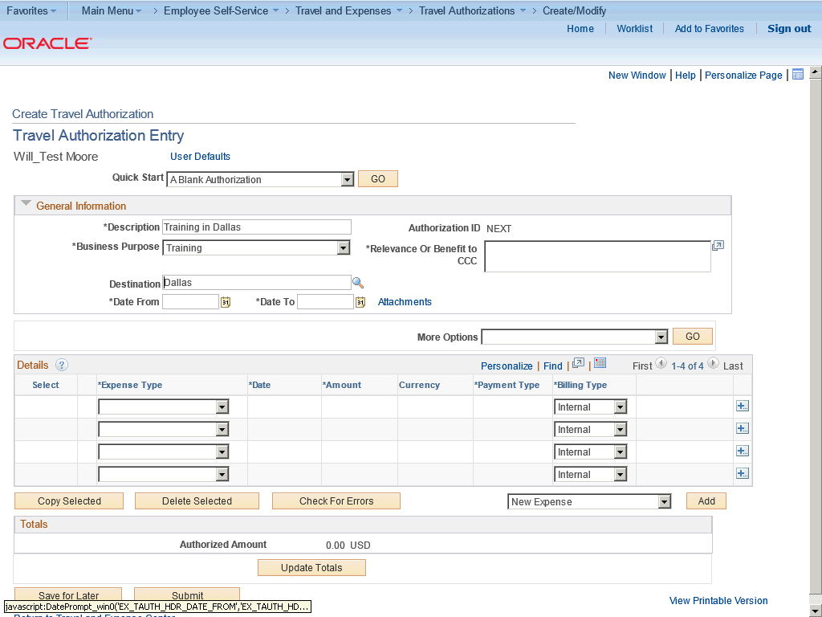

Step | Action
 | Click the Choose a date (Alt+5) button.

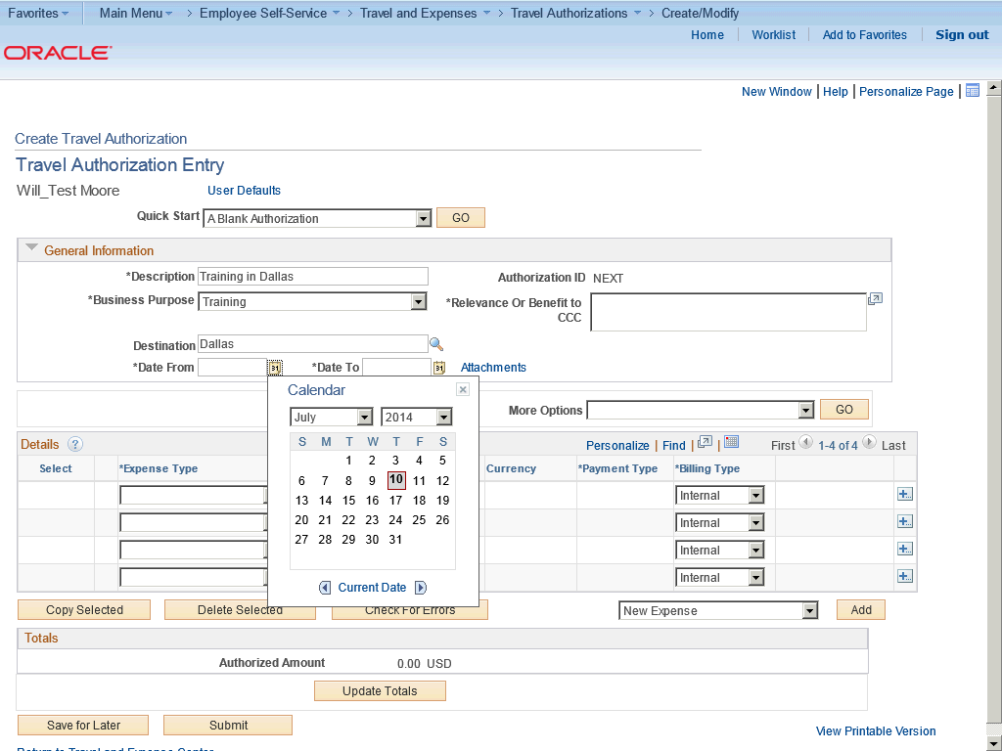

Step | Action
 | Click the desired date.

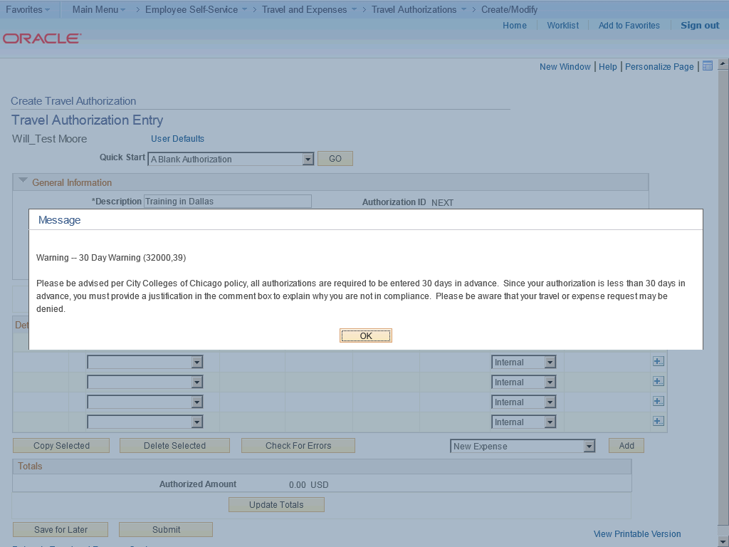

Step | Action
If the day you select is not 30 days in advance of your travel, a warning message appears and an explanation comment will be required.

Click the OK button.

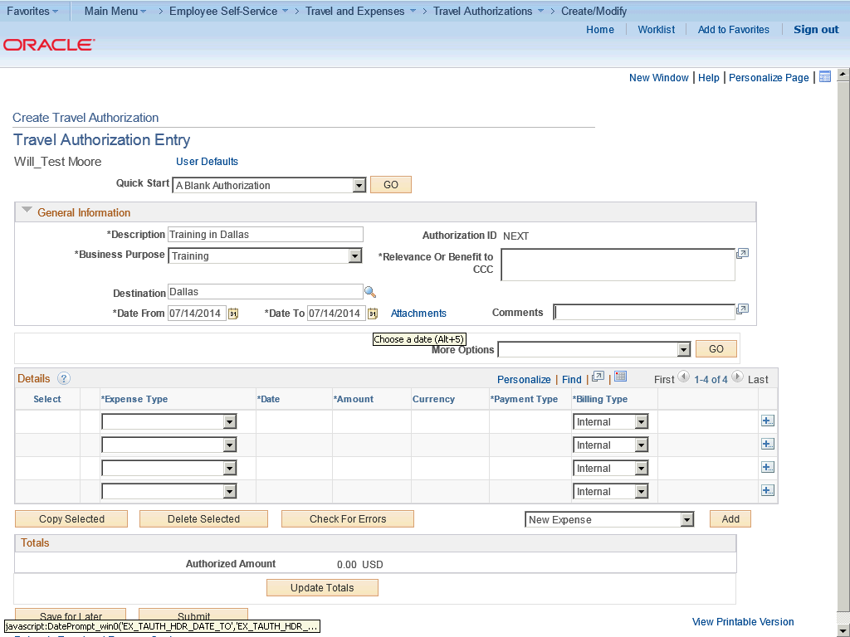

Step | Action
 | Click the Choose a date (Alt+5) button.

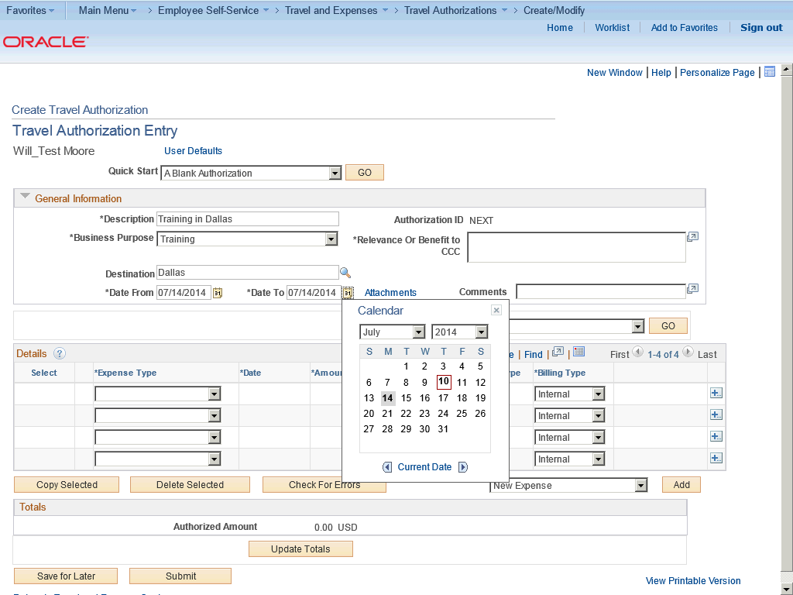

Step | Action
 | Click the desired date.

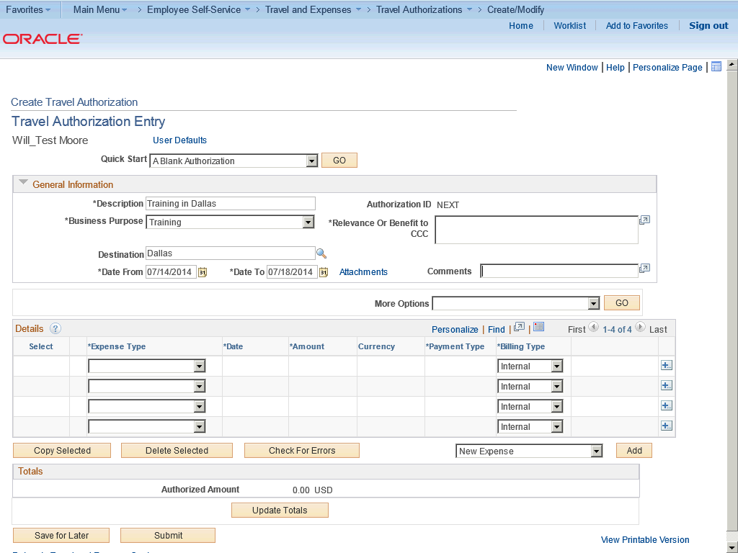

Step | Action
Enter the required information into the Comments field.

Enter "Just found out about class today".

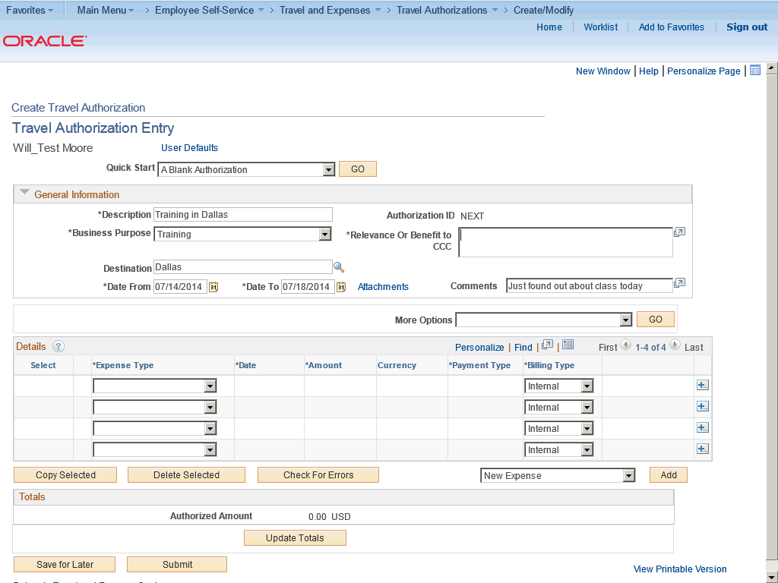

Step | Action
Enter the desired information into the Relevance Or Benefit to CCC field.

Enter "UPK Training".

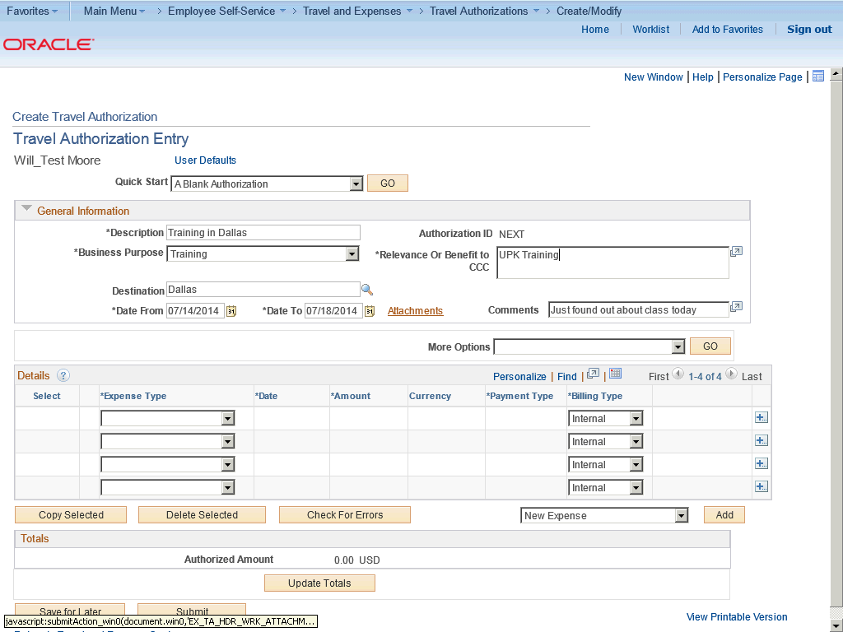

Step | Action
Add attachments that include supporting information about your trip.

Click the Attachments link.

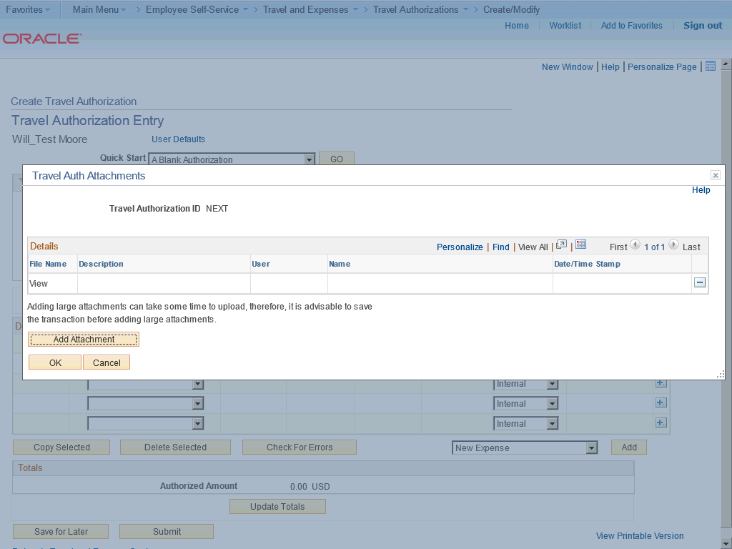

Step | Action
 | Click the Add Attachment button.

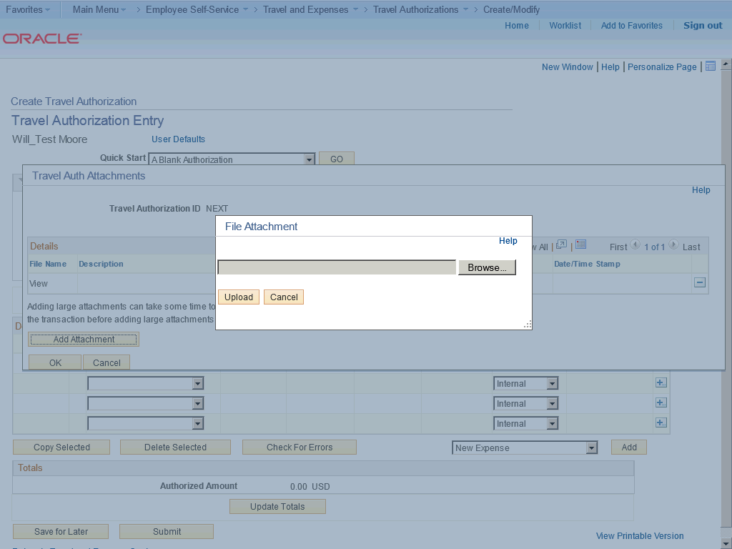

Step | Action
 | Click the Browse button.

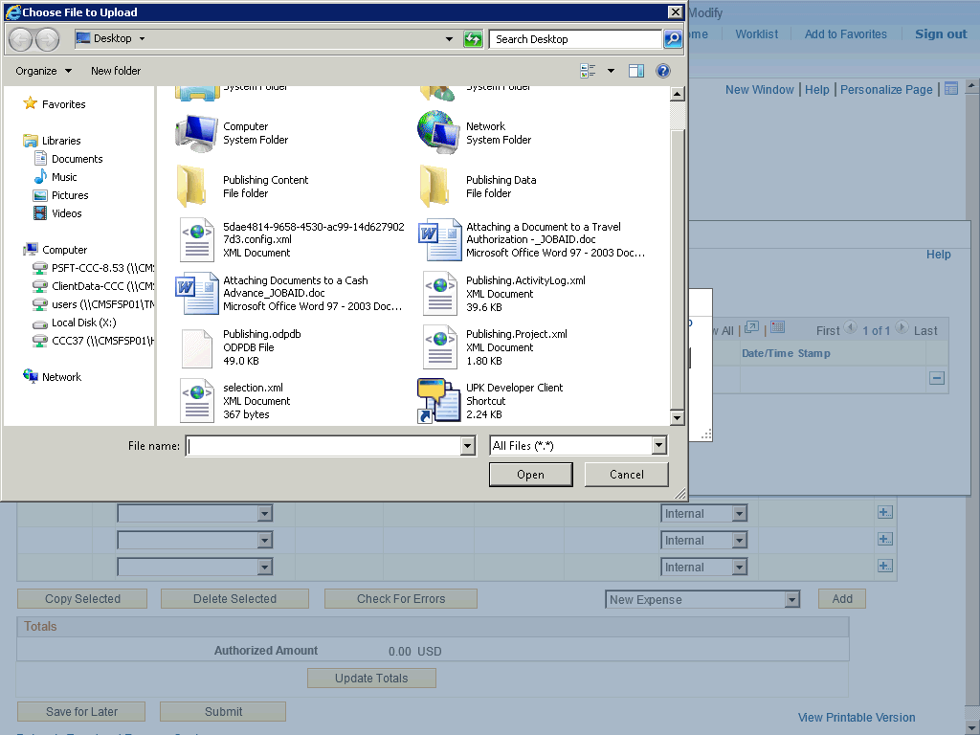

Step | Action
Navigate to the file attachment.

Click the 5dae4814-9658-4530-ac99-14d6279027d3.config.xml list item.
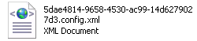

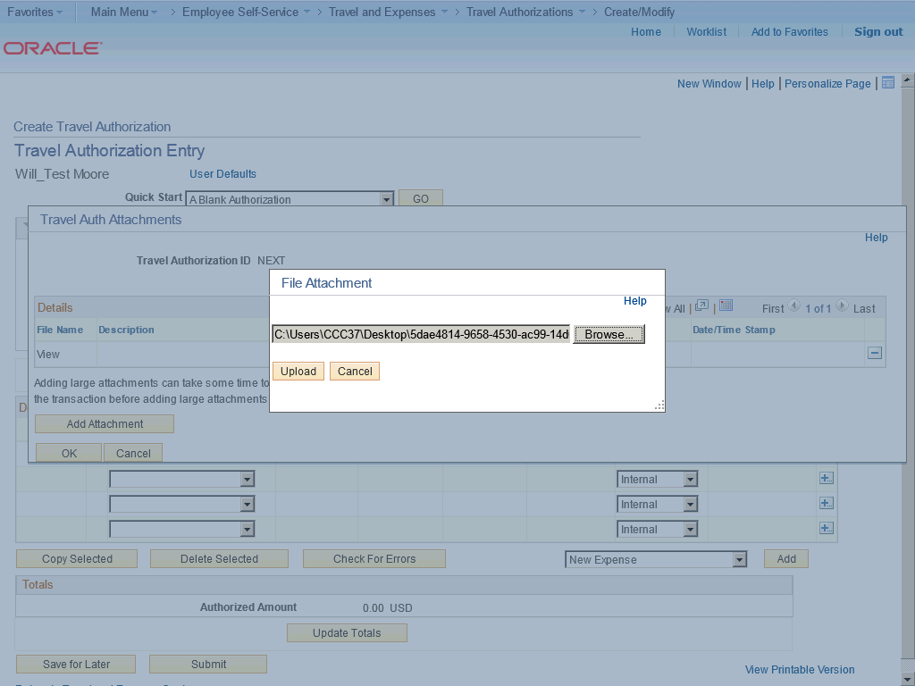

Step | Action
 | Click the Upload button.

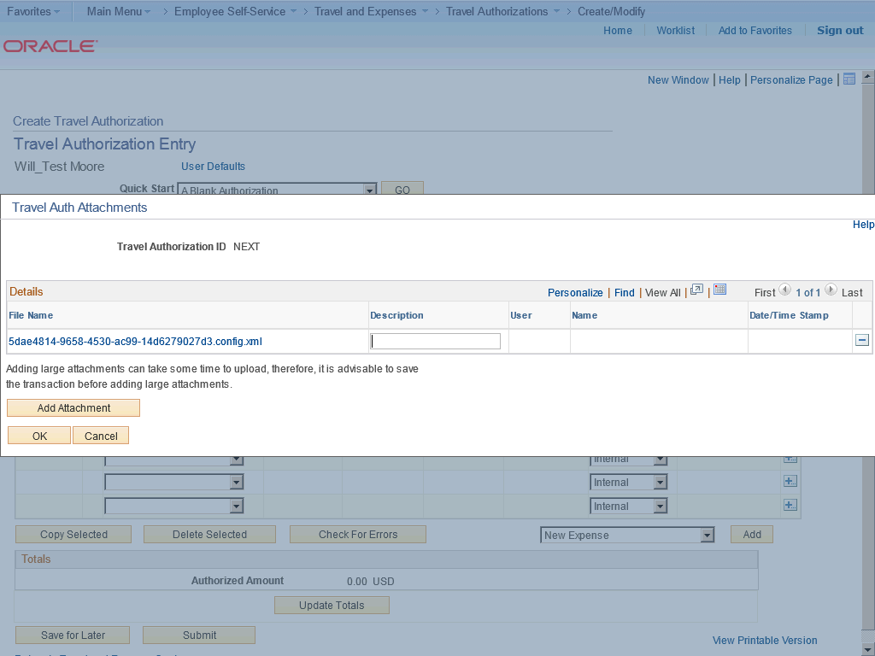

Step | Action
 | Enter the desired information into the Description field. Enter "Travel itinerary".

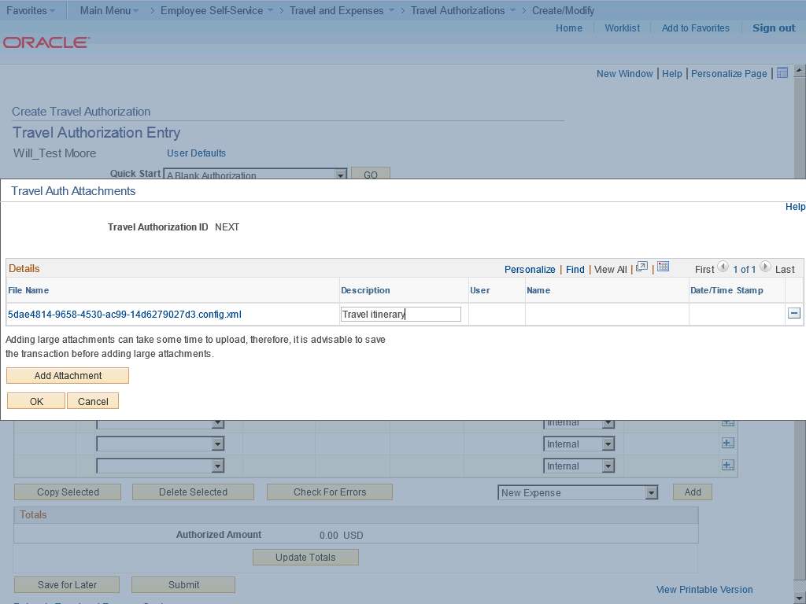

Step | Action
 | Click the OK button.

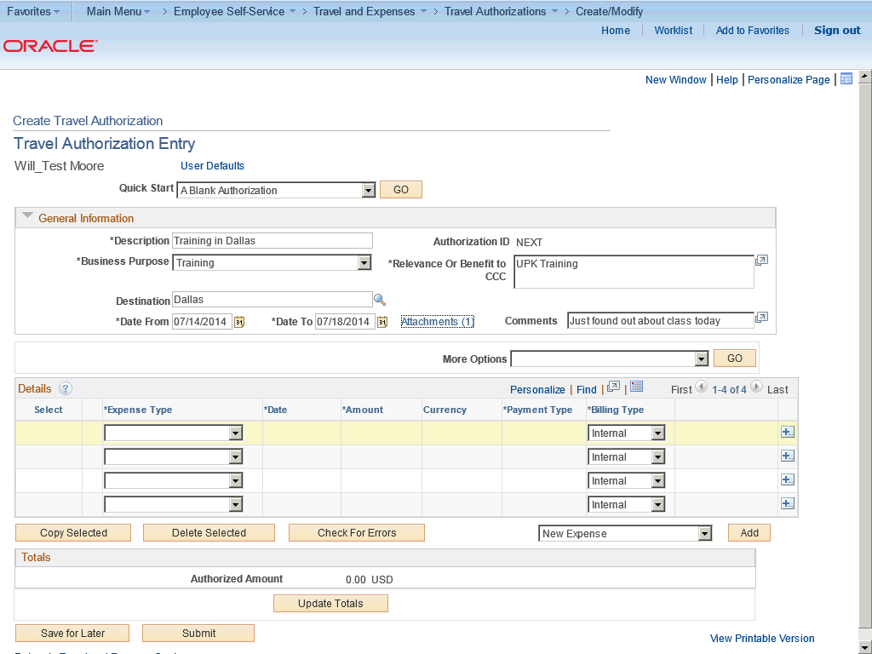

Step | Action
 | Click the Expense Type list.

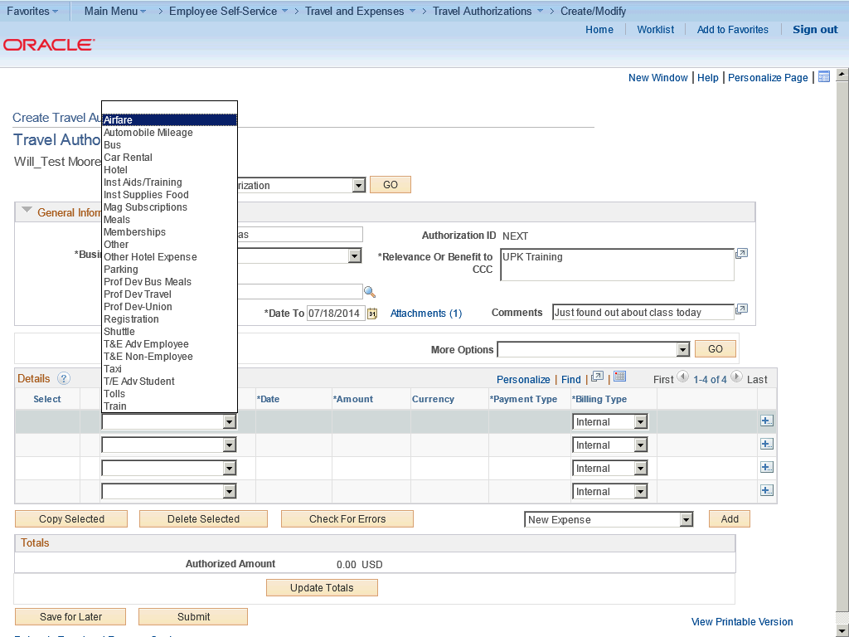

Step | Action
Choose the type of expense.

Click the Airfare list item.

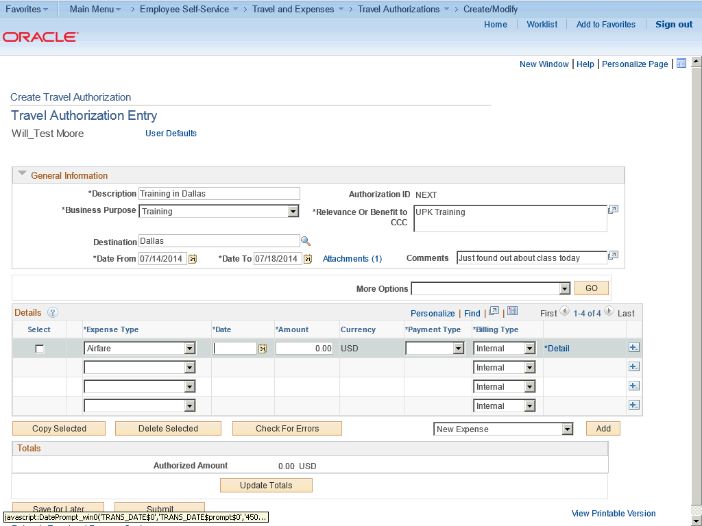

Step | Action
 | Click the Choose a date (Alt+5) button.

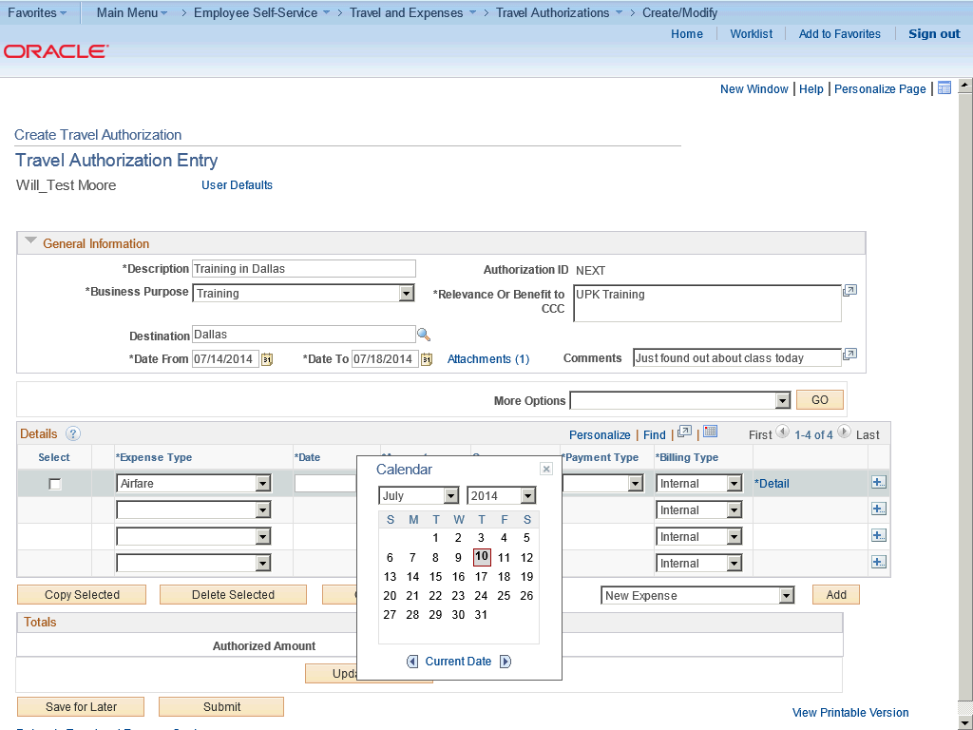

Step | Action
 | Click the desired date.

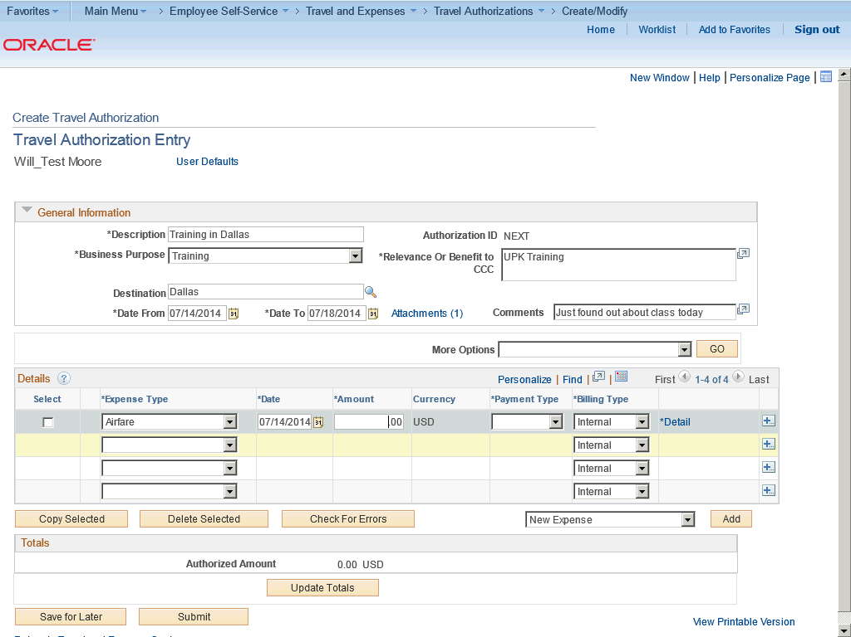

Step | Action
 | Enter the desired information into the Amount field. Enter "150".

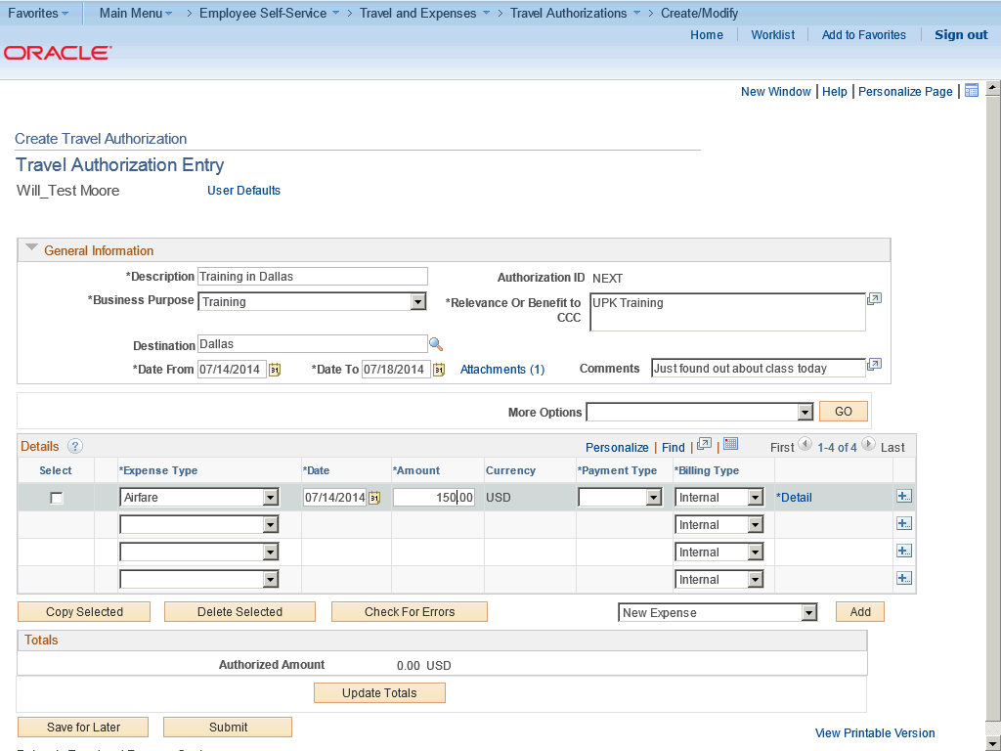

Step | Action
 | Click the Payment Type list.

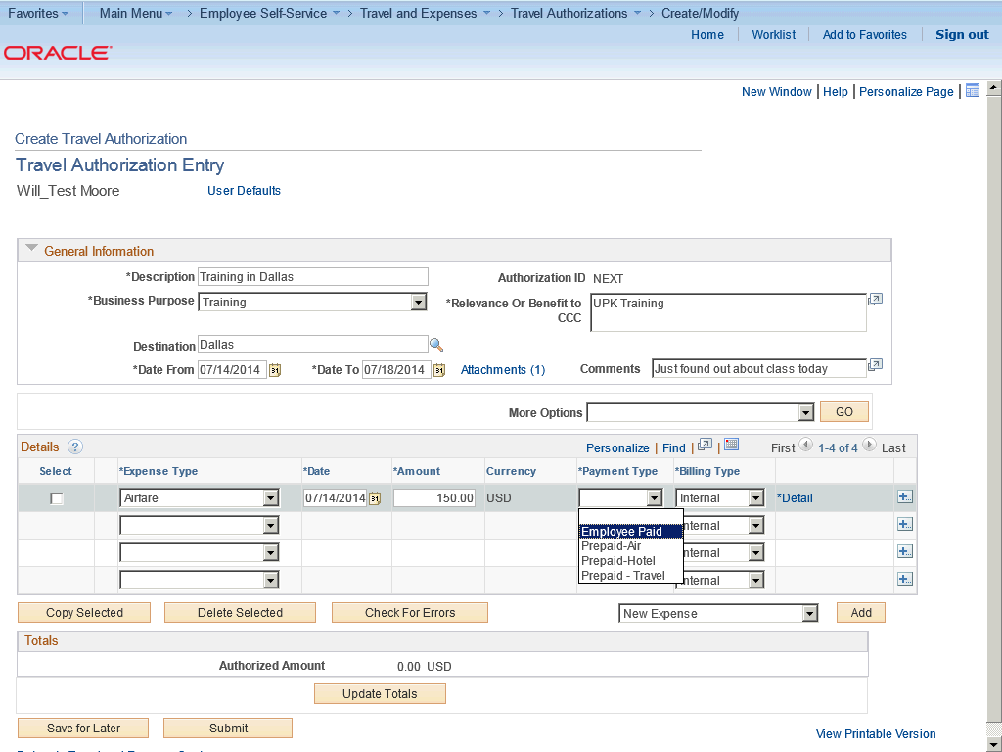

Step | Action
 | Click the Employee Paid list item.

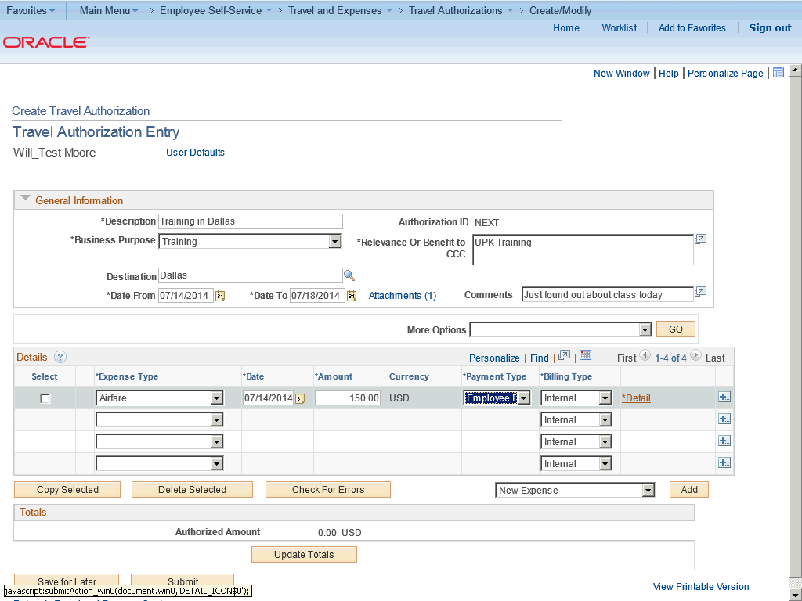

Step | Action
 | Click the Detail link.

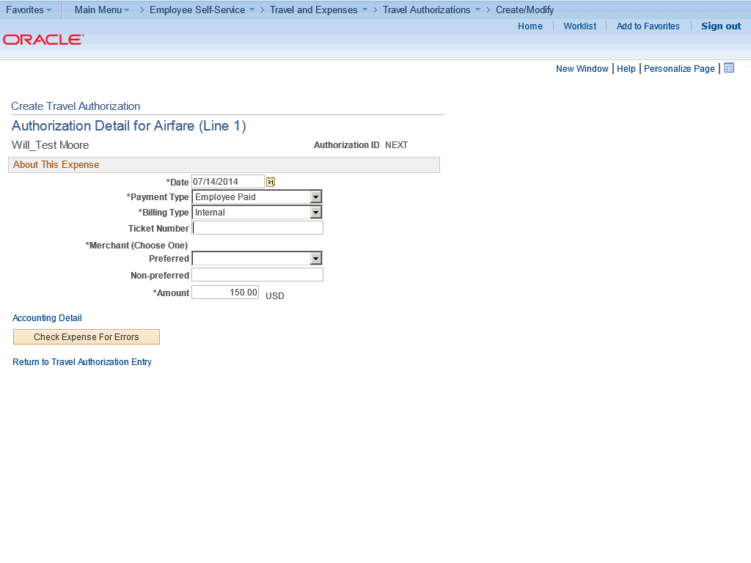

Step | Action
 | The Detail link takes you to the Authorization Detail page to enter the details about the expense.

Step | Action
Enter the desired information into the Ticket Number field.

Enter "abcde".

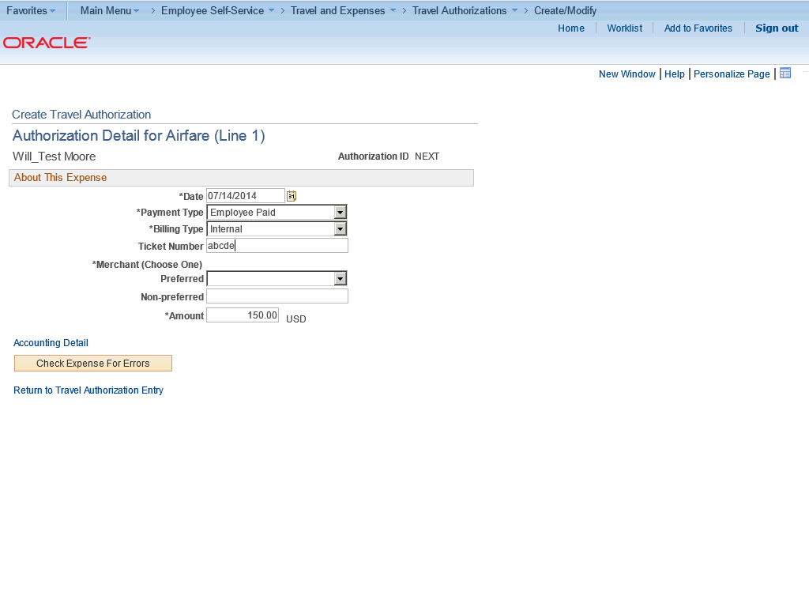

Step | Action
 | Click the Preferred list.

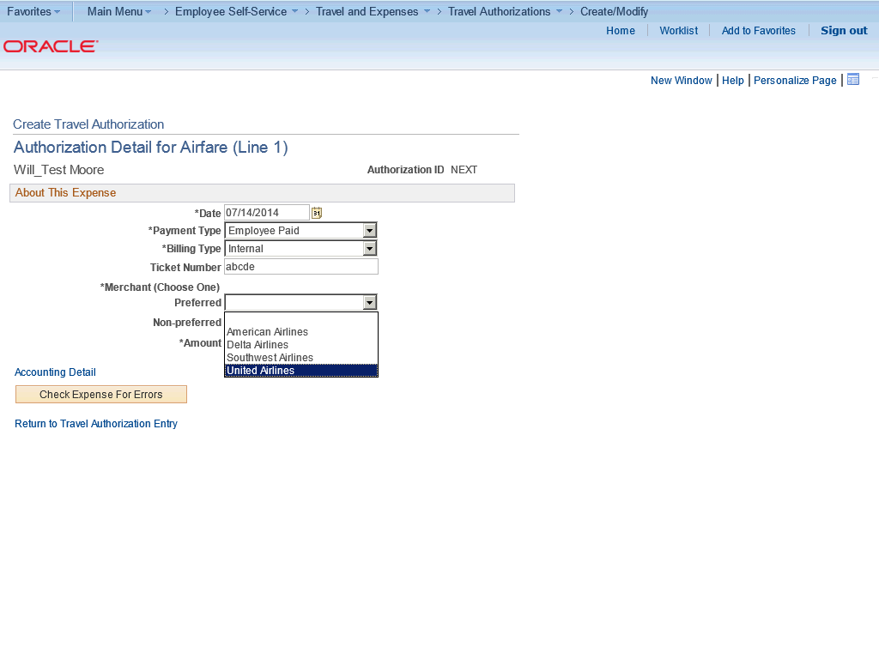

Step | Action
 | Click the United Airlines list item.

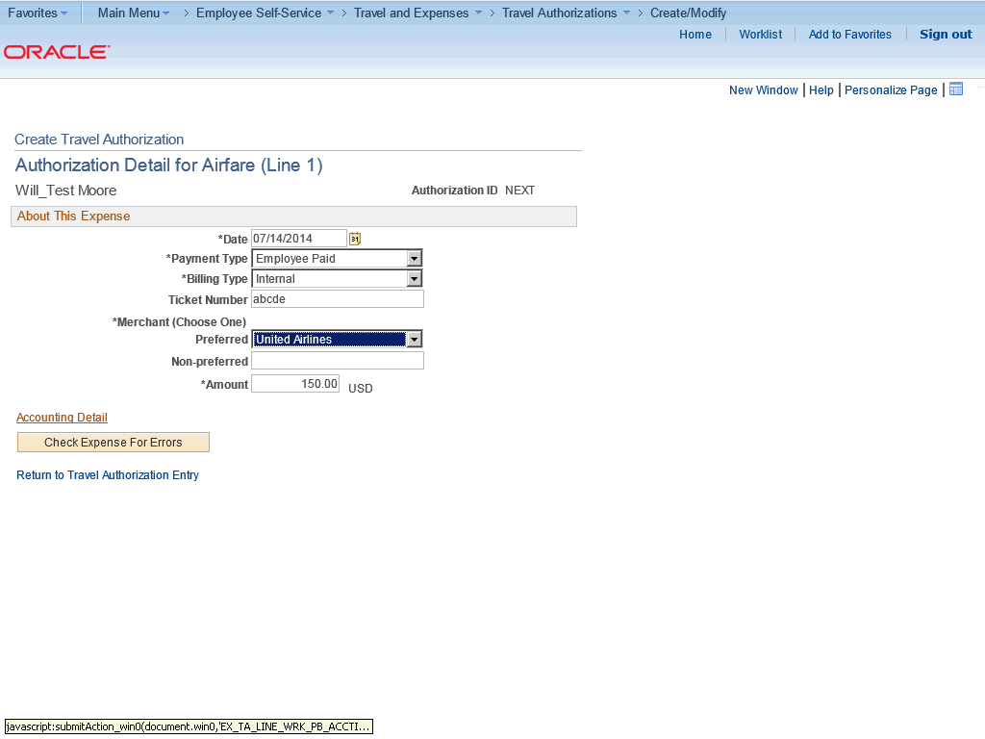

Step | Action
 | Click the Accounting Detail link.

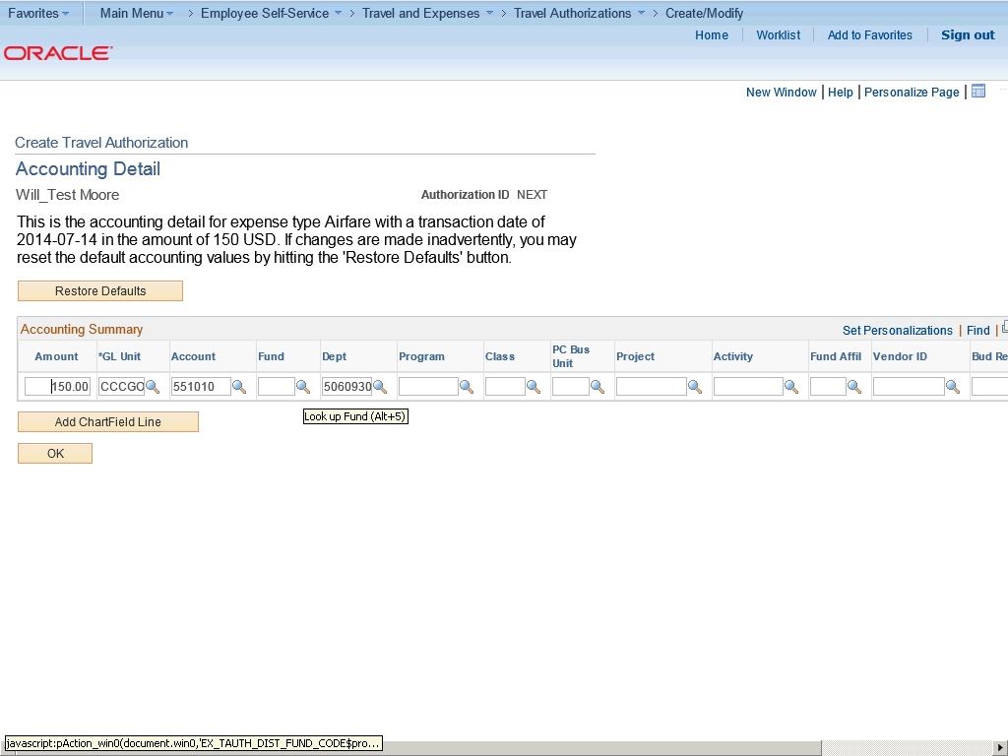

Step | Action
The chartfield string (budget) will default but you may need to add or change additional chartfield information.

Click the Look up Fund (Alt+5) button.

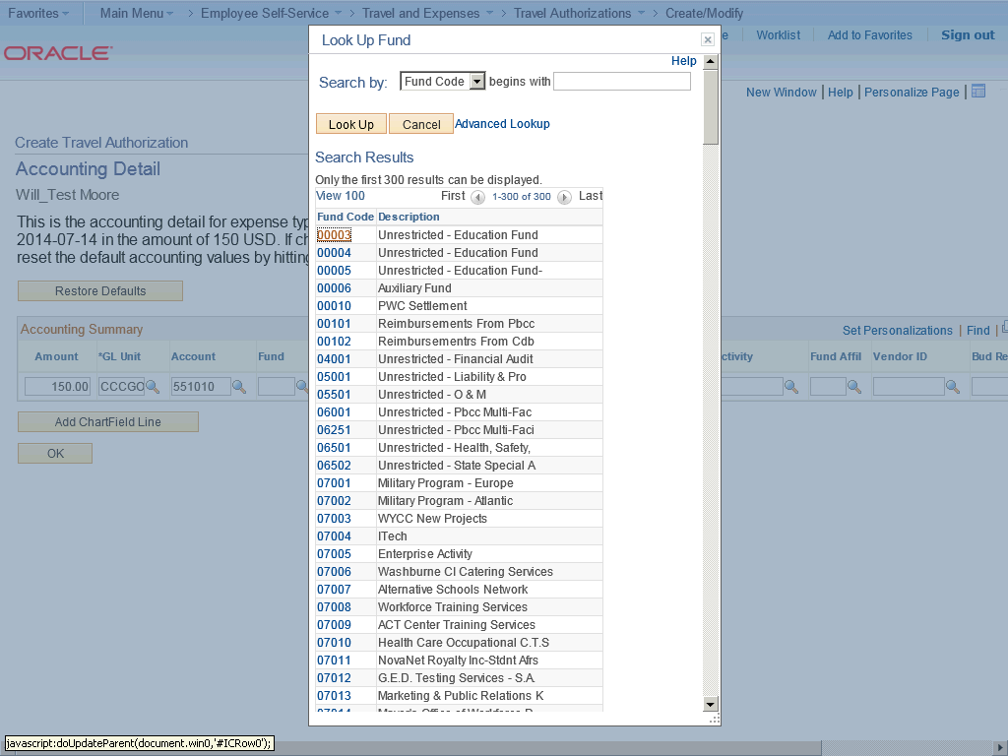

Step | Action
 | Click the 00003 link.

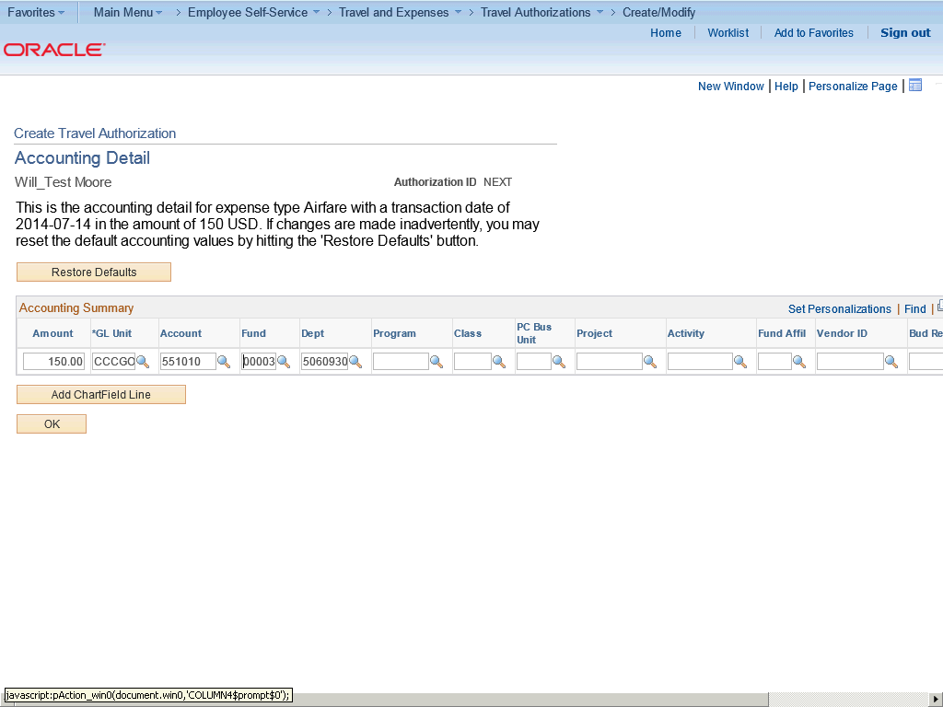

Step | Action
 | Click the Look up Dept (Alt+5) button.

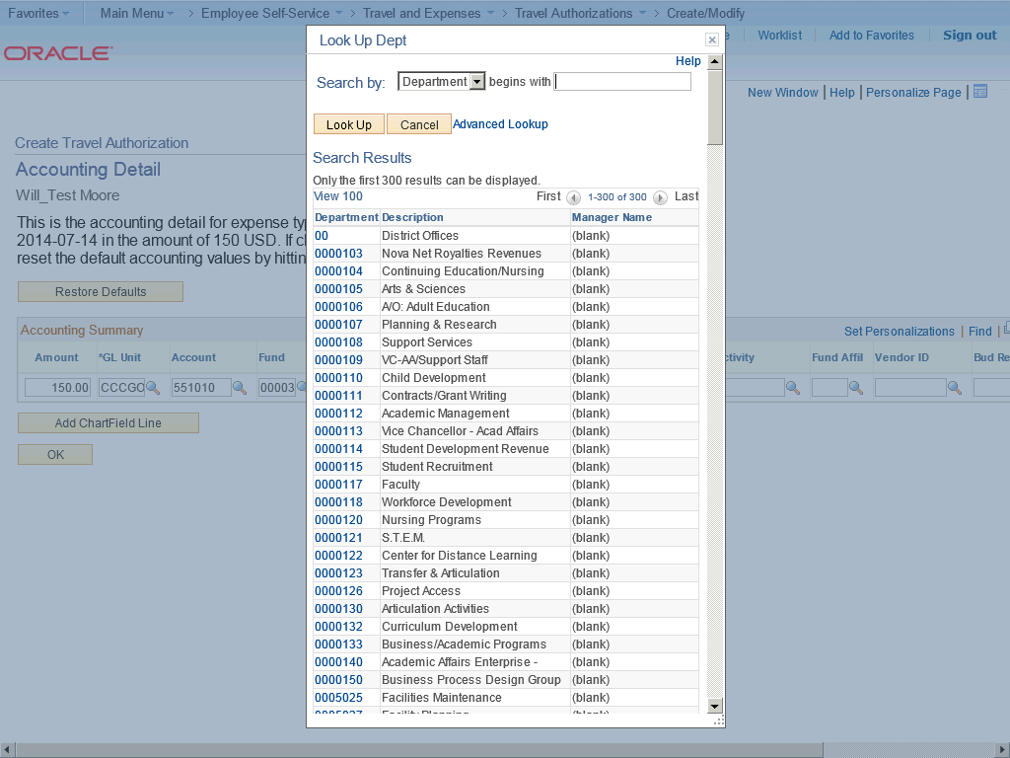

Step | Action
You can search for the Department. Enter the desired information into the begins with field.

Enter "0023001".

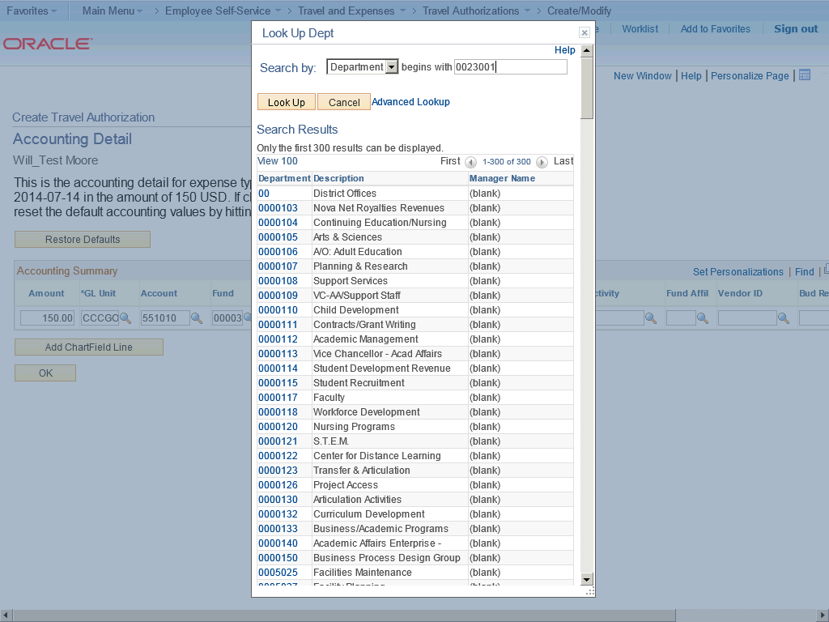

Step | Action
 | Click the Look Up button.

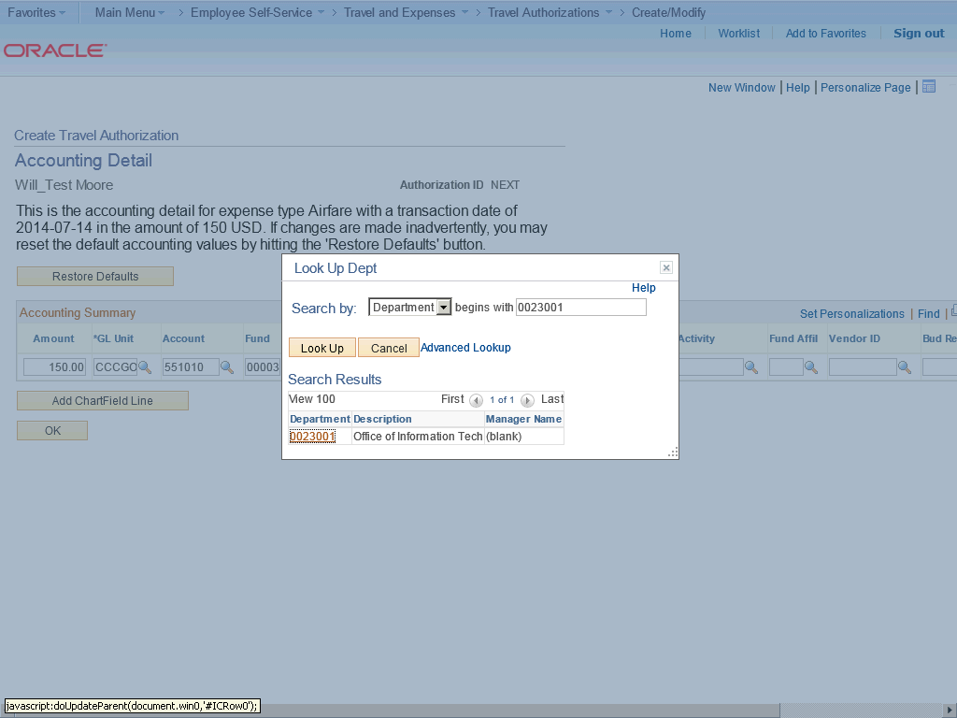

Step | Action
 | Click the 0023001 link.

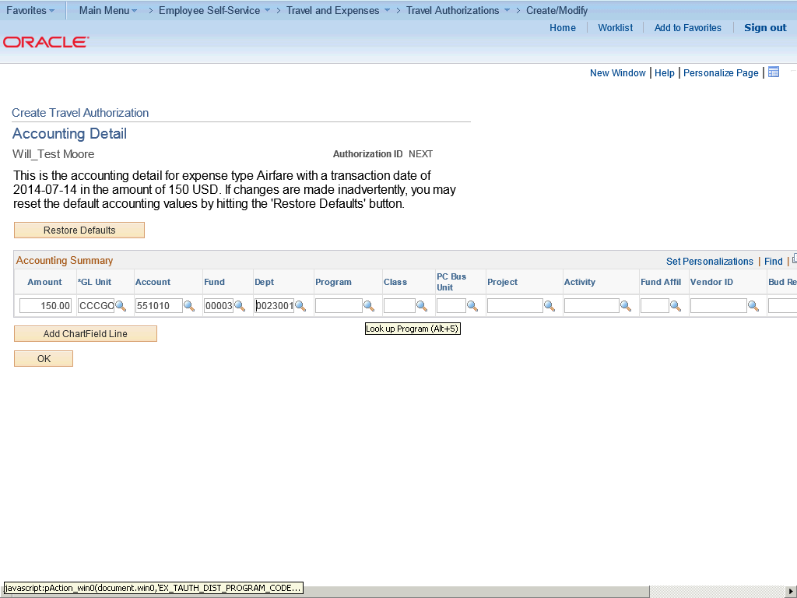

Step | Action
 | Click the Look up Program (Alt+5) button.

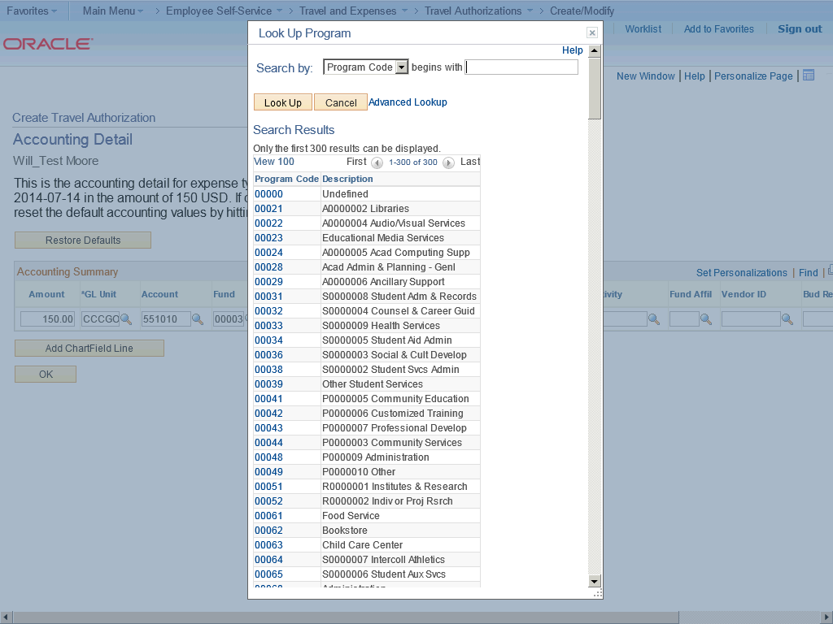

Step | Action
 | Enter the desired information into the begins with field. Enter "80000".

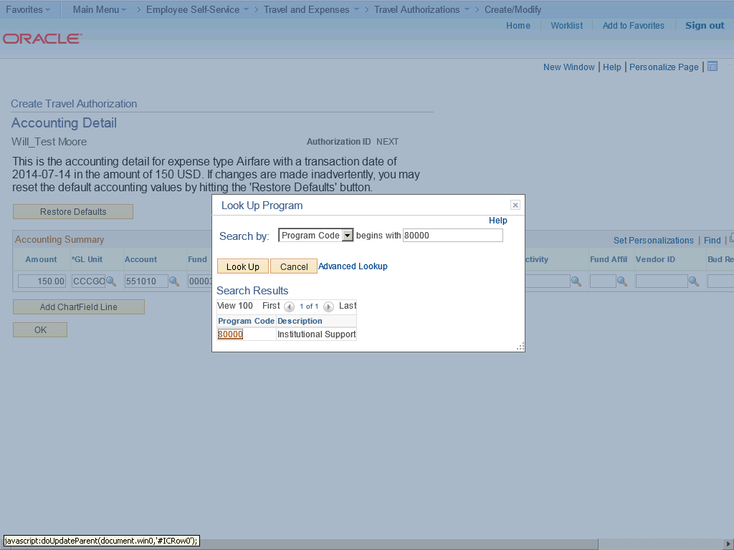

Step | Action
 | Click the 80000 link.

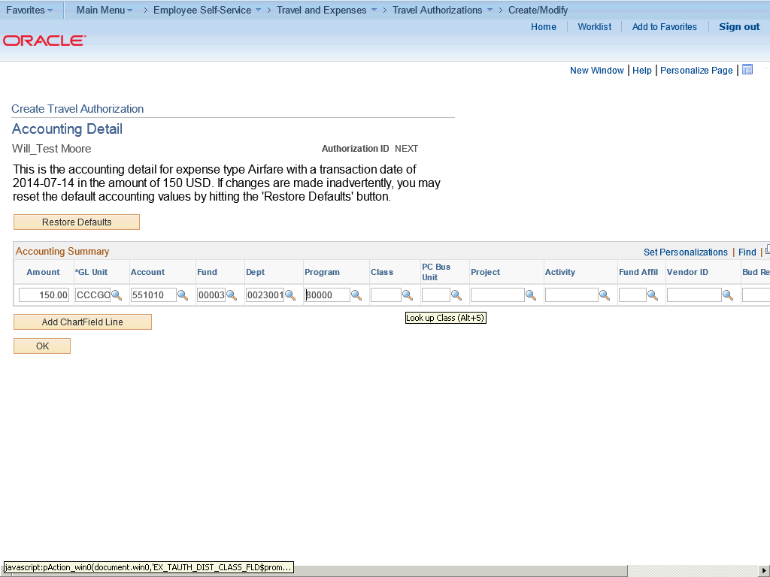

Step | Action
 | Click the Look up Class (Alt+5) button.

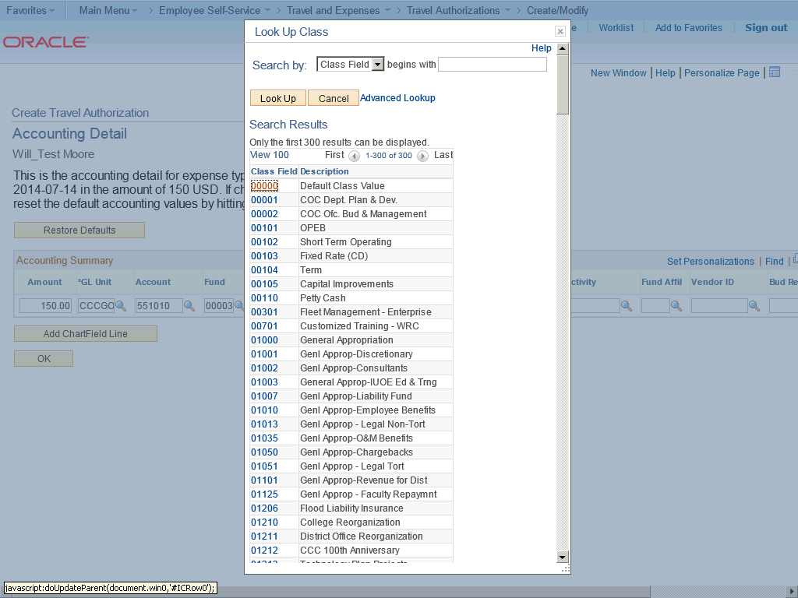

Step | Action
 | Click the 00000 link.

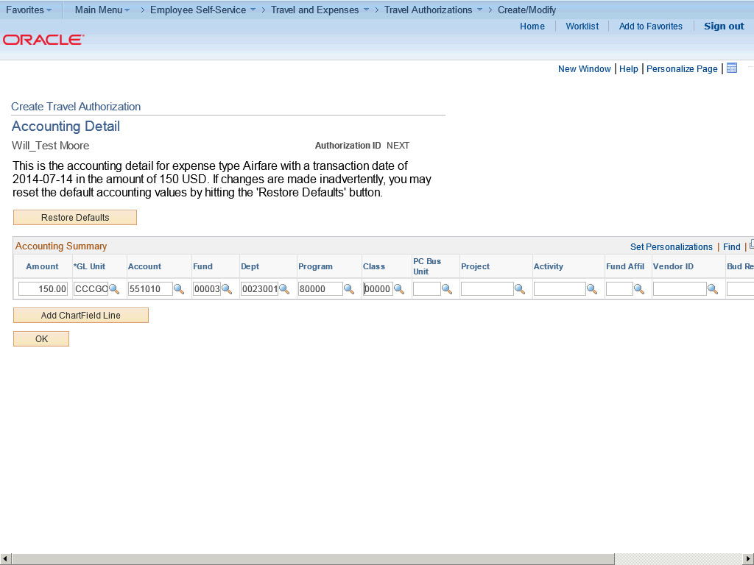

Step | Action
 | Click the OK button.

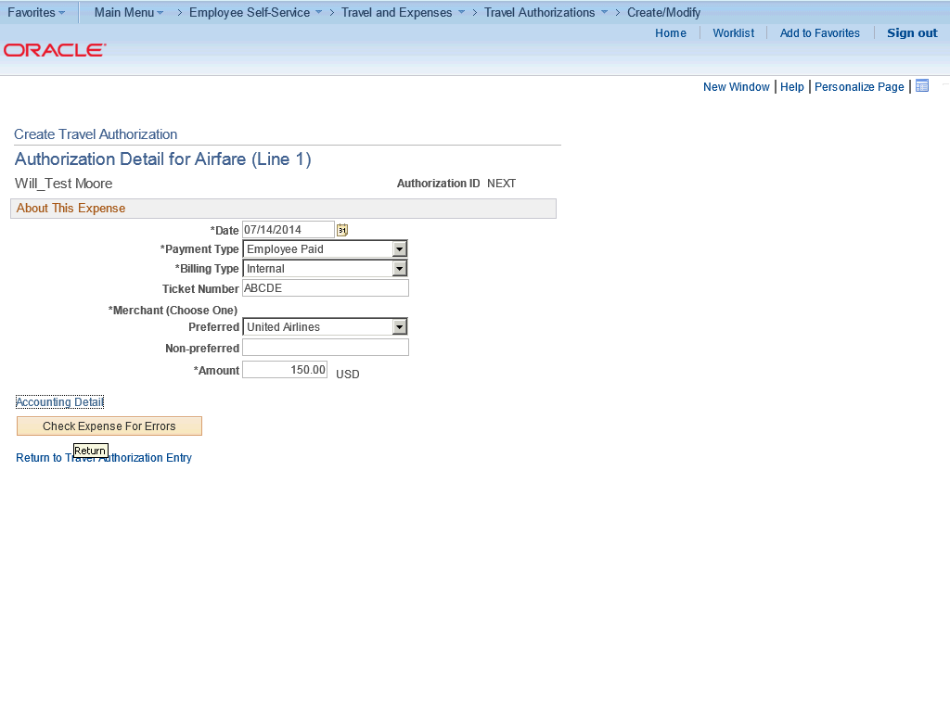

Step | Action
 | Click the Check Expense For Errors button.

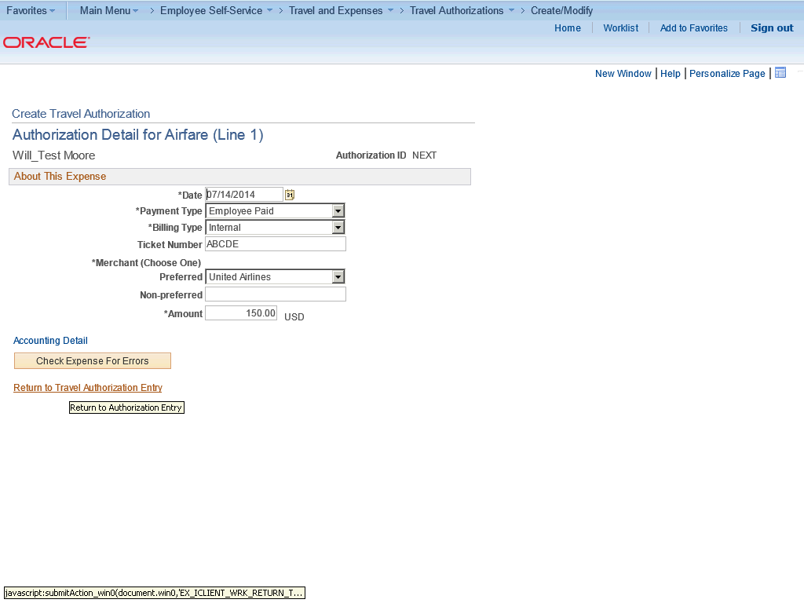

Step | Action
 | Click the Return to Travel Authorization Entry link.

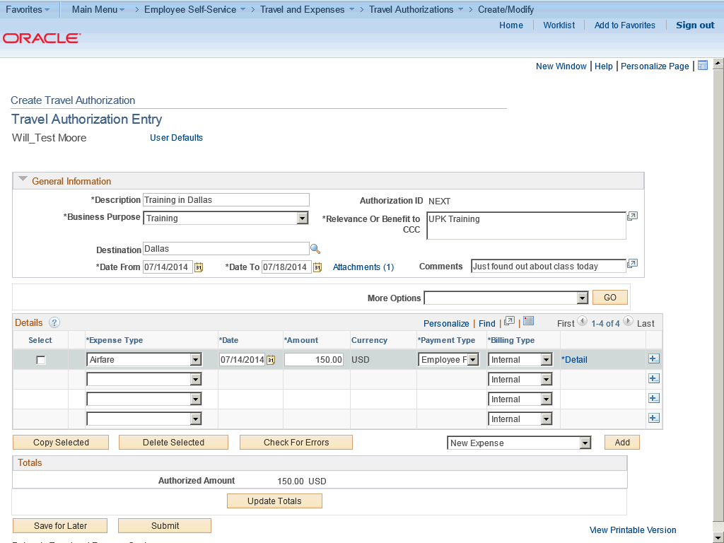

Step | Action
 | Click the Save for Later button.

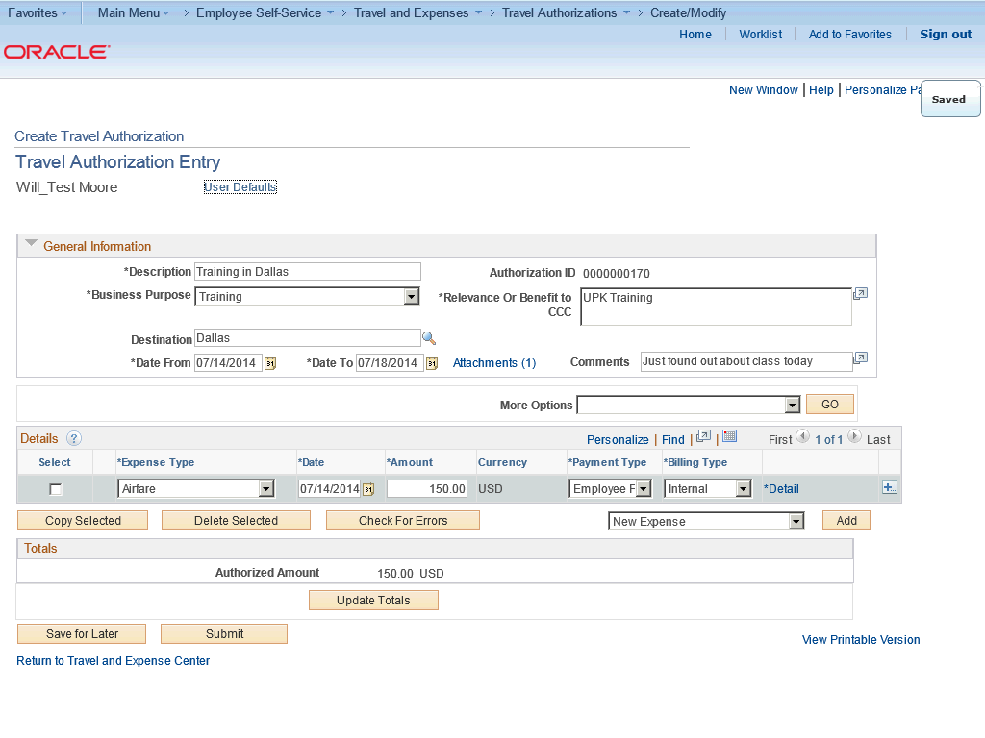

Step | Action
 | Note: Click the Save for Later button to save the travel authorization without submitting it for approval. You can save the report with or without invalid information and modify it later.

Step | Action
 | Click the Submit button.

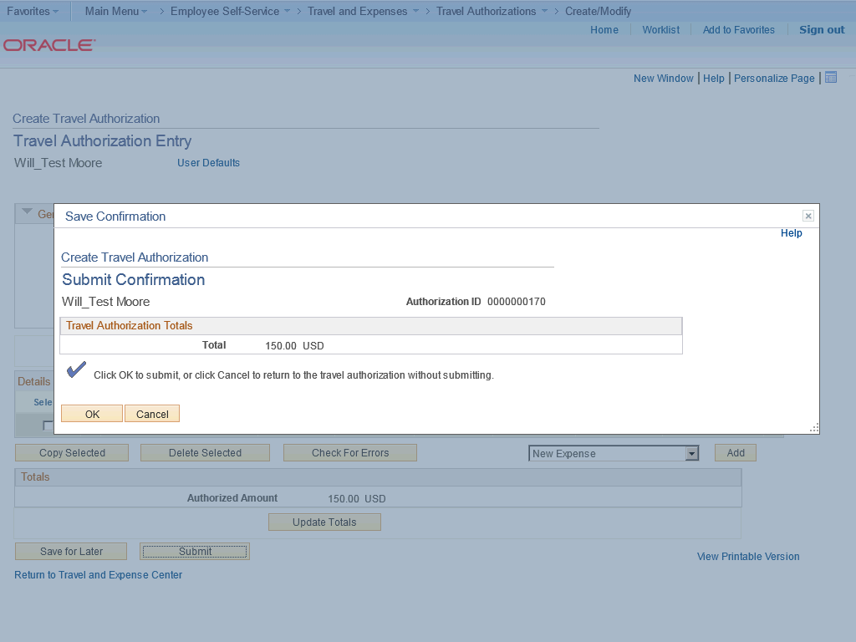

Step | Action
 | Note: When you click the Submit button, Expenses displays the Submit Confirmation page to indicate that it successfully saved and submitted the travel authorization.

Step | Action
 | Click the OK button.

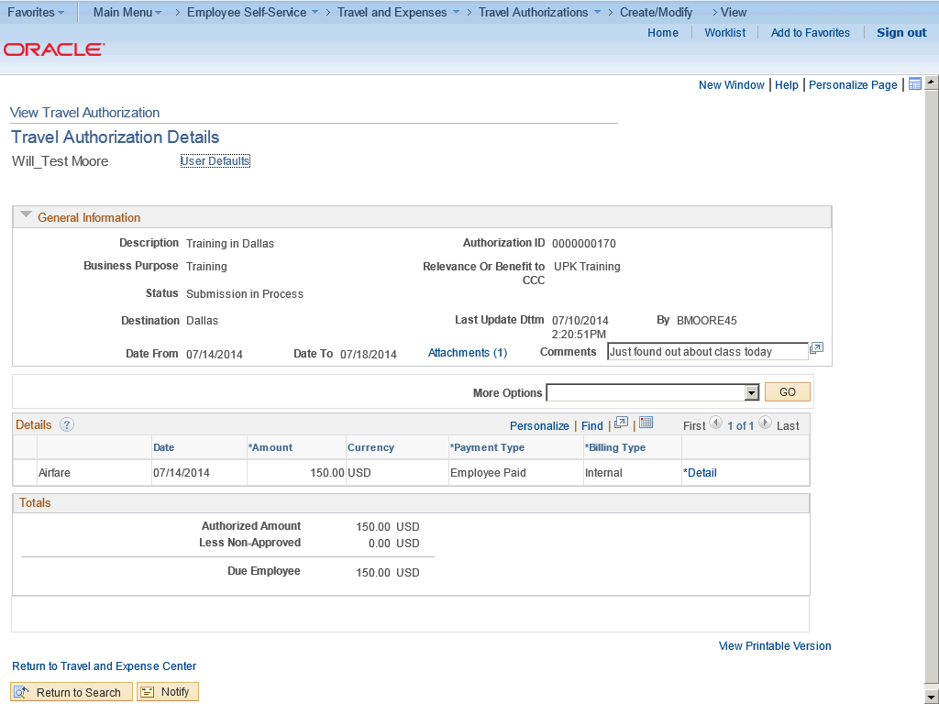

Step | Action
In this topic you have learned the following:

- How to create a travel authorization.

You have successfully completed this training session.
End of Procedure.

Adding Multiple Travel Authorization Expense Lines
Adding Multiple Travel Authorization Expenses

Expenses enables you to select multiple expense types to add to a travel authorization. You can also select whether to add one occurrence or a daily occurrence of the expense types for a date range that you specify. Expenses adds the multiple expense lines to your travel authorization and you enter the remaining information that pertains to each expense type.

In this topic, you have already started a travel authorization for a five-day business trip. You want to quickly add lines for lunch and breakfast expense items.
Procedure

In this topic you will learn the following:

- How to add multiple travel authorization expense lines.
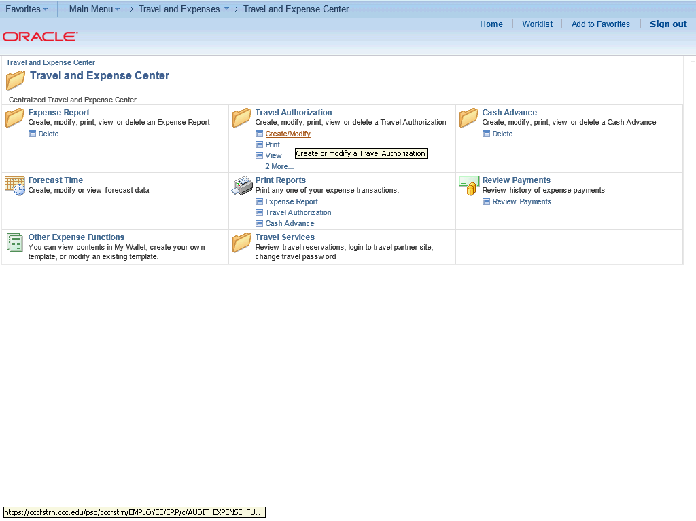

Step | Action
 | Begin by navigating to the Travel and Expense Center page.

Step | Action
From the Travel and Expense Center, navigate to the Travel Authorizations options.

Click the Create/Modify link.

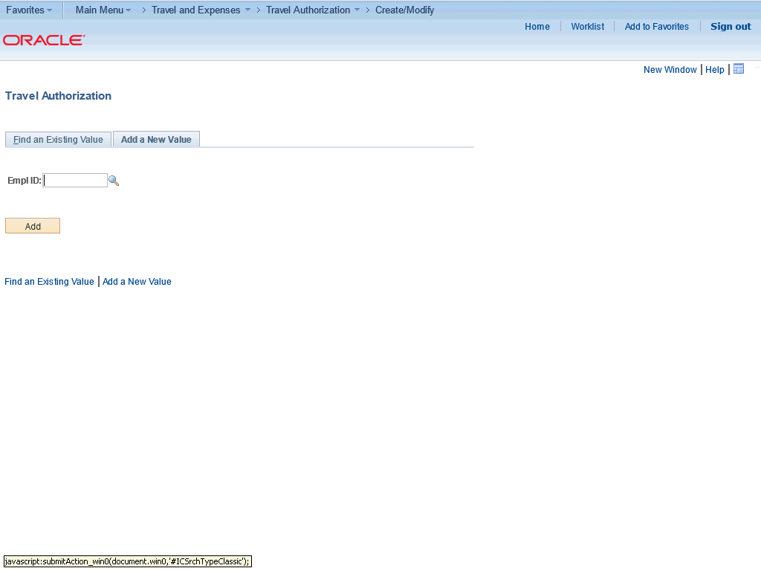

Step | Action
 | Click the Find an Existing Value tab.

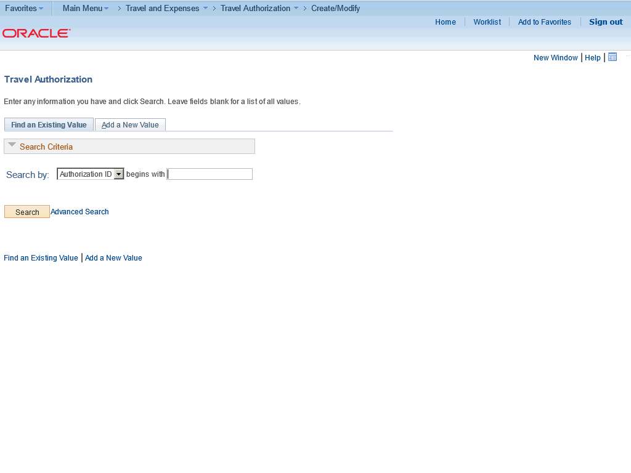

Step | Action
 | Click the Search button.

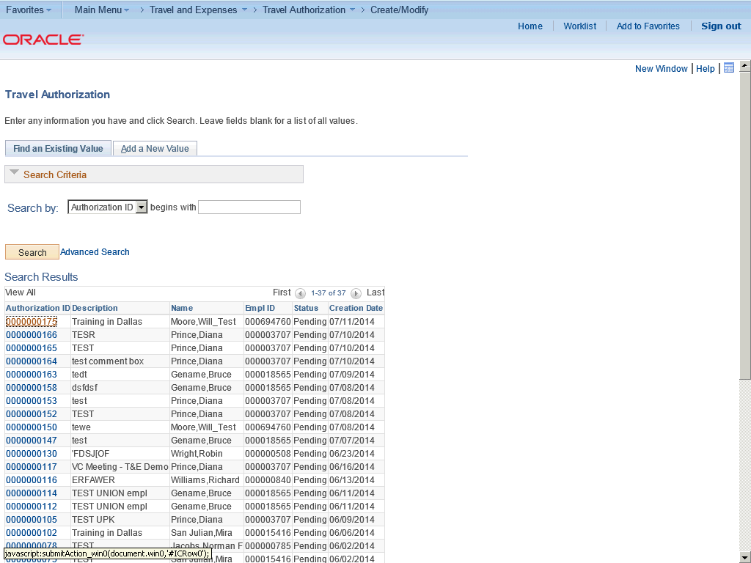

Step | Action
Search for the Travel Authorization to be modified.

Click the 0000000175 link.

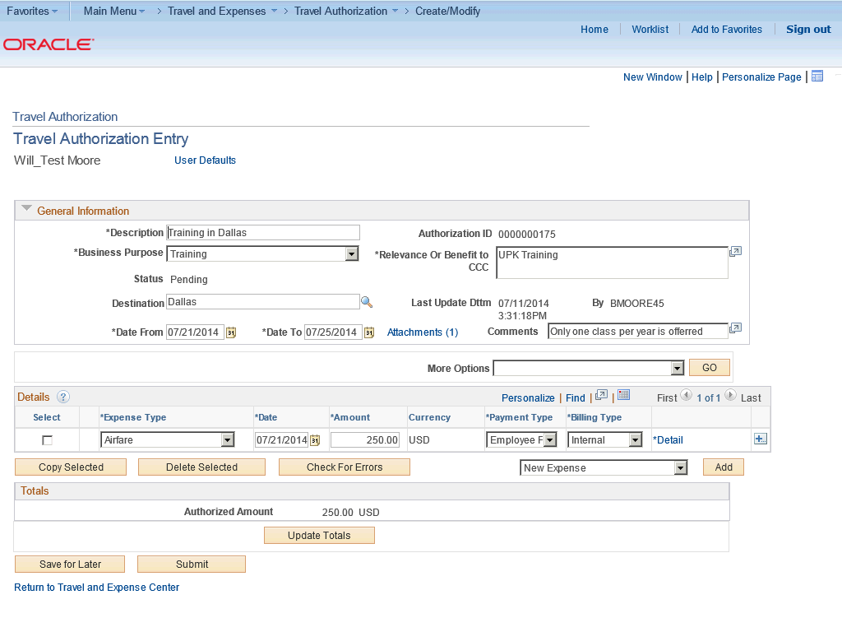

Step | Action
 | To add an new expense line, click the Add button.

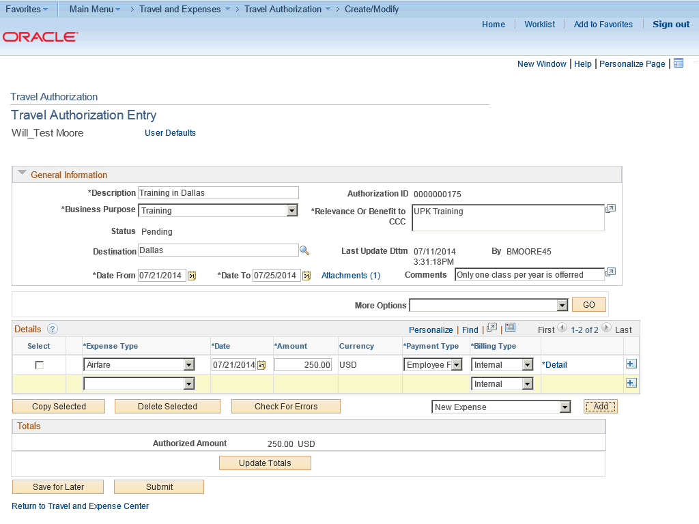

Step | Action
 | Click the Expense Type list.

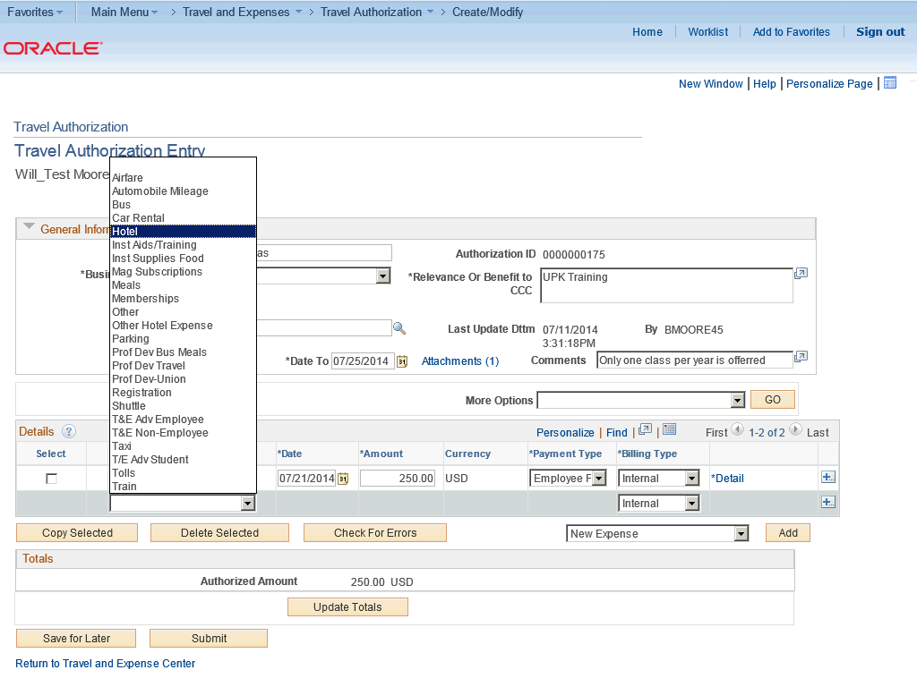

Step | Action
 | Click the Hotel list item.

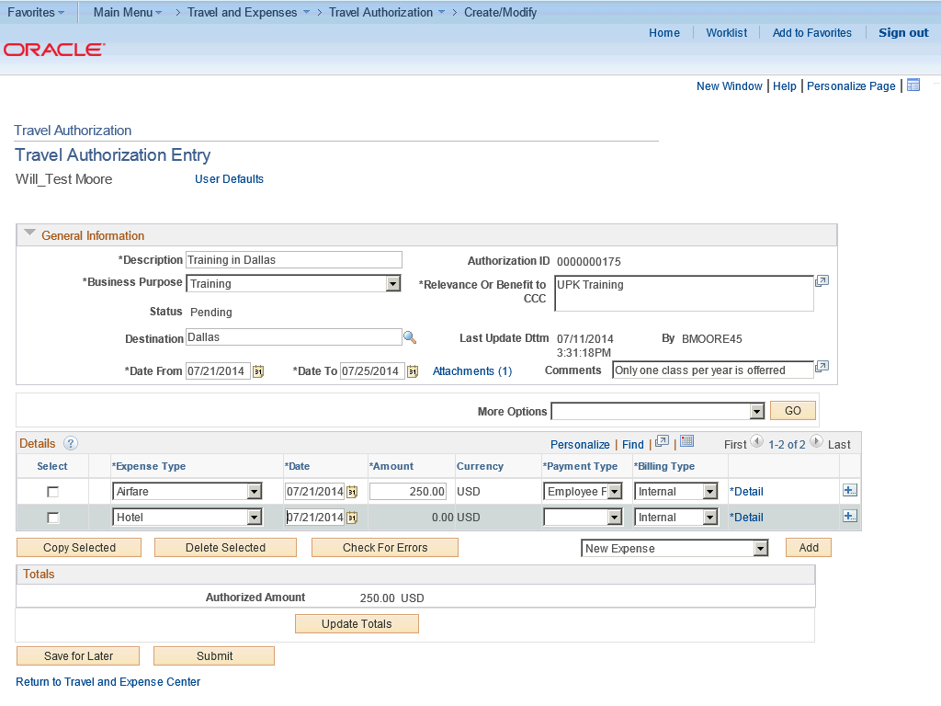

Step | Action
 | Click the Payment Type list.

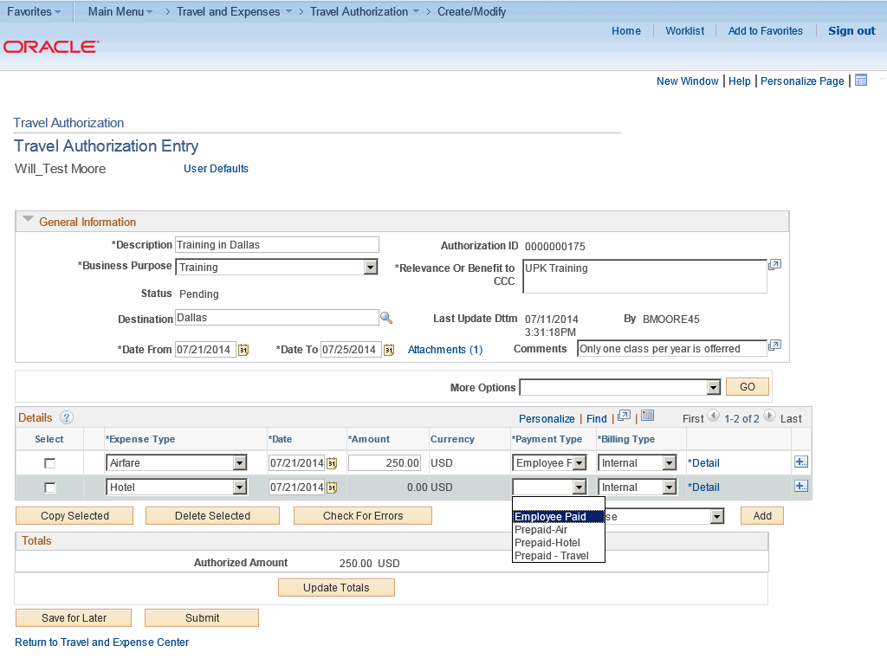

Step | Action
 | Click the Employee Paid list item.

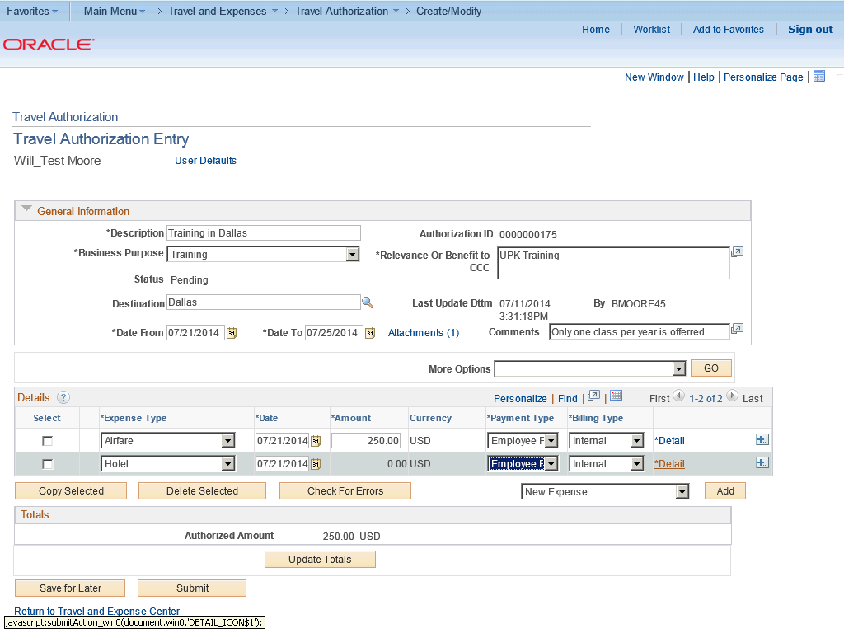

Step | Action
 | Click the Detail link.

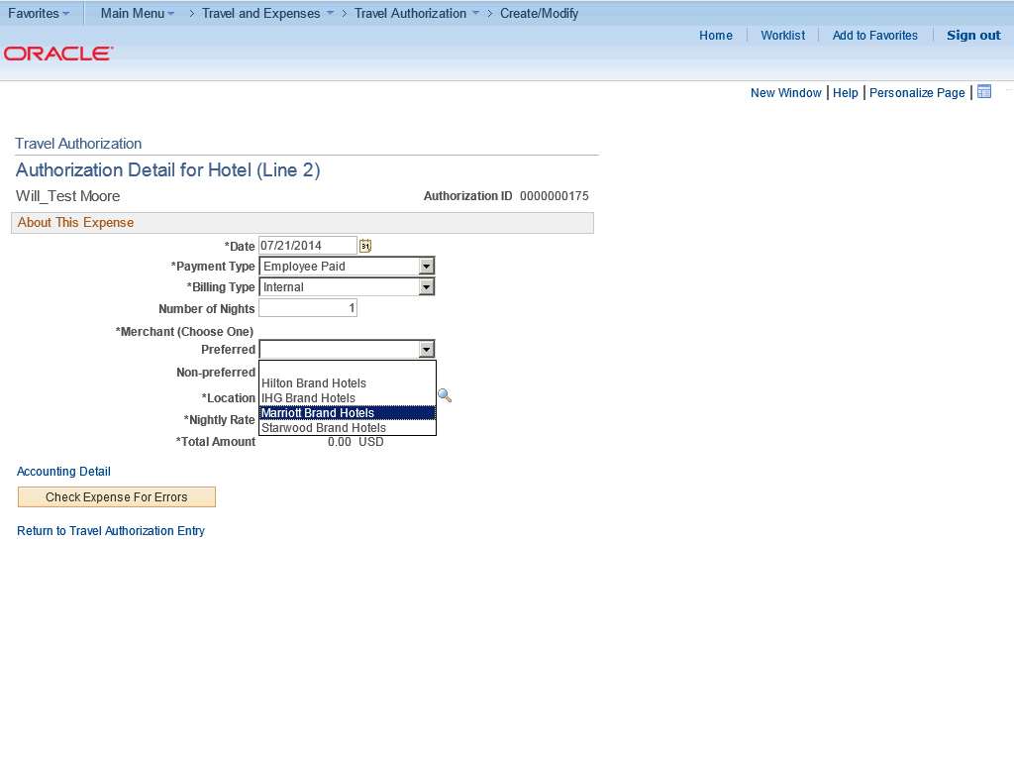

Step | Action
 | Click the Marriott Brand Hotels list item.

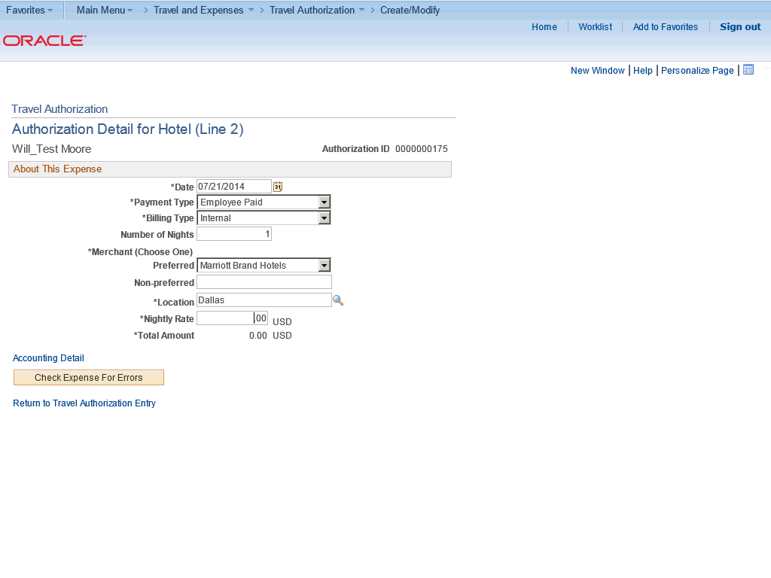

Step | Action
 | Enter the desired information into the Nightly Rate field. Enter "110".

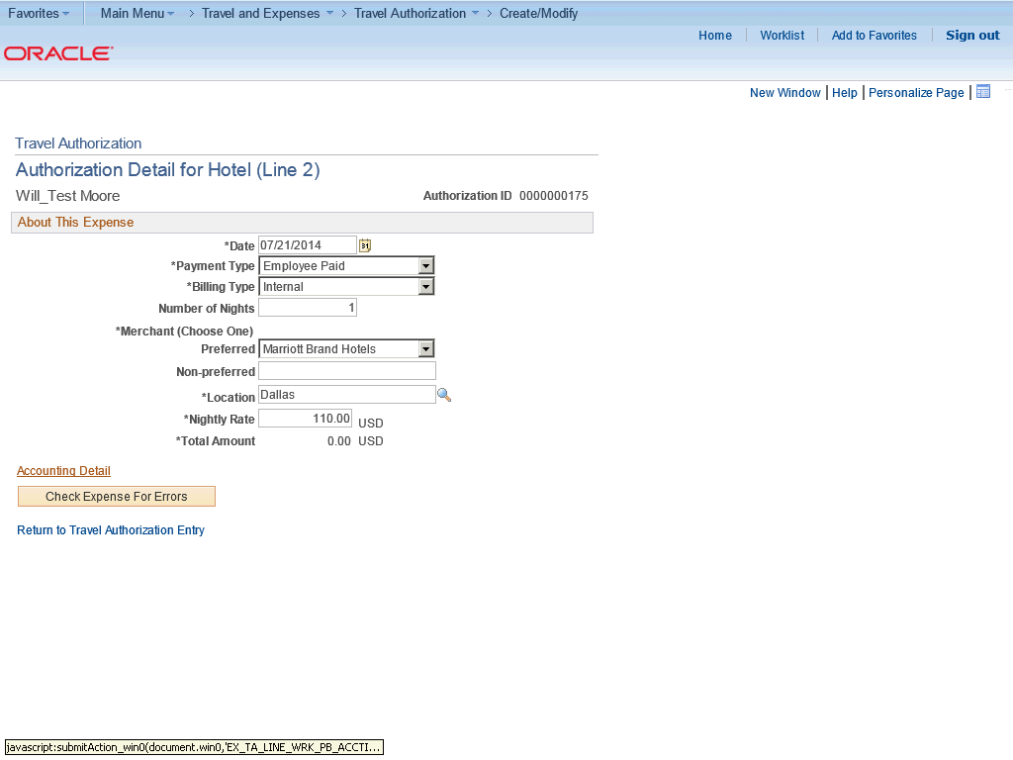

Step | Action
 | Click the Accounting Detail link.

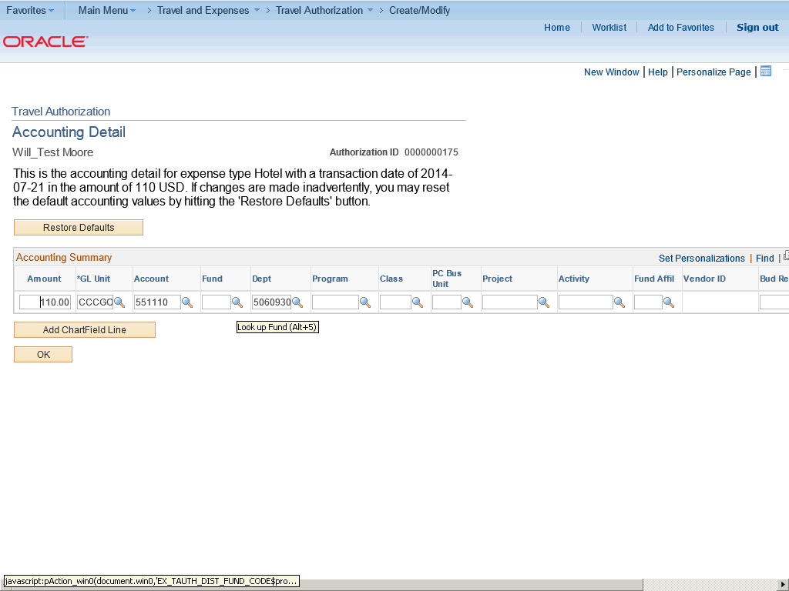

Step | Action
The chartfield string (budget) will default but you may need to add or change additional chartfield information.

Click the Look up Fund (Alt+5) button.

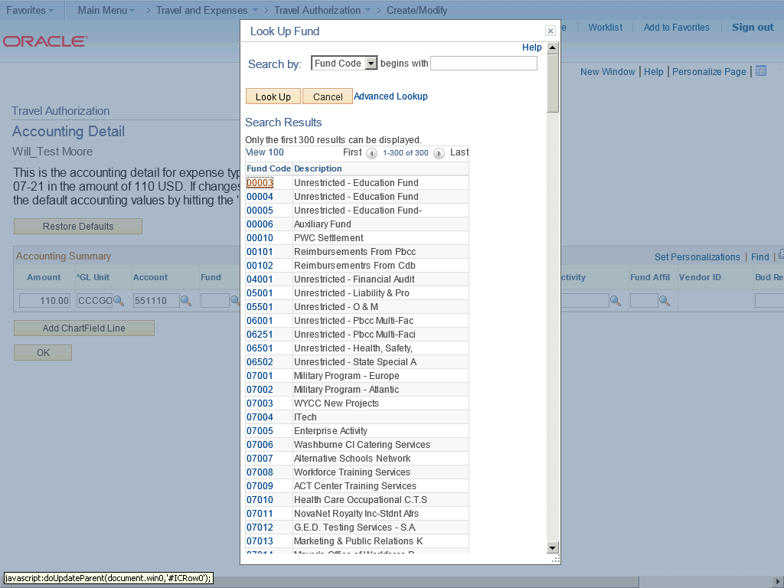

Step | Action
 | Click the 00003 link.

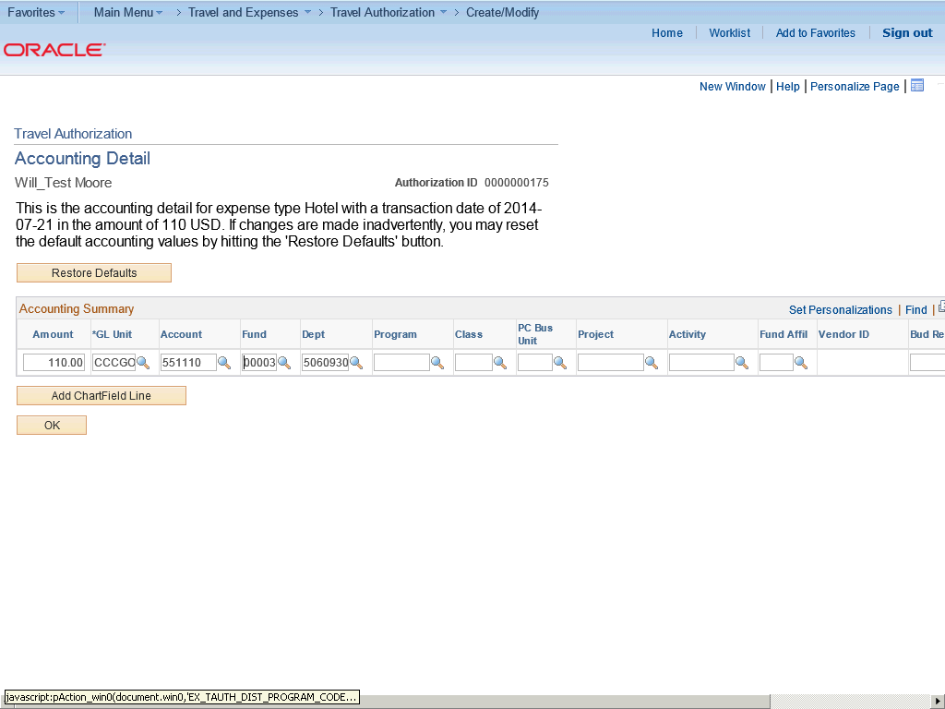

Step | Action
 | Click the Look up Program (Alt+5) button.

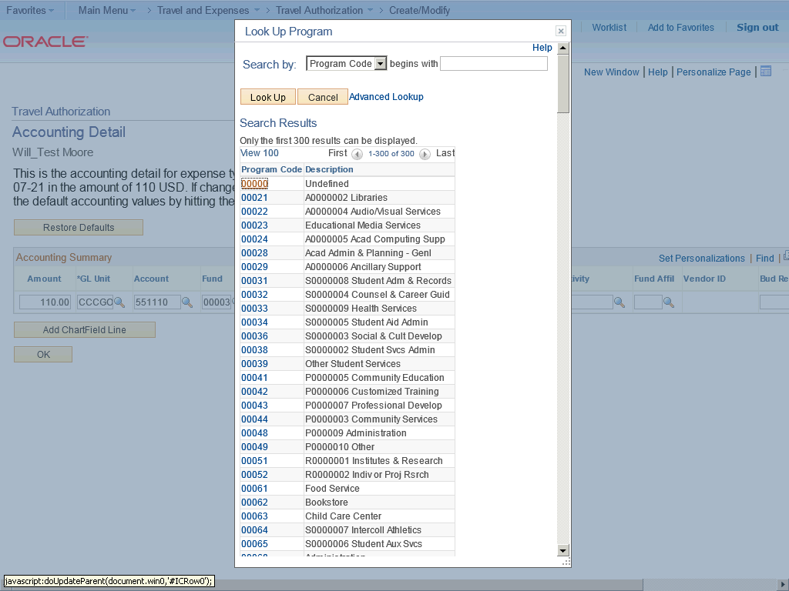

Step | Action
 | Click the 00000 link.

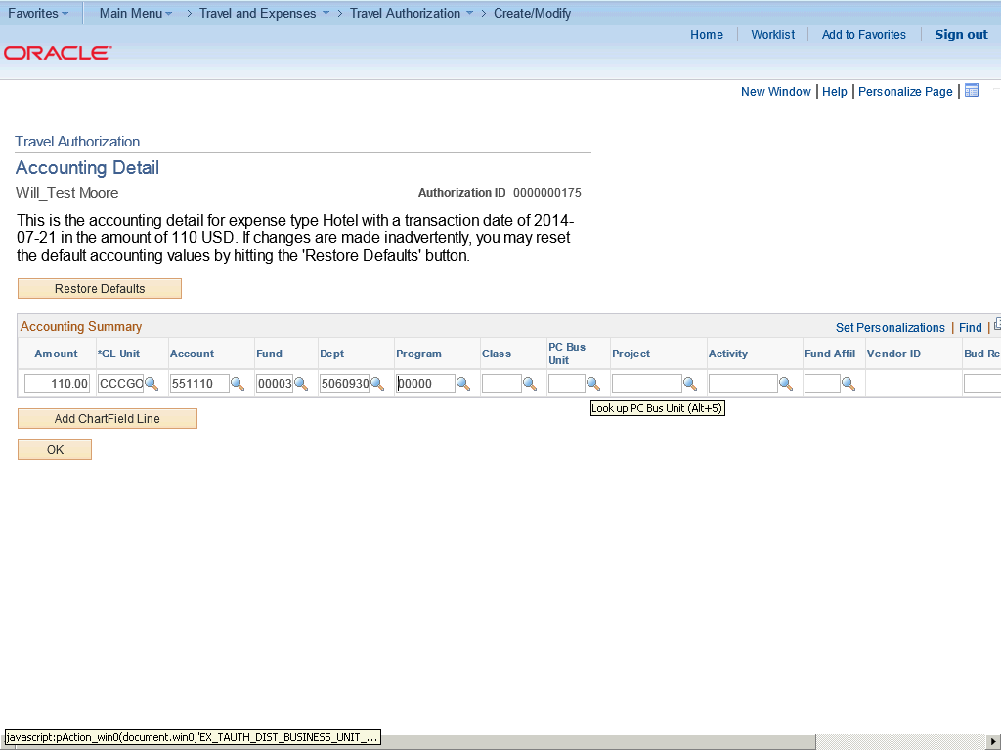

Step | Action
 | Click the Look up PC Bus Unit (Alt+5) button.

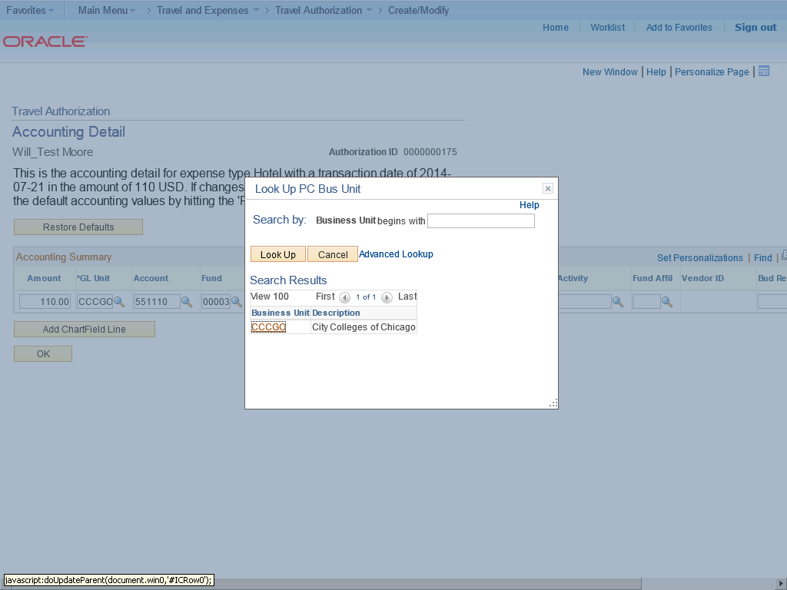

Step | Action
 | Click the CCCGO link.

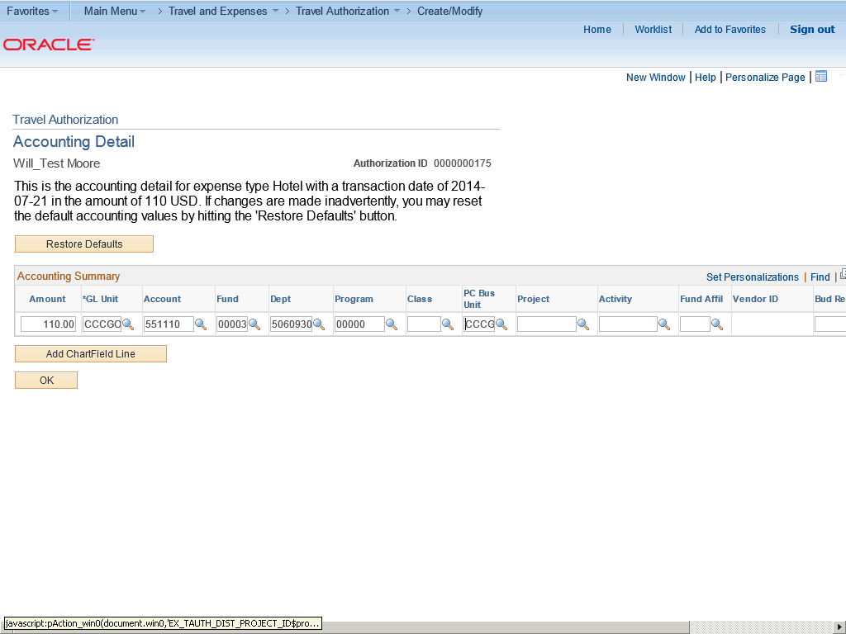

Step | Action
 | Click the Look up Project (Alt+5) button.

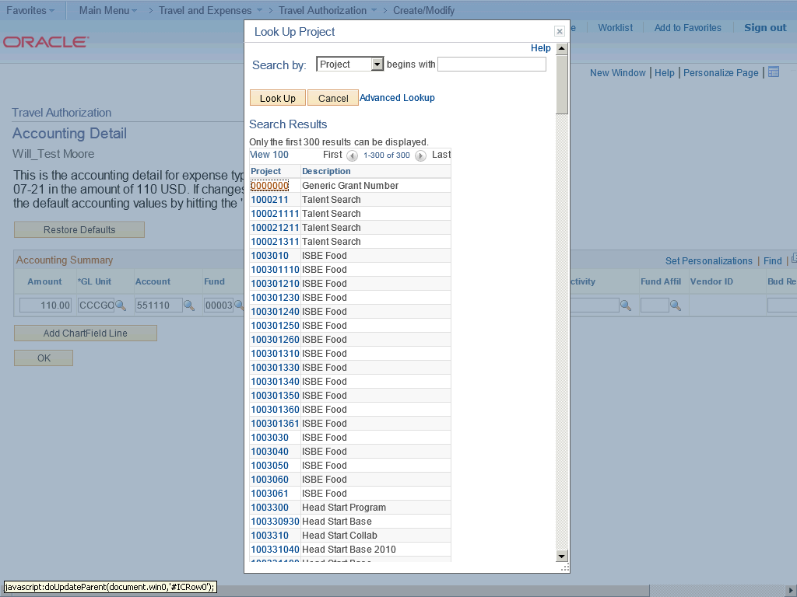

Step | Action
 | Click the 0000000 link.

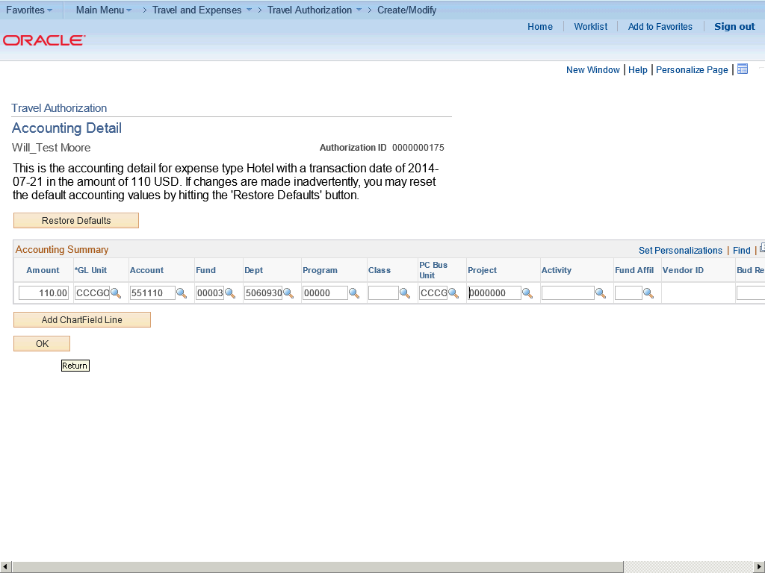

Step | Action
 | Click the OK button.

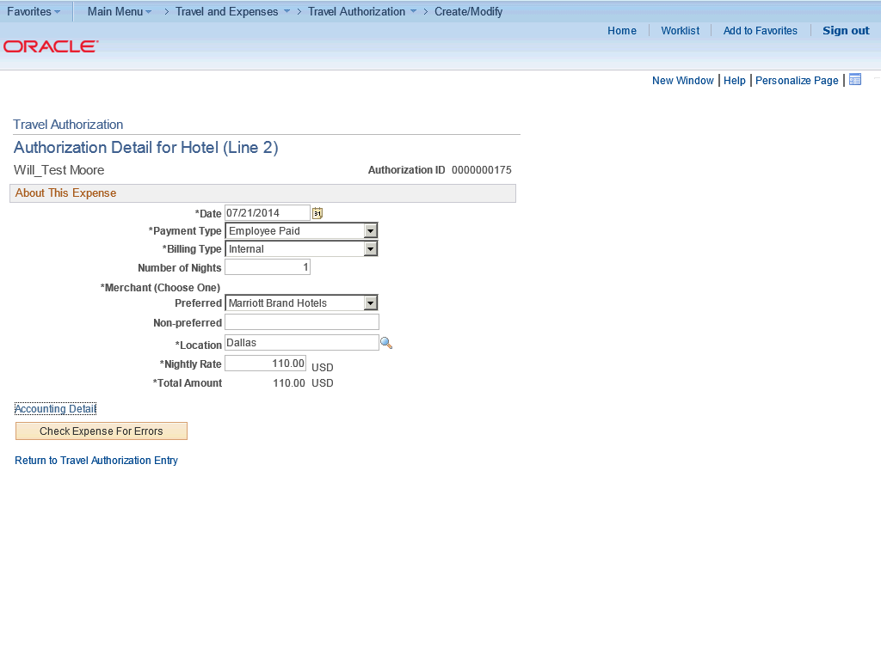

Step | Action
 | Click the Check Expense For Errors button.

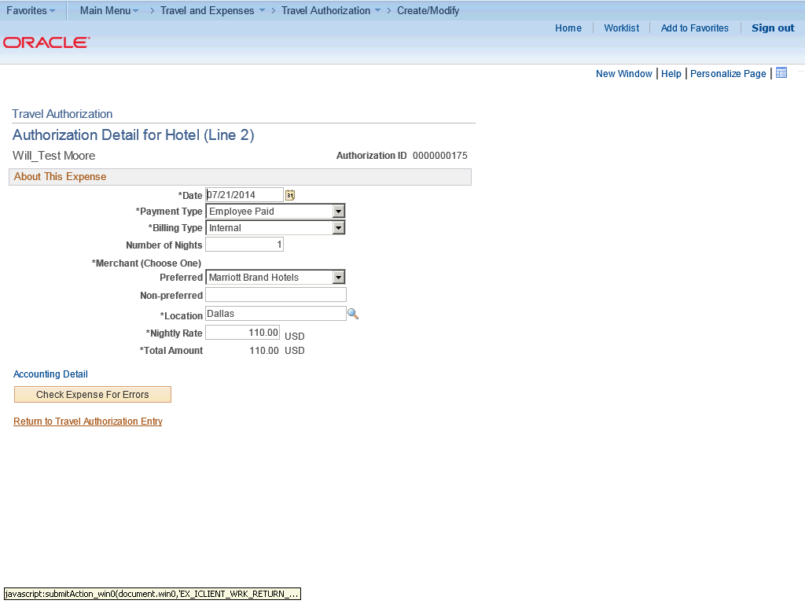

Step | Action
 | Click the Return to Travel Authorization Entry link.

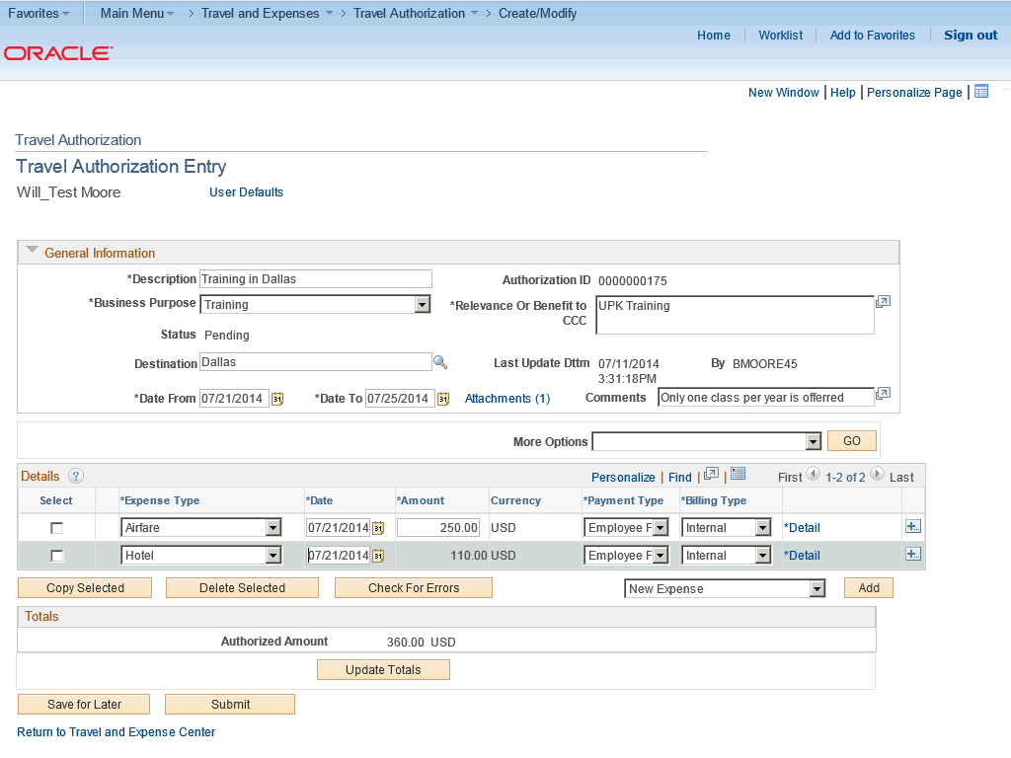

Step | Action
 | To add an new expense line, click the Add button.

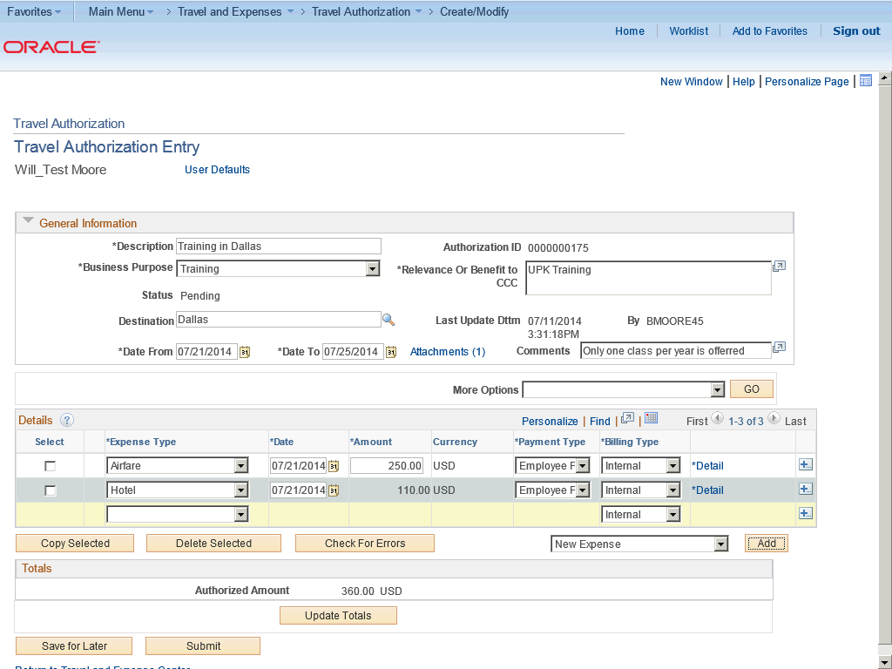

Step | Action
 | Click the Expense Type list.

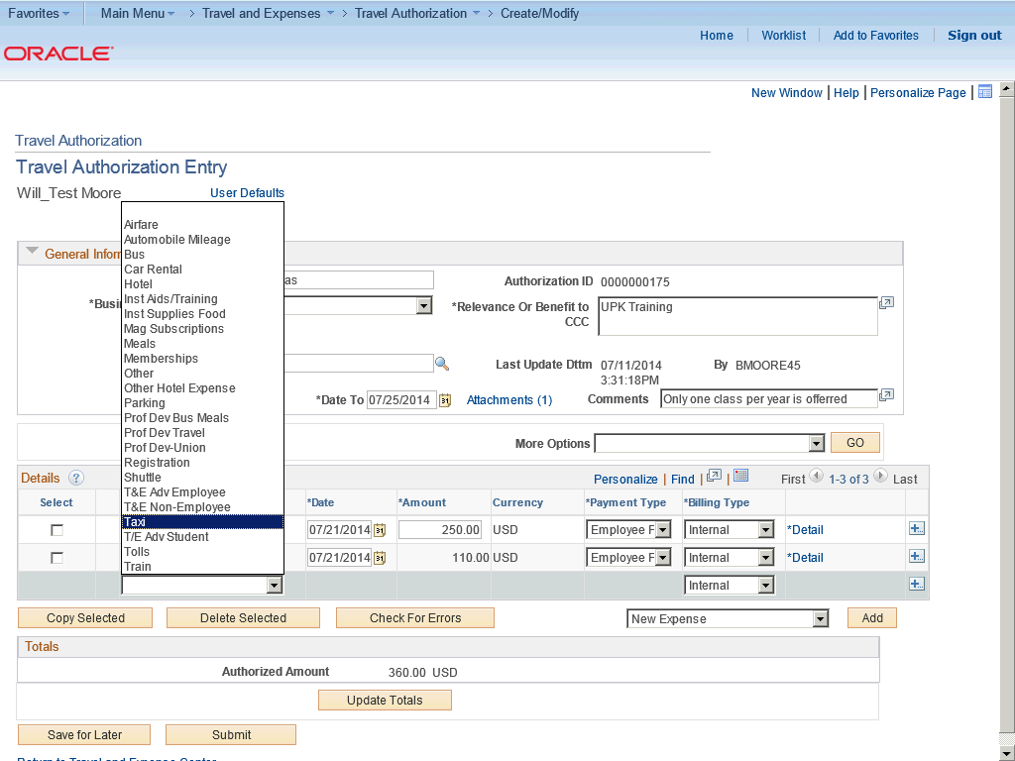

Step | Action
 | Click the Taxi list item.

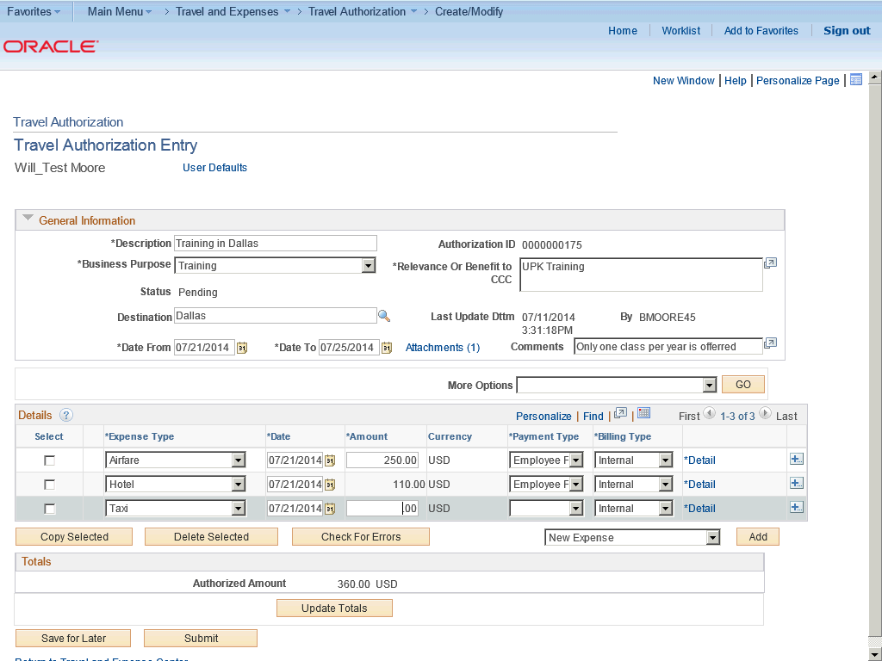

Step | Action
 | Enter the desired information into the Amount field. Enter "30".

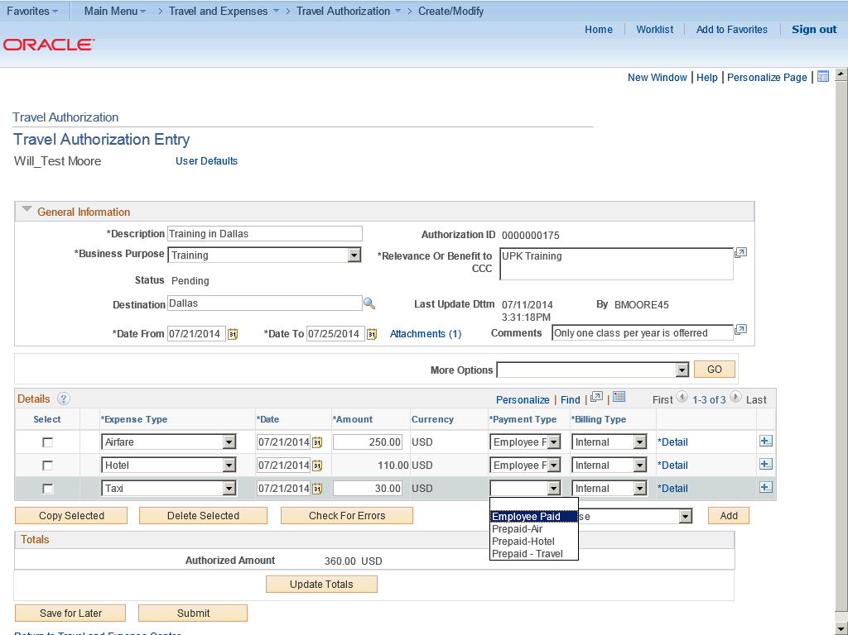

Step | Action
 | Click the Employee Paid list item.

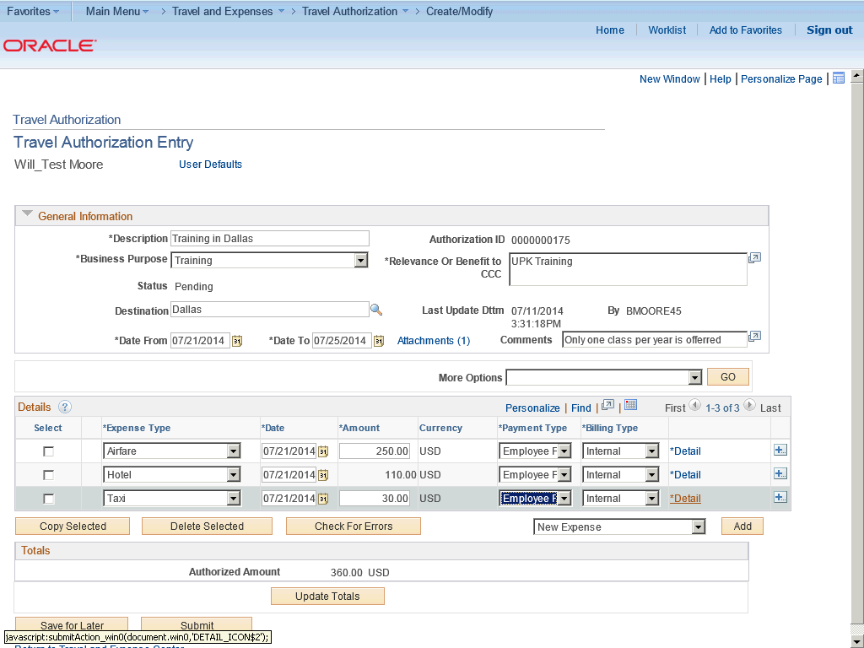

Step | Action
 | Click the Detail link.

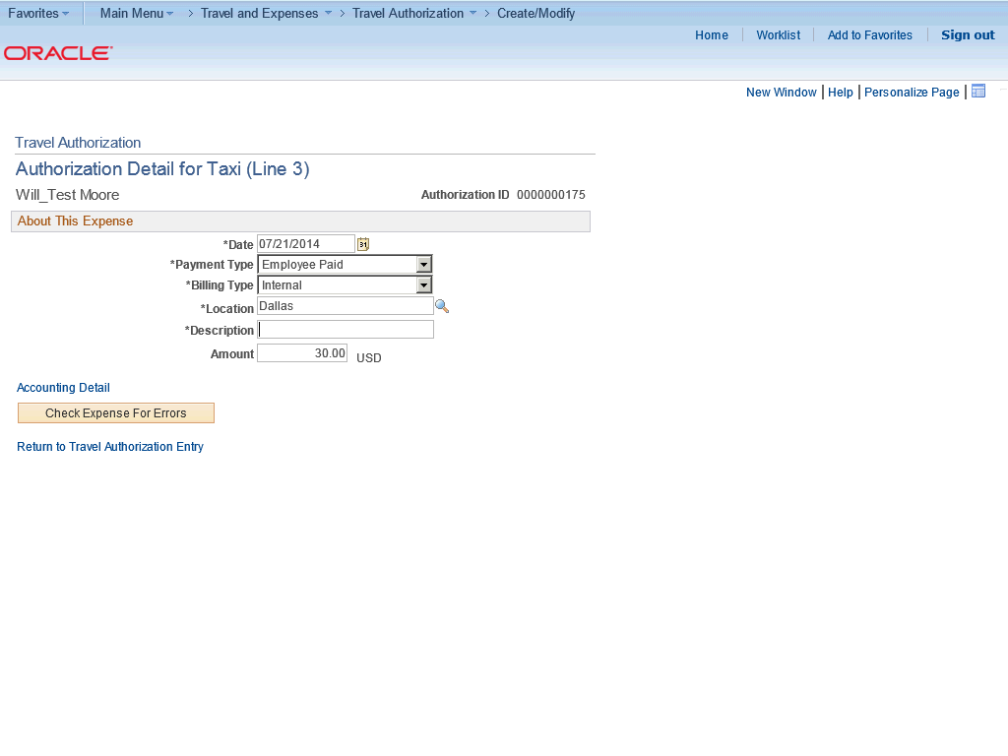

Step | Action
 | Enter the desired information into the Description Required field. Enter "Taxi from Airport".

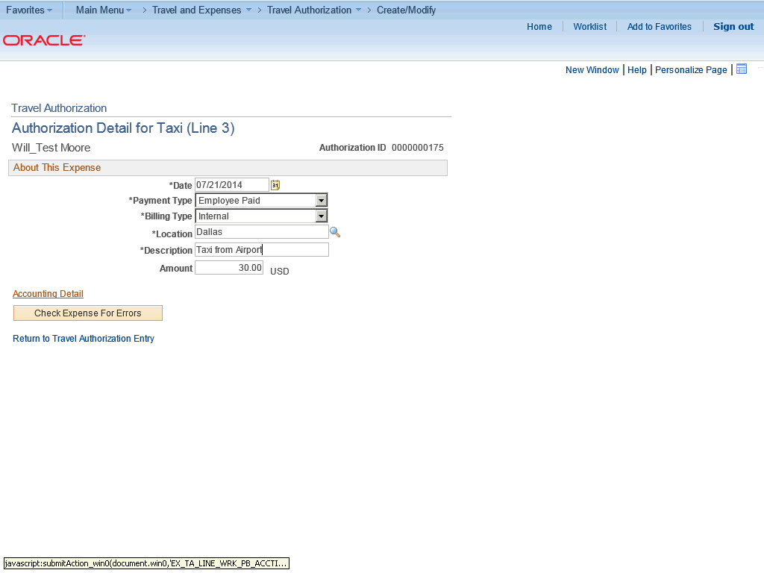

Step | Action
 | Click the Accounting Detail link.

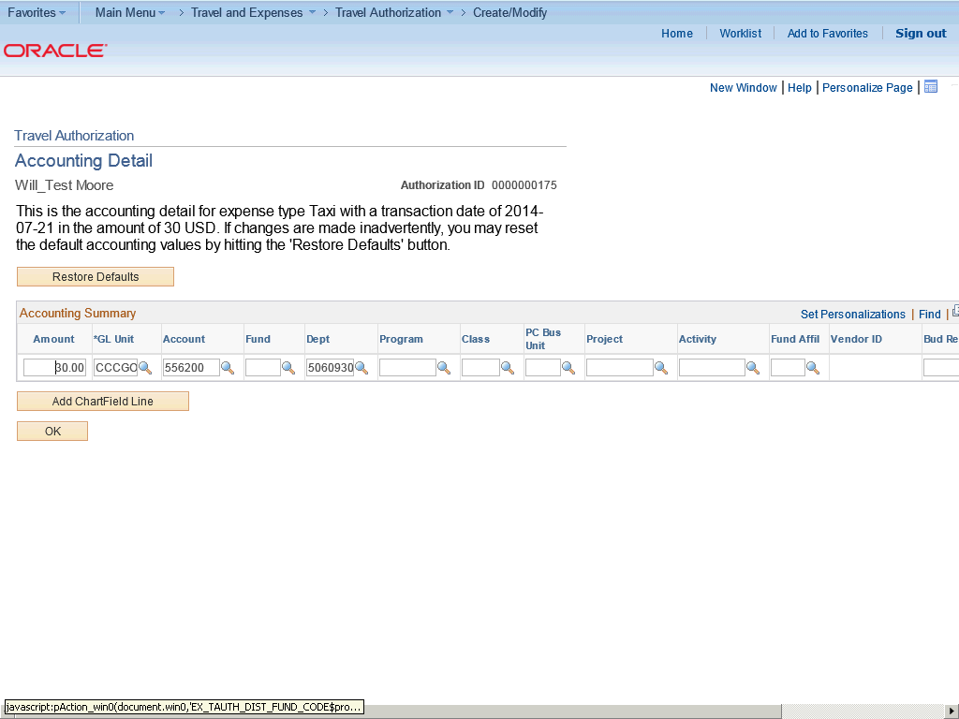

Step | Action
The chartfield string (budget) will default but you may need to add or change additional chartfield information.

Click the Look up Fund (Alt+5) button.

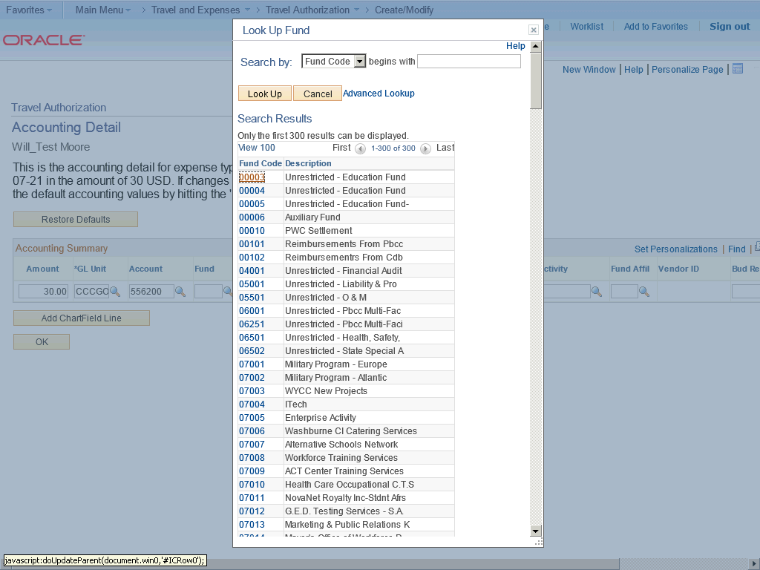

Step | Action
 | Click the 00003 link.

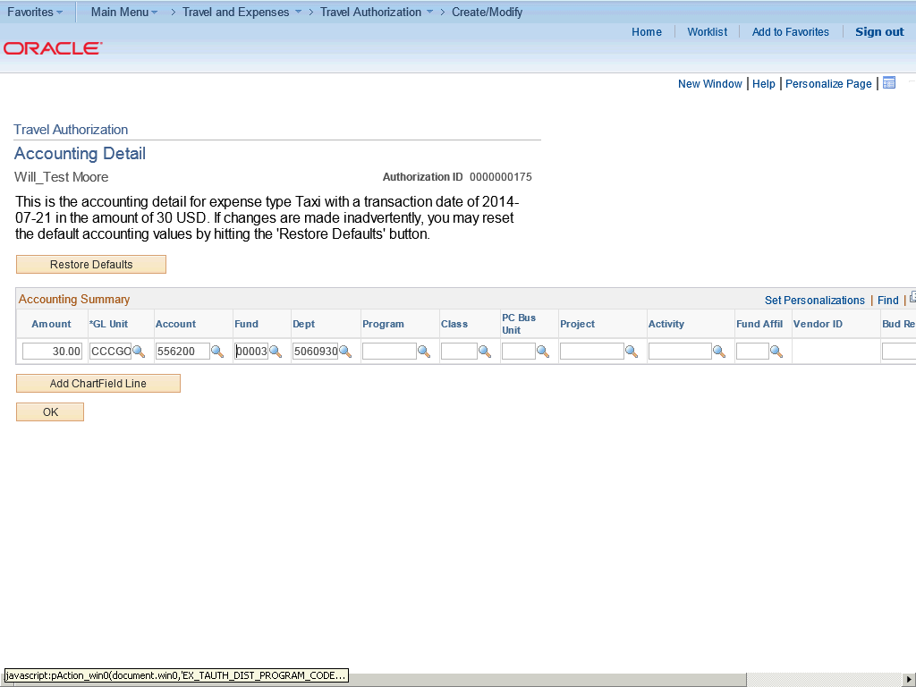

Step | Action
 | Click the Look up Program (Alt+5) button.

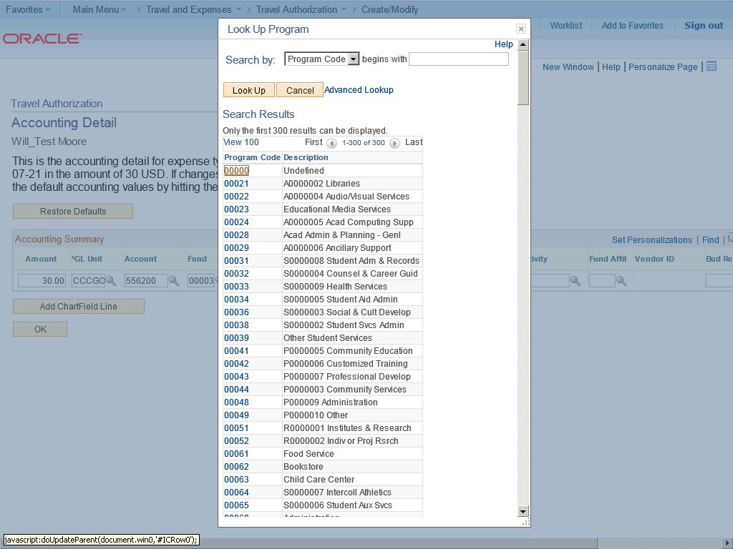

Step | Action
 | Click the 00000 link.

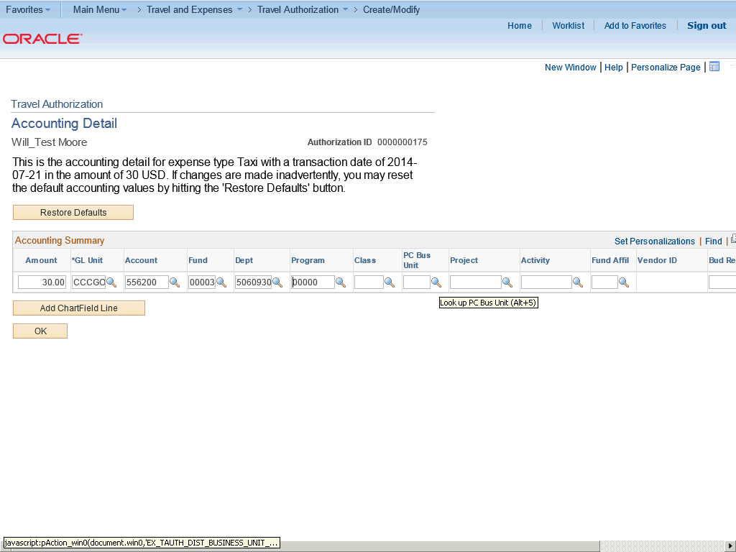

Step | Action
 | Click the Look up PC Bus Unit (Alt+5) button.

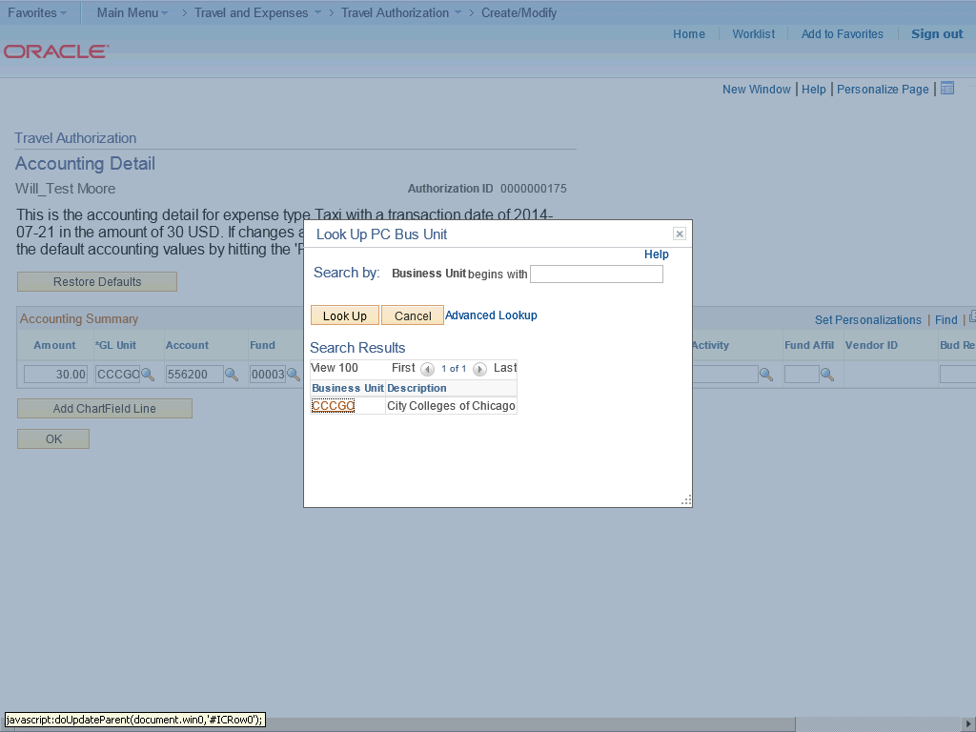

Step | Action
 | Click the CCCGO link.

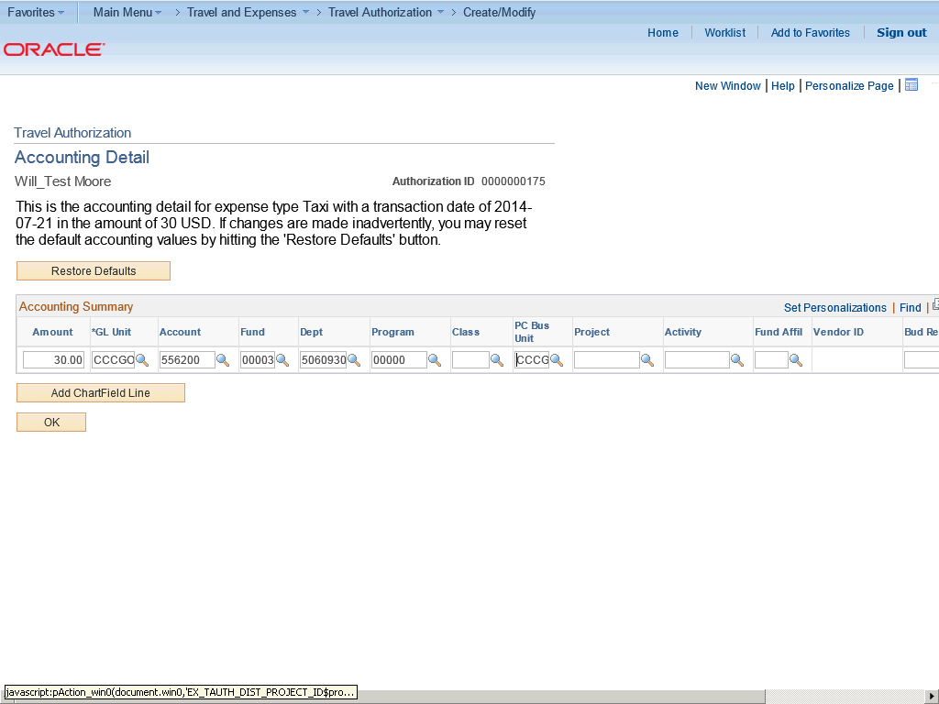

Step | Action
 | Click the Look up Project (Alt+5) button.

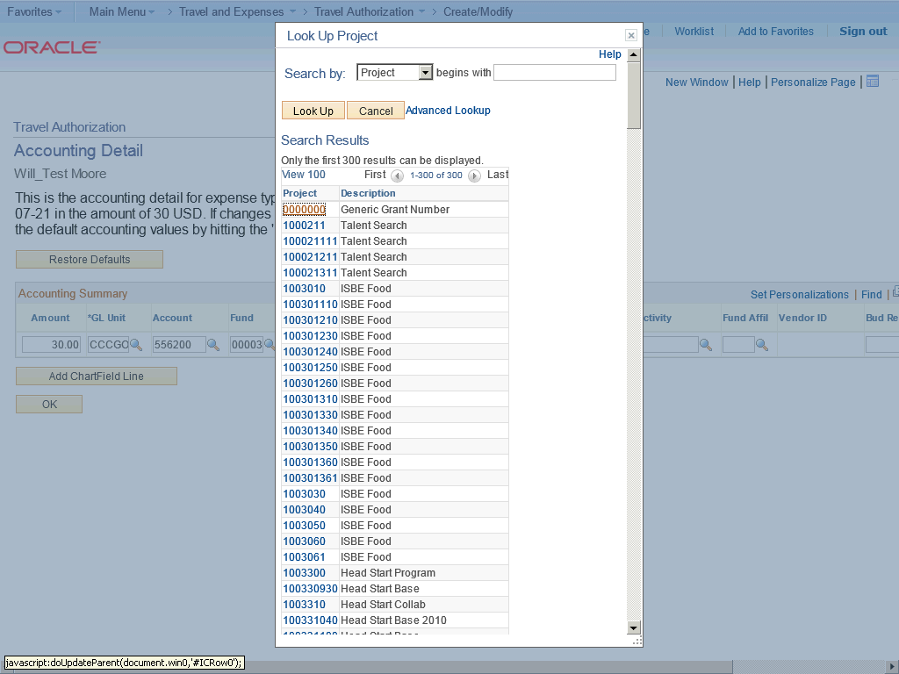

Step | Action
 | Click the 0000000 link.

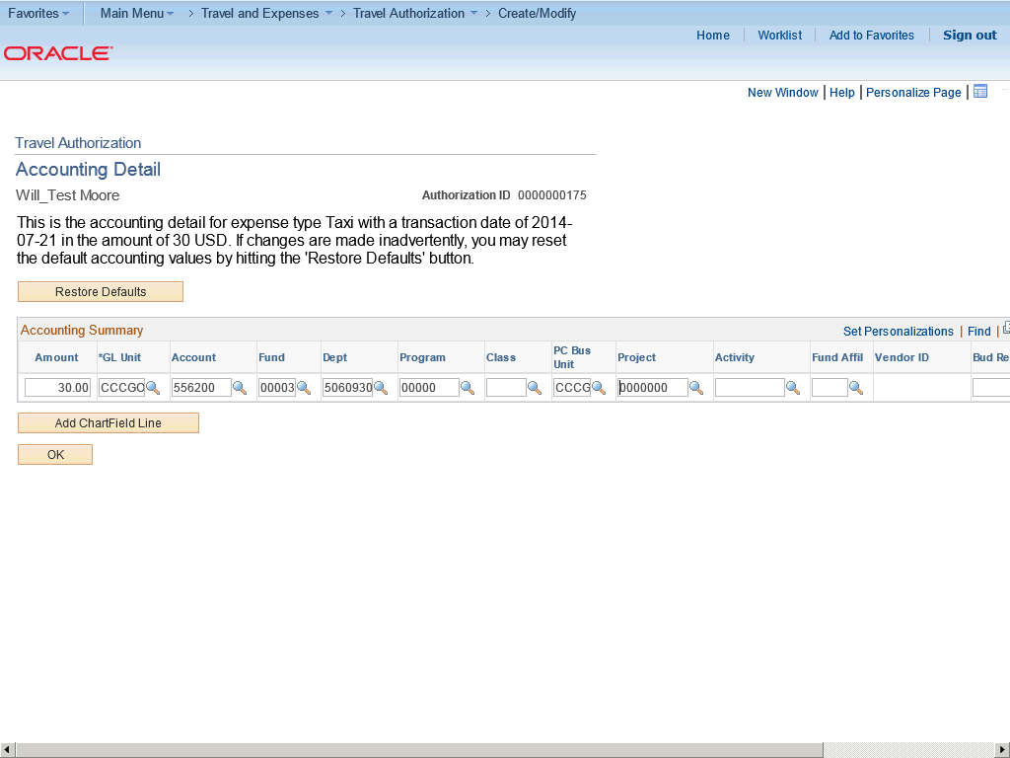

Step | Action
 | Click the OK button.

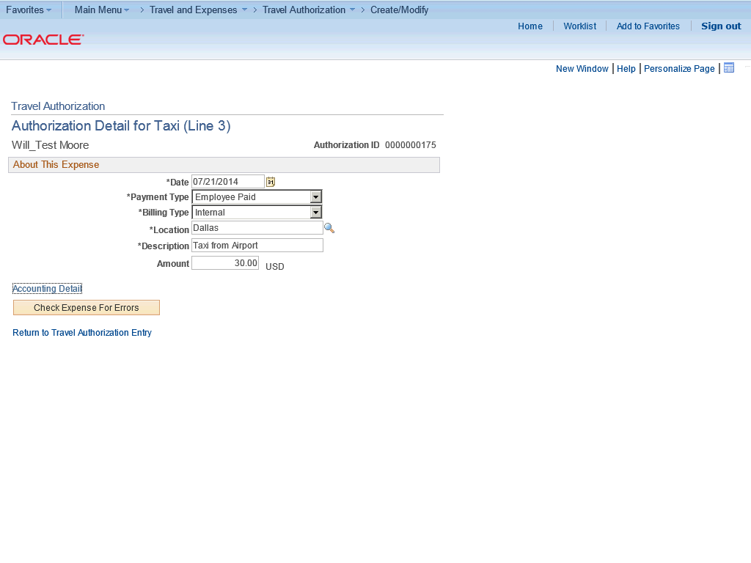

Step | Action
 | Click the Check Expense For Errors button.

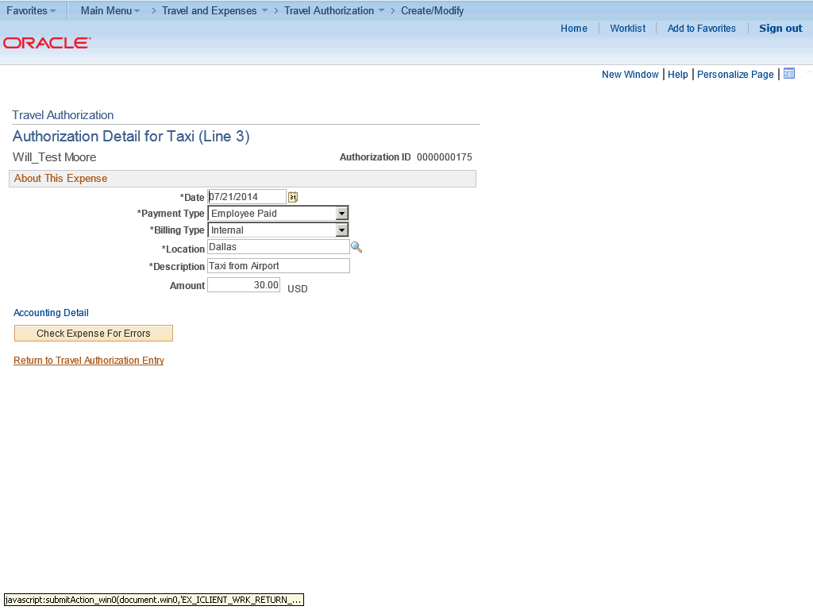

Step | Action
 | Click the Return to Travel Authorization Entry link.

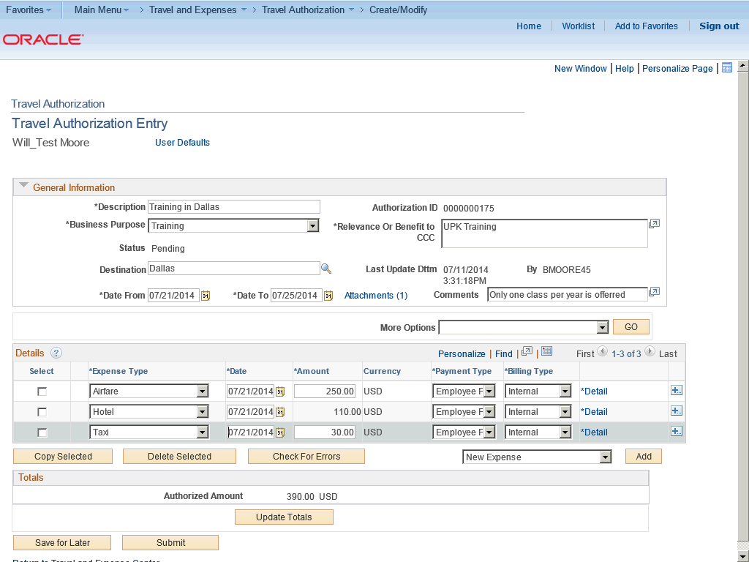

Step | Action
 | Click the Save for Later button.

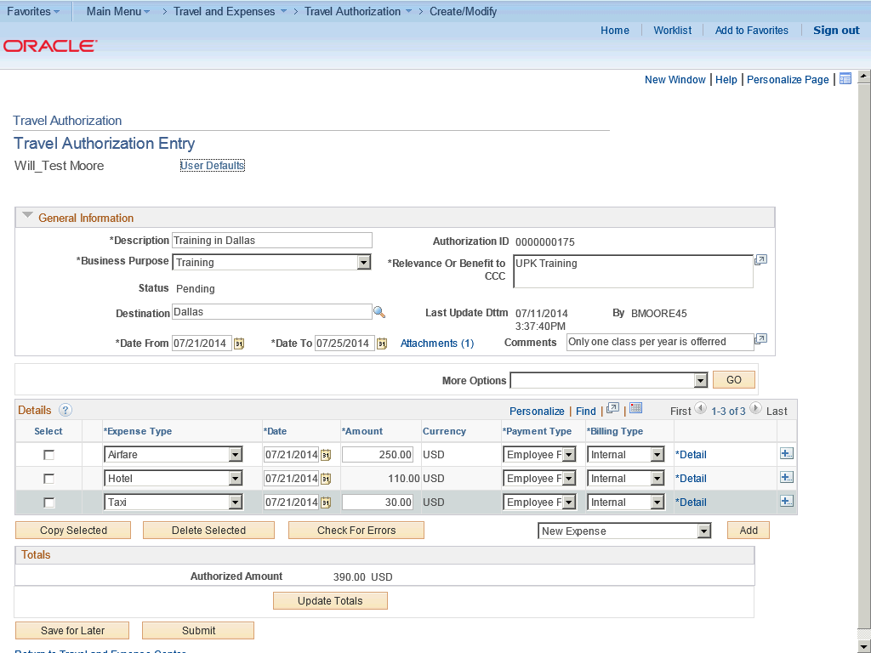

Step | Action
In this topic you have learned the following:

- How to add multiple travel authorization expense lines.

You have successfully completed this training session.
End of Procedure.

Viewing and Modifying Travel Authorizations
Viewing and Modifying Travel Authorizations

Once a travel authorization has been entered, it can be viewed at any time. Typically an employee would view travel authorization to check the status of an existing travel authorization request.

If you access the Travel Authorization Details page using the View navigation, Expenses displays the page in read-only mode. You can only view travel authorizations that you submitted for approval.

If you access the Travel Authorization Details page using the Modify navigation, Expenses enables you to edit all the fields. You can modify a travel authorization if you have not submitted it for approval or if an approver sent it back for revision or correction.

In this topic, you are going to view a travel authorization to make sure everything was entered correctly. Upon viewing it, you realize that you forgot to add an expense item. You then need to modify it to add the missing item.
Procedure

In this topic you will learn the following:

- How to view and modify travel authorizations.
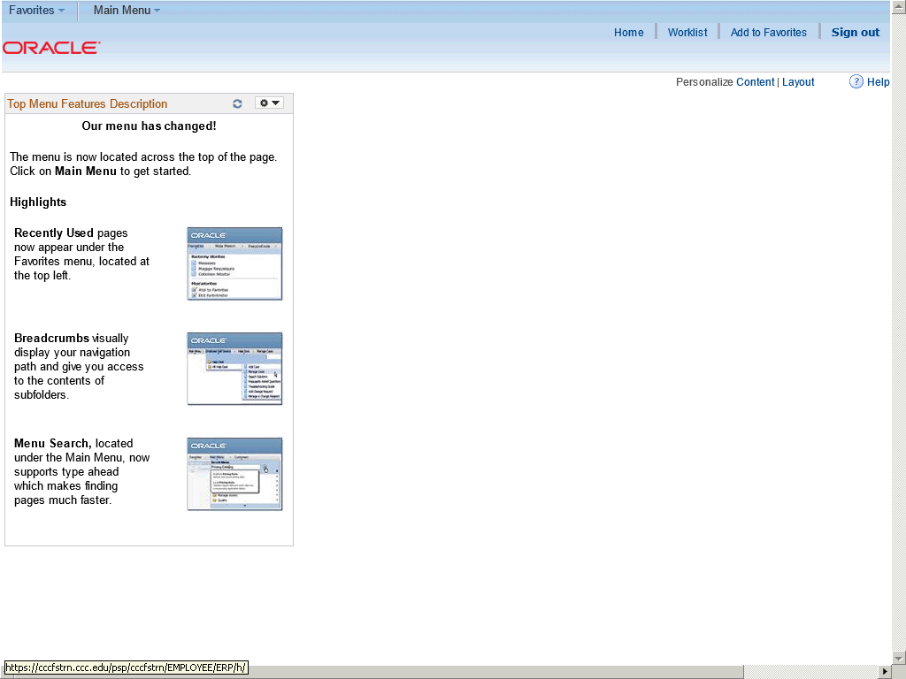

Step | Action
Begin by navigating to the View/Modify Page.

Click the Main Menu button.

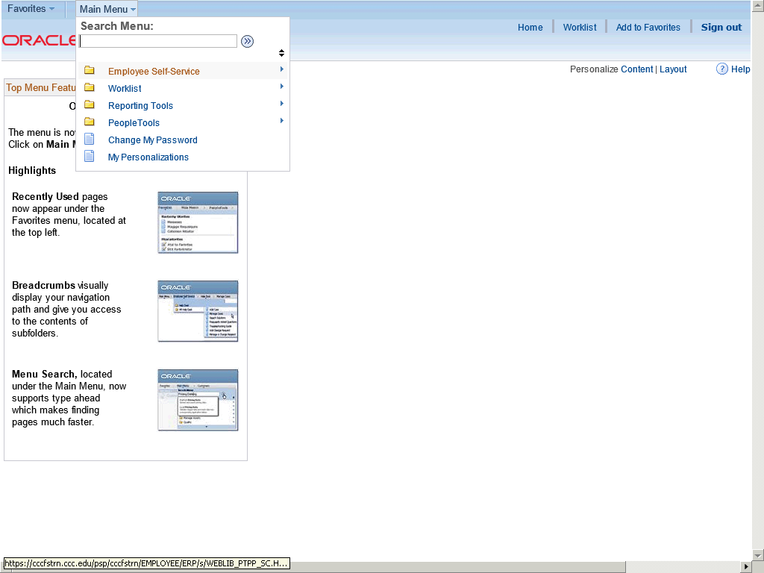

Step | Action
 | Click Employee Self-Service.

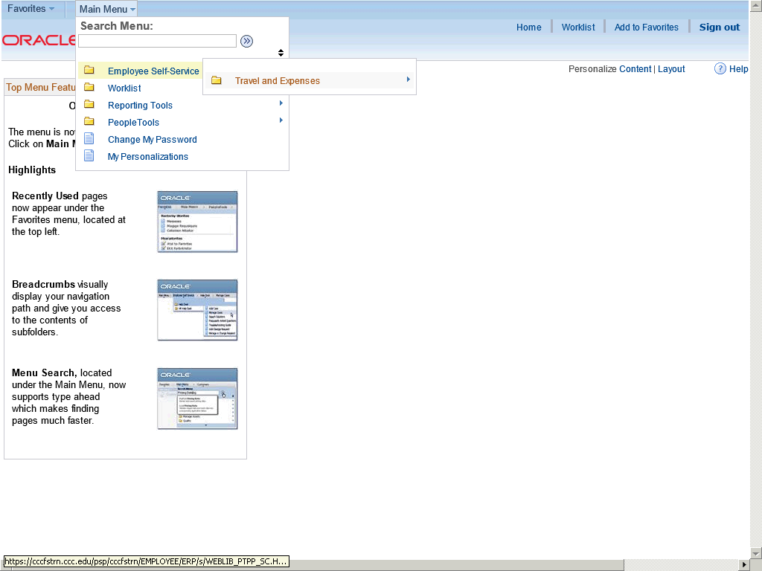

Step | Action
 | Click Travel and Expenses.

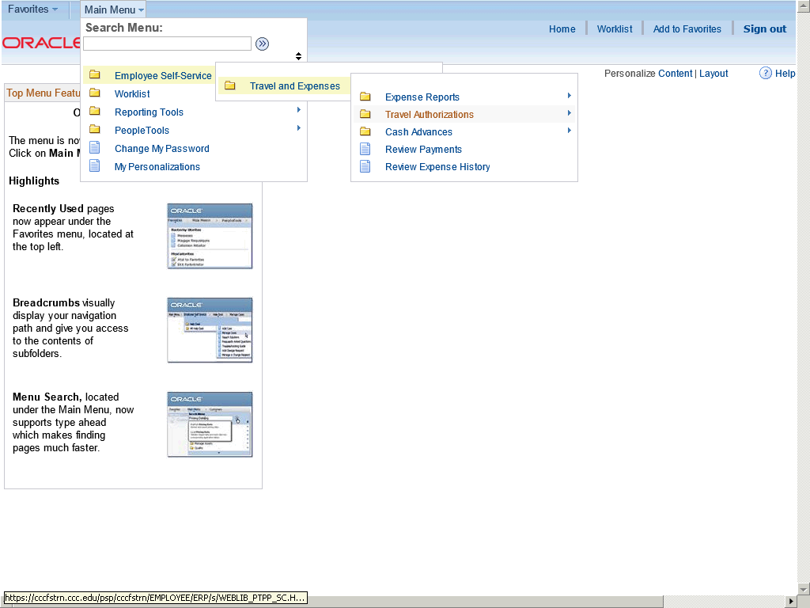

Step | Action
 | Click Travel Authorizations.

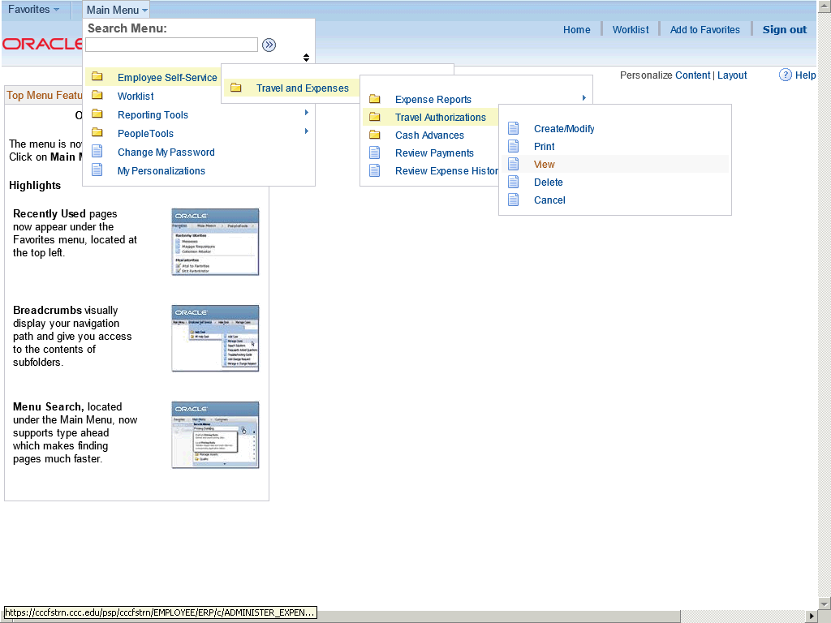

Step | Action
 | Click View.

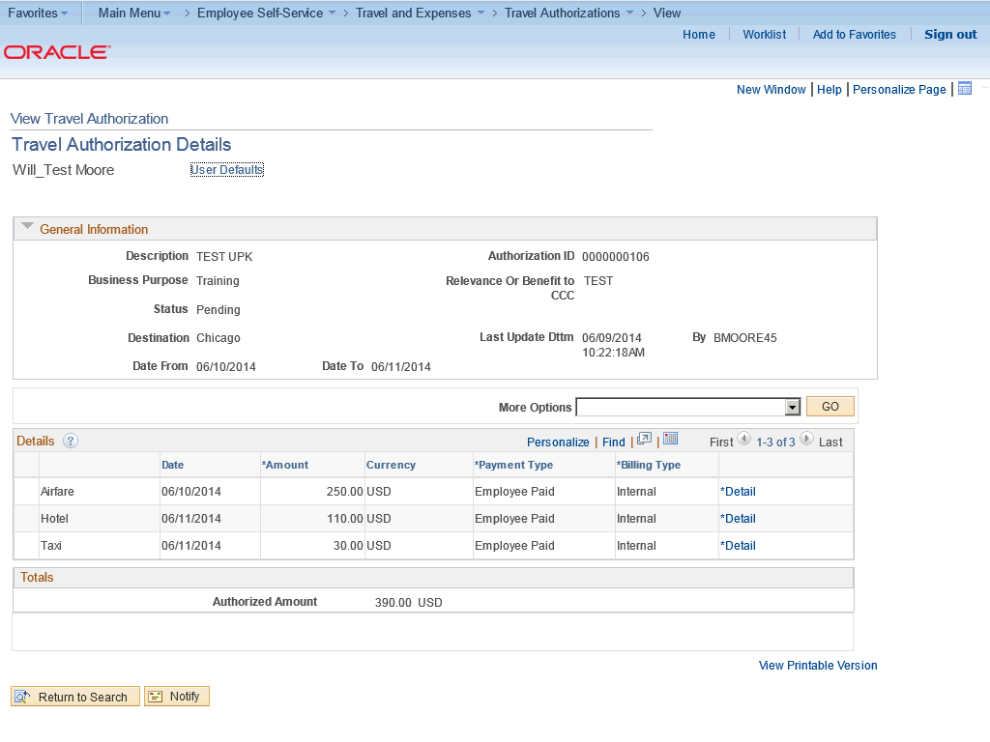

Step | Action
 | Use the Travel Authorization Details page to review the details of the travel authorization. This page is read-only and cannot be modified.

Step | Action
 | Click the Return to Search button.

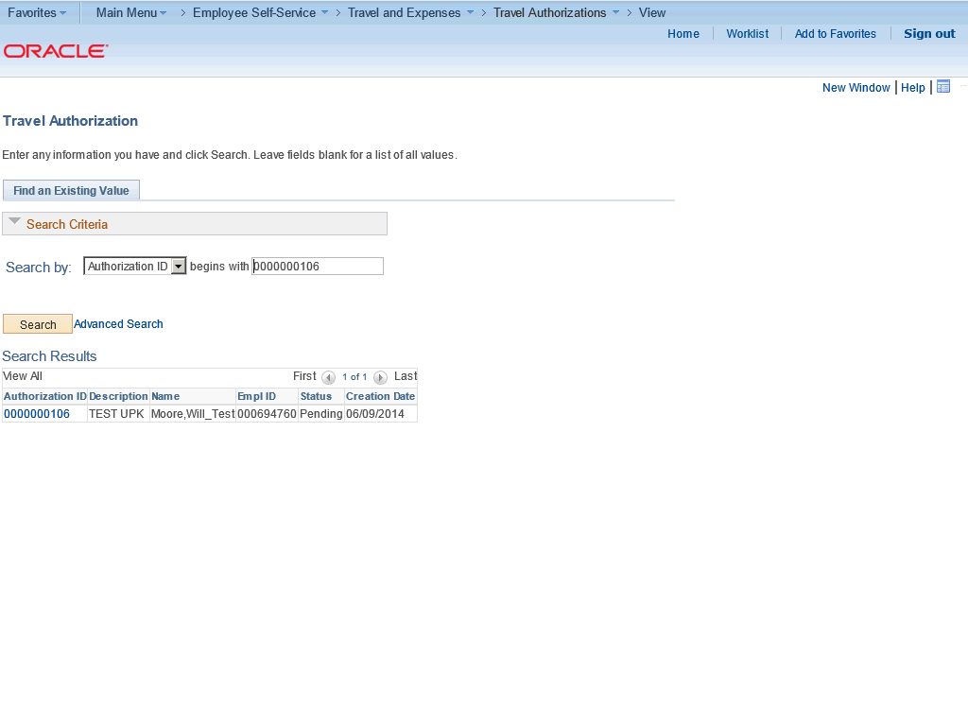

Step | Action
 | Click Travel Authorizations.

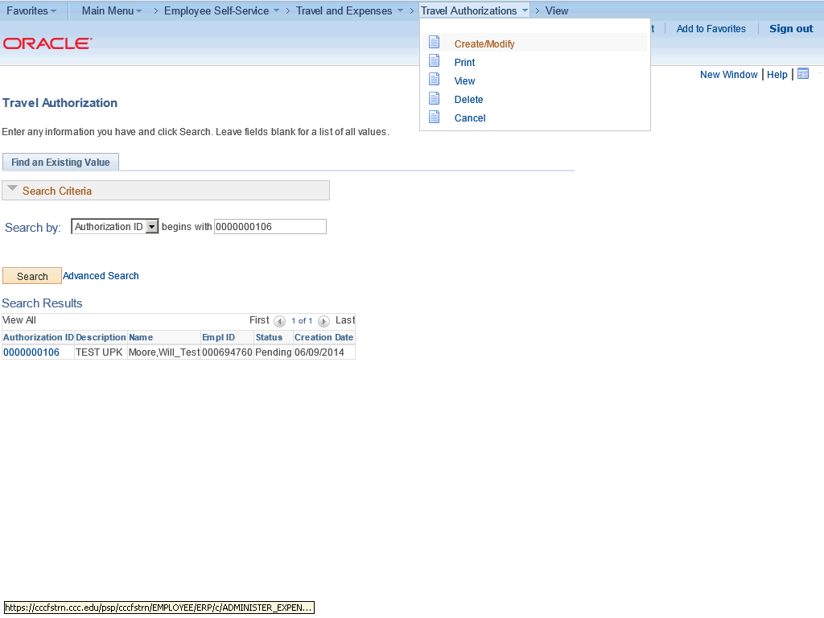

Step | Action
 | Click Create/Modify.

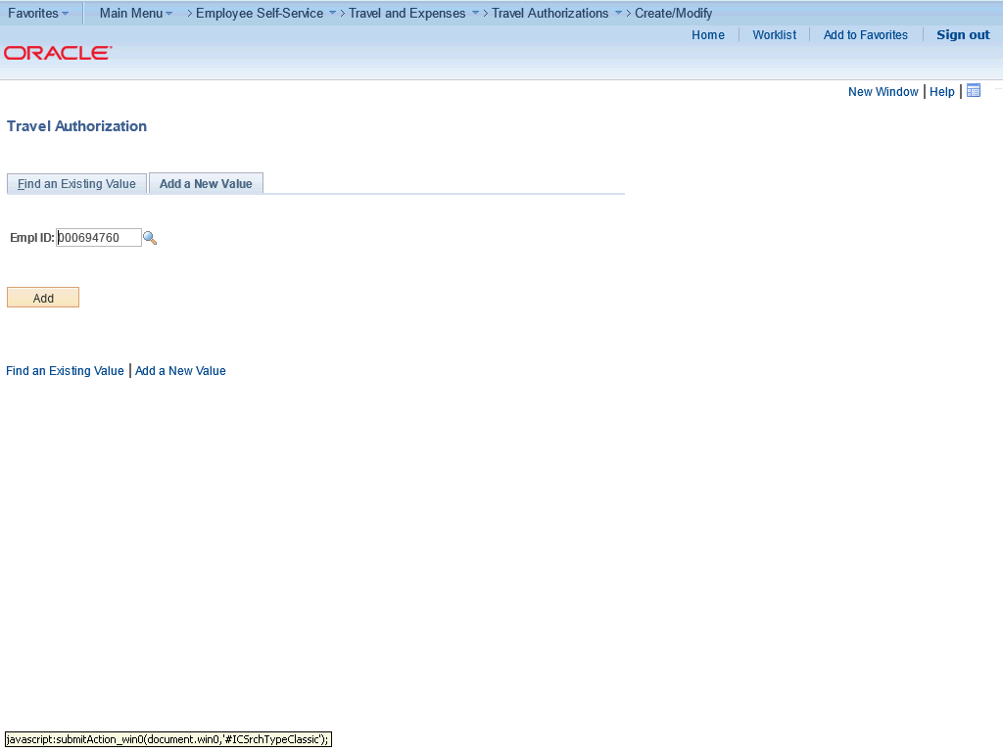

Step | Action
 | Click the Find an Existing Value tab.

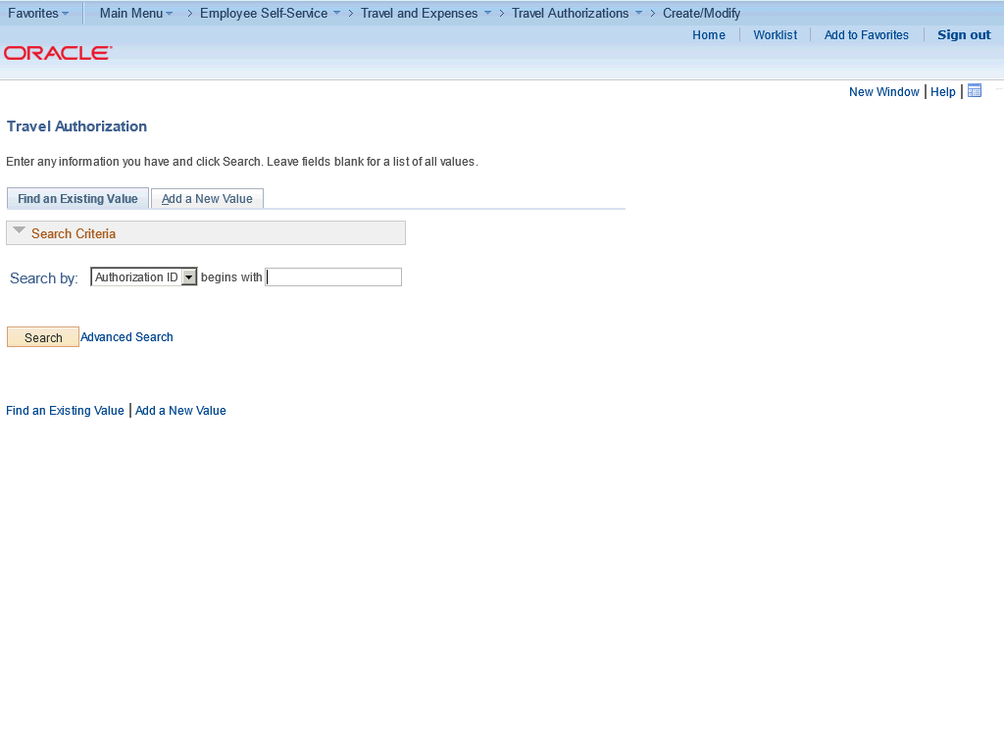

Step | Action
 | Click Search.

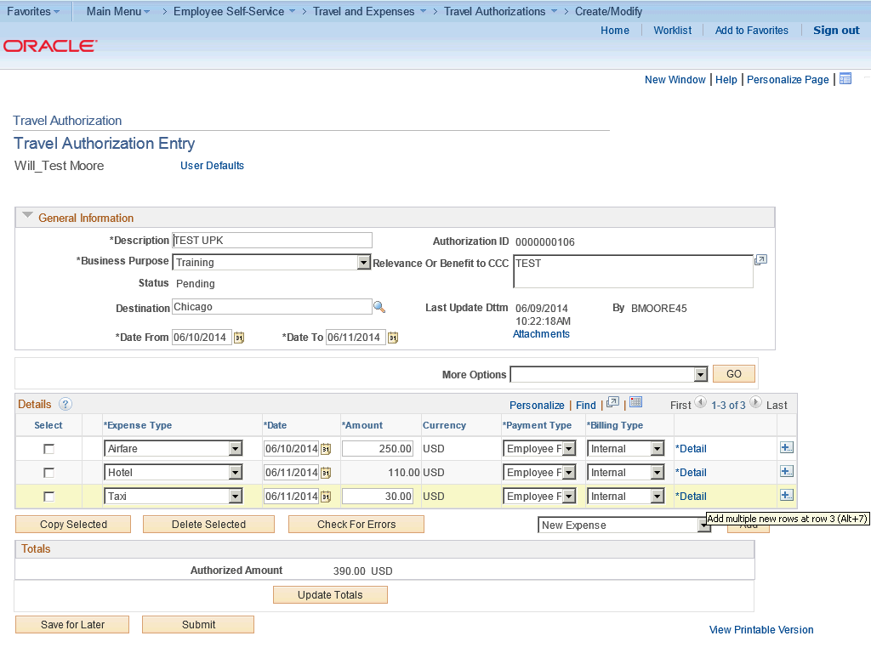

Step | Action
 | Click the Add multiple new rows at row 3 (Alt+7) button.

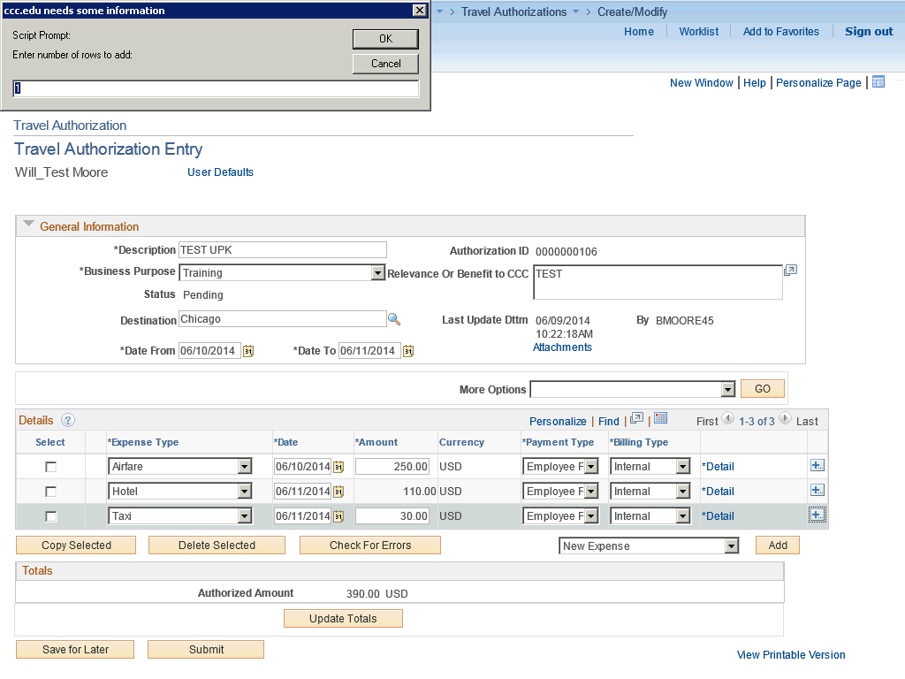

Step | Action
You are prompted to enter multiple expense items. For this example, you will accept the default value.

Click OK.

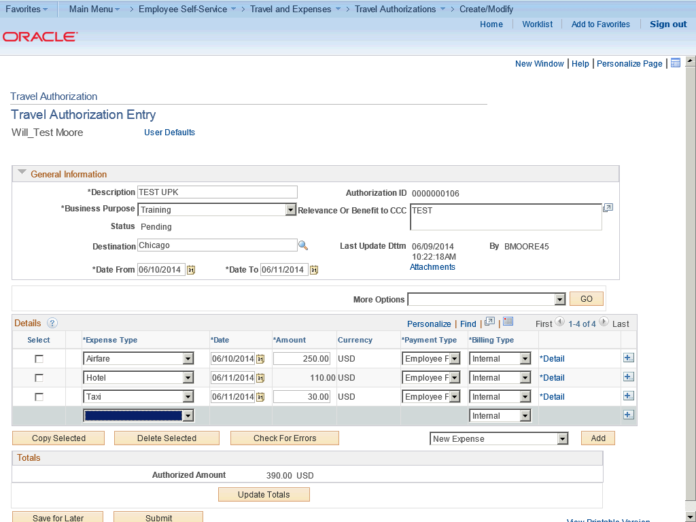

Step | Action
Select an expense type to add an expense item.

Click the Expense Type list.

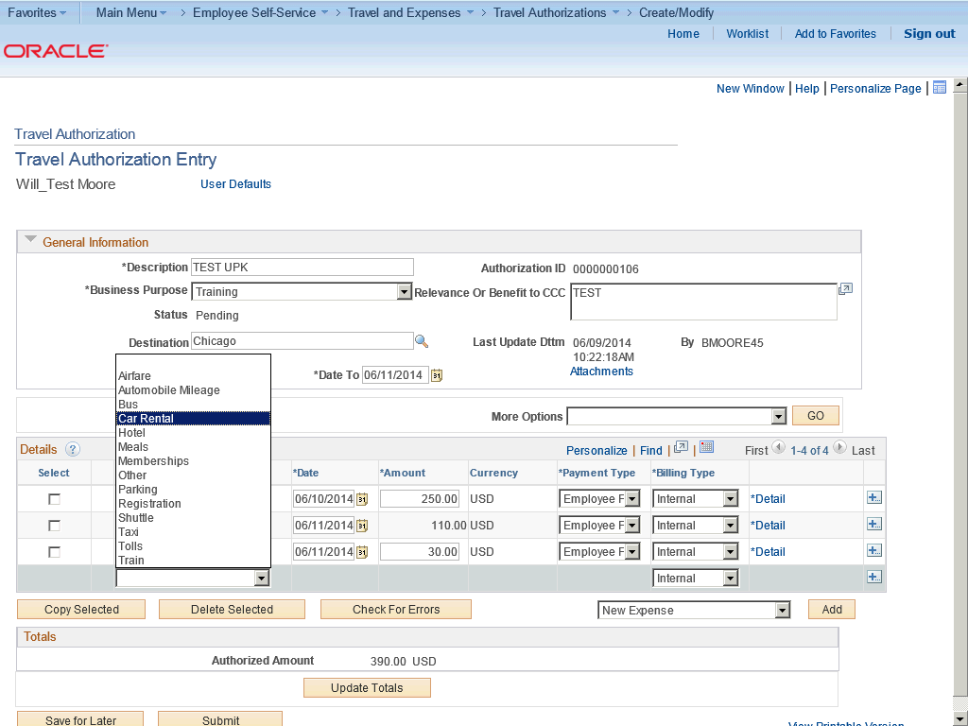

Step | Action
 | Click the Car Rental list item.

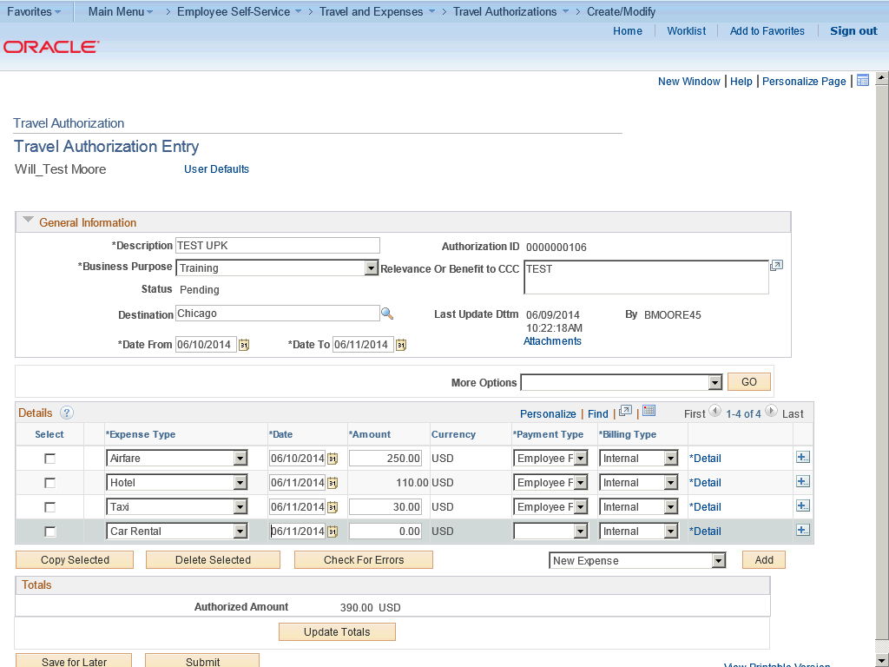

Step | Action
 | Click in the Amount field.

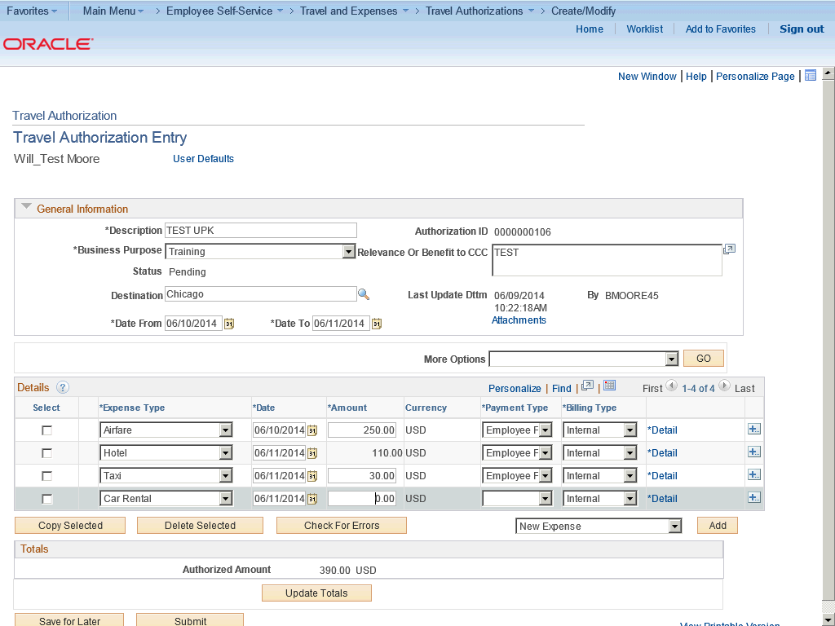

Step | Action
 | Enter the desired information into the Amount field. Enter "15".

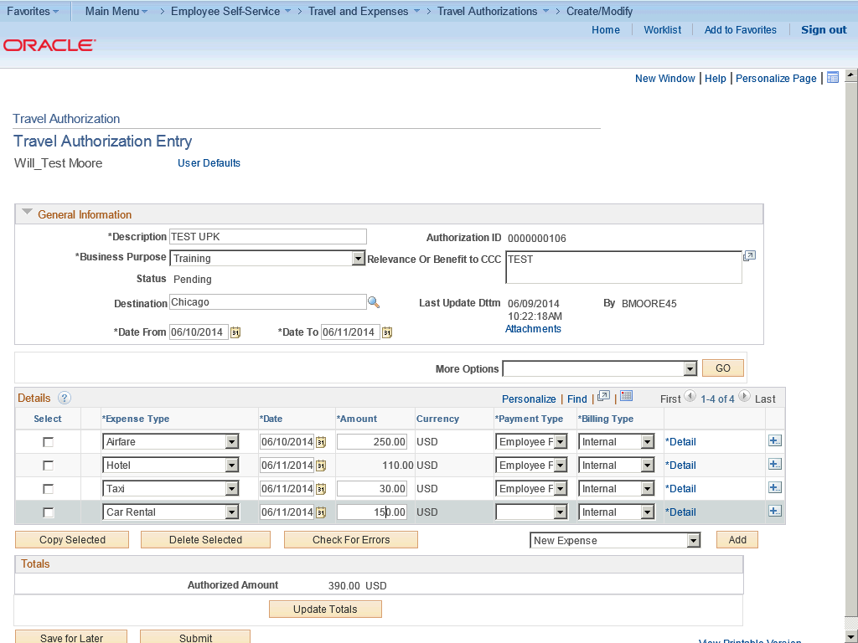

Step | Action
 | Click the Payment Type list.

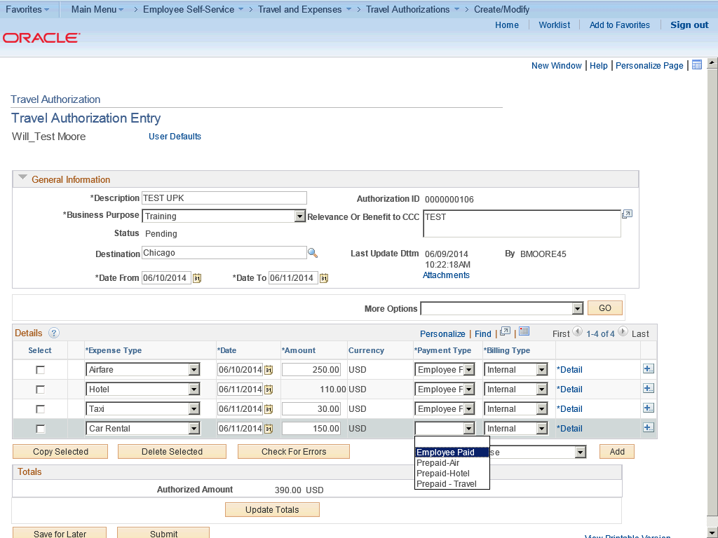

Step | Action
 | Click the Employee Paid list item.

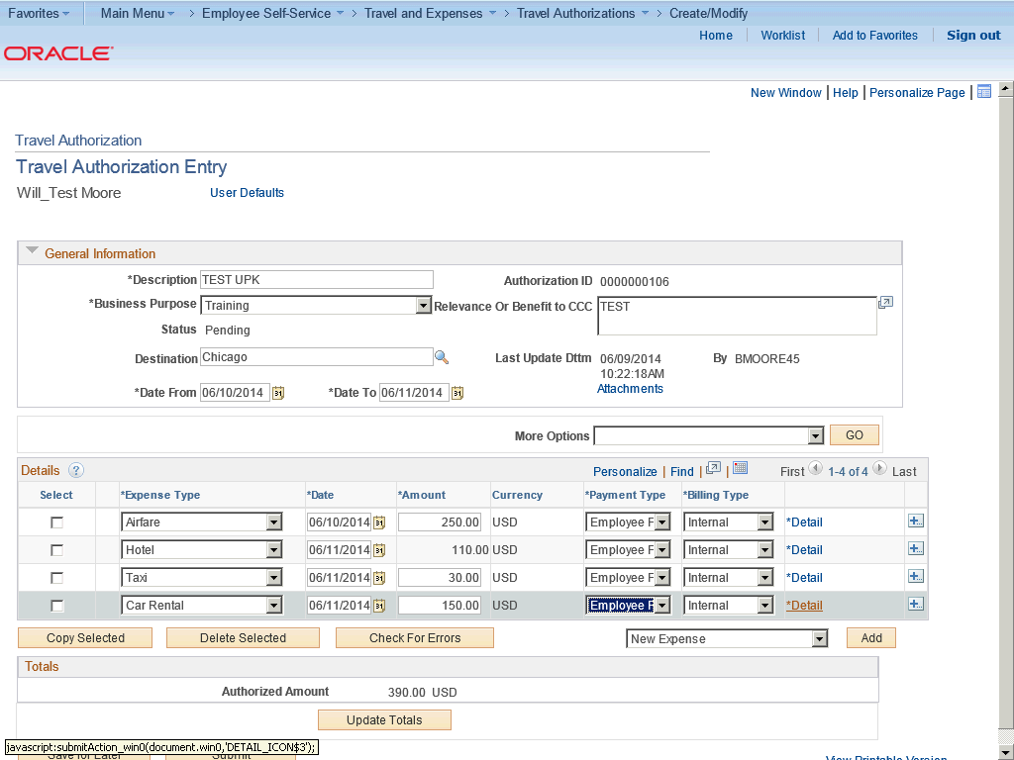

Step | Action
The Detail link will access the Authorization Detail page to enter additonal information for the expense transaction line.

Click the Detail link.

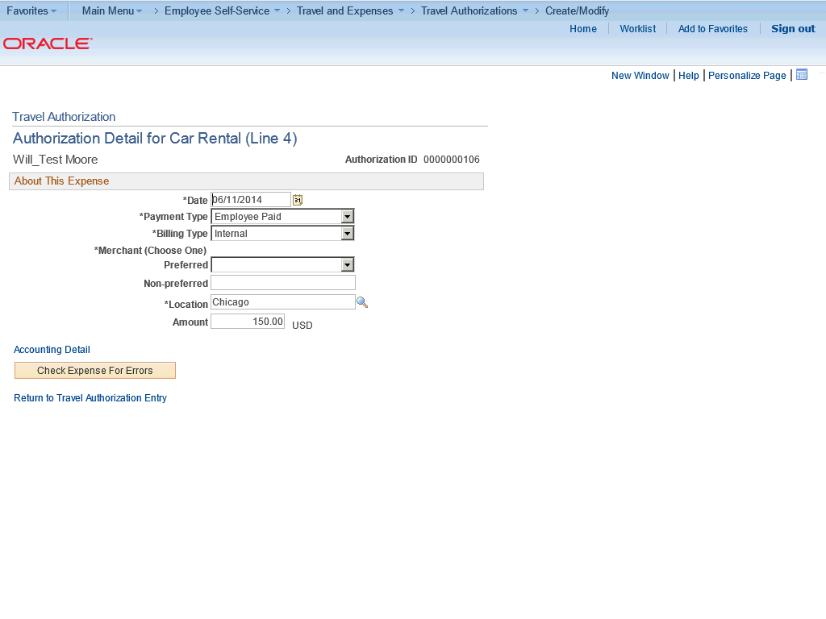

Step | Action
 | Click the Preferred list.

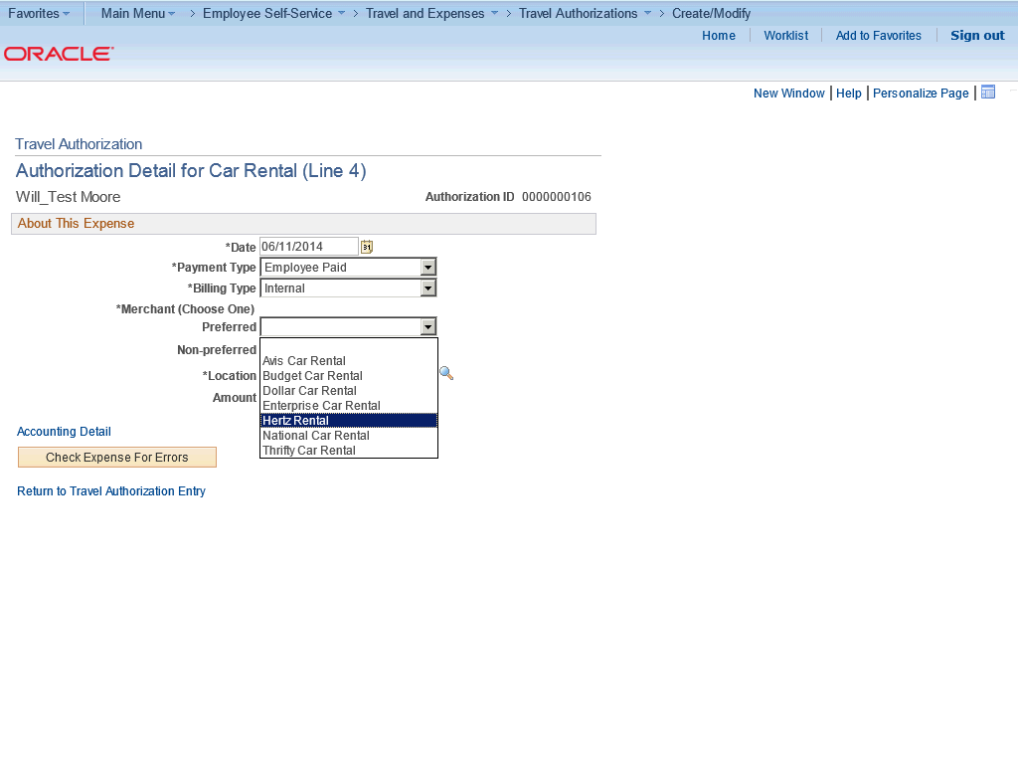

Step | Action
 | Click the Hertz Rental list item.

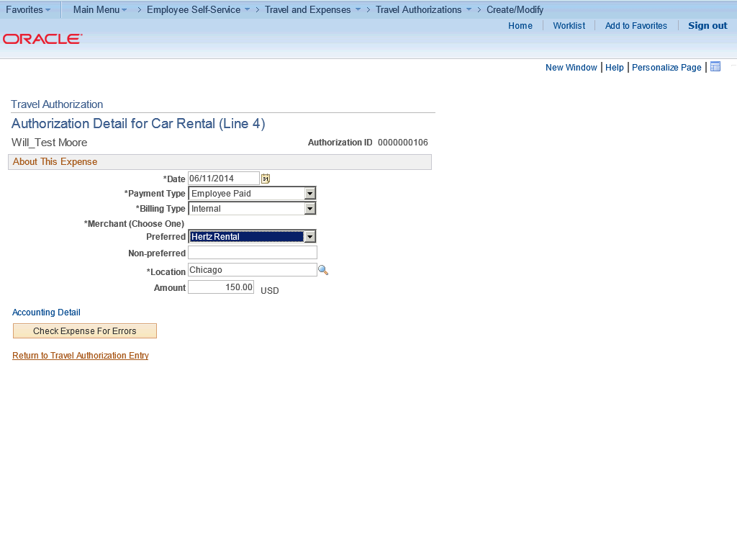

Step | Action
 | Click the Return to Travel Authorization Entry link.

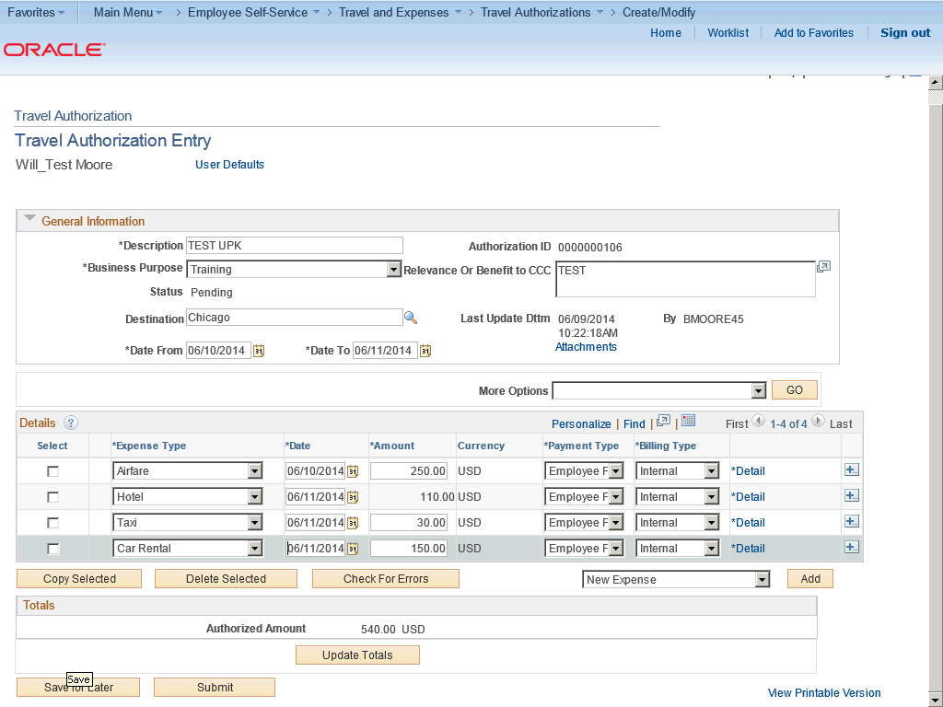

Step | Action
 | Click the Save for Later button.

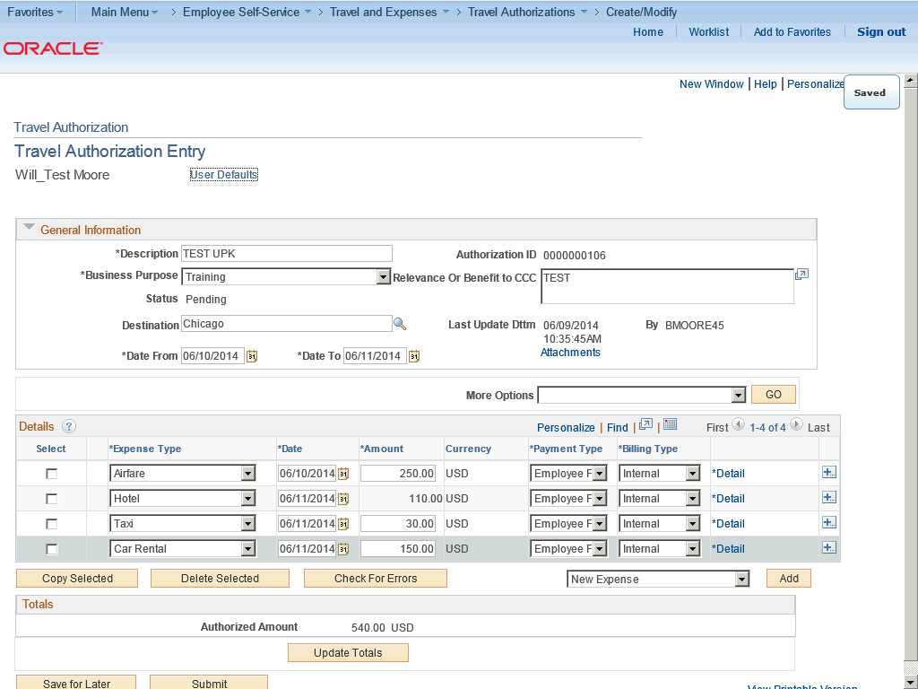

Step | Action
In this topic you have learned the following:

- How to view and modify travel authorizations.

You have successfully completed this training session.
End of Procedure.

Attaching a Document to a Travel Authorization
Attaching a Document to a Travel Authorization

PeopleSoft Expenses enables you to attach documents to Travel Authorizations, Cash Advances, Expense Reports,and My Wallet transactions.

To use the Attachment feature, you must access the Installation Options - Expenses page (Set Up Financials/Supply Chain, Install, Installation Options, Expenses). In the Receipts Configuration group box, select Attachments in the Option list, and select the attachment location that you want to use for Expenses. The attachment location indicates where you allow employees to attach documents; at the header level, the line level, or both.

When attaching large documents to transactions, it is recommended that you create and save the transaction prior to attaching large documents.

In this topic, you will create a travel authorization for air travel, attach the agenda at the header level, and attach your other document at the line level. Then you will save the authorization.
Procedure

In this topic you will learn the following:

- How to attach a document to a travel authorization.
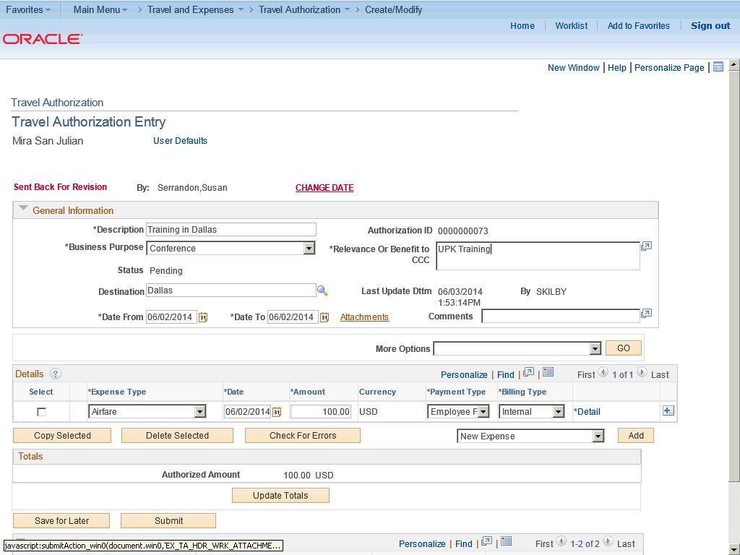

Step | Action
 | Use the Travel Authorization Entry page to create a new travel authorization request.

Step | Action
When attaching large documents to transactions, it is recommended that you create and save the transaction first.

In this case, the attachments are small. You will crate a travel authorization for air travel, save the authorization and then attach the agenda at the header level.

Step | Action
 | After creating and saving the Travel Authorization, click the Attachments link.

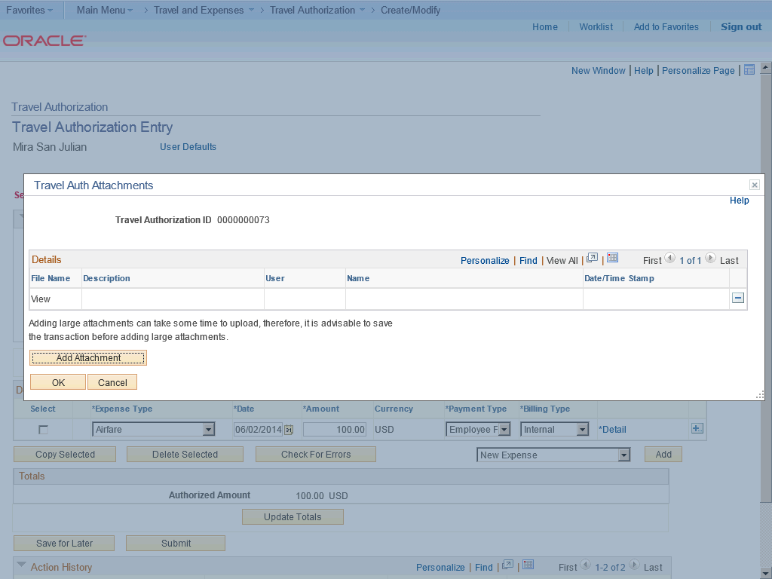

Step | Action
 | Click the Add Attachment button.

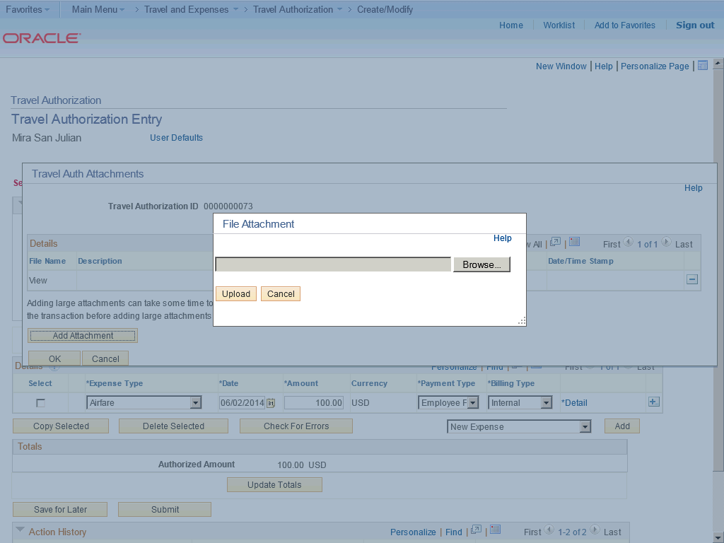

Step | Action
 | Click the Browse button.

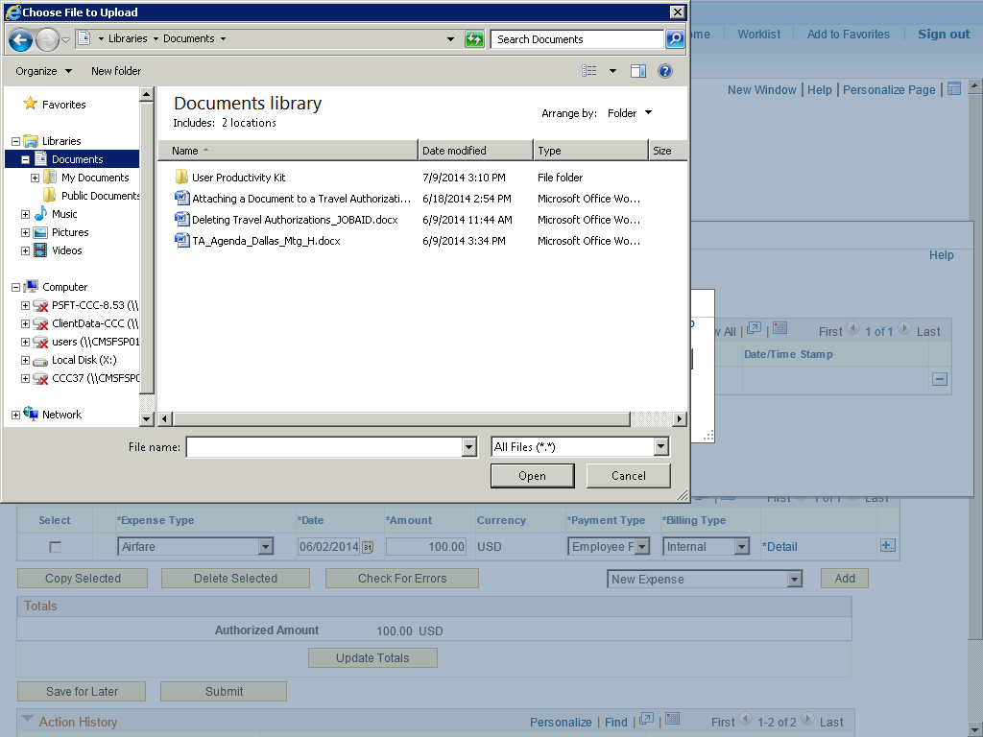

Step | Action
Navigate to the document you want to attach.

Click the TA_Agenda_Dallas_Mtg_H.docx list item.

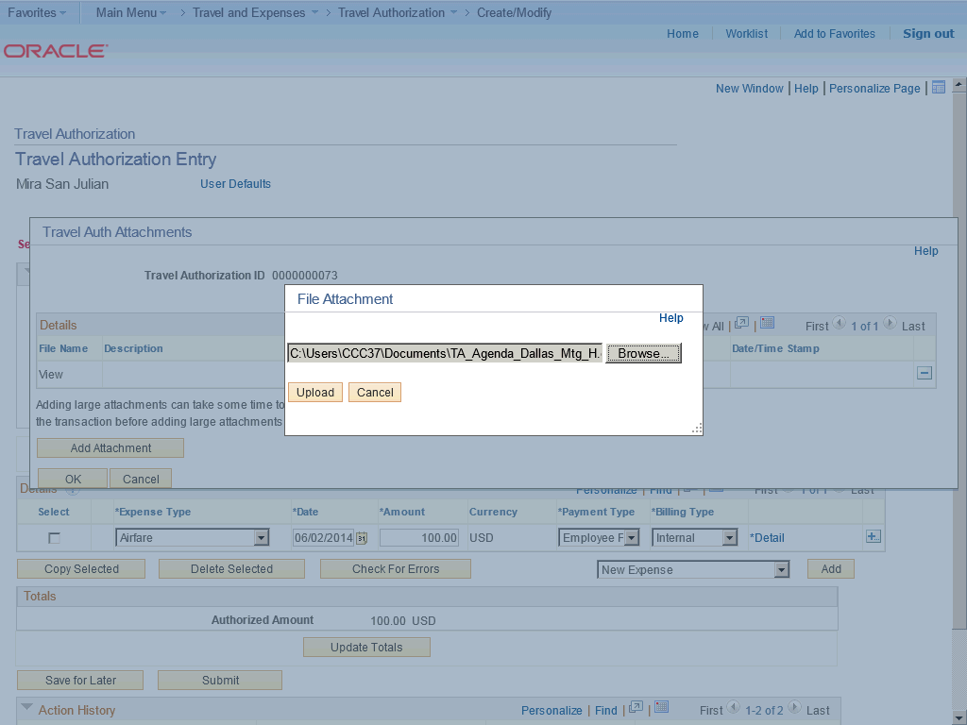

Step | Action
 | Click the Upload button.

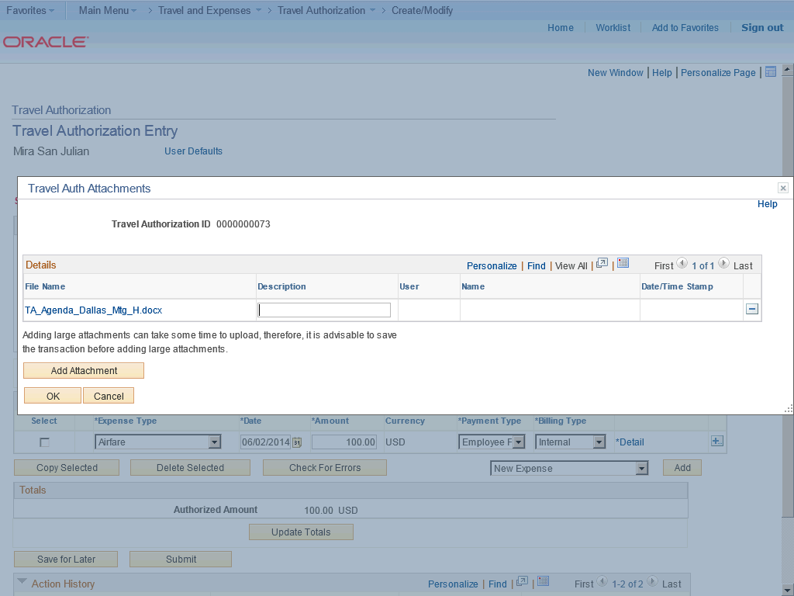

Step | Action
 | Enter the desired information into the Description field. Enter "Travel Itinerary".

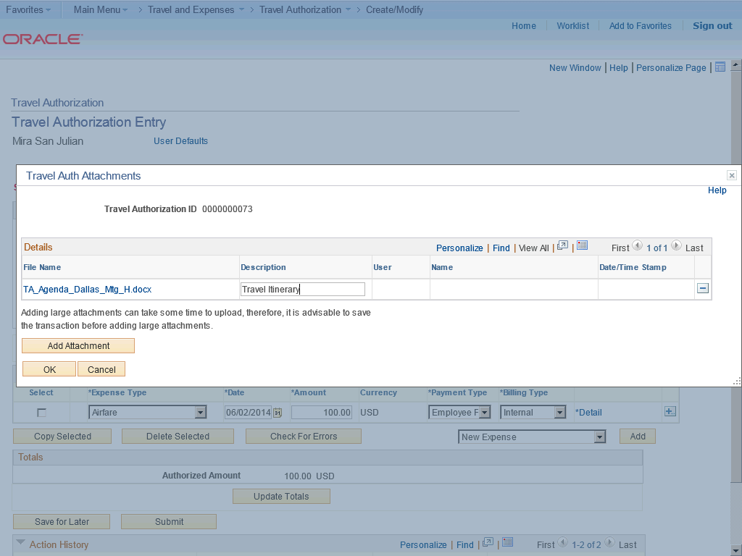

Step | Action
 | Click the OK button.

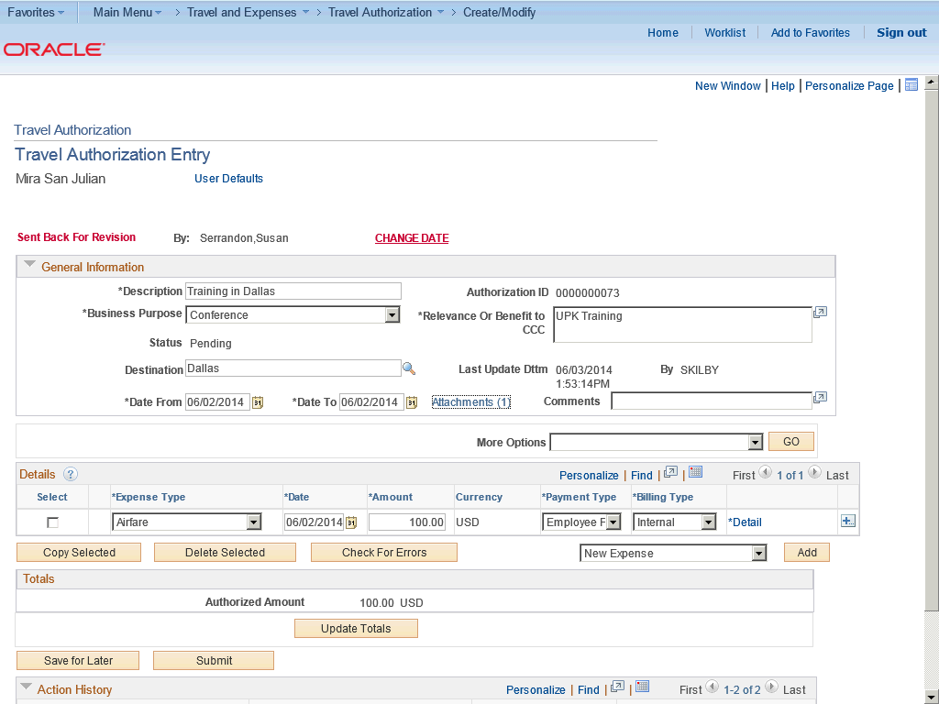

Step | Action
In this topic you have learned the following:

- How to attach a document to a travel authorization.

You have successfully completed this training session.
End of Procedure.

Copying Travel Authorization Expense Lines
Copying Travel Authorization Expense Lines

Expenses enables you to copy one or more selected expense lines for a single day or a range of dates. You can also indicate whether you want to include holidays and weekends. The functionality associated with the Copy Selected Expenses page is for all expense types, including per diem expense types. When you copy an expense line to create new expense lines, Expenses automatically populates the new expense lines with the same ChartFields as the original line item.

Procedure

In this topic you will learn the following:

- How to copy travel authorization expense lines.
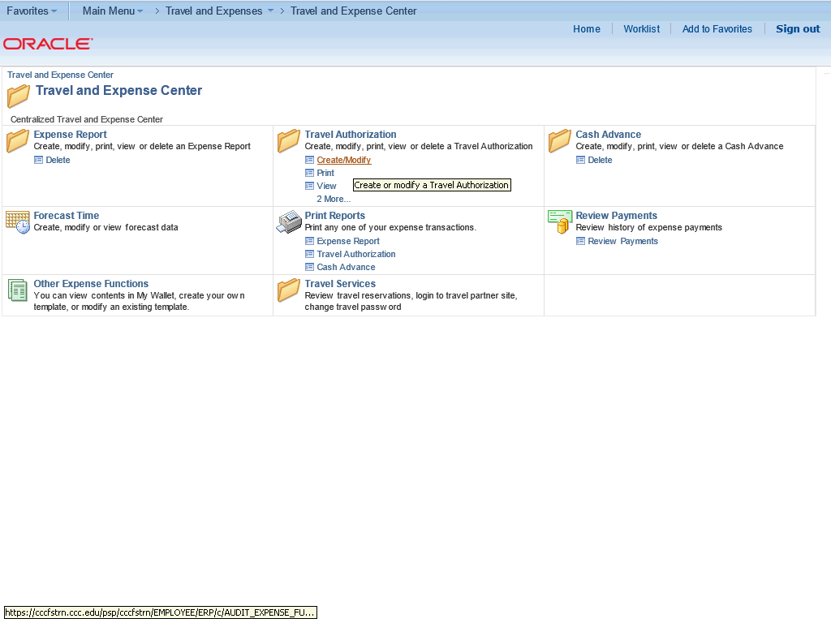

Step | Action
 | Begin by navigating to the Travel and Expense Center page.

Step | Action
From the Travel and Expense Center, navigate to the Travel Authorizations options.

Click the Create/Modify link.

Step | Action
 | Click the Find an Existing Value tab.

Step | Action
 | Click the Search button.

Step | Action
 | Click the 0000000175 link.

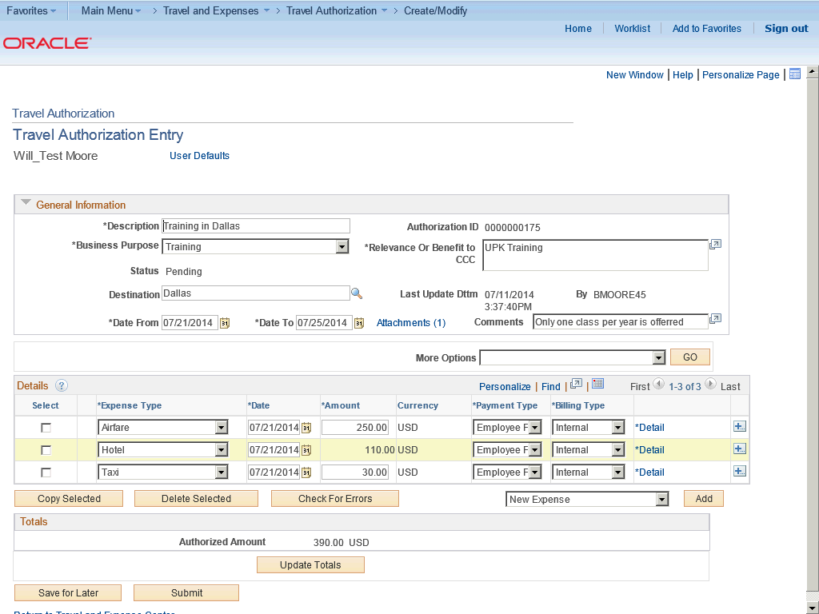

Step | Action
 | Use the Travel Authorization Entry page to copy expense lines for travel authorizations.

Step | Action
 | Click the Select option.

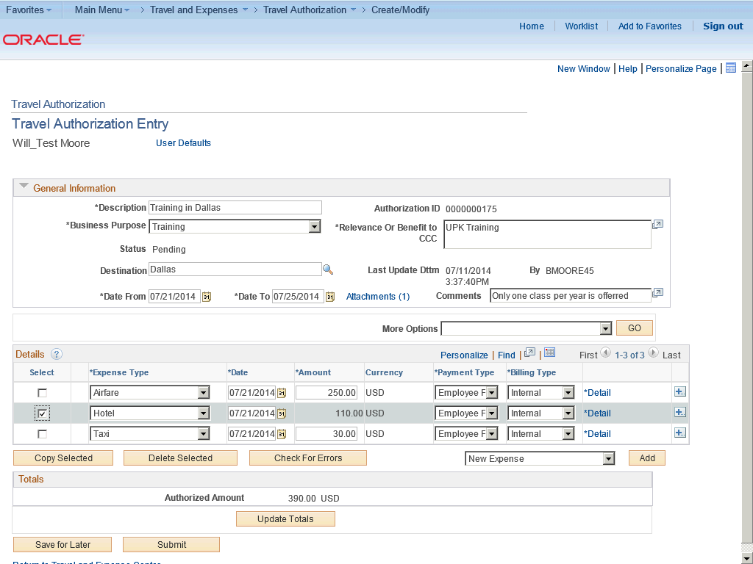

Step | Action
 | Click the Copy Selected button.

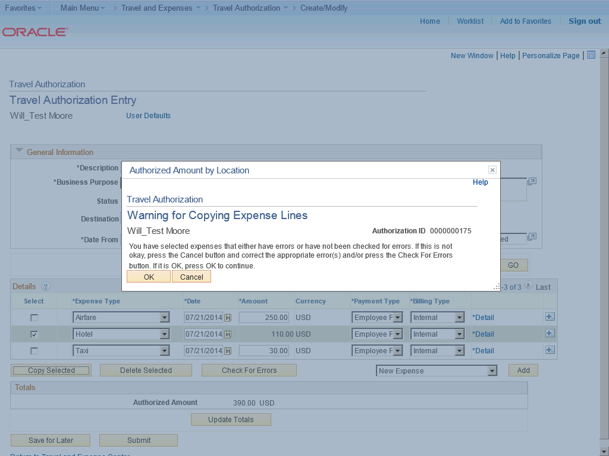

Step | Action
Expenses warns you if you selected expense lines that have errors or have not been checked for errors. Click the Cancel button to correct the appropriate errors or click OK to continue.

Click the OK button.

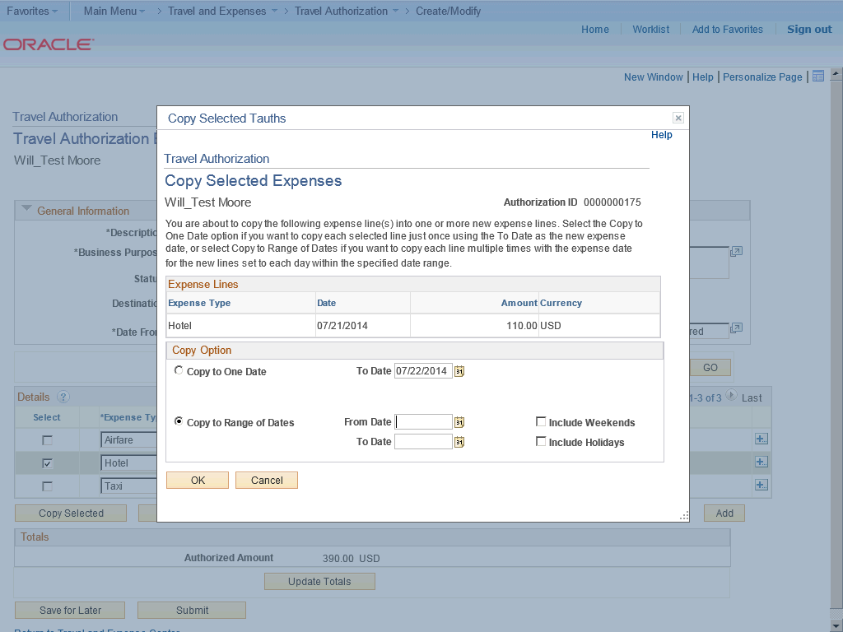

Step | Action
 | Click the Copy to One Date option.

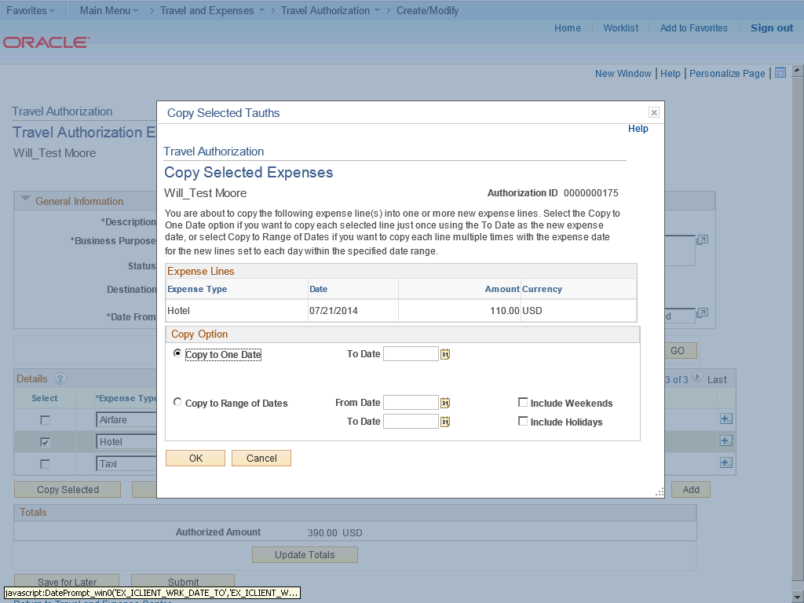

Step | Action
 | Click the Choose a date (Alt+5) button.

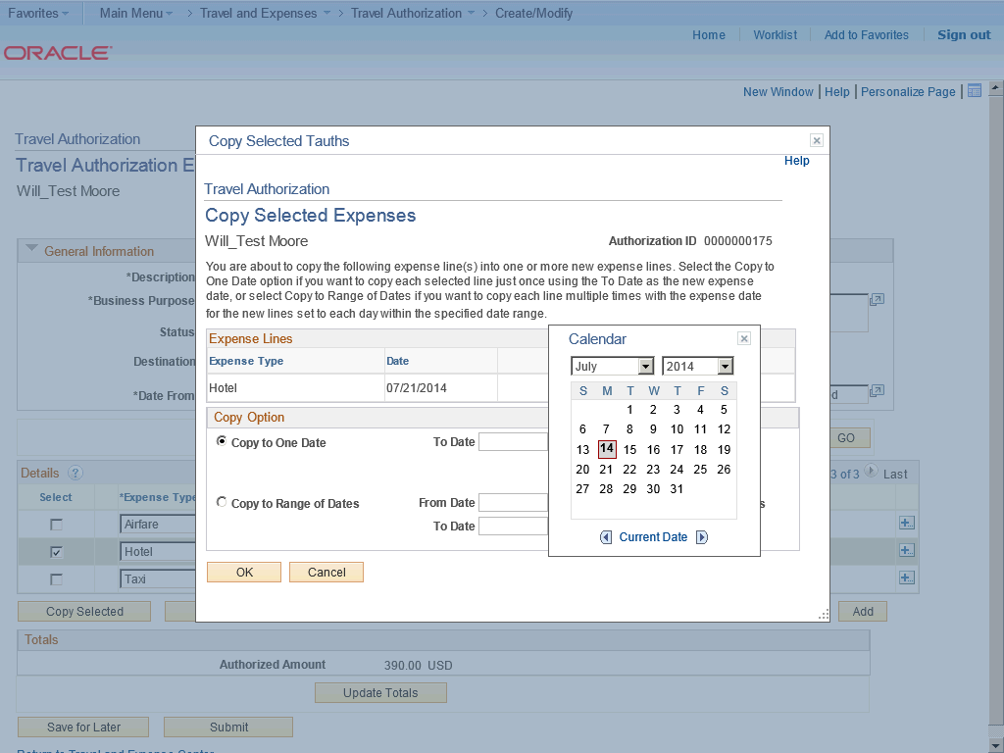

Step | Action
 | Click the desired date.

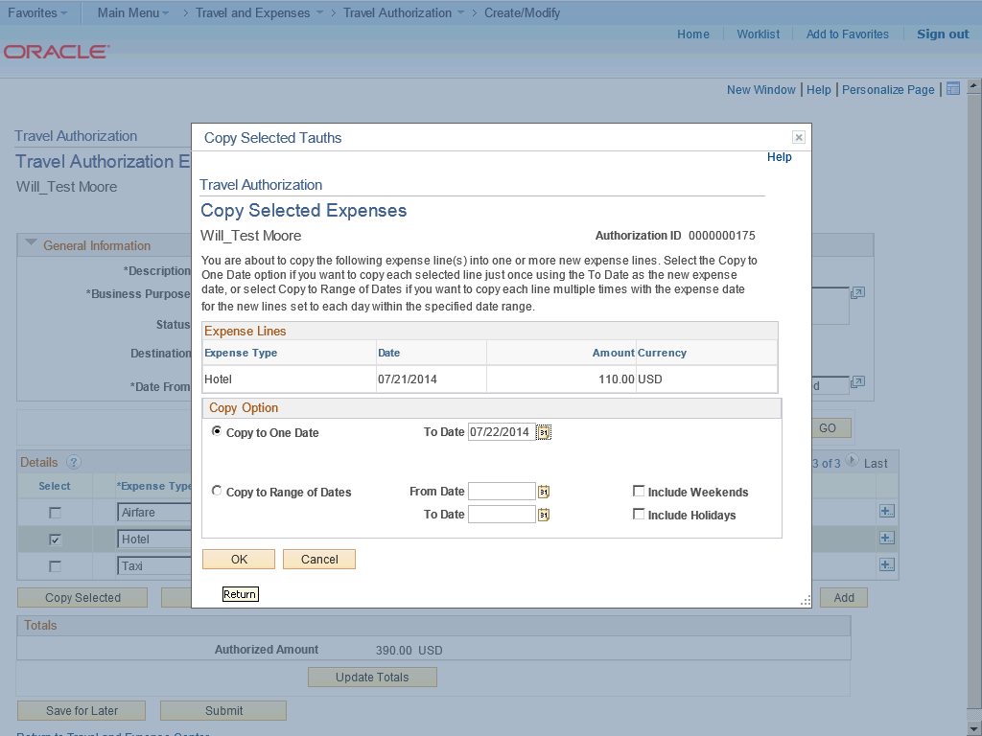

Step | Action
 | Use the Copy to Range of Dates option to copy each line multiple times with the expense date for the new lines set to each date within the specific date range.

Step | Action
If you do not select to include weekends, Expenses checks the day of the week and does not copy expense lines for Saturdays or Sundays.

If you do not select to include holidays, Expenes checks the holiday calendar for the employee's business unit.

Expenses does not copy expense lines for days that the calendar designates as holidays.

Step | Action
 | Click the OK button.

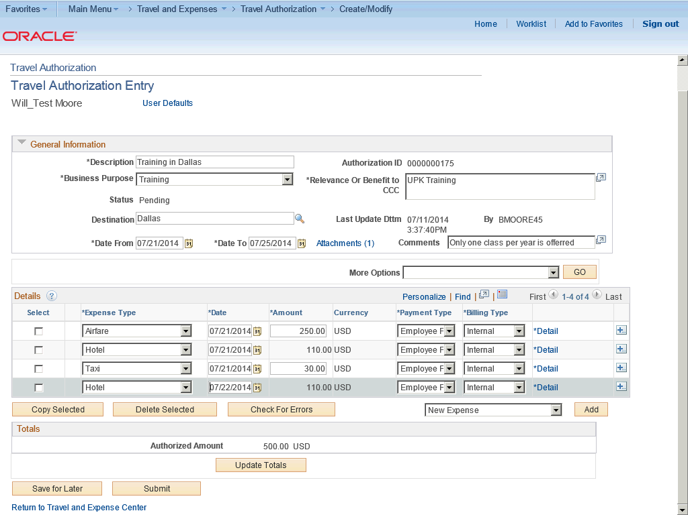

Step | Action
 | Click the Save for Later button.

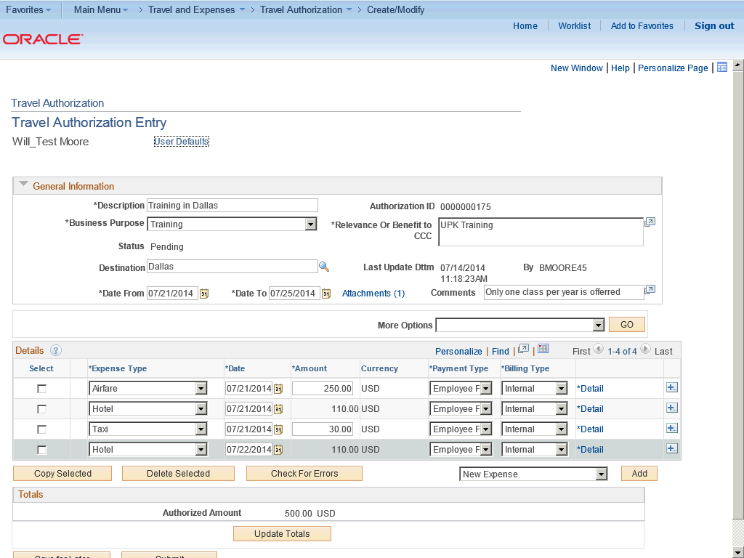

Step | Action
In this topic you have learned the following:

- How to copy travel authorization expense lines.

You have successfully completed this training session.
End of Procedure.

Deleting Travel Authorizations
Deleting Travel Authorizations

Expenses enables you to delete travel authorizations:
- If you create a travel authorization and decide not to process it, you can delete it before you submit it for approval.
- If you submit a travel authorization and the approver returns it to you, you can delete the travel authorization.
- If you cancel the travel authorization, you may delete it.

In this topic, you will delete a travel authorization for a business trip that was cancelled.
Procedure

In this topic you will learn the following:

- How to delete a travel authorization that is in pending status.
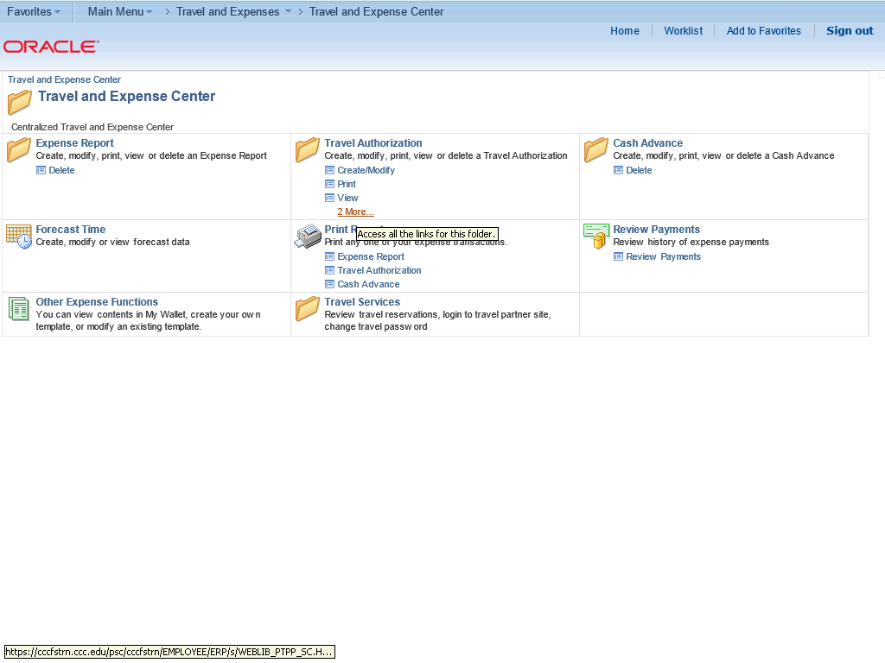

Step | Action
 | Begin by navigating to the Travel and Expense Center page.

Step | Action
From the Travel and Expense Center, navigate to the Travel Authorizations options.

Click the 2 More... link.

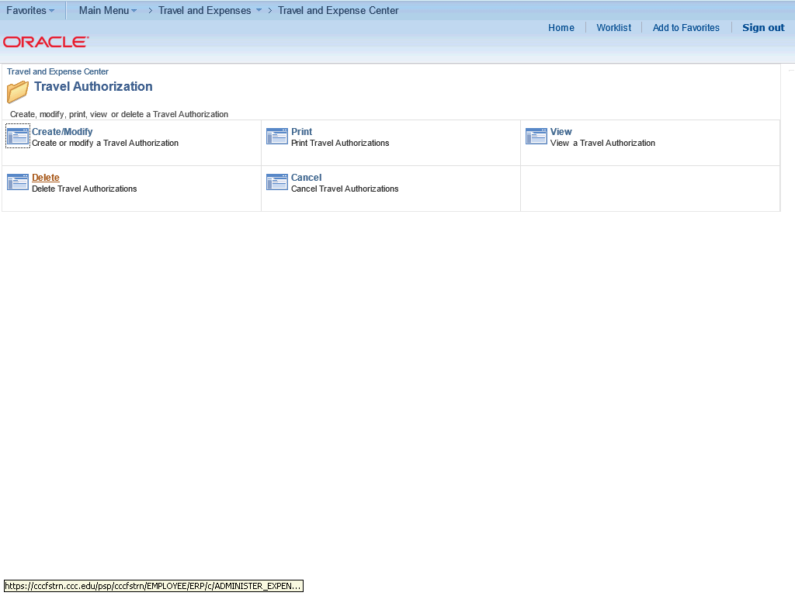

Step | Action
 | Click the Delete link.

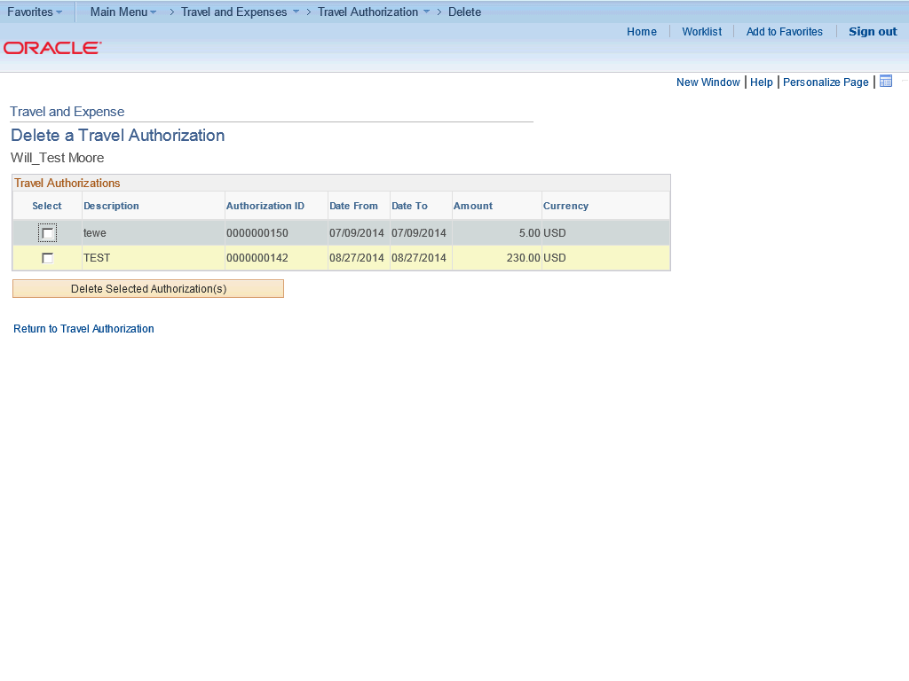

Step | Action
 | Note: Expenses displays a list of unsubmitted or denied travel authorizations.

Step | Action
Search for the Travel Authorization to be deleted.

Click the Select option.

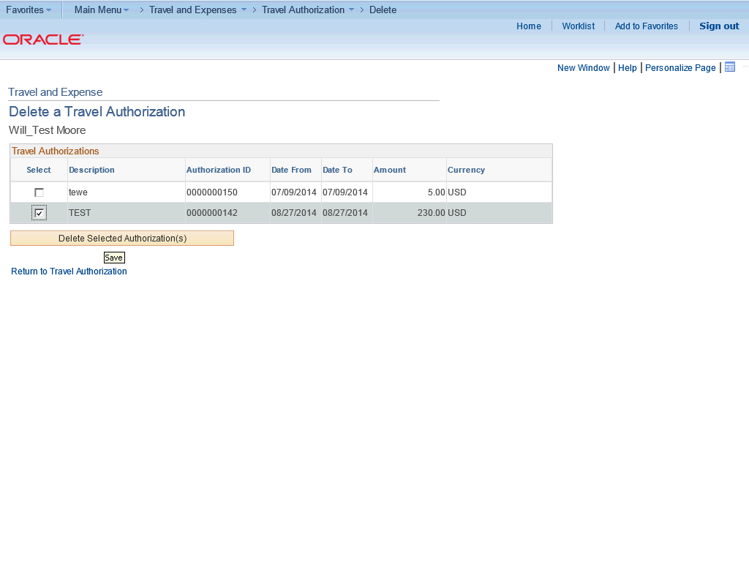

Step | Action
 | Click the Delete Selected Authorization(s) button.

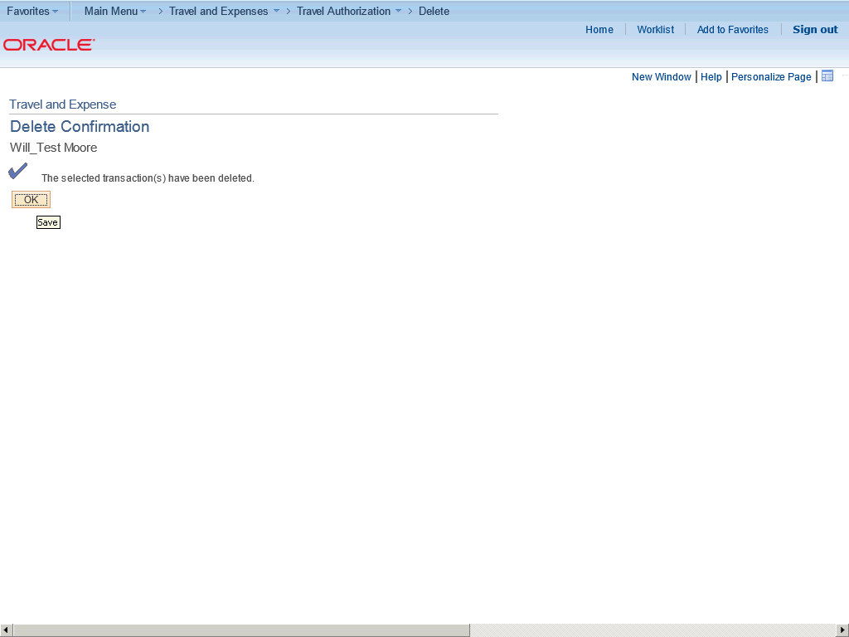

Step | Action
 | Click the OK button.

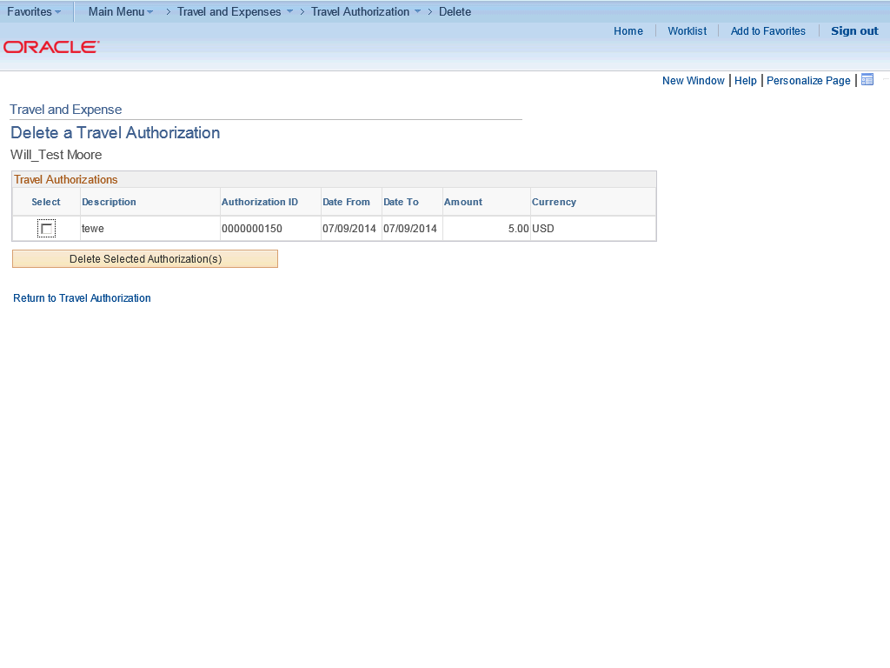

Step | Action
In this topic you have learned the following:

- How to delete a travel authorization that is in pending status.

You have successfully completed this training session.
End of Procedure.

