HOW TO ATTACH DOCUMENTS TO REQUISITIONS

1. **Log into PeopleSoft.**

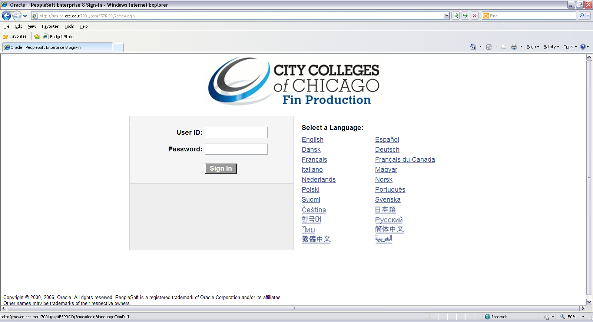

1. **Navigate to Purchasing**

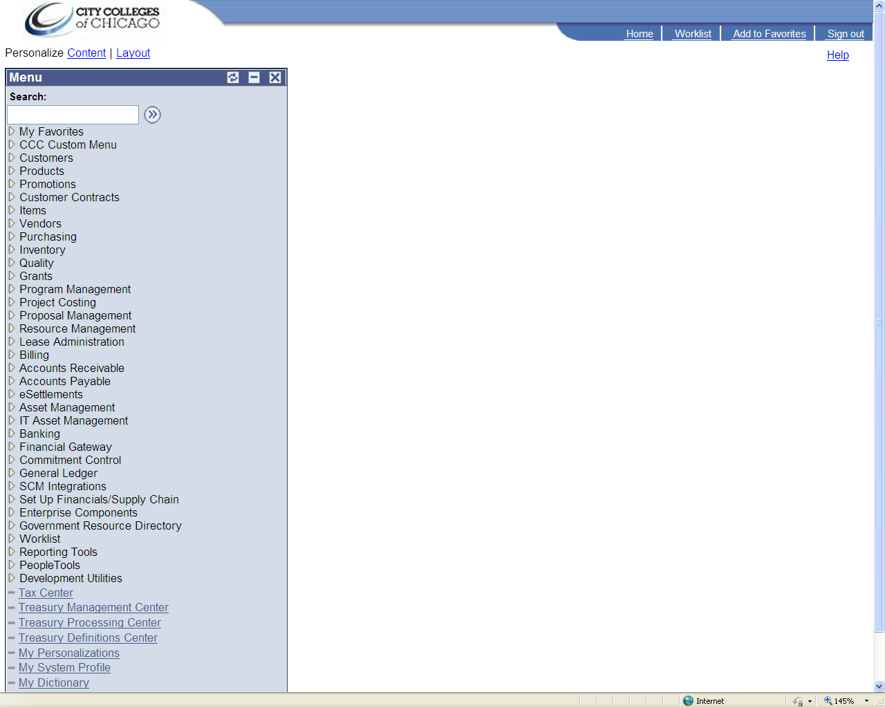

1. **Select Requisitions**

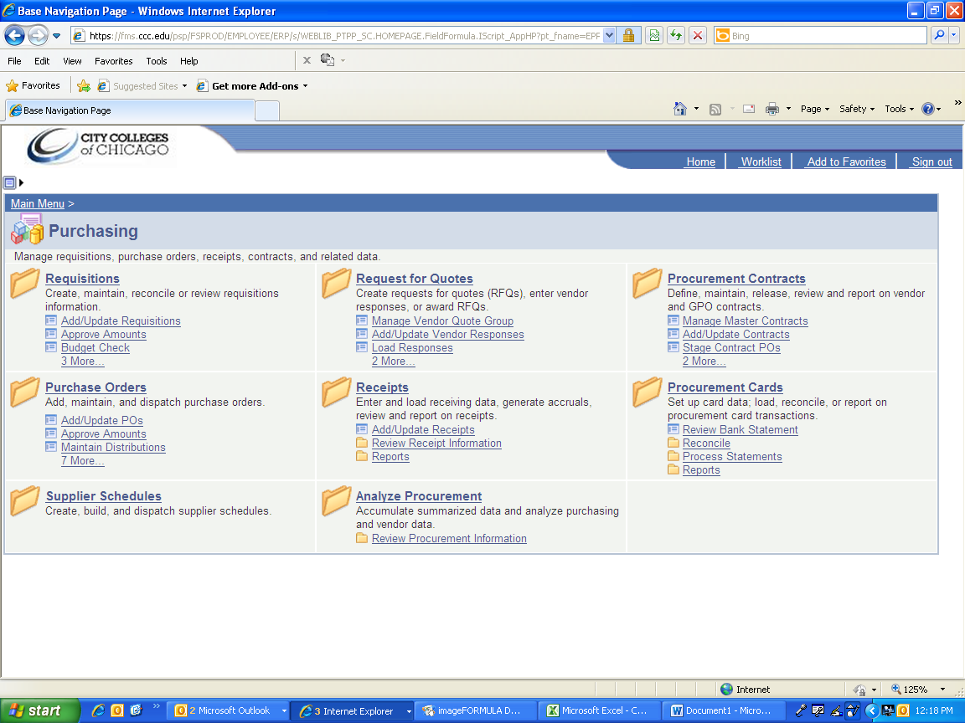

1. **Select Add/Update Requisition**

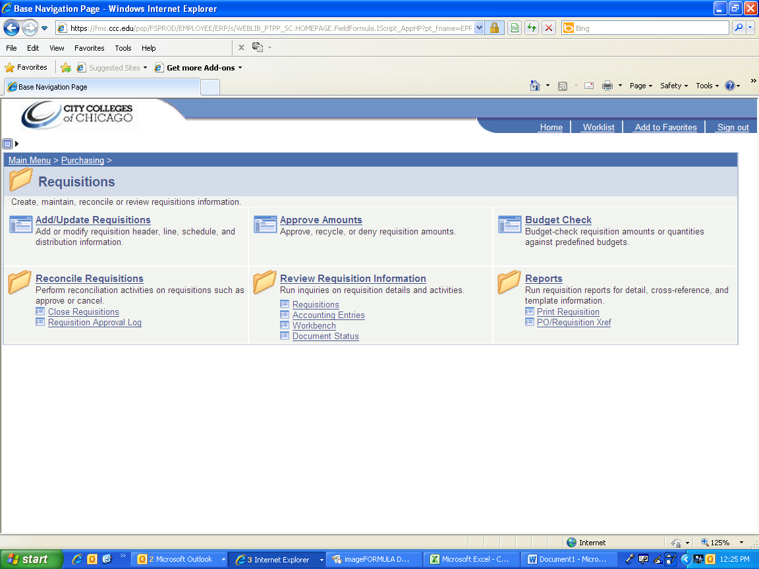

1. **Select Add a New Value**

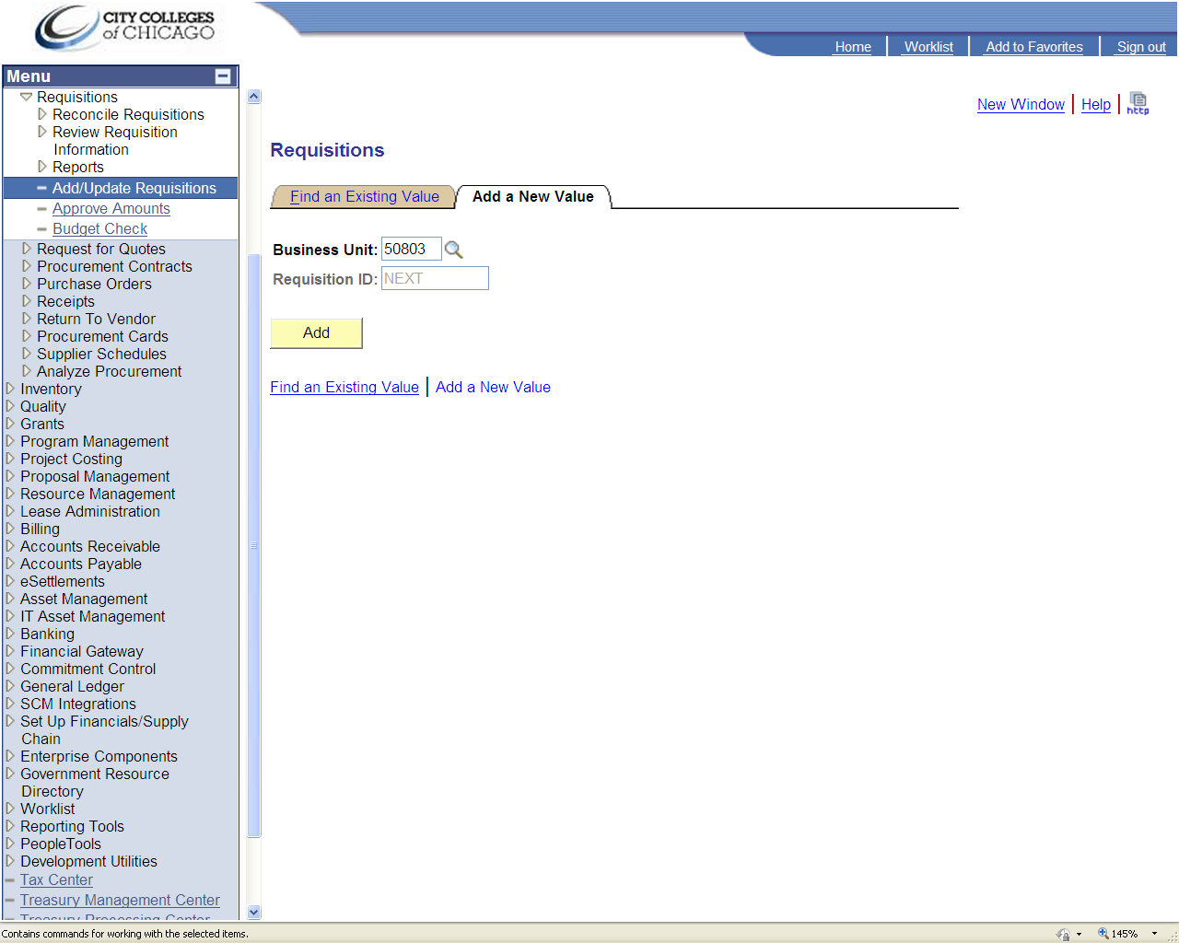

1. **Select Add Comments**

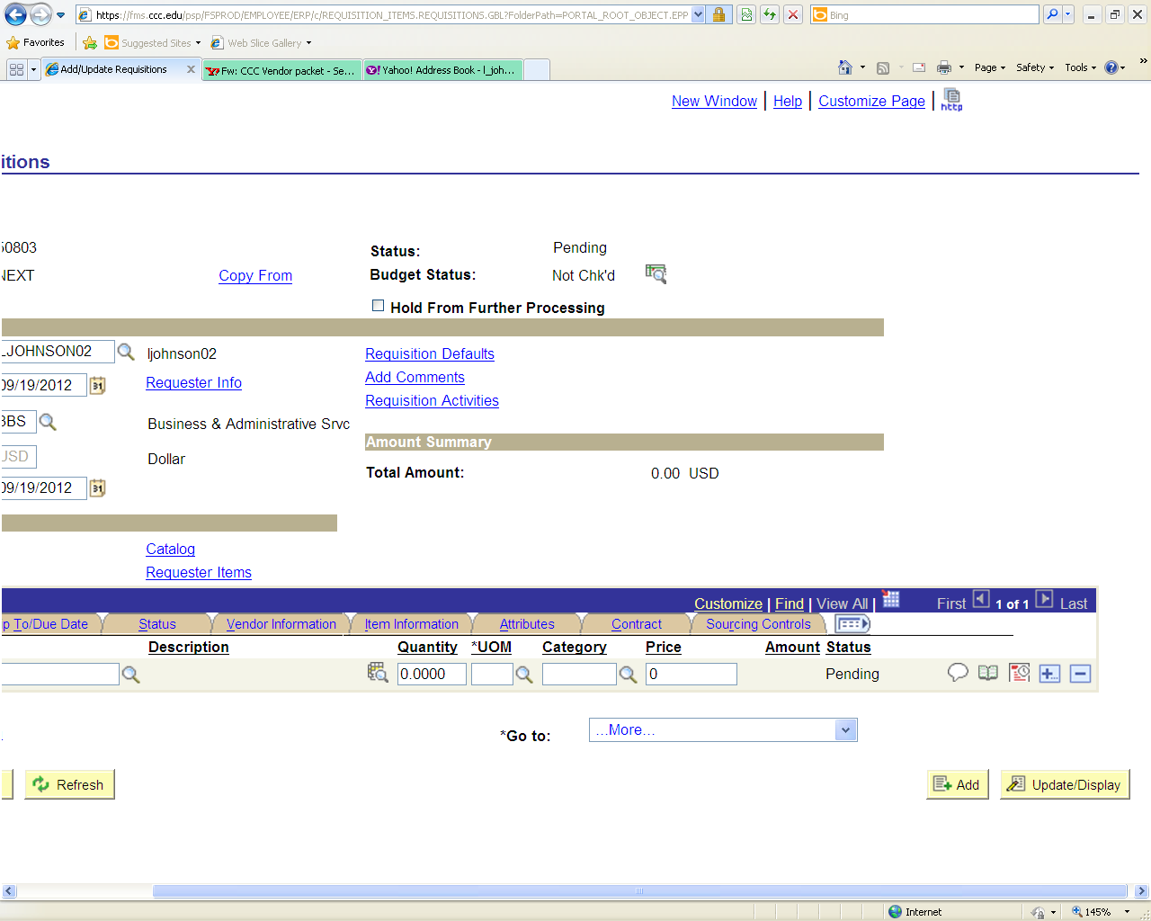

1. **Click Attach**
   1. **Documents must be saved to a file prior to uploading to the Requisition Panel.**

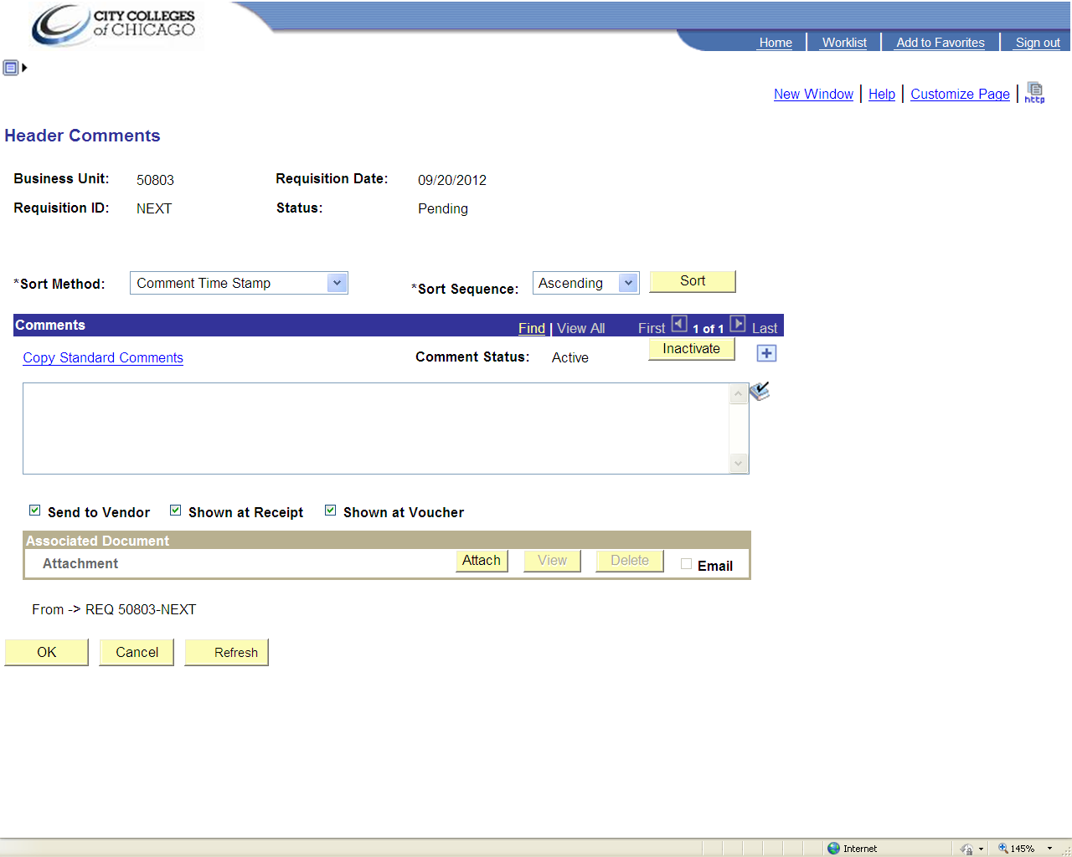

1. **Click Browse**

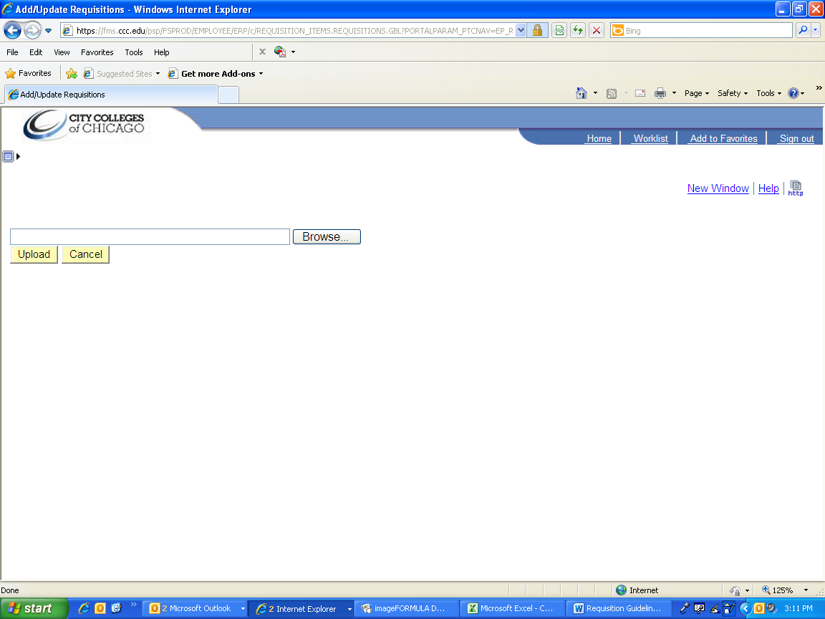

1. **Select the document from your file.**
   1. **Select the file you wish to upload**
   2. **Click Open**

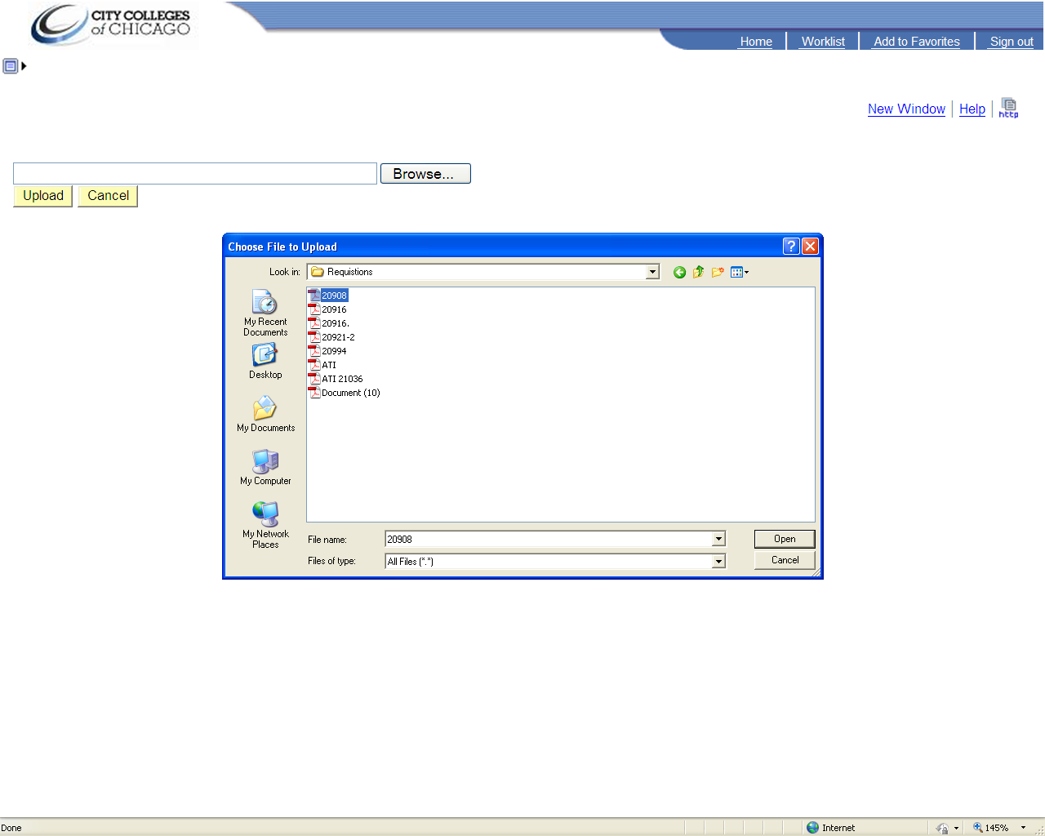

1. **Click Upload**

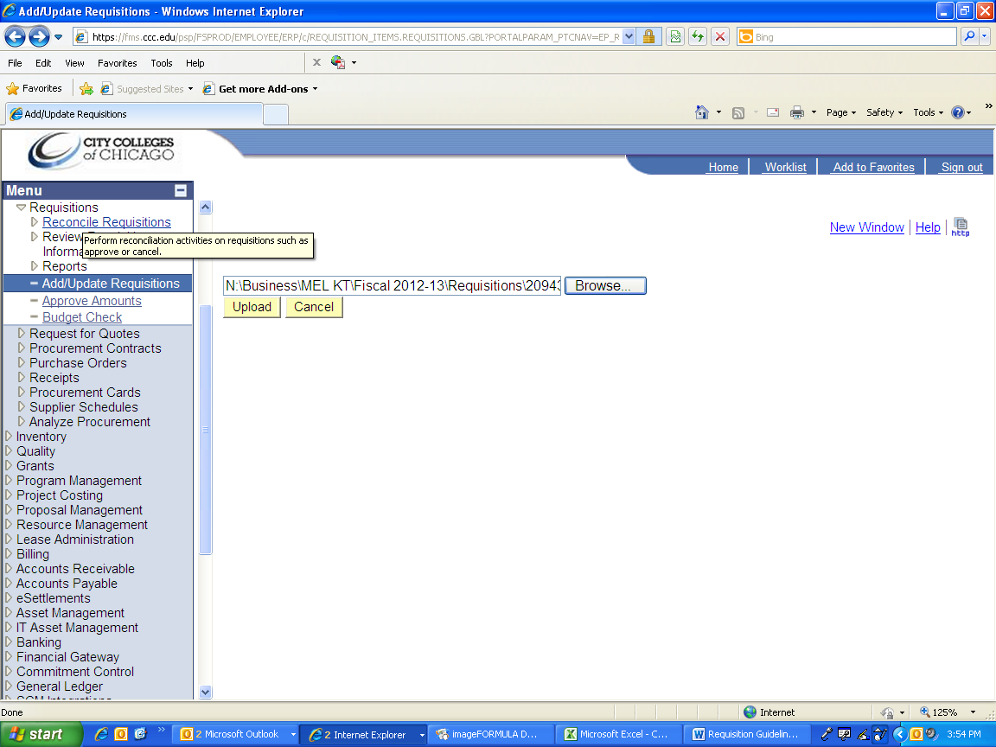

1. **The uploaded document will appear in the Associated Document field.**
   1. **To view the attachment select view. A separate window will appear with the viewable PDF documents.**
   2. **Only one file can be uploaded to this panel.**
2. **Click Ok. Proceed with regular requisition entry.**

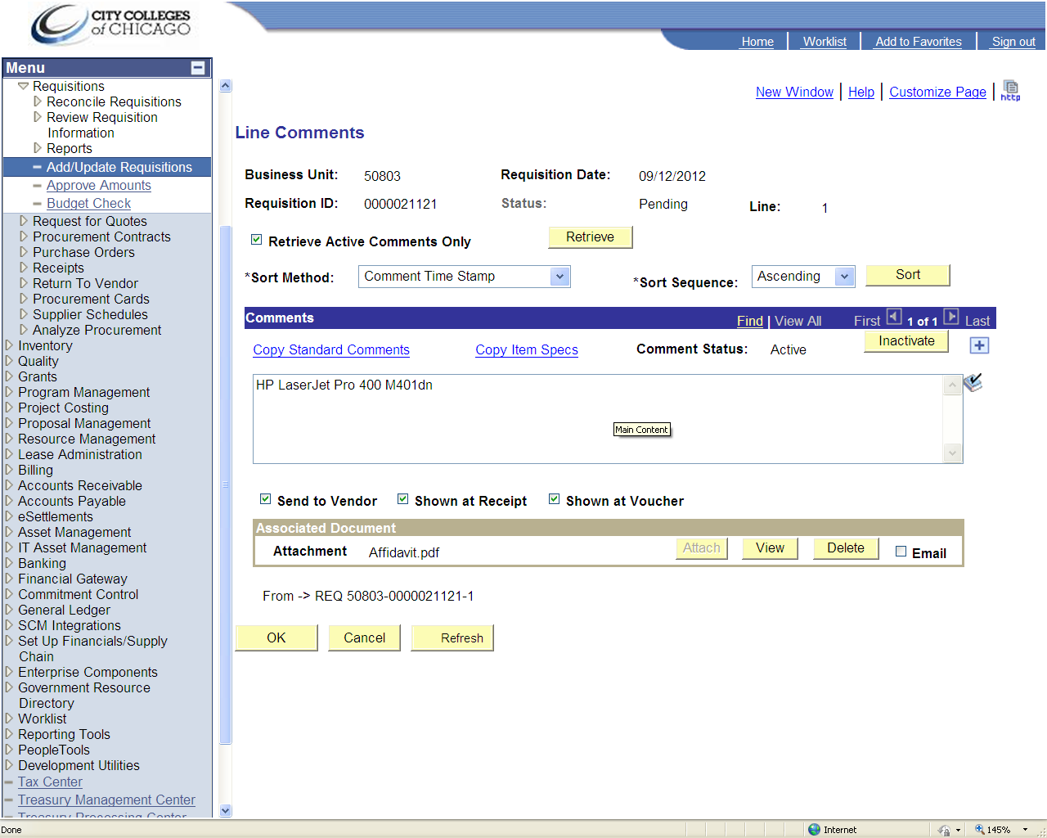

***Use the following instructions, if there is an existing requsition that requires updating***

1. **Select Find Existing Value.**

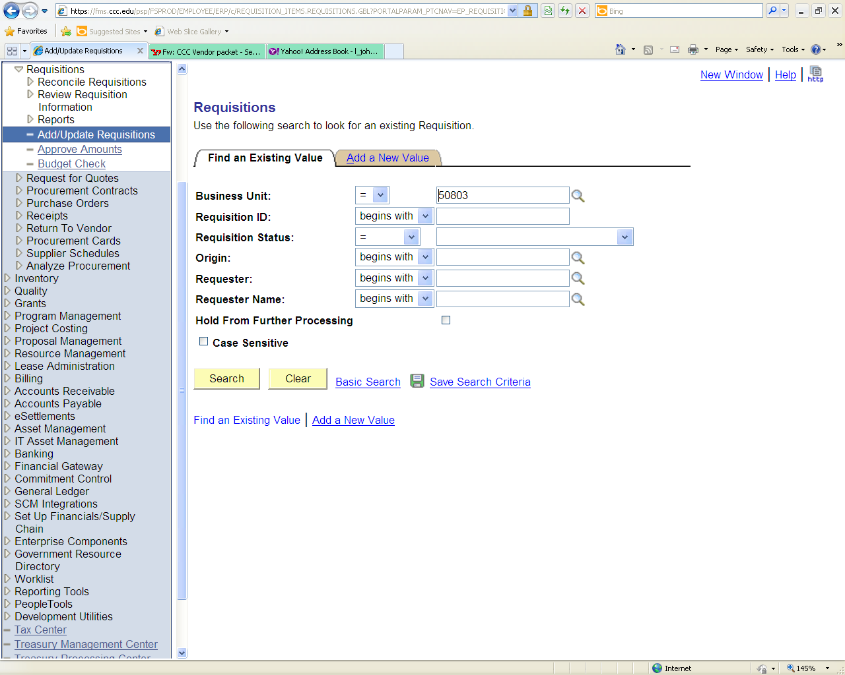

1. **Enter the Requisition ID (including preceding zeros).**
2. **Select Search**

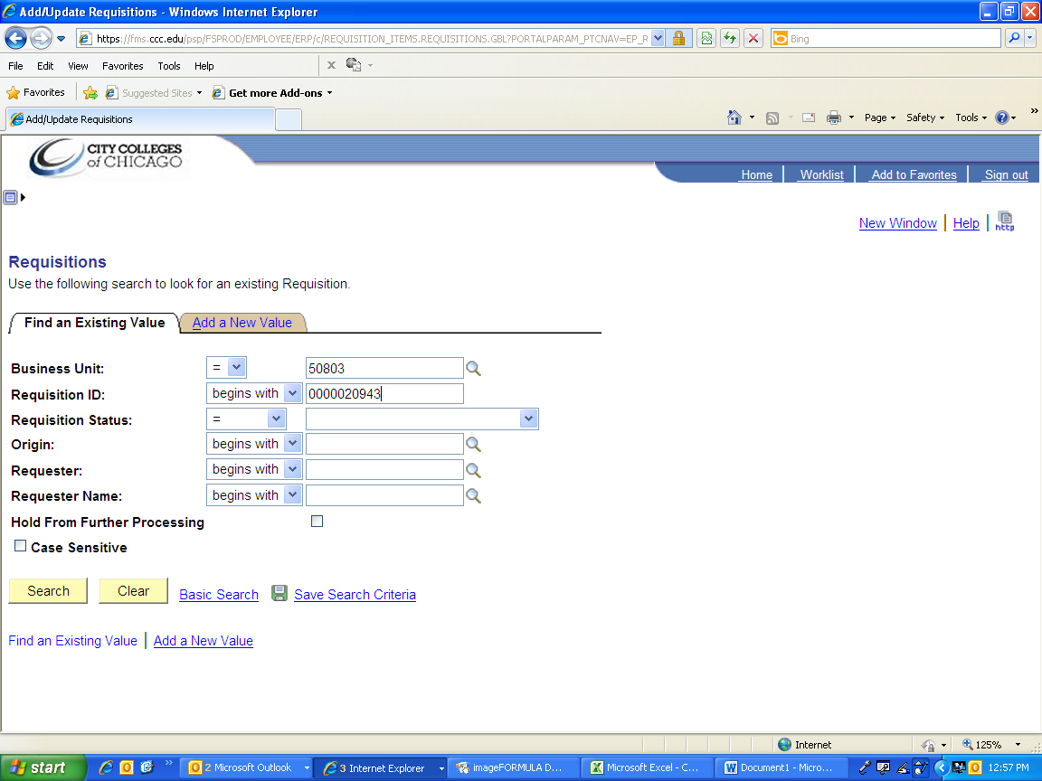

1. **Select Edit Comments**

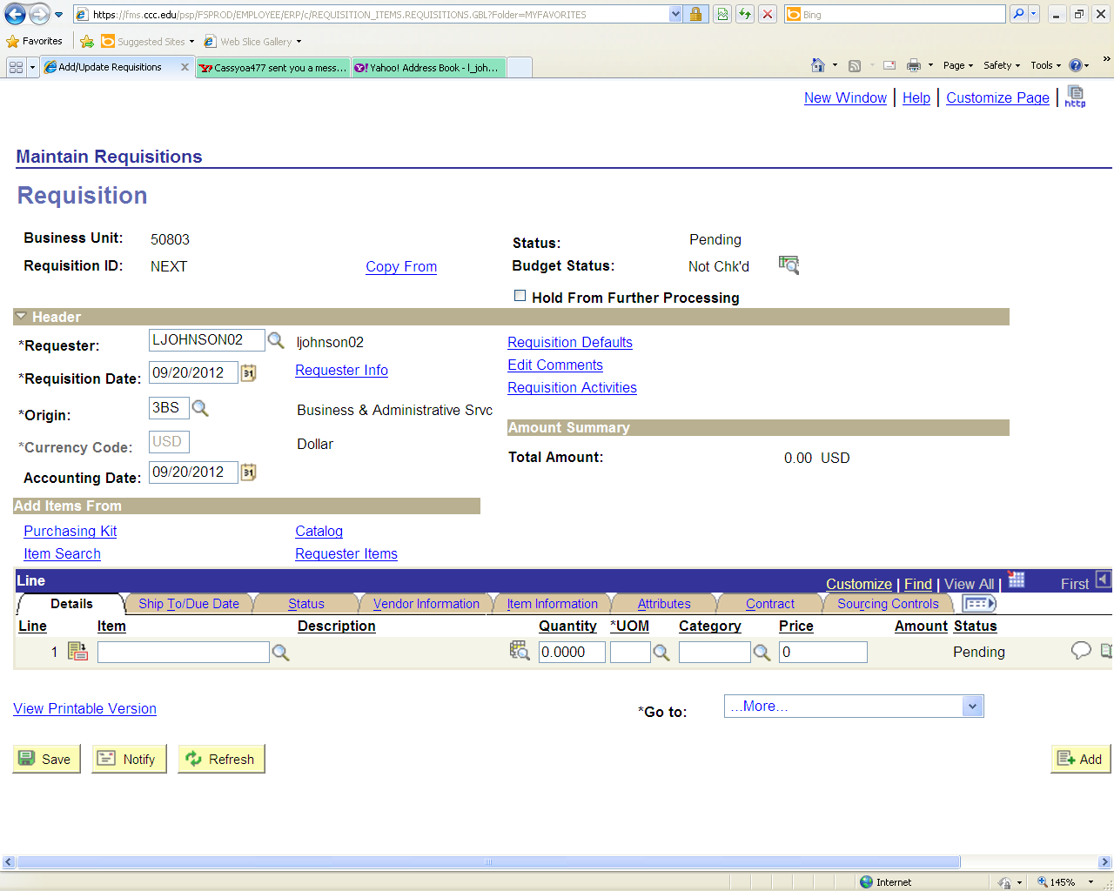

1. **Click Attach**
   1. **Documents must be saved to a file prior to uploading to the Requisition Panel.**

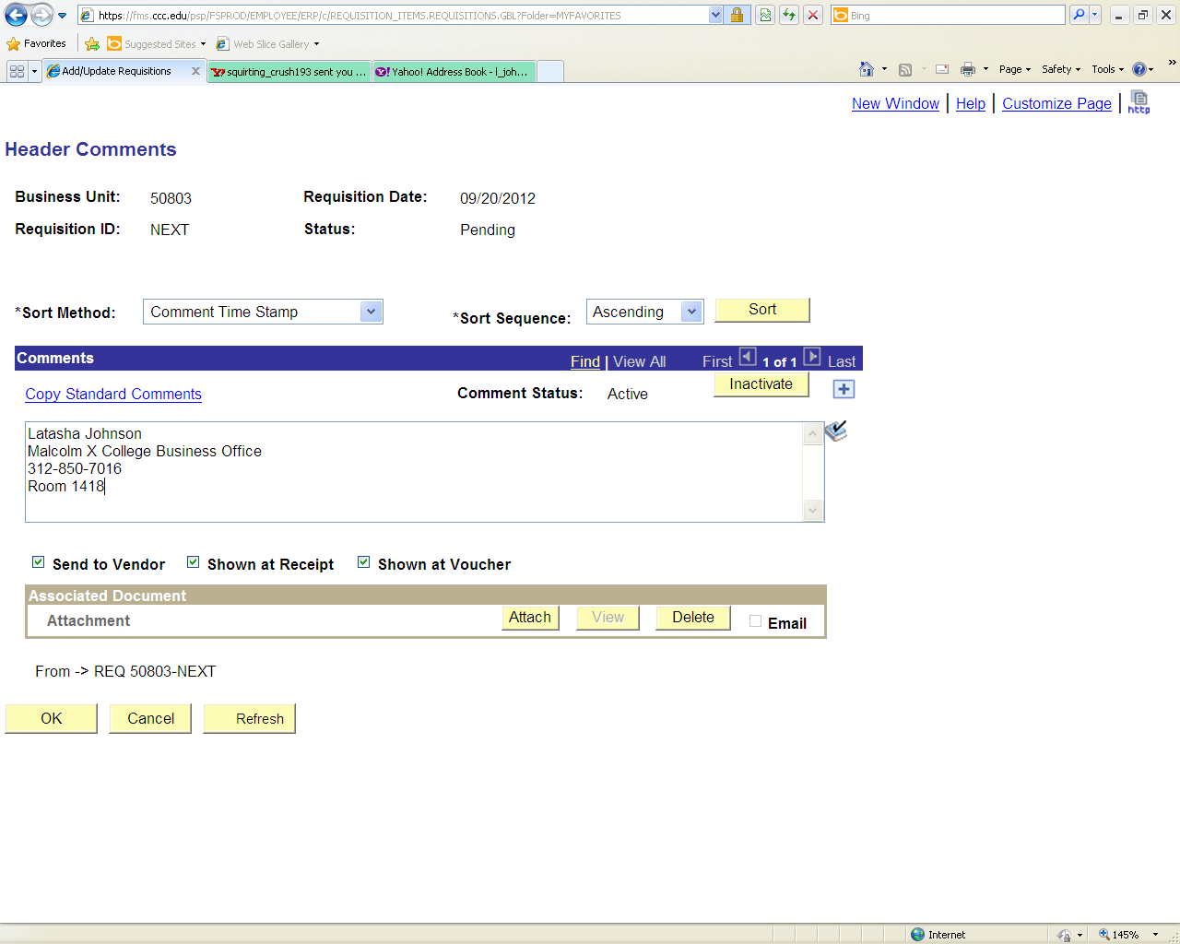

1. **Click Browse**



1. **Select the document from your file.**
   1. **Select the file you wish to upload**
   2. **Click Open**



1. **Click Upload**



1. **The uploaded document will appear in the Associated Document field.**
   1. **To view the attachment select view. A separate window will appear with the viewable PDF documents.**
   2. **Only one document can be uploaded to this panel.**
2. **Click Ok. Proceed with regular requisition entry.**

