PeopleSoft Expense Reports
Created on 2/26/2016 03:58:00 PM

Table of Contents
PeopleSoft Expenses 1
Preparing Expense Reports 1
Creating Expense Reports 2
Viewing Expense Reports 21
Viewing Analytics for an Expense Report 26
Modifying Expense Reports 34
Correcting Expense Line Errors 41
Splitting Receipts 53
Itemizing Hotel Bills Using The Hotel Wizard 88
Withdrawing an Expense Report 105
Deleting Expense Reports 110

PeopleSoft Expenses

PeopleSoft Enterprise Expense Management allows your employees to capture and submit time and expenses in online, disconnected, or wireless mode. Employees save time and you save on processing costs. This module reviews the fundamentals you will need to use PeopleSoft Expenses.

Upon completion of this module, you will be able to:

- Prepare travel authorizations.
- Prepare cash advances.
- Prepare expense reports.
- Process expense report exceptions.
- Use commitment control with Expenses.
- Manage approvals in Expenses.
- Process expense payments.
- View accounting transactions in Expenses.
- Run reports.

Preparing Expense Reports

Expenses makes it easy to transform a handful of receipts into a final expense reimbursement. This chapter discusses how to convert expense transactions into expense reports that meet your auditing standards, approval policies, and tax reporting requirements. Expenses supports a variety of features designed to streamline your entry from defaults to importing credit card transactions. The way in which you set up your expense system determines what data is required and how your accounting system processes it. For example, if an employee takes a business trip that different departments within your organization fund, the expense report can reflect this so that the appropriate departments share the expenses.

Expenses provides functionality to decrease the time that you spend entering expense reports. You can:
- Create expense reports populated with information from user defaults.
- Populate information from My Wallet to expense reports.
- Apply cash advances to expense reports.
- Copy multiple expense lines at one time on an expense report.
- Insert multiple rows at one time on the Create Expense Report page.
- Save an expense report with errors or missing information.

Upon completion of this lesson, you will be able to:
- Create user templates.
- Create expense reports.
- Copy expense report expense lines.
- Add multiple expense report expense lines.
- Attach a document to an expense report.
- View or modify default accounting.
- View or modify accounting details.
- View analytics for an expense report.
- Apply cash advances to an expense report.
- Correct expense line errors.
- Split receipts.
- Itemize hotel bills using the Hotel Wizard.
- View expense reports.
- Modify expense reports.
- Delete expense reports.
- View My Wallet transaction details.
- Apply My Wallet transactions to expense reports.
- Attach a document to a My Wallet transaction.

Creating Expense Reports
Creating Expense Reports

When you create an expense report, you have several options from which to base the new document. The selections that you make trigger other choices that prompt you for details about the report. You can start with a blank expense report or populate one with data from another source.

In this topic, you will create an expense report for an internal off-site meeting.
Procedure

In this topic you learn the following:

- How to create an expense report.
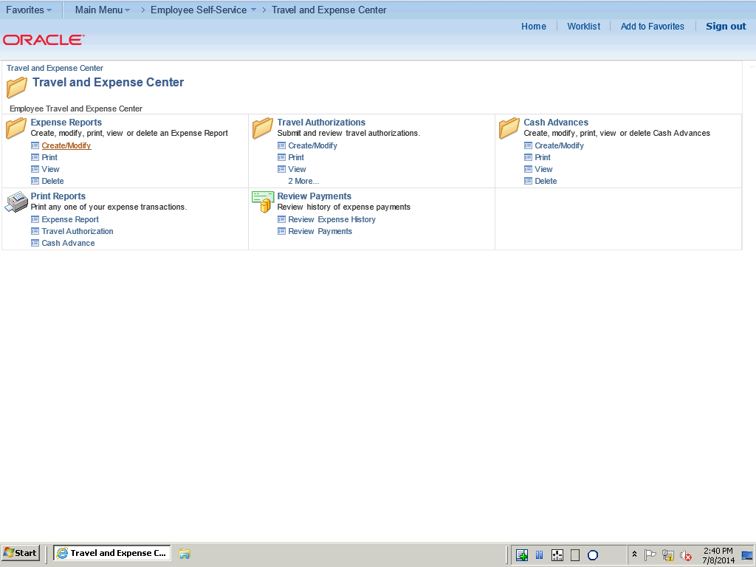

Step | Action
 | Click the Expense Reports Create/Modify link on the Travel and Expense Center.

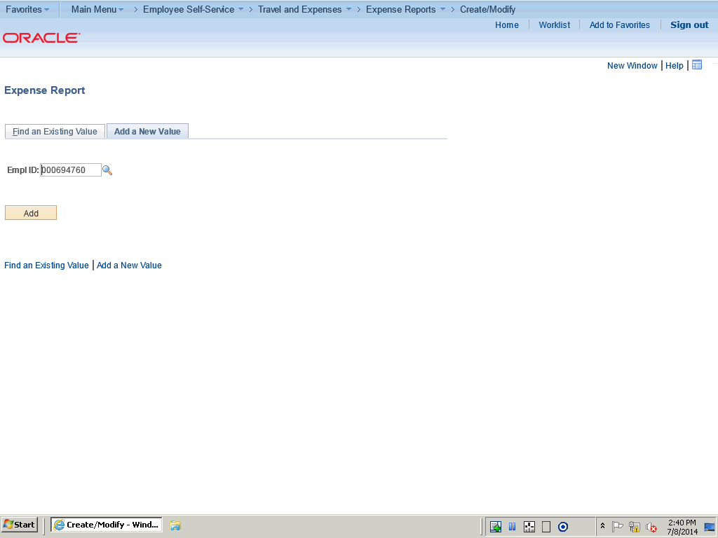

Step | Action
 | Click the Add button.

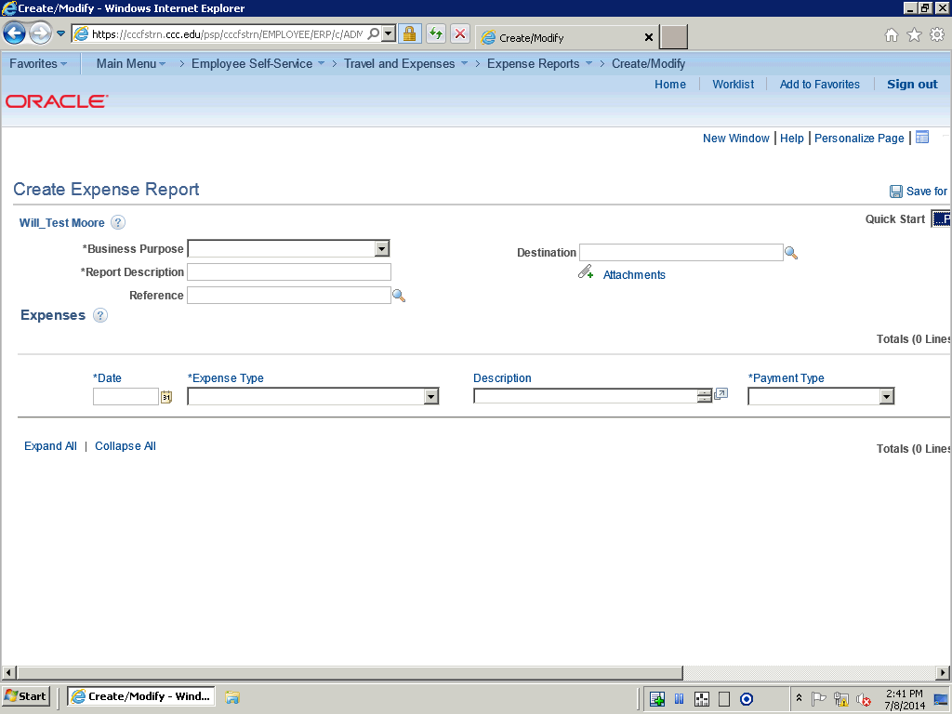

Step | Action
 | Use the Create Expense Report page to create a new expense report from an approved Travel Authorization.

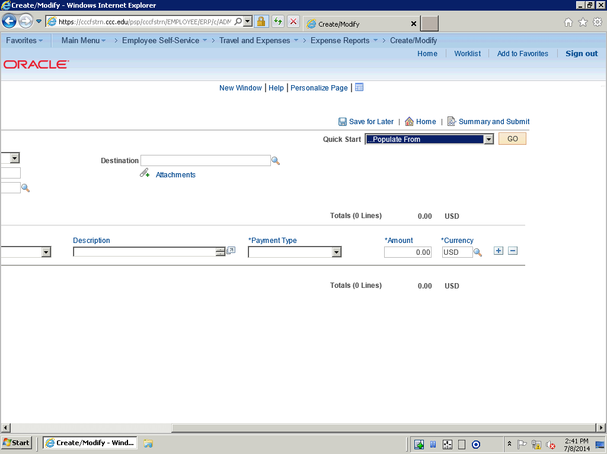

Step | Action
 | Note: You must have an approved Travel Authorization to create an Expense Report.

Step | Action
 | Click the Quick Start list.

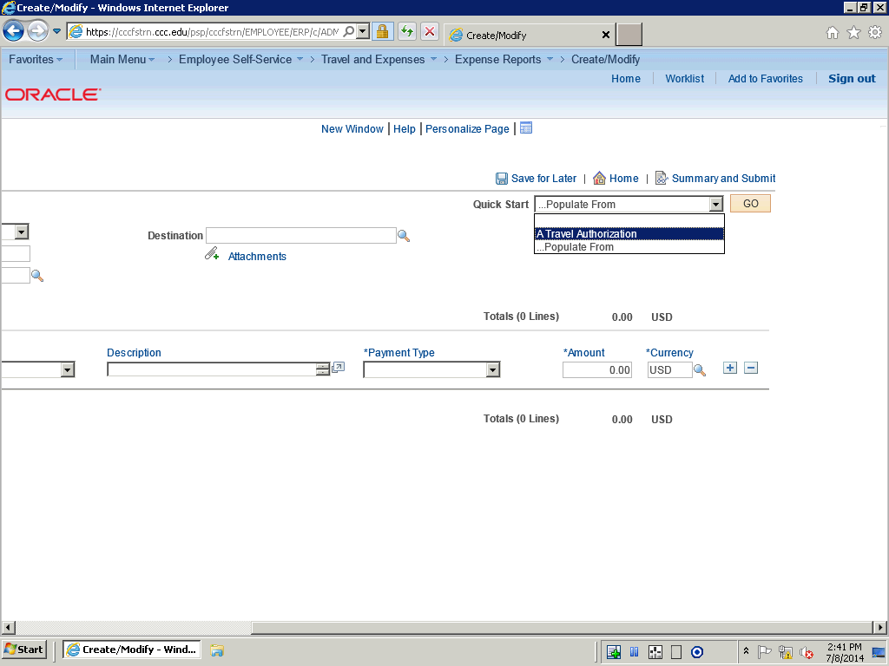

Step | Action
 | Click the A Travel Authorization list item to populate from.

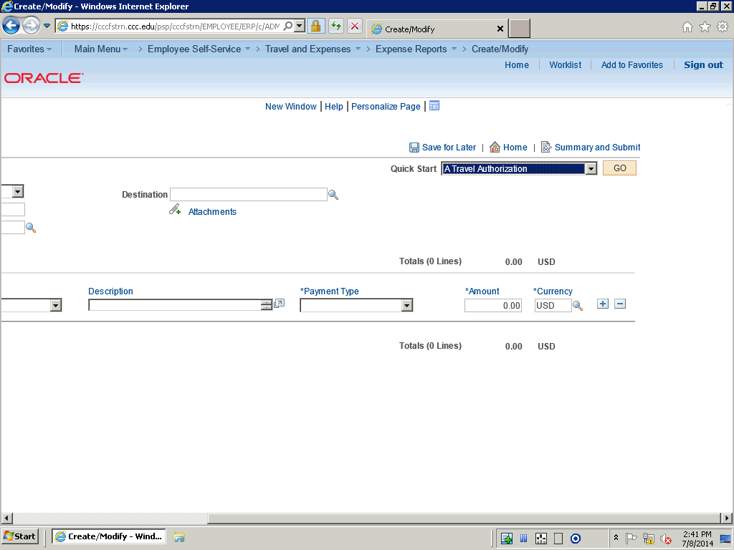

Step | Action
 | Click the GO button.

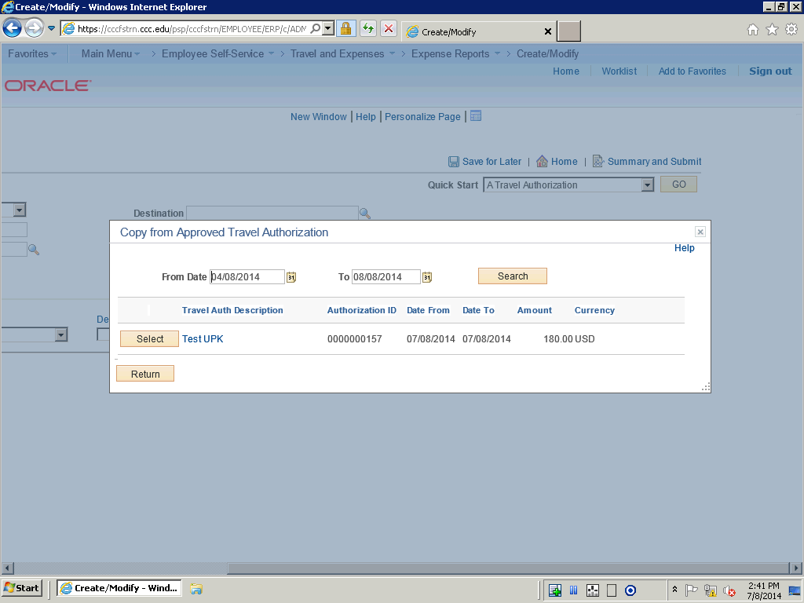

Step | Action
 | Locate the Travel Authorization and click the Select button.

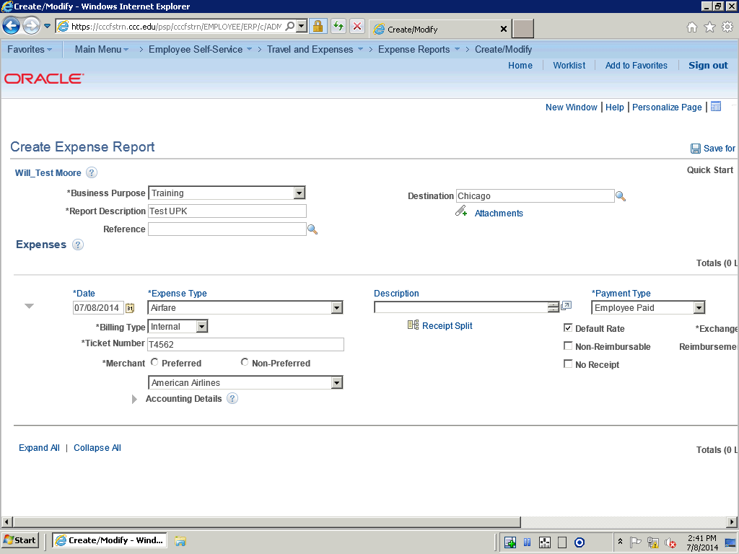

Step | Action
 | The information from the approved Travel Authorization populates the fields on the Expense Report.

Step | Action
 | Click the Preferred option.

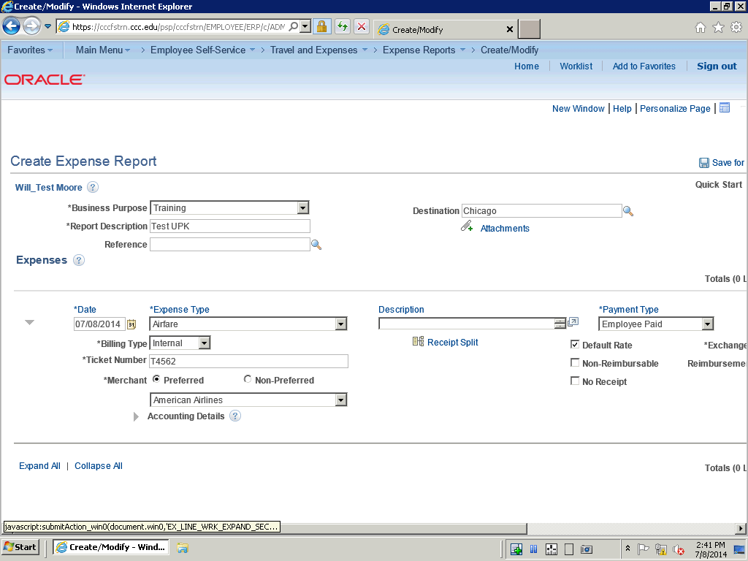

Step | Action
 | Click the Expand Accounting Lines button.

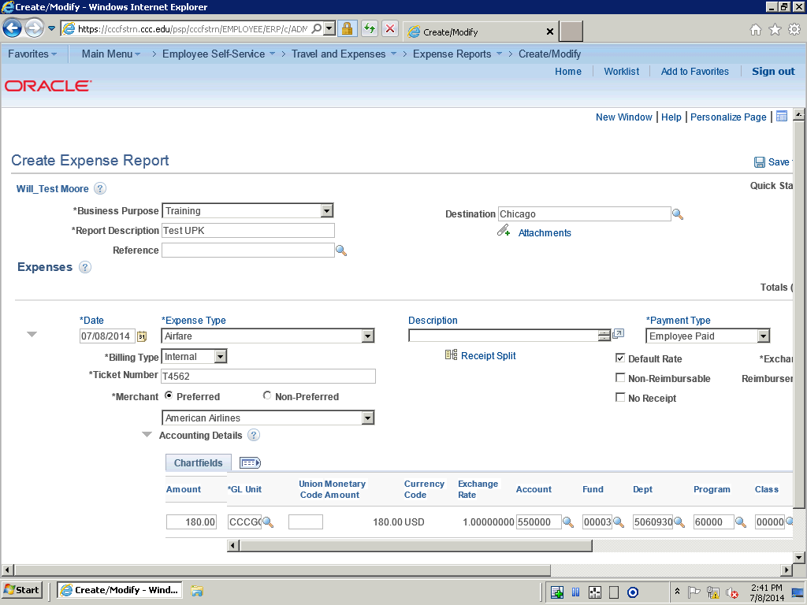

Step | Action
 | Verify that the accounting line chartfields are correct.

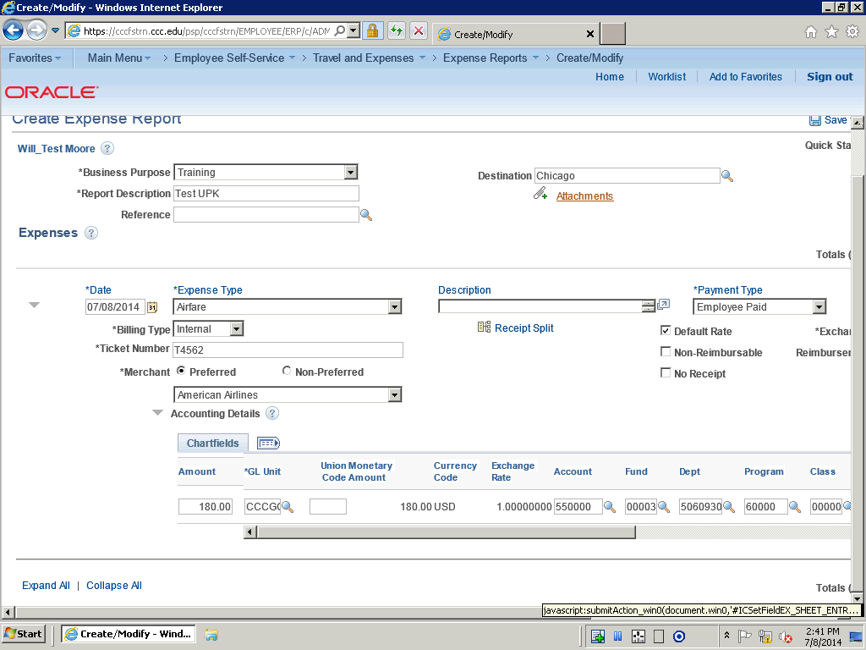

Step | Action
 | Click the Attachments link.

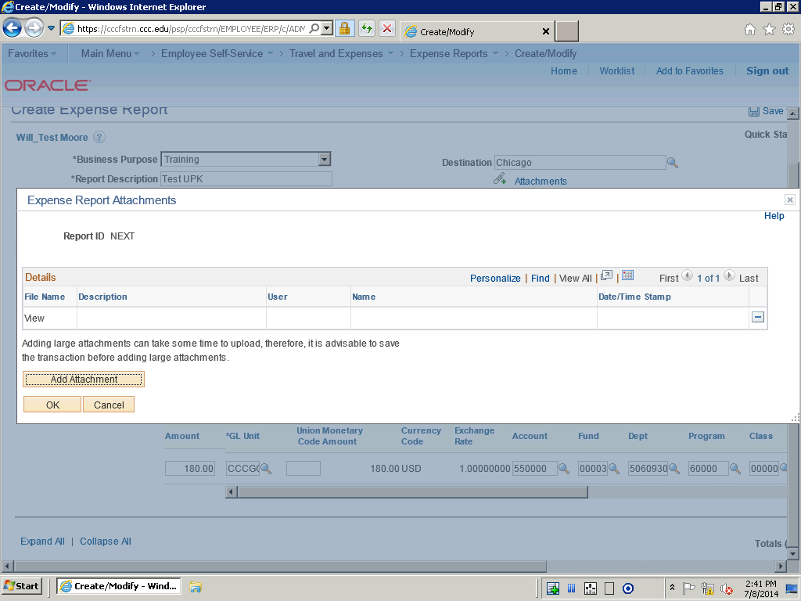

Step | Action
 | Use the Expense Report Attachments page to add new attachments, view existing attachments, or remove attachments.

Step | Action
 | Click the Add Attachment button.

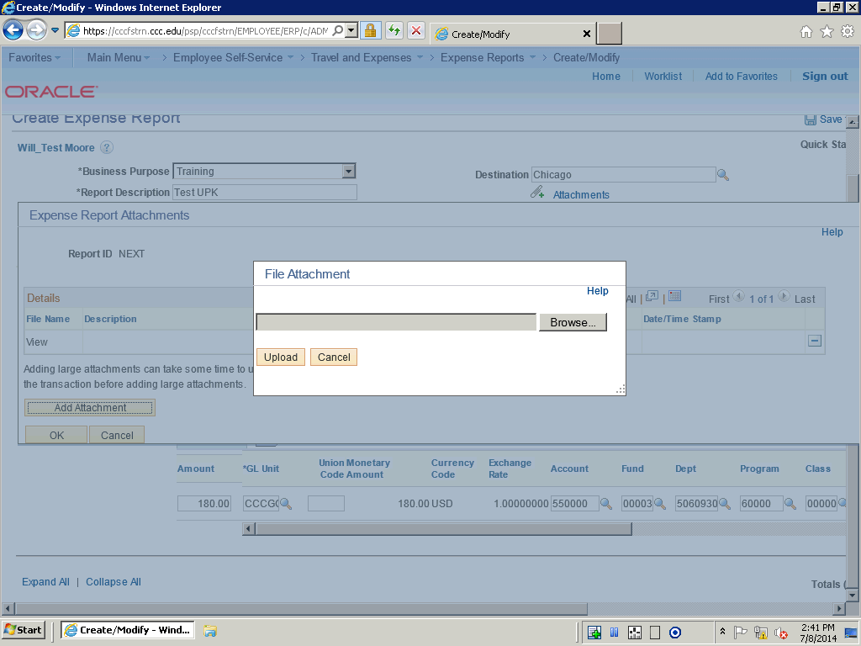

Step | Action
 | Click in the Browse button.

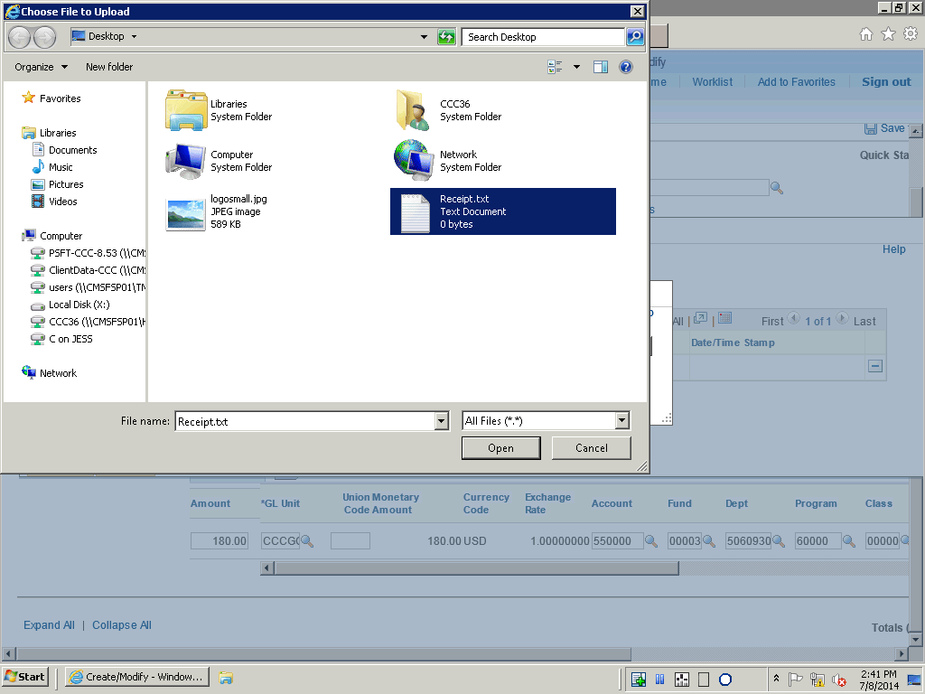

Step | Action
 | Select the desired attachments and click the Open button.

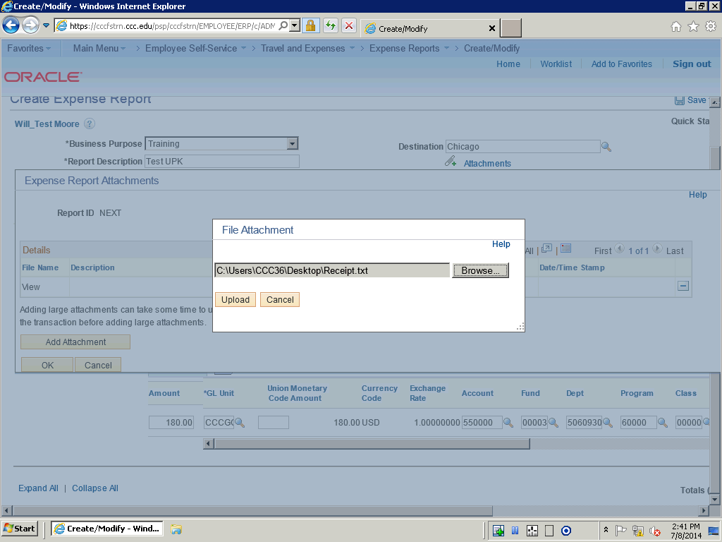

Step | Action
 | Click the Upload button.

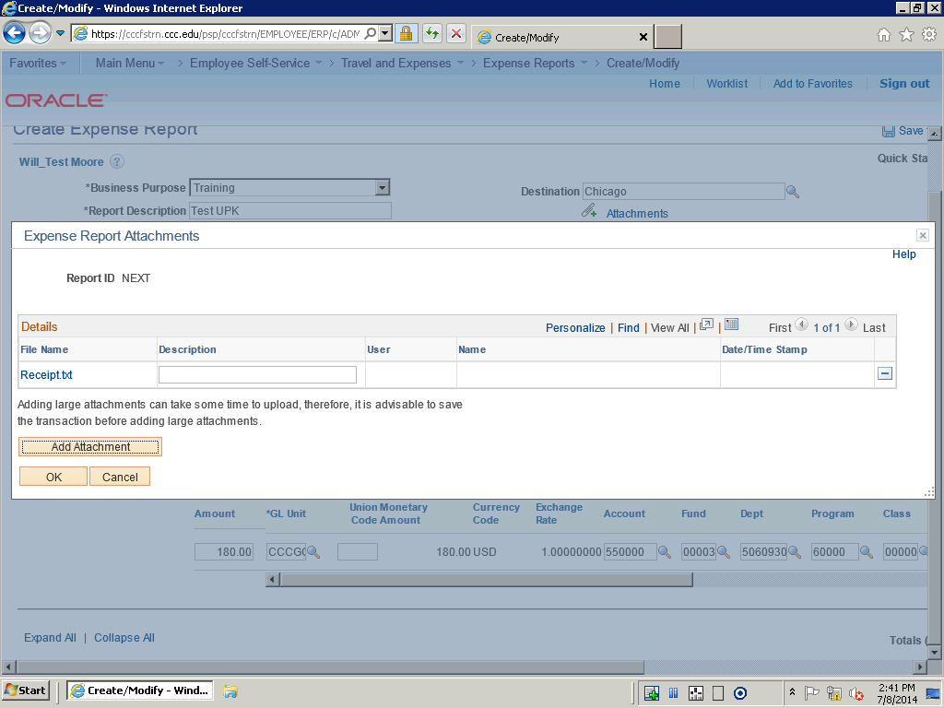

Step | Action
 | Click in the Description field if you wish to add a description.

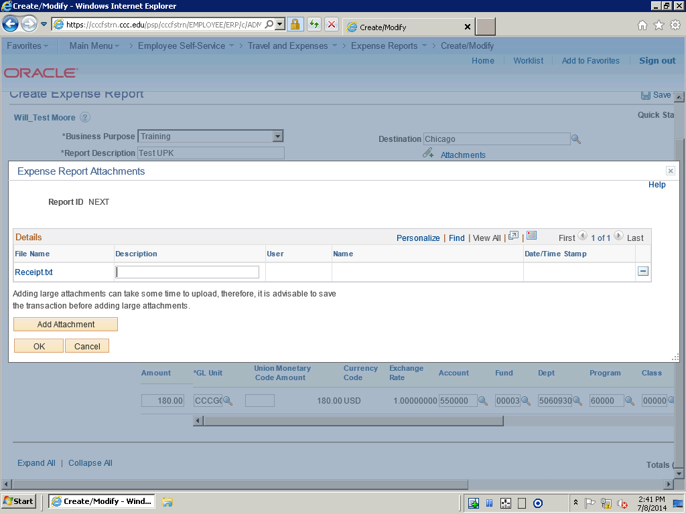

Step | Action
 | Enter the desired information into the Description field. Enter "OPTIONAL".

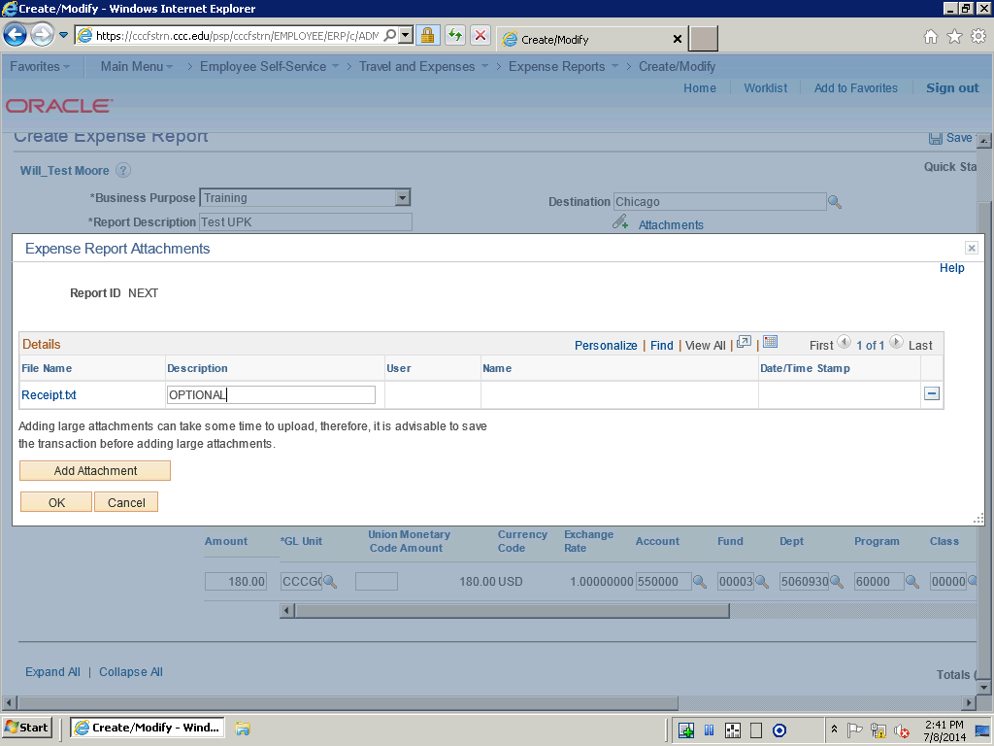

Step | Action
 | Click the OK button.

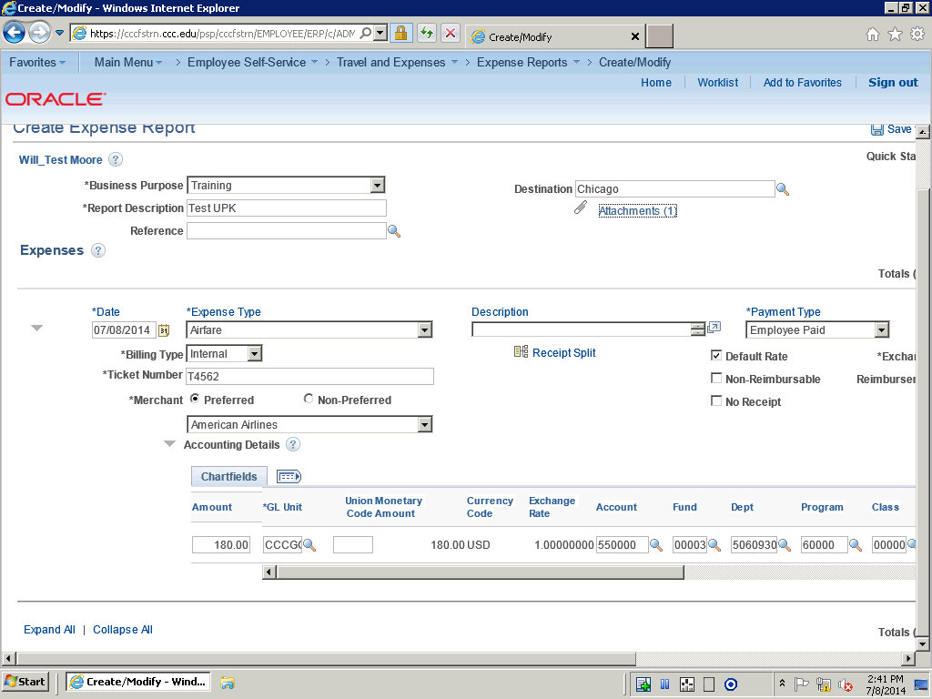

Step | Action
 | Use the horizontal scroll bar to navigate to the right.

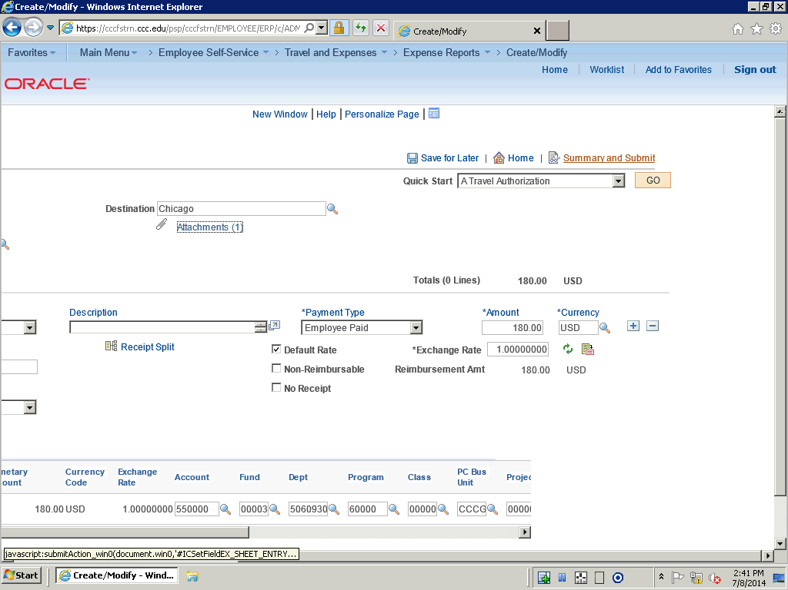

Step | Action
 | Click the Summary and Submit link.

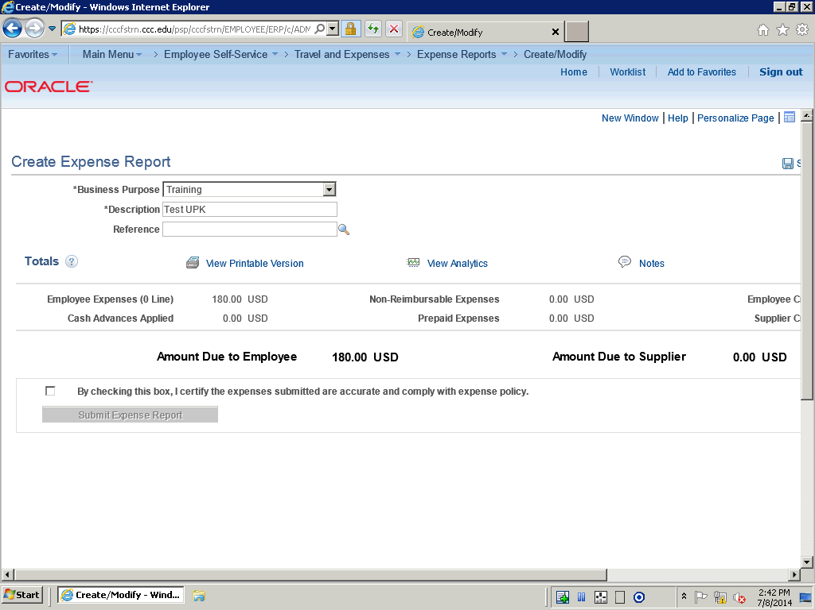

Step | Action
 | Check the Submit Checkbox option to confirm the submission.

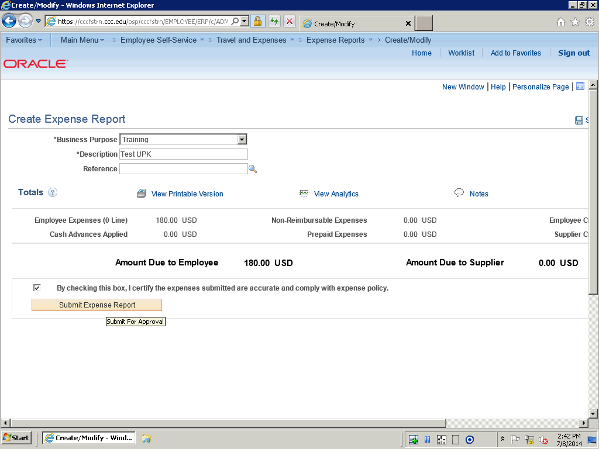

Step | Action
 | Click the Submit Expense Report button.

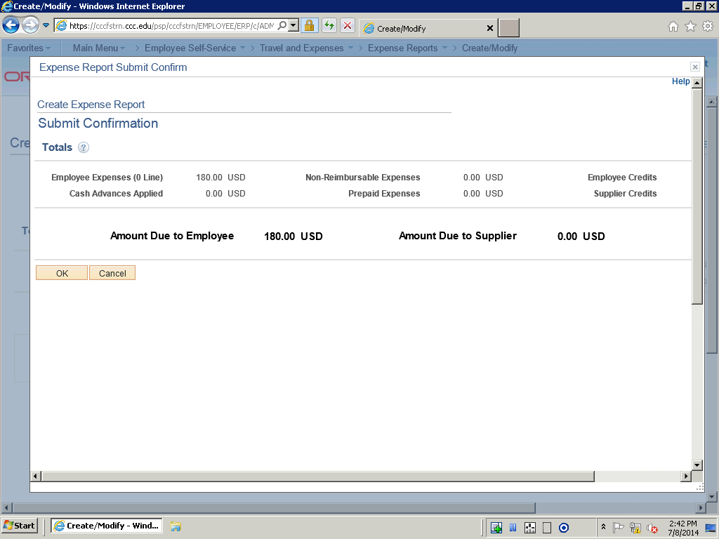

Step | Action
 | Click the OK button.

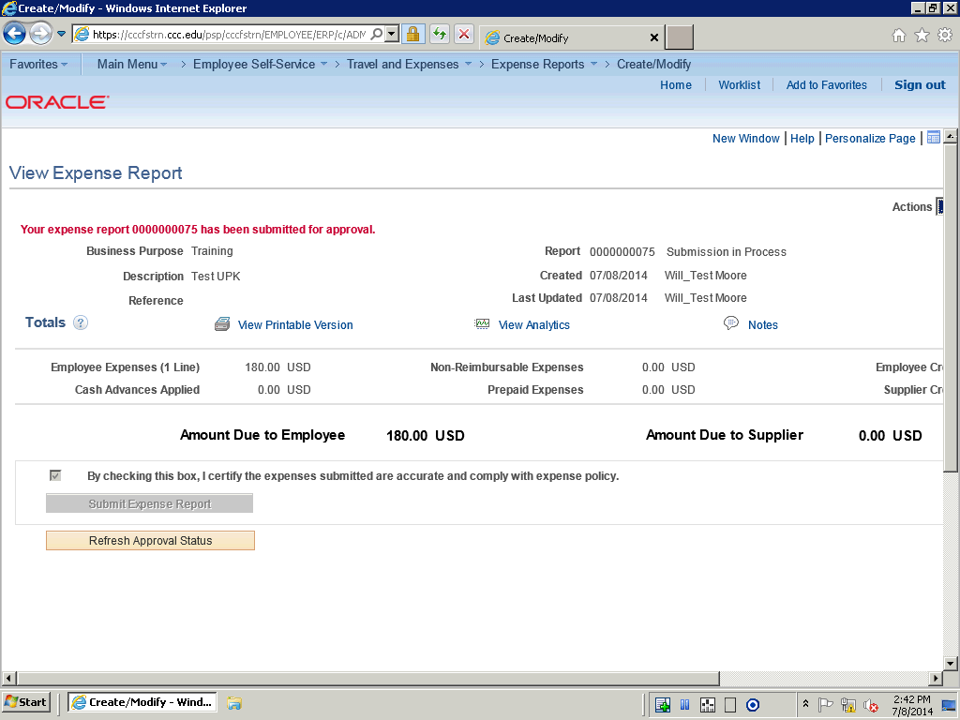

Step | Action
 | Note: that a message appears on the Expense Report confirming that the report was submitted for approval.

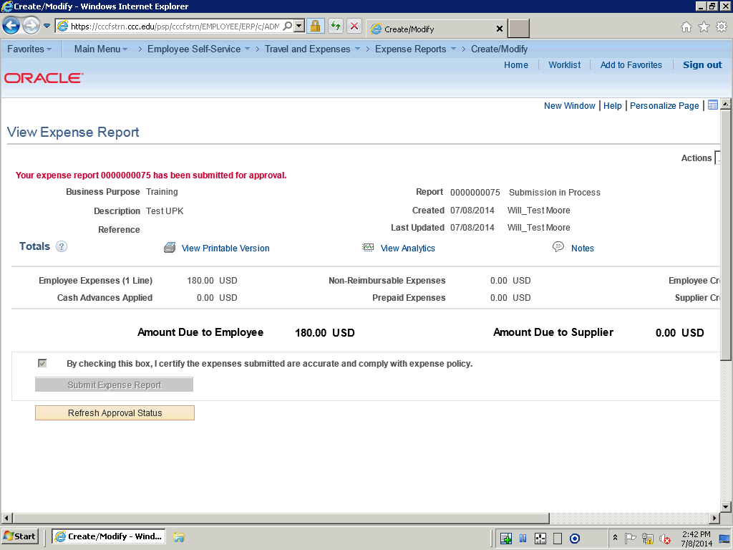

Step | Action
In this topic you will learn the following:

- How to create an expense report.

You have successfully completed this training session.
End of Procedure.

Viewing Expense Reports
Viewing Expense Reports

When you access the View Expense Report page, Expenses displays the page in read-only mode. After you submit an expense report for approval, you can only view it. You can view expense reports with these statuses: Approved, Closed, Denied, In Process, Paid, Pending, Submitted, and On Hold.

In this topic, you will view an expense report that is in a Pending status.
Procedure

In this topic you will learn the following:

- How to view an expense report.
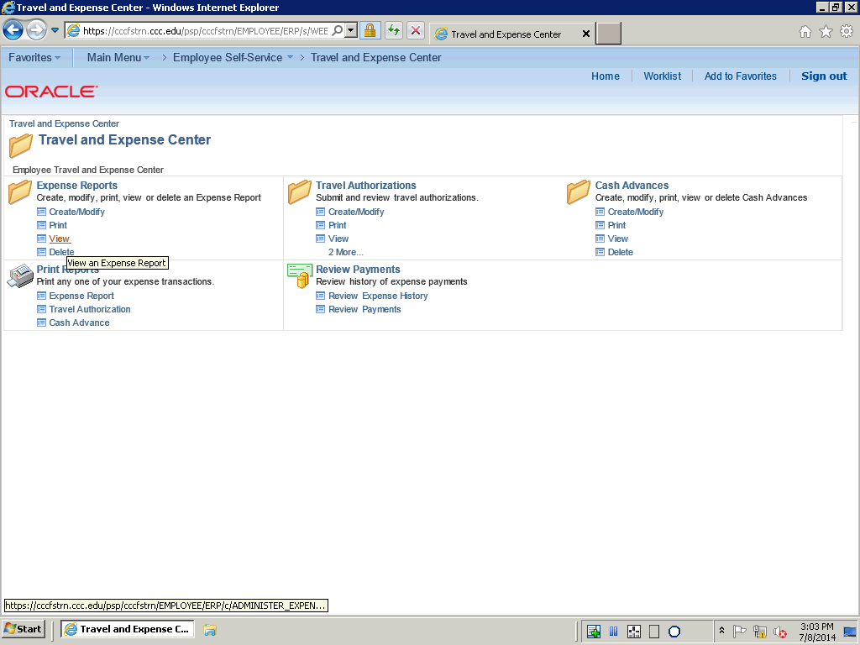

Step | Action
 | Click the Expense Reports View link on the Travel and Expense center.

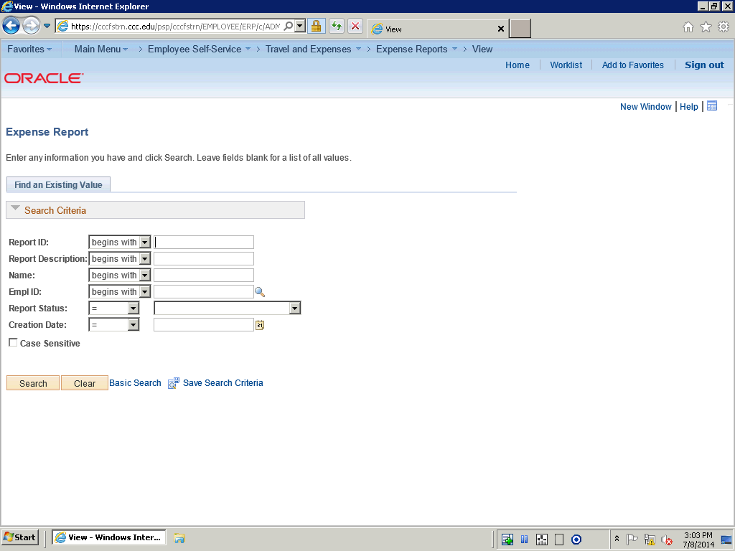

Step | Action
 | Click the Search button.

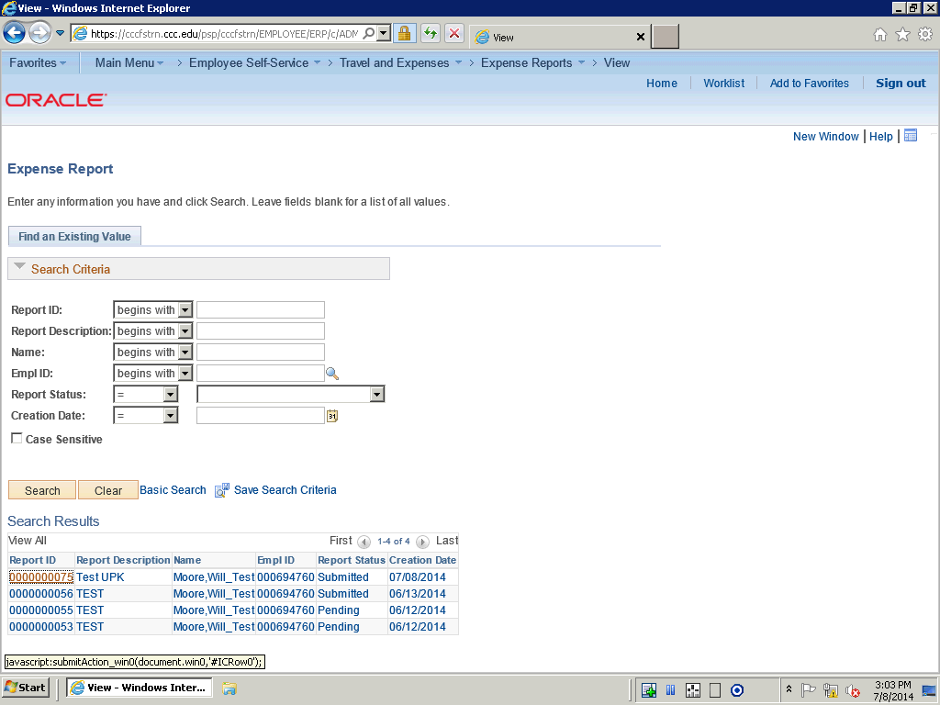

Step | Action
 | Click the 0000000075 link.

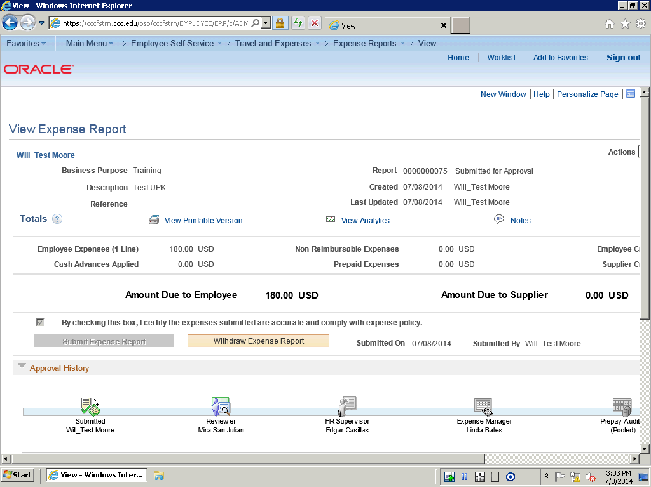

Step | Action
 | Use the View Expense Report page to view an expense report in read-only mode.

Step | Action
 | Note: Next to the report ID, the system displays the status of the expense report. This report is in a Submitted for Approval status.

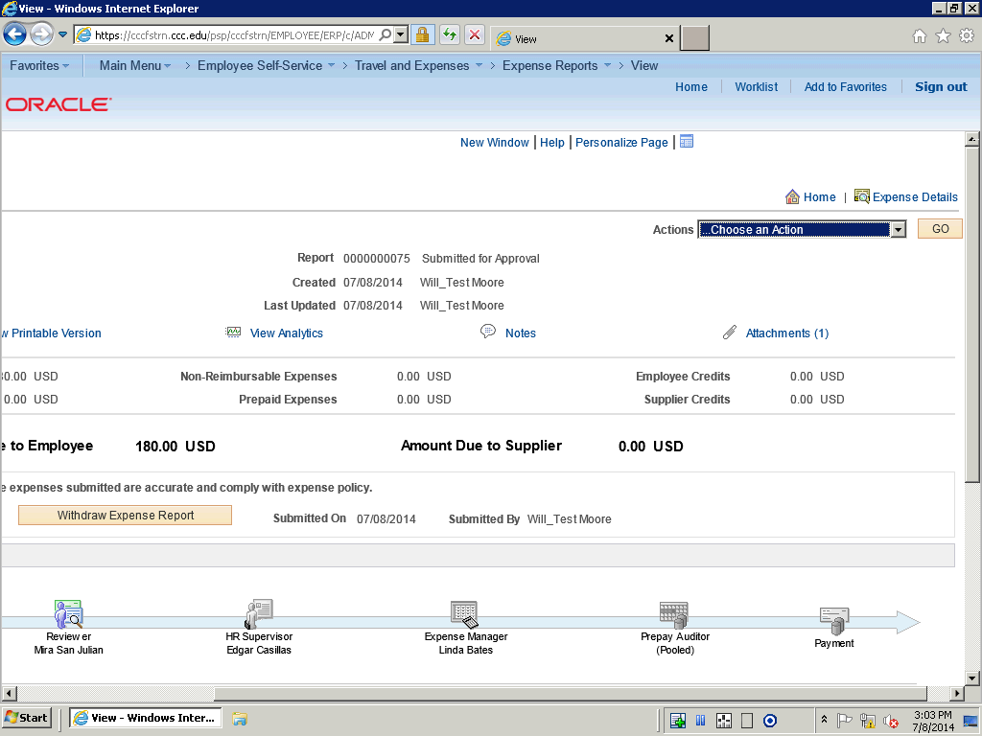

Step | Action
 | Use the horiztonal scroll bar to navigate to the right to view the entire expense report.

Step | Action
In this topic you have learned the following:

- How to view an expense report.

You have successfully completed this training session.
End of Procedure.

Viewing Analytics for an Expense Report
Viewing Analytics for an Expense Report
Procedure

In this topic you will learn the following:

- How to View Analytics for an Expense Report.
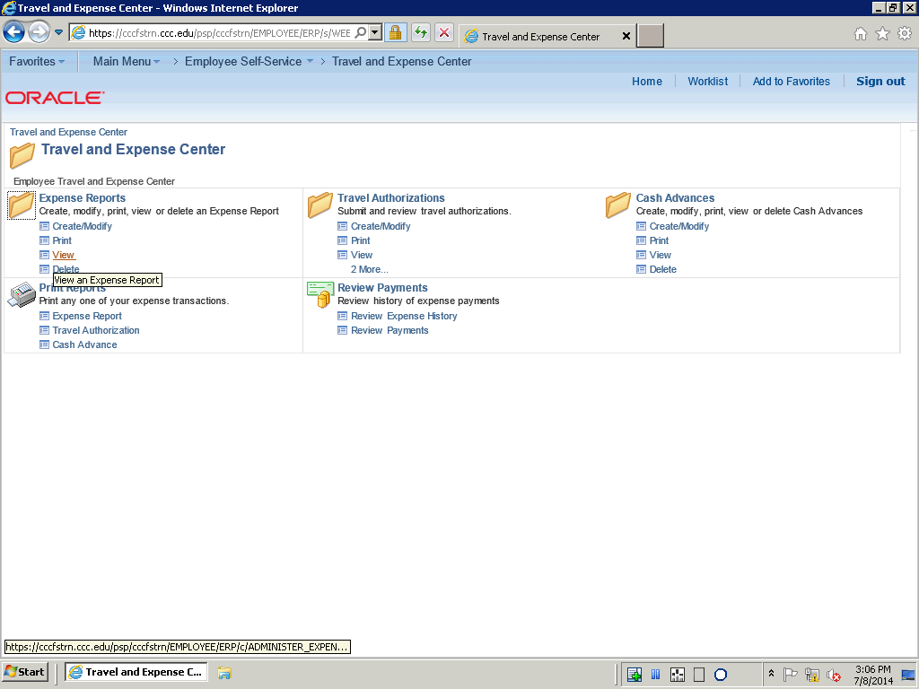

Step | Action
 | Click the Expense Reports View link on the Travel and Expense Center.

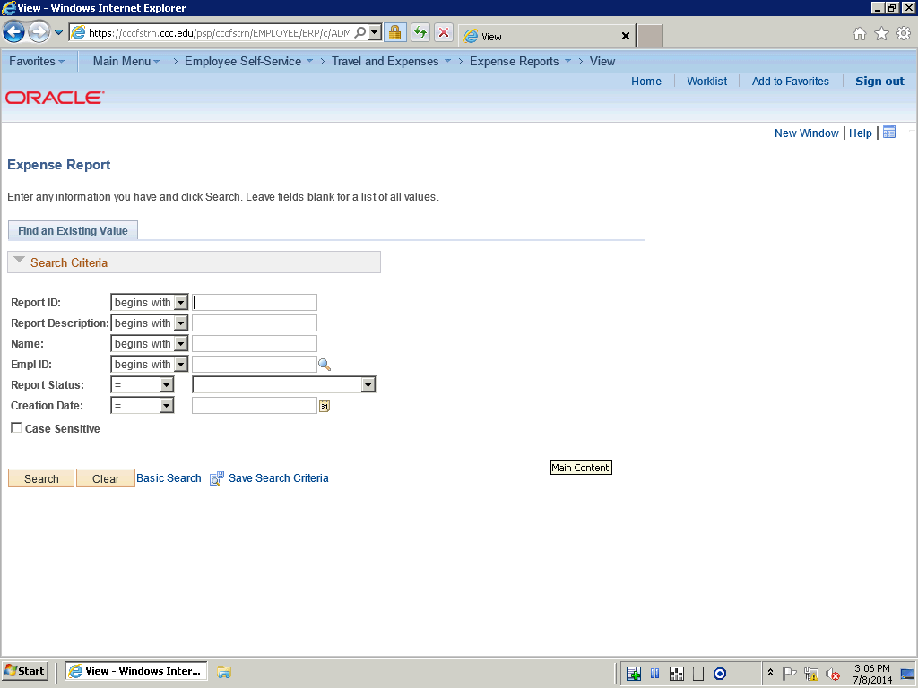

Step | Action
 | Click the Search button.

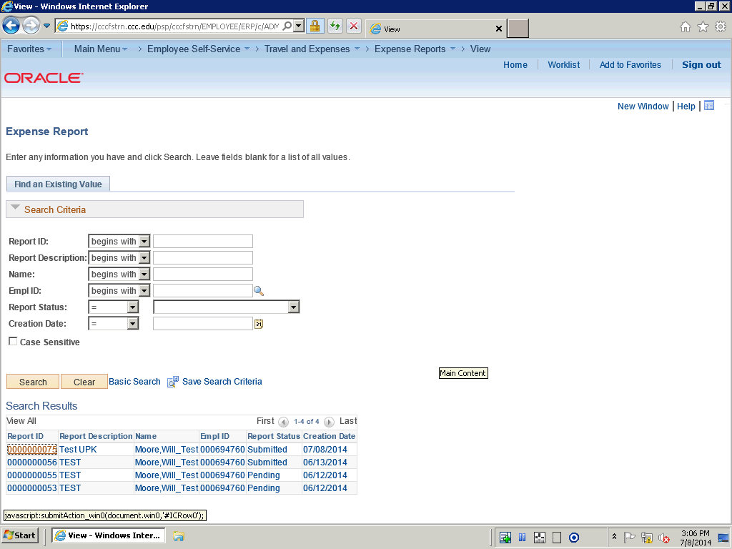

Step | Action
 | Click the 0000000075 link.

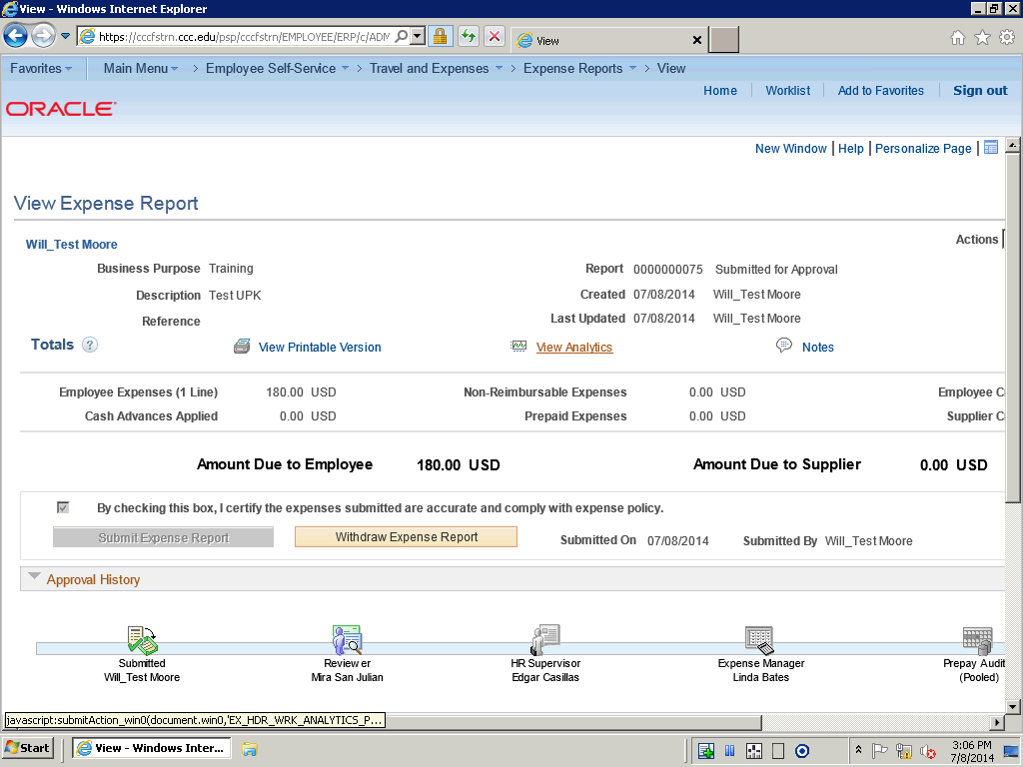

Step | Action
 | Use the View Analytics link to view expenses by week, department, and project and activity for this expense report.

Step | Action
 | Click the View Analytics link.

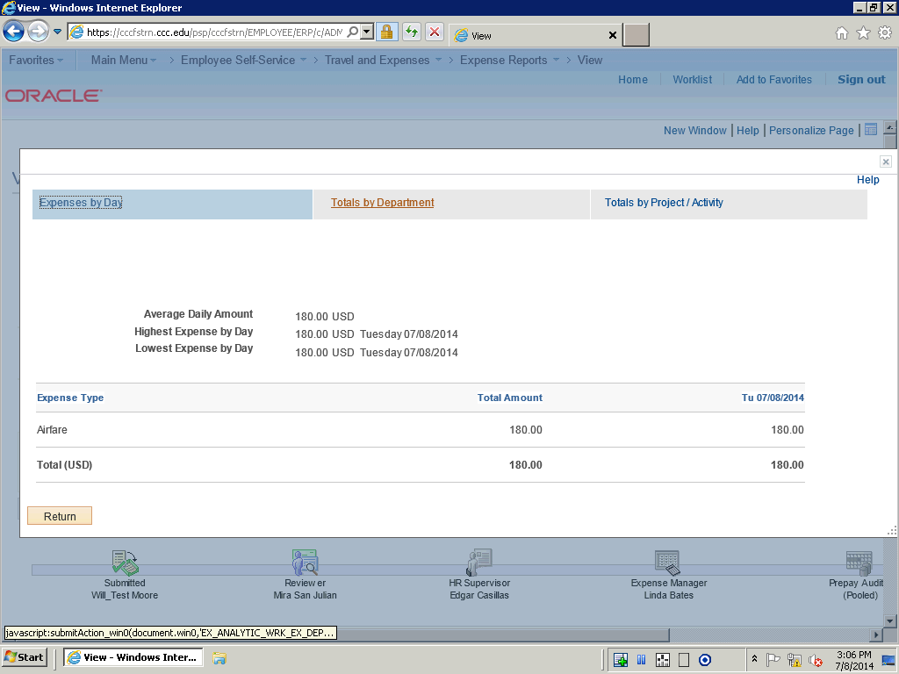

Step | Action
 | The Expenses by day page is to view an expense report in read-only mode.

Step | Action
 | Click the Totals by Department link.

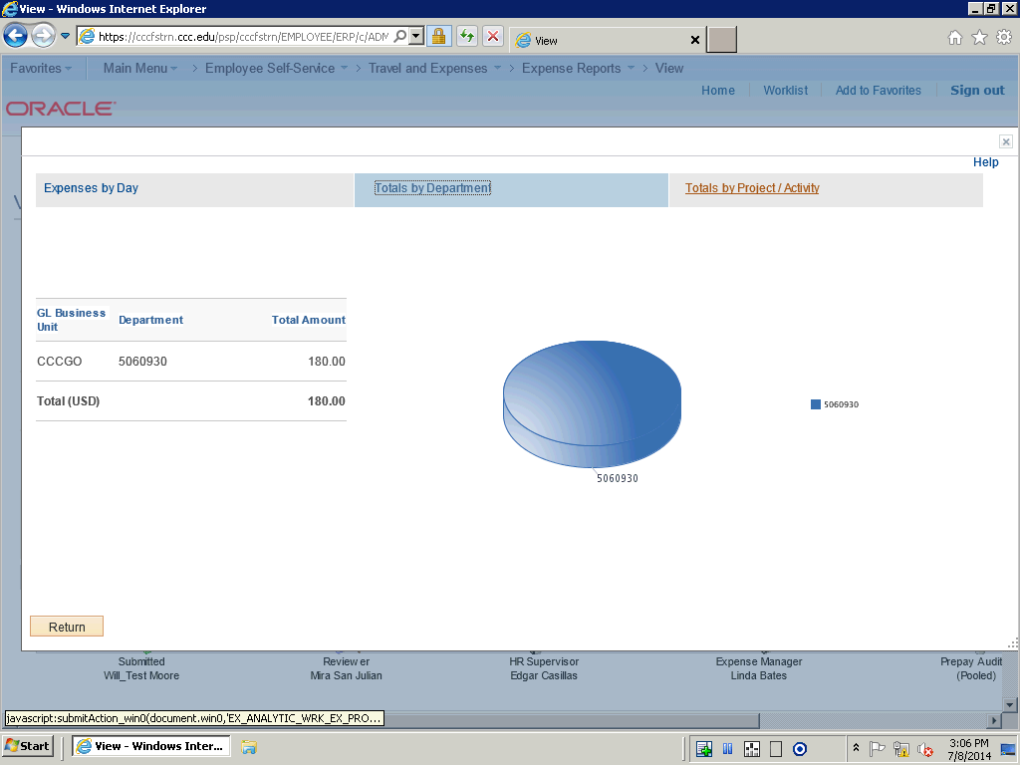

Step | Action
 | The Totals by Department page is used to view totals based on department IDs entered in the Accounting Detail section of the expense report.

Step | Action
 | Click the Totals by Project / Activity link.

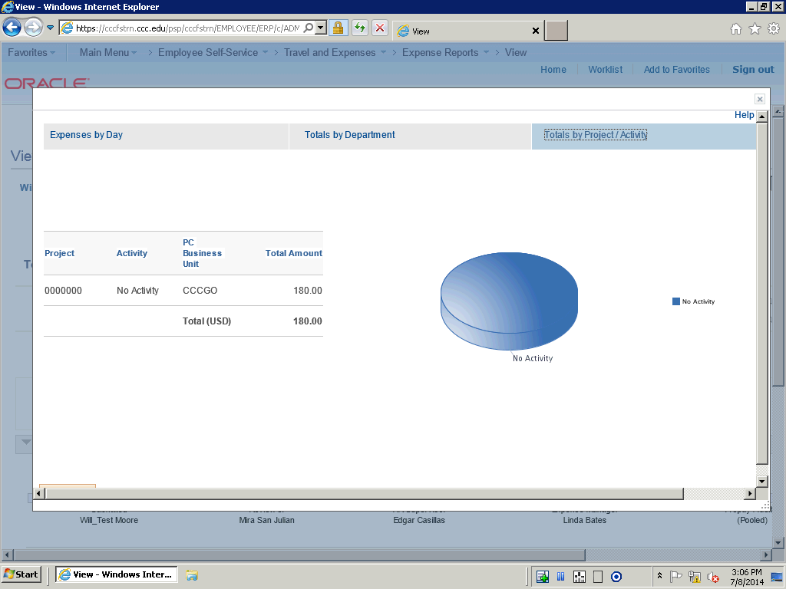

Step | Action
 | The Totals by Project/Activity page is used to view totals based on the projects and activities entered in the Accounting Detail section of the expense report.

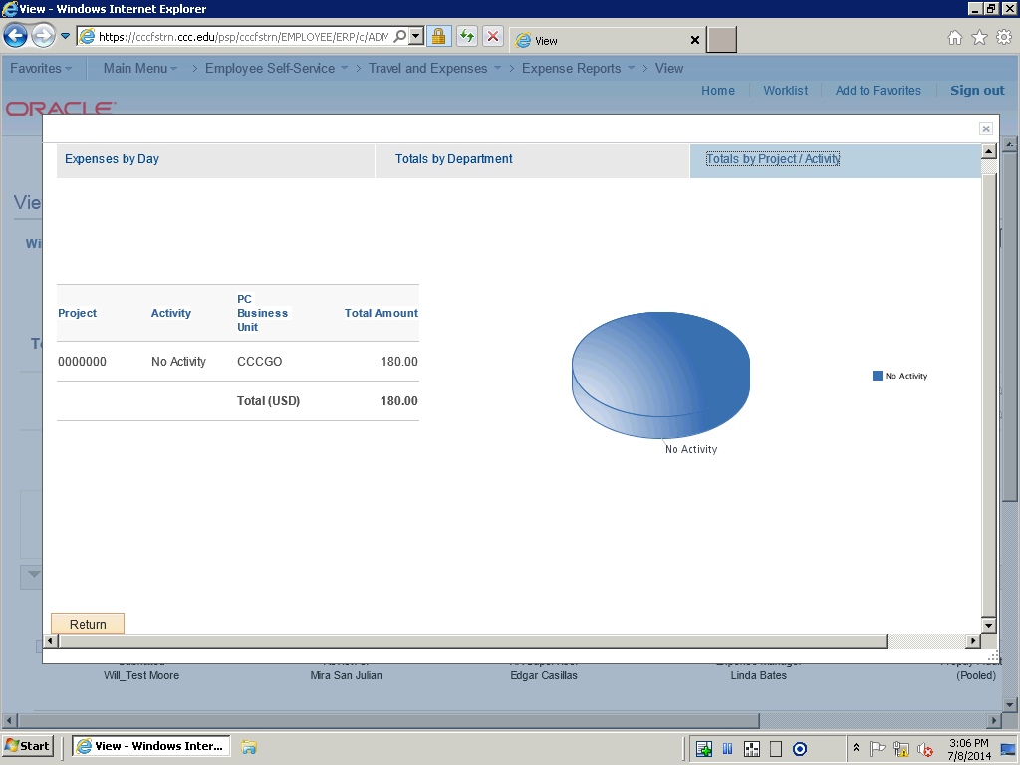

Step | Action
 | Click the Return button.

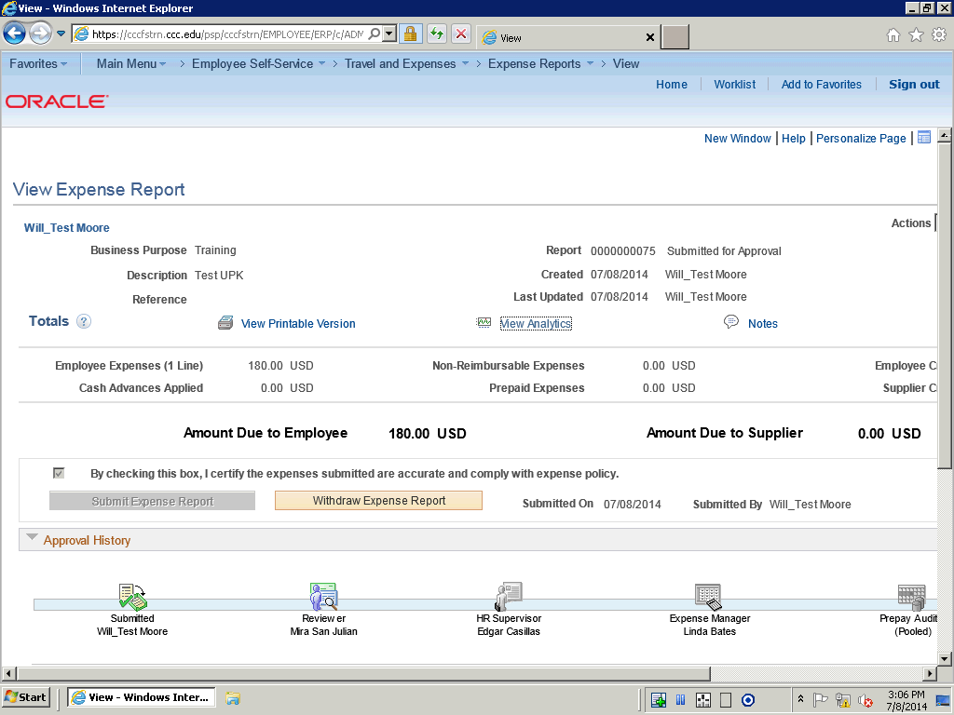

Step | Action
In this topic you have learned the following:

- How to View Analytics for an Expense Report.

You have successfully completed this training session.
End of Procedure.

Modifying Expense Reports
Modifying Expense Reports

Expenses enables you to edit the fields on the Modify Expense Report p age, when an expense report has been previously saved, but not submitted it for approval, or if an approver sends it back for revision or correction.

In this topic, an expense report has been returned by the approver. You will modify the expense report and resubmit it.
Procedure

In this topic you will learn the following:

- How to modify and expense report.
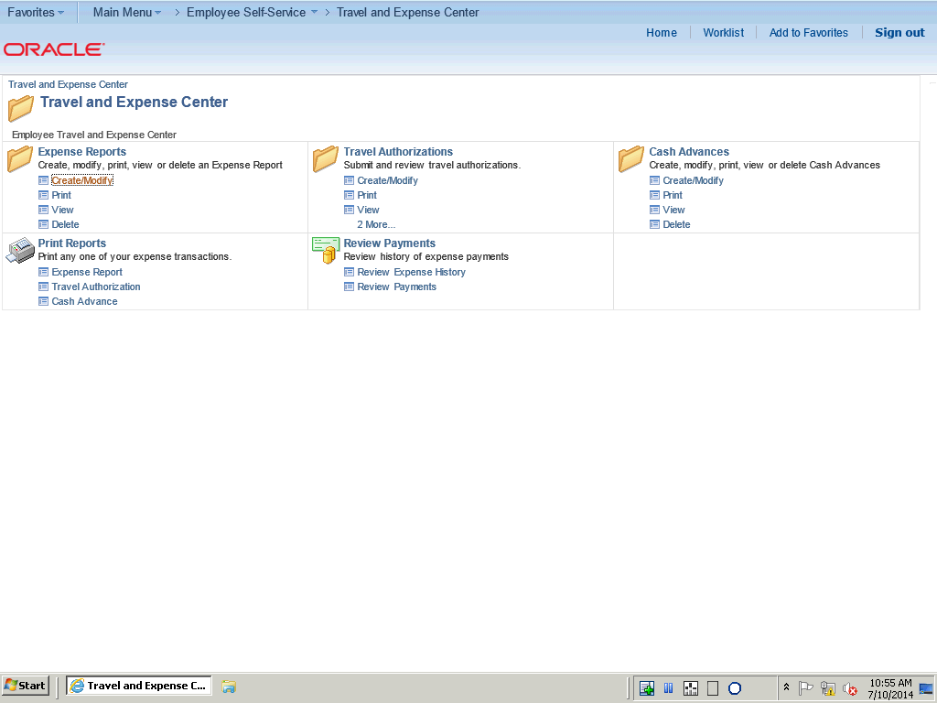

Step | Action
 | Click the Expense Reports Create/Modify link on the Travel and Expense Center.

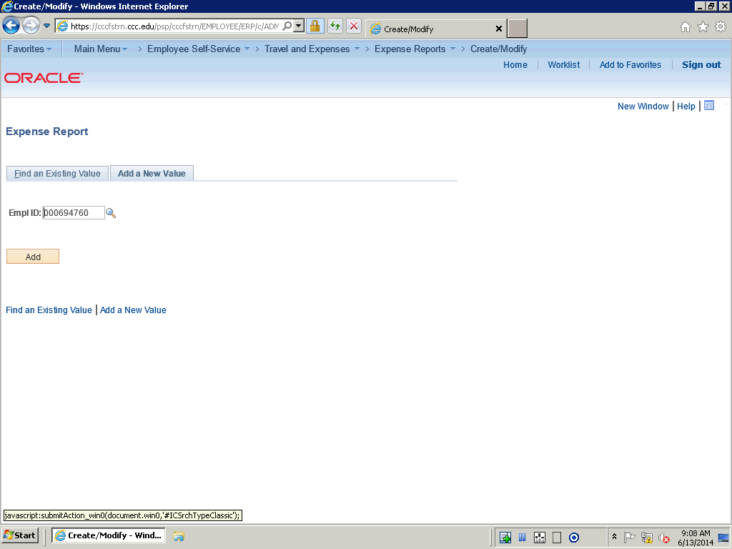

Step | Action
 | Click the Find an Existing Value tab.

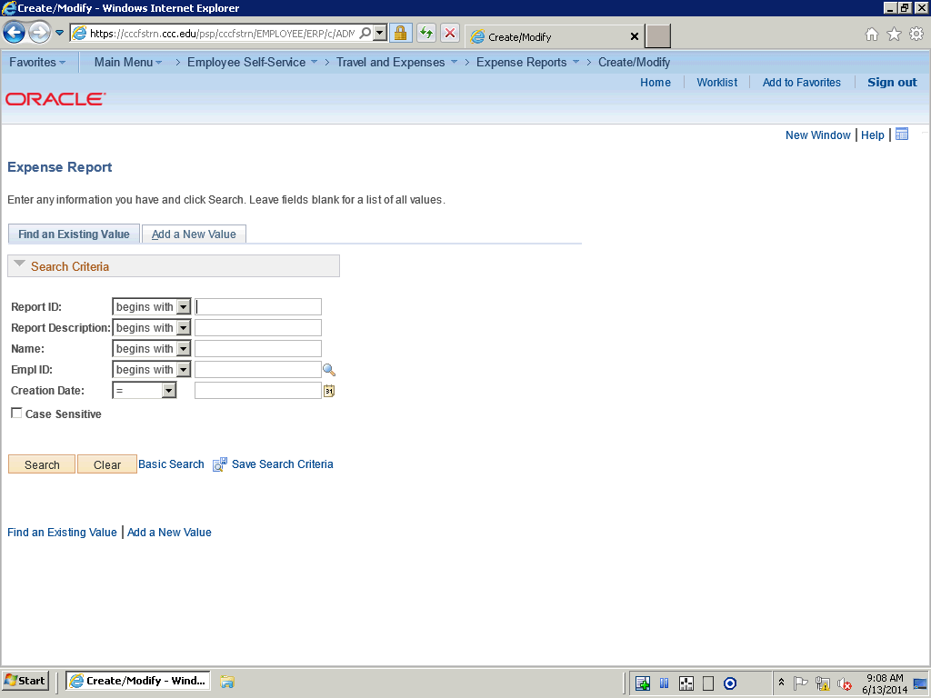

Step | Action
 | Click the Search button.

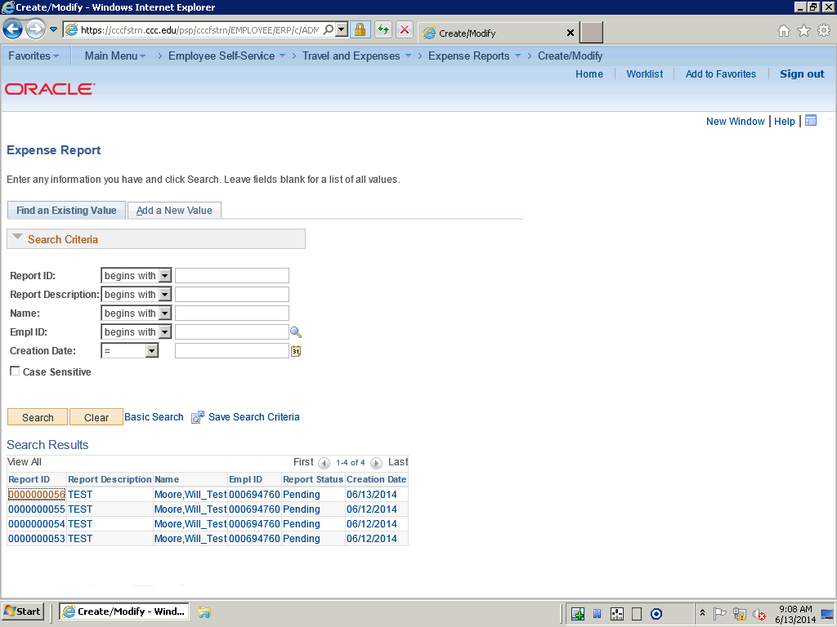

Step | Action
 | Click the 0000000056 link.

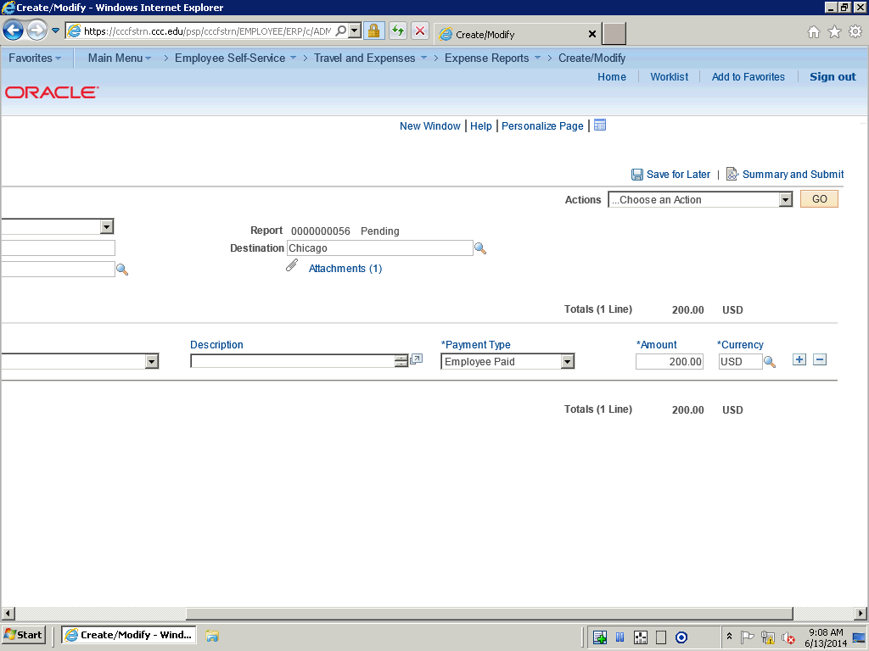

Step | Action
 | Use the Horizontal scrollbar to navigate to the part of the expense report you would like to modify.

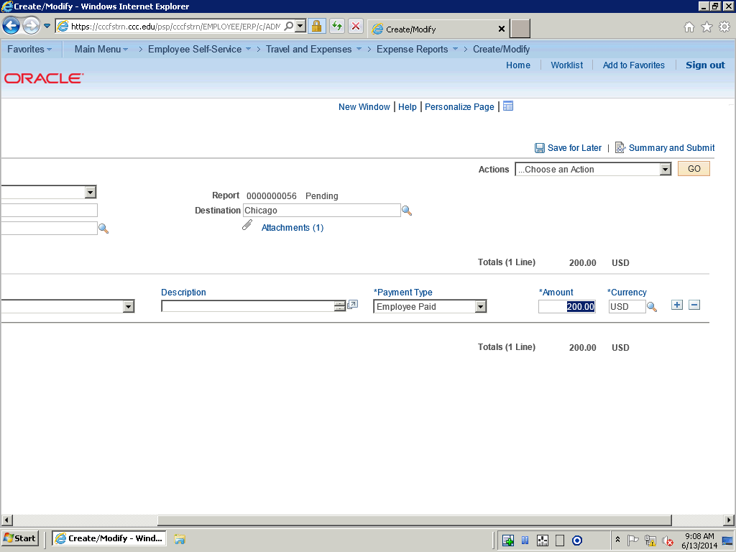

Step | Action
In this example we will modify the Amount.

Enter the desired information into the Amount field. Enter "230.00".

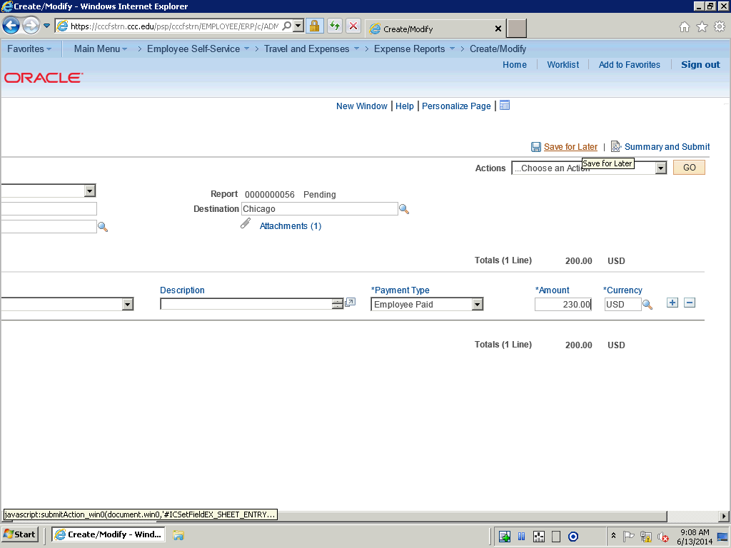

Step | Action
 | Click the Save for Later link.

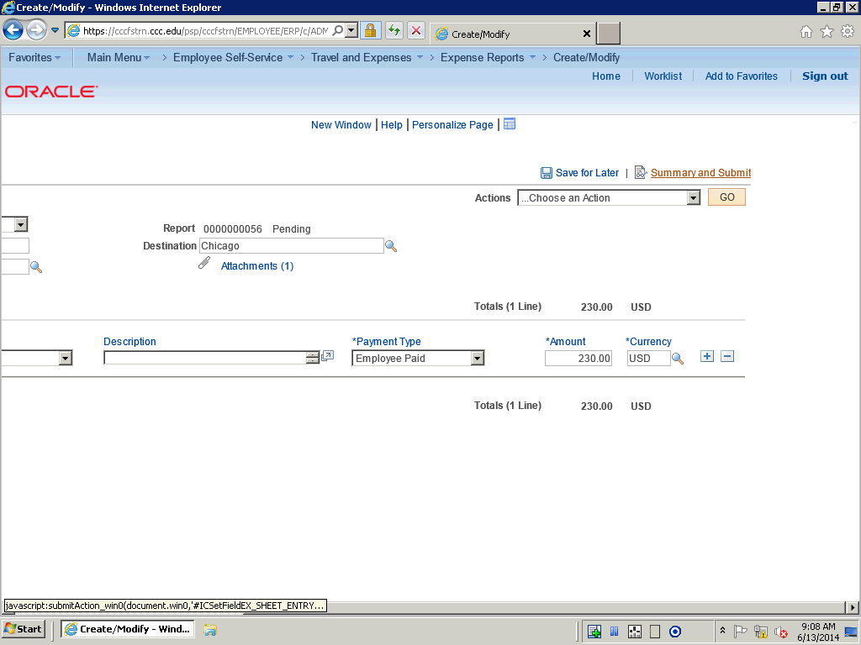

Step | Action
 | Click the Summary and Submit link if you are ready to Submit.

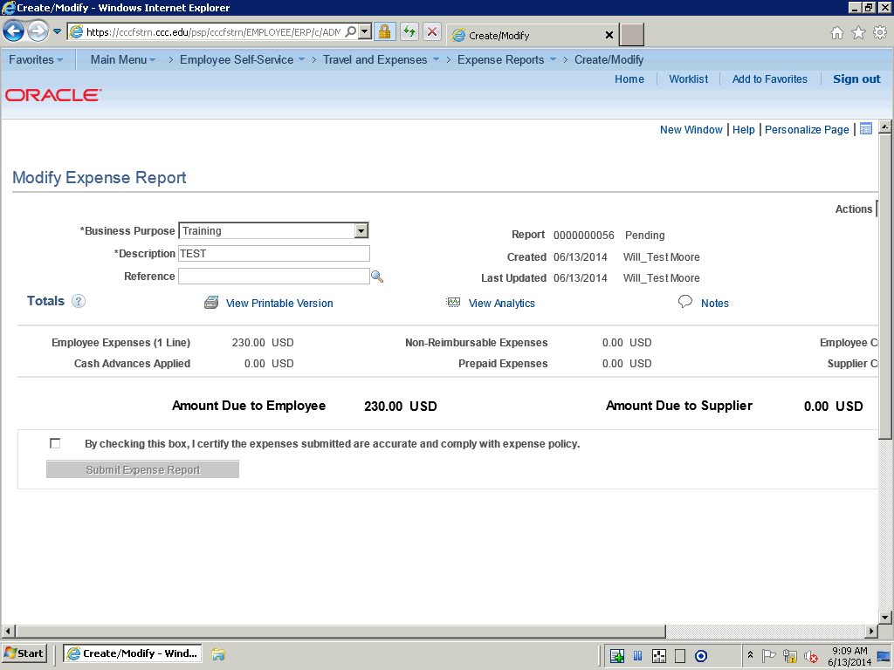

Step | Action
In this topic you have learned the following:

- How to modify and expense report.

You have successfully completed this training session.
End of Procedure.

Correcting Expense Line Errors
Correcting Expense Line Errors

After you add expense lines on the Create Expense Report page, you can click the Save for Later button or the Summary and Submit button. Expenses immediately validates the data and displays visual indicators next to expense lines that have missing or invalid information.

You can click the Missing or invalid information button to access the Expense Report Line Errors window . This window displays an explanation of the problem.

When you correct the errors, the messages and visual indicators disappear.

In this topic, you are going to add an expense line without all the required fields. You will click the Save for Later button and view the line errors. You will then correct the errors before saving the expense report.
Procedure

In this topic you will lean the following:

- How to correct expense line errors
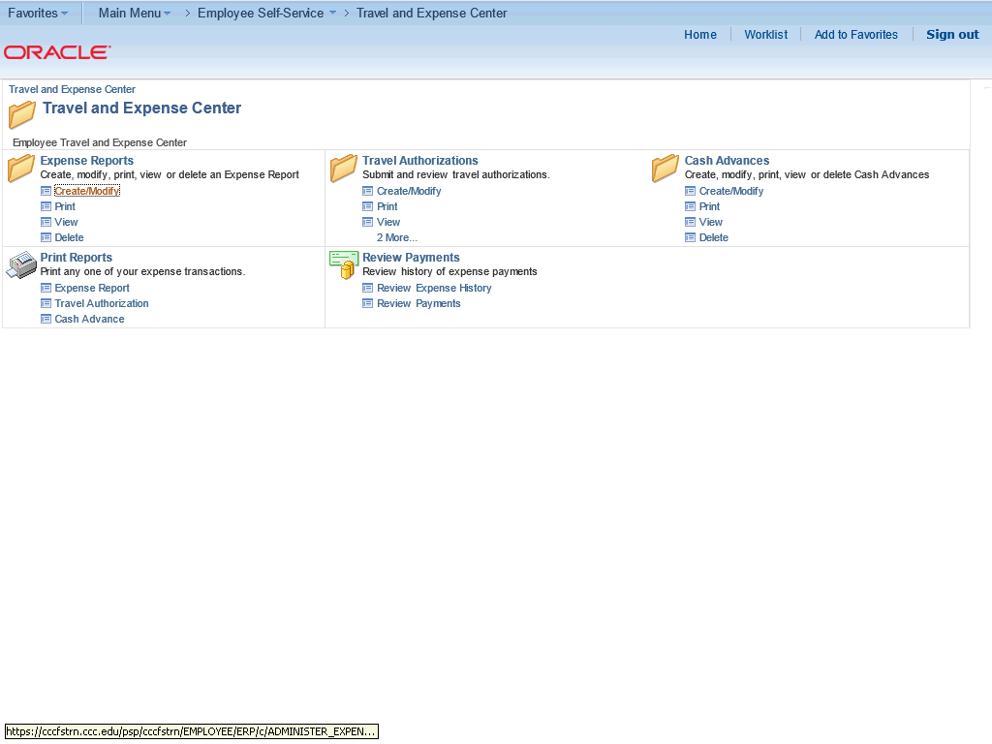

Step | Action
 | Click the Expense Report Create/Modify link on the Travel and Expense Center.

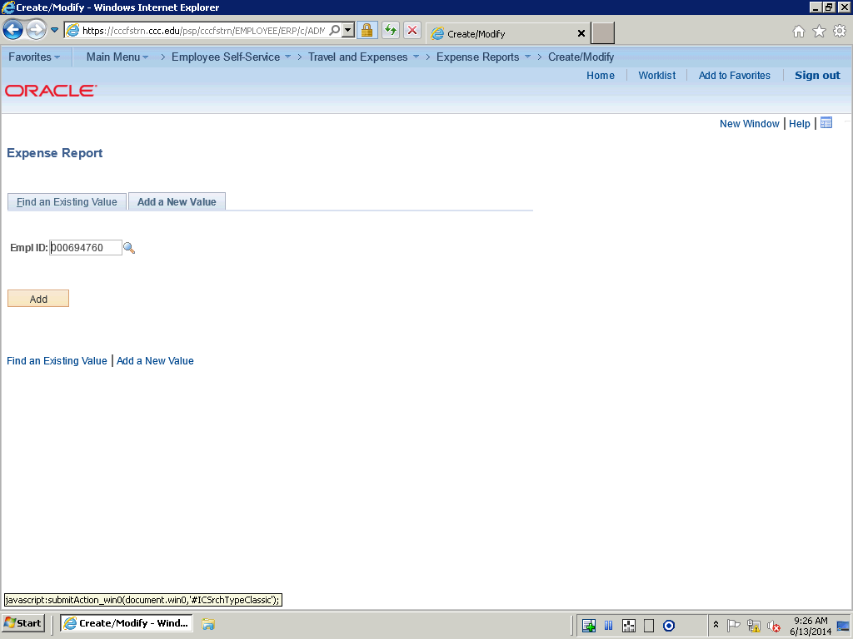

Step | Action
 | Click the Find an Existing Value tab.

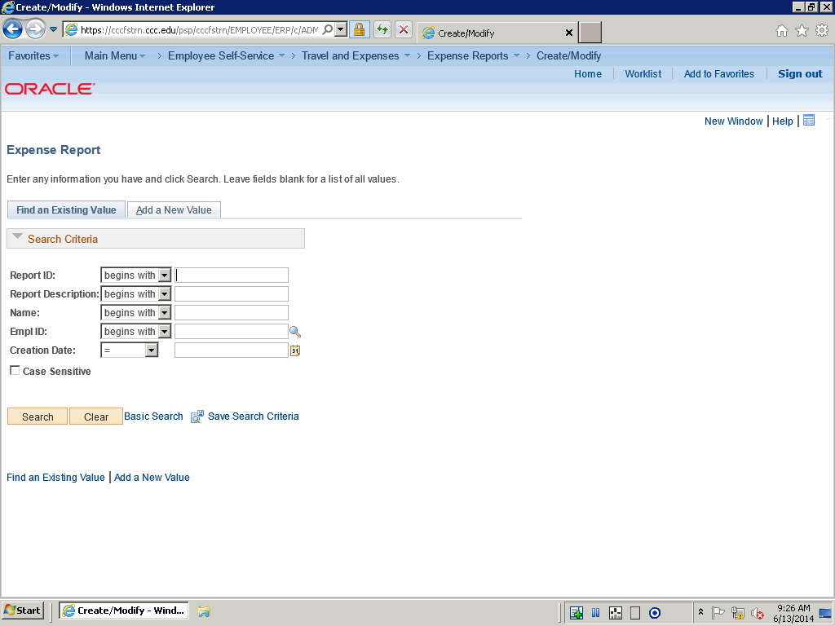

Step | Action
 | Click the Search button.

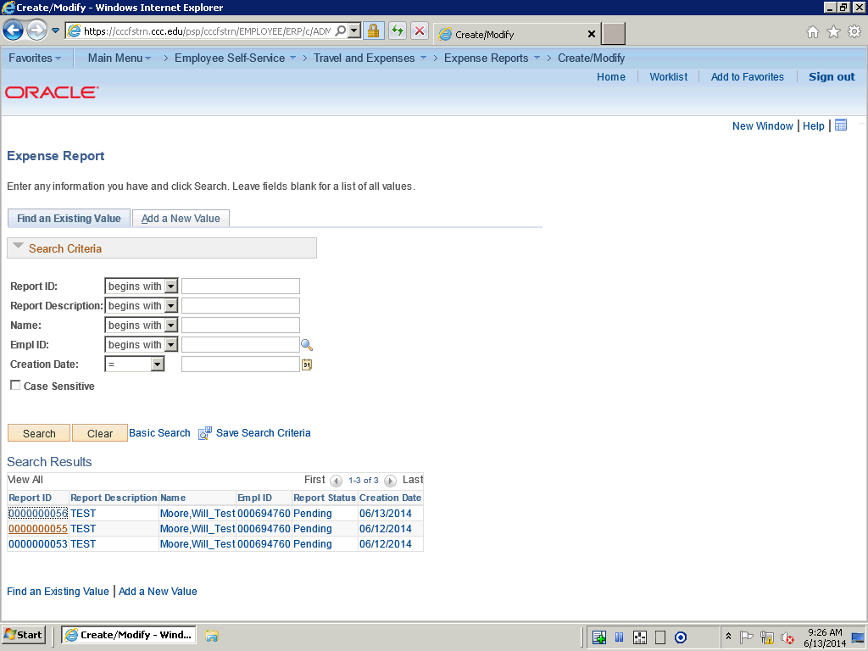

Step | Action
 | Click the 0000000055 link.

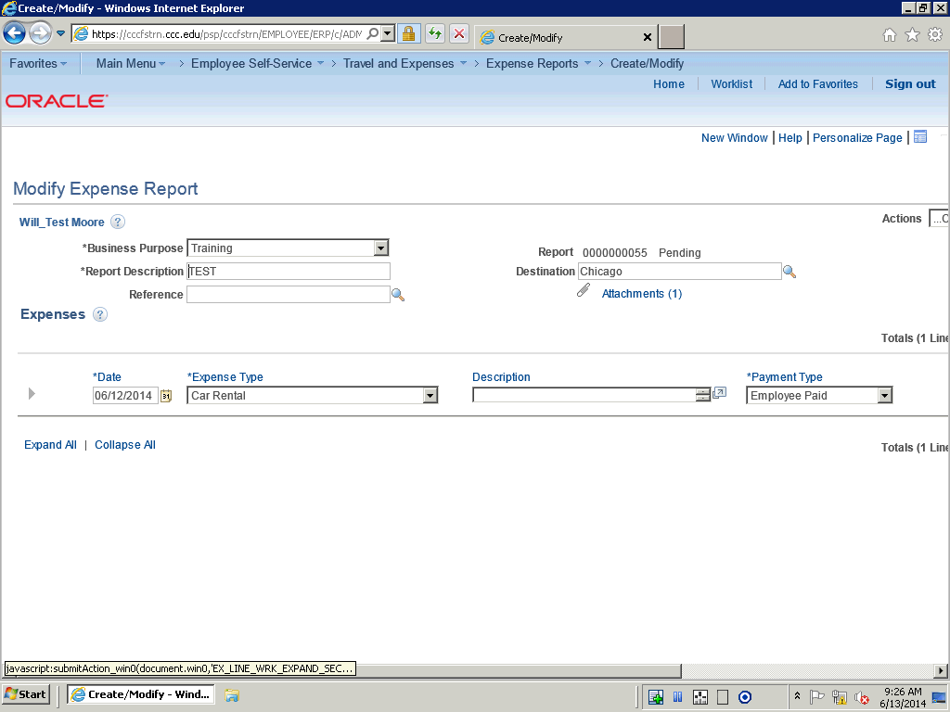

Step | Action
 | Use the Create Modify Report page to make changes to expense reports that have not been submitted or that have been returned for correction.

Step | Action
 | Click the Expand Section button.

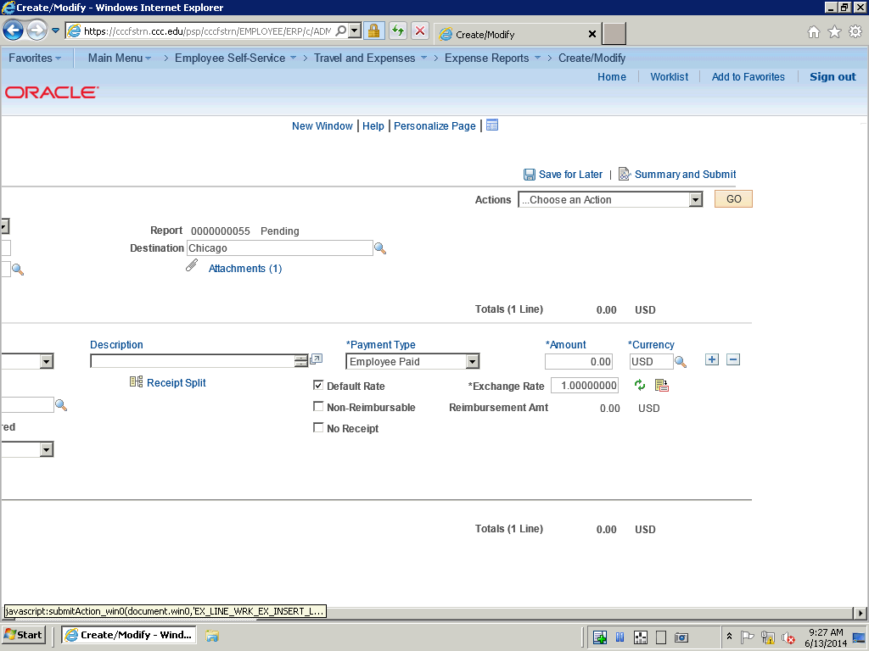

Step | Action
 | Click the Insert Line button.

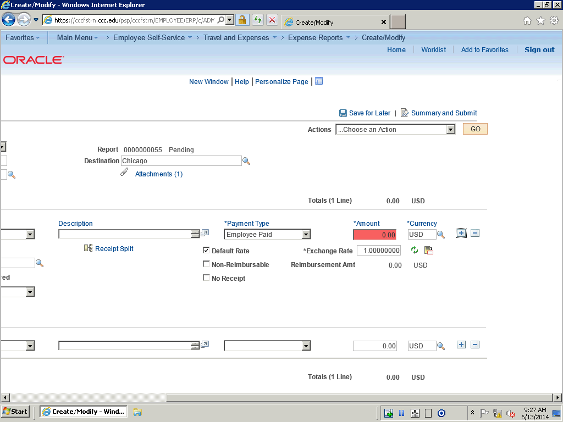

Step | Action
Note that the Amount field turns red.

Use the horizontal scroll bar to navigate to the left.

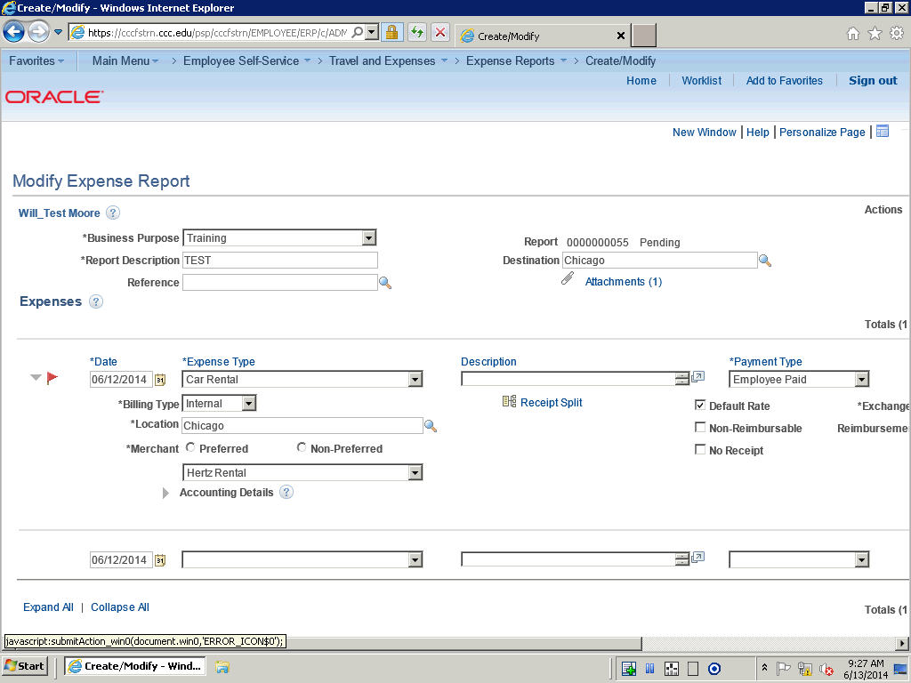

Step | Action
 | If errors exist, Expenses displays the Missing or invalid information button next to the expense type with the error. It also highlights the field that has the missing or invalid information in red.

Step | Action
 | Click the Missing or invalid information was found button.

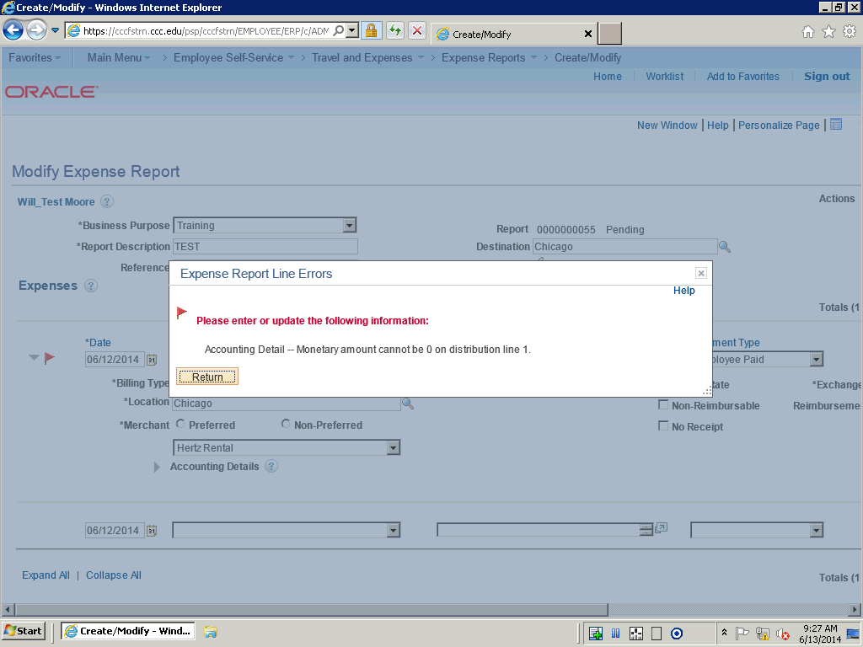

Step | Action
The error cause is explained.

Click the Return button.

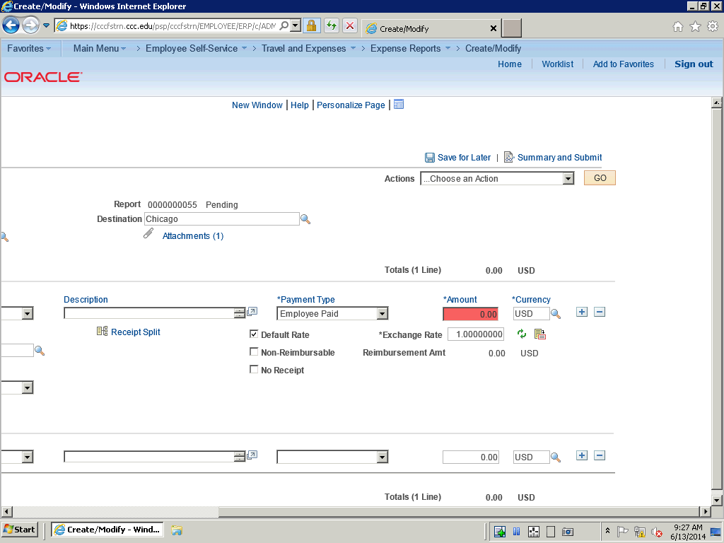

Step | Action
 | Click in the Amount field to correct the error.

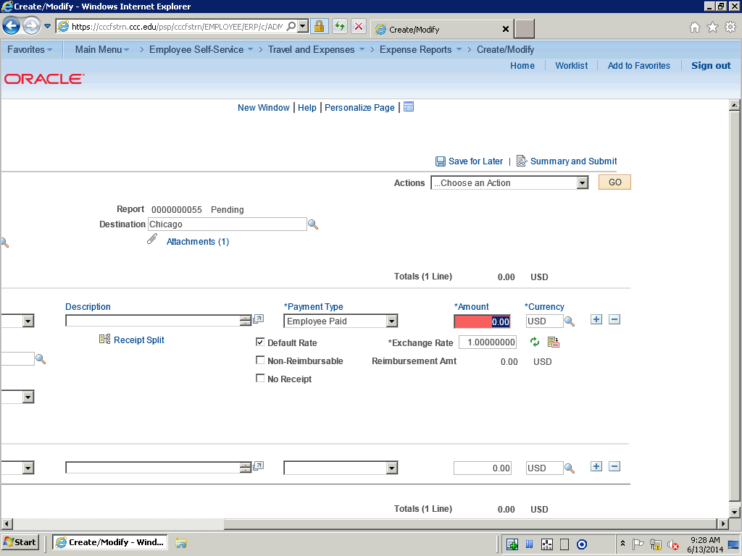

Step | Action
 | Enter the desired information into the Amount field. Enter "110.00".

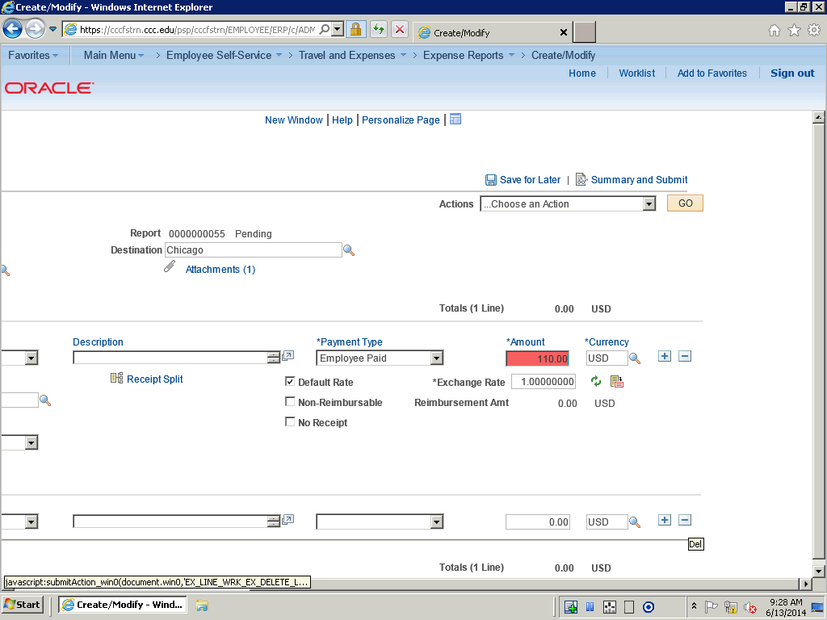

Step | Action
 | Click the Del button to remove the extra line.

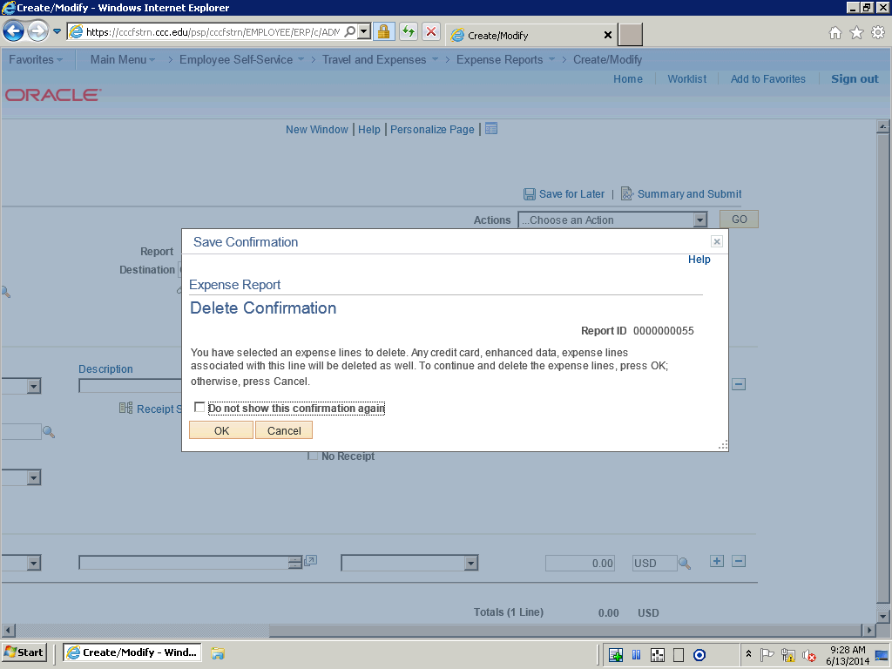

Step | Action
 | Click OK.

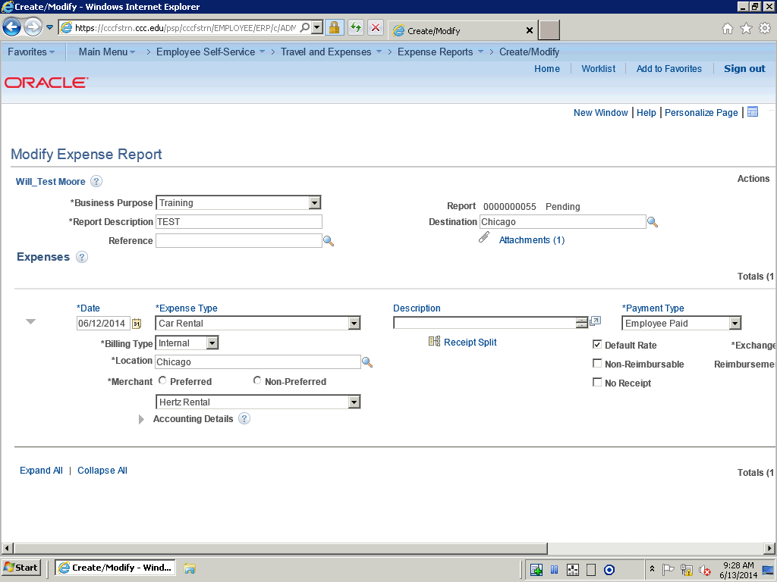

Step | Action
 | Click the Preferred option.

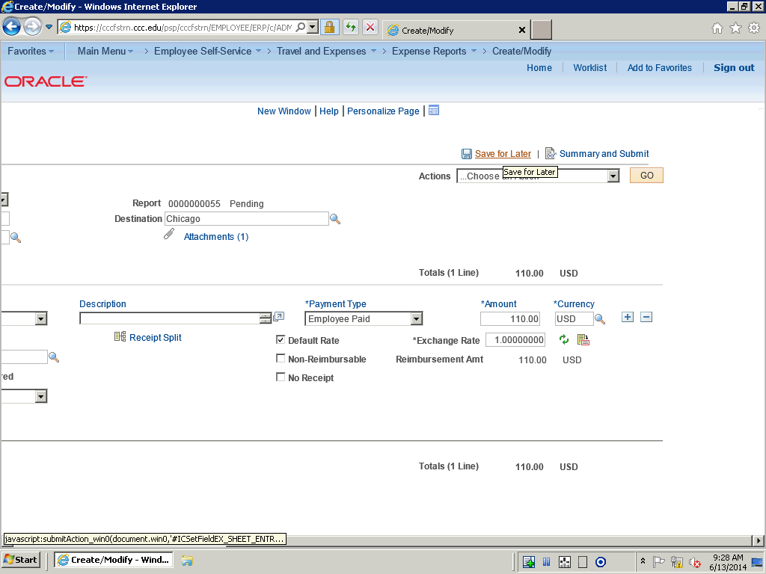

Step | Action
 | Click the Save for Later link.

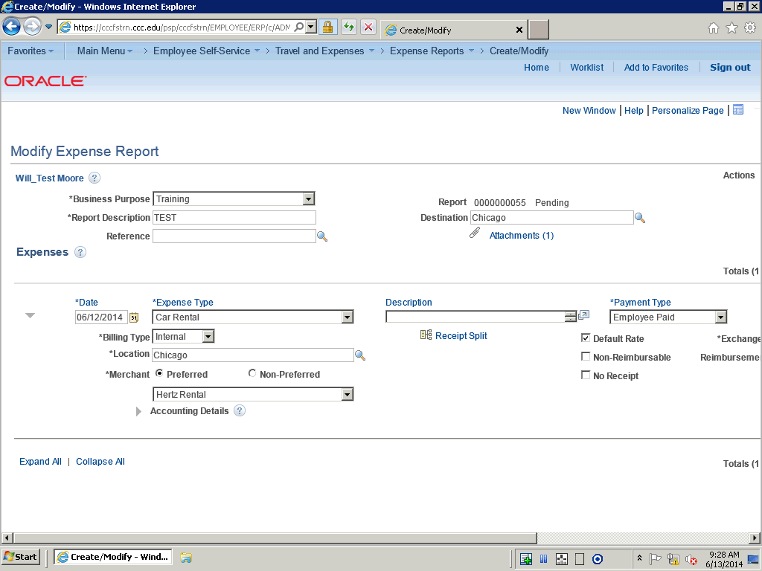

Step | Action
In this topic you have learned the following:

- How to correct expense line errors

You have successfully completed this training session.
End of Procedure.

Splitting Receipts
Splitting Receipts

Receipt splitting enables you to divide a receipt into multiple expense lines. Expenses supports two utilities for itemizing receipts: Receipt Split and Hotel Wizard. For example, a hotel bill may enter Expenses through a credit card feed as one expense transaction; however, the bill may include charges for telephone calls, laundry service, room service, and parking. You can track, report, and book these items individually if your organization requires it. You may have a receipt for several purchases, one of which is a personal expense. You can then split out the individual purchases in order to mark the personal expense as non-reimbursable.

You can:
- Split an expense on a receipt into small, detailed expenses.
- Add more expenses to a receipt.
- Edit an expense on the receipt.
- Change the receipt total amount.

If you split a receipt that came from a credit card feed, Expenses prevents you from changing some fields on the Receipt Detail For Expense page, such as exchange rate and currency code. In addition, if the receipt came from a credit card feed, the sum of all the split lines must equal the original receipt total amount.

In this topic, you will split a receipt into two expense lines.
Procedure

In this topic you will learn the following:

- How to Split Receipts.
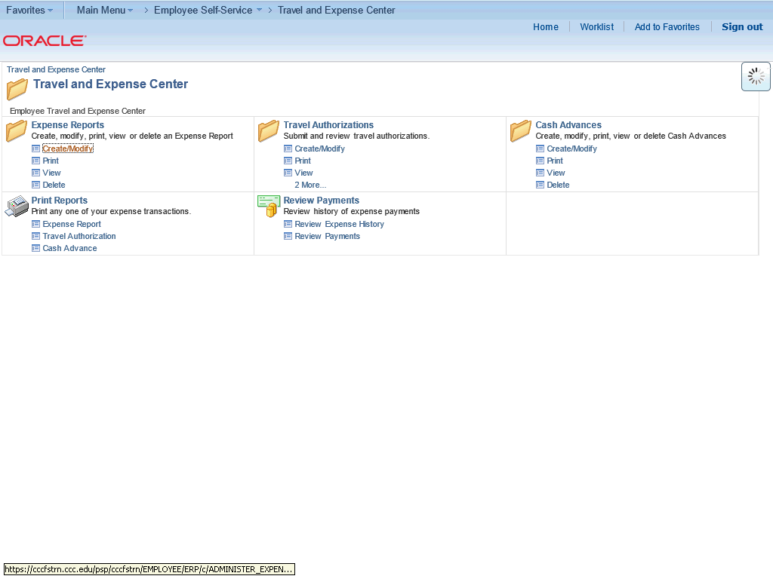

Step | Action
 | Click the Expense Reports Create/Modify link from the Travel and Expense Center.

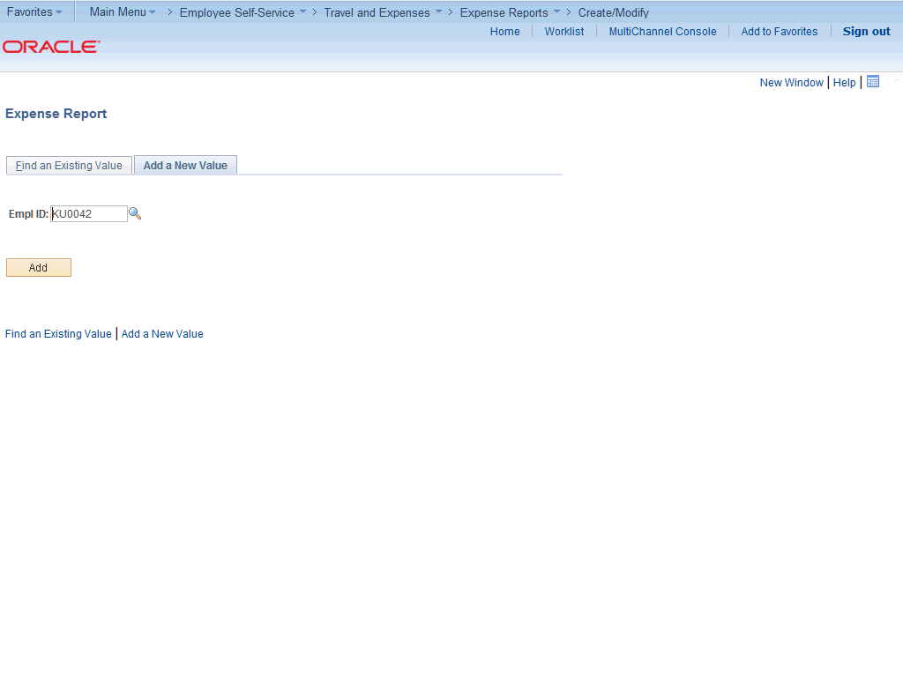

Step | Action
 | Click the Add button.

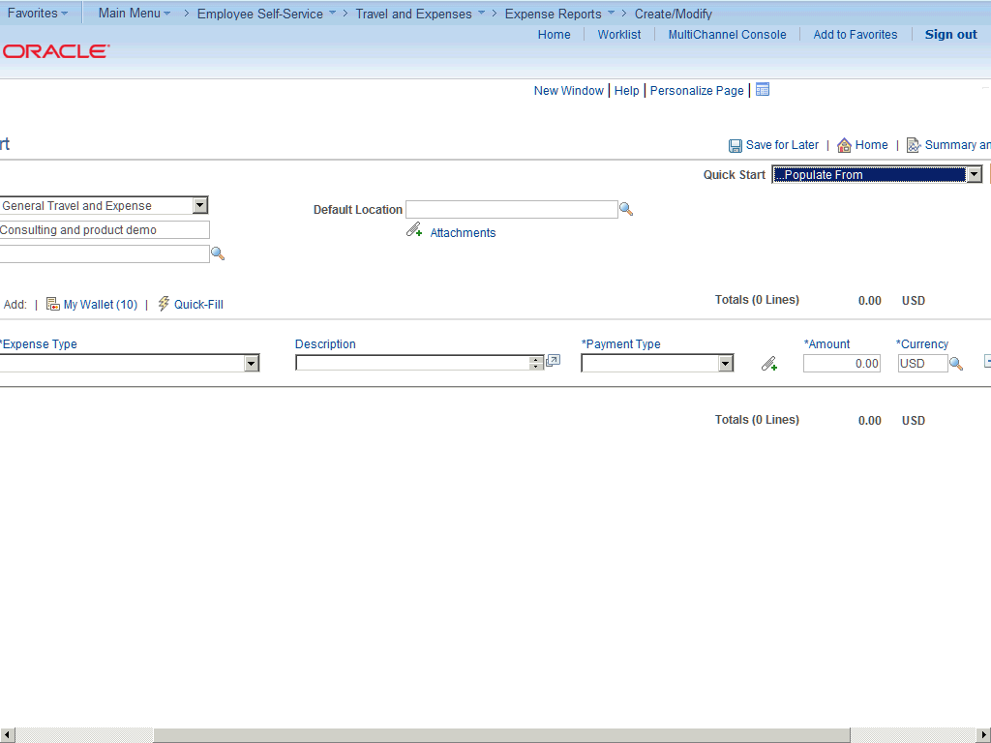

Step | Action
 | Click the horizontal scrollbar.

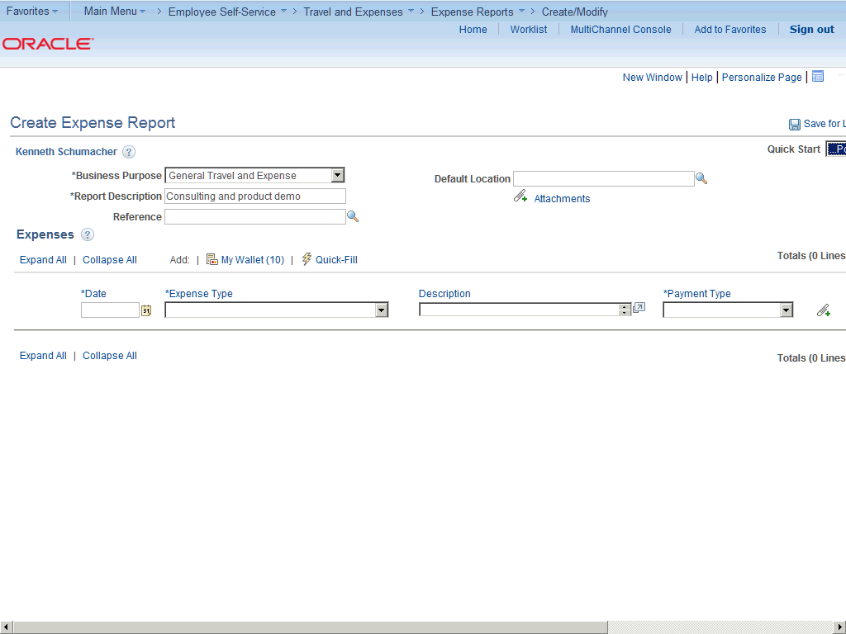

Step | Action
 | Use the Create Expense Report page to add expense lines and provide information that is specific for each expense type.

Step | Action
 | Click in the Default Location field.

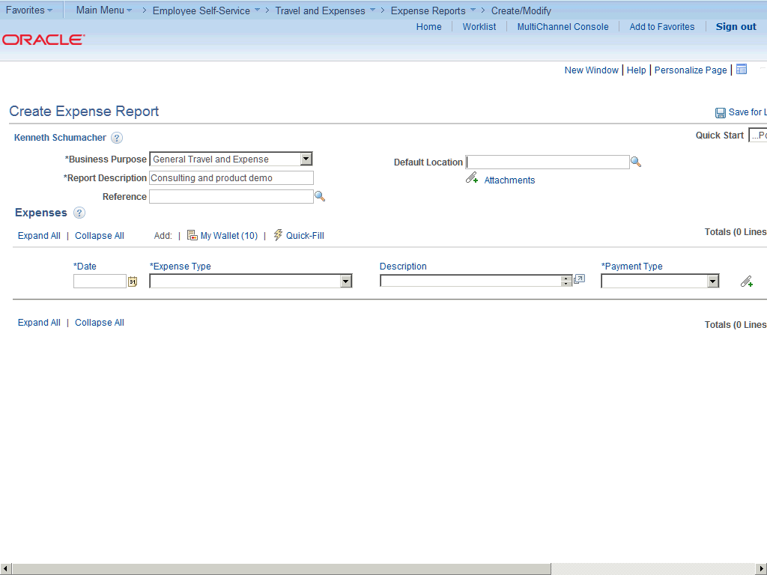

Step | Action
 | Enter the desired information into the Default Location field. Enter "New York, New York".

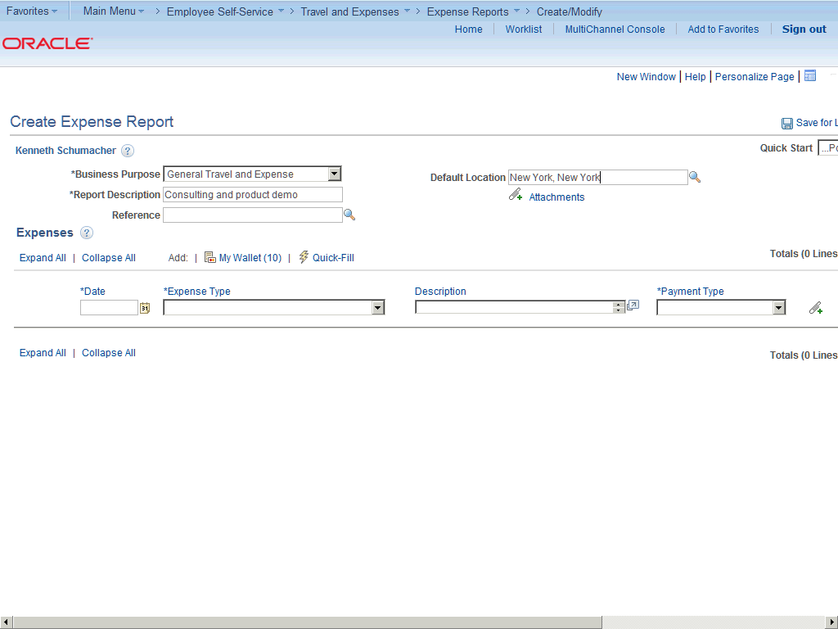

Step | Action
 | Click in the Date field.

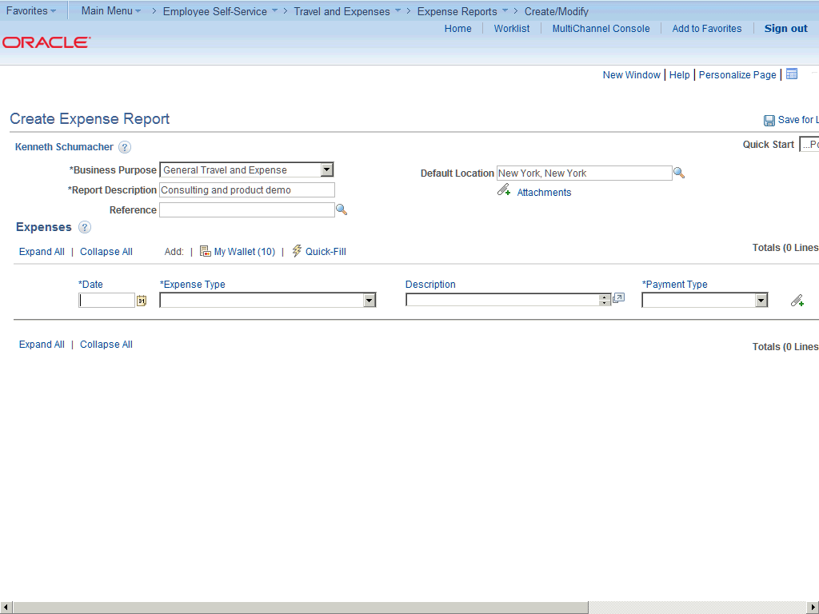

Step | Action
 | Enter the desired information into the Date field. Enter "08/13/2013".

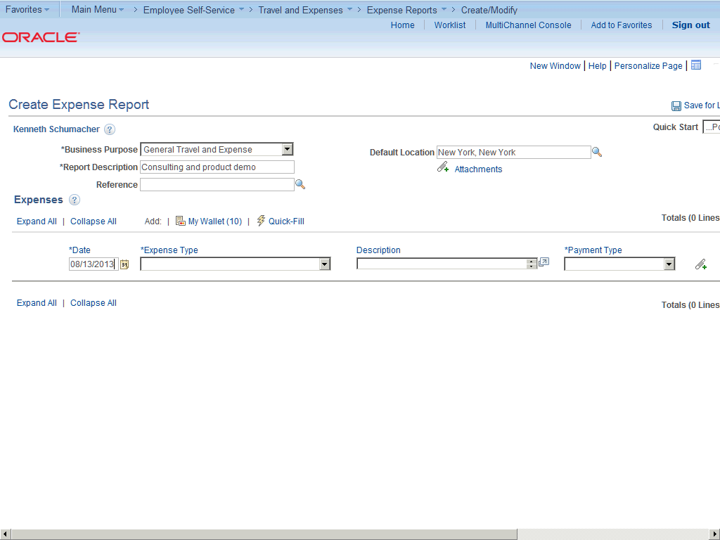

Step | Action
 | Click the Expense Type list.

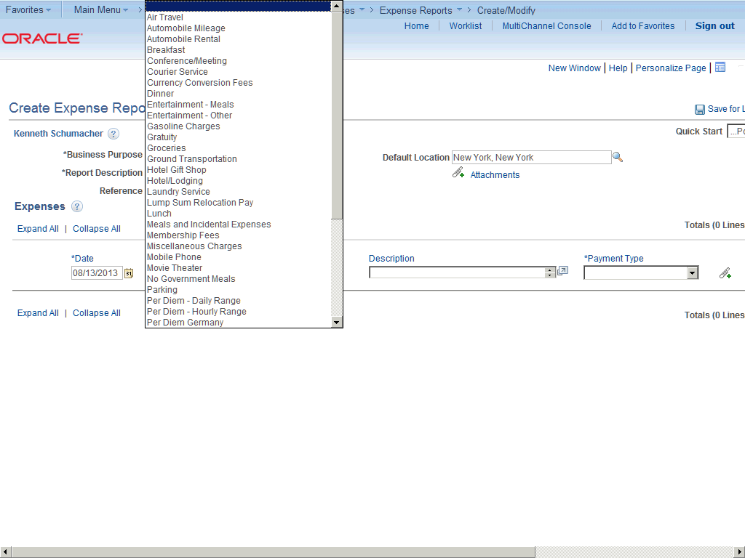

Step | Action
 | Click the Dinner list item.

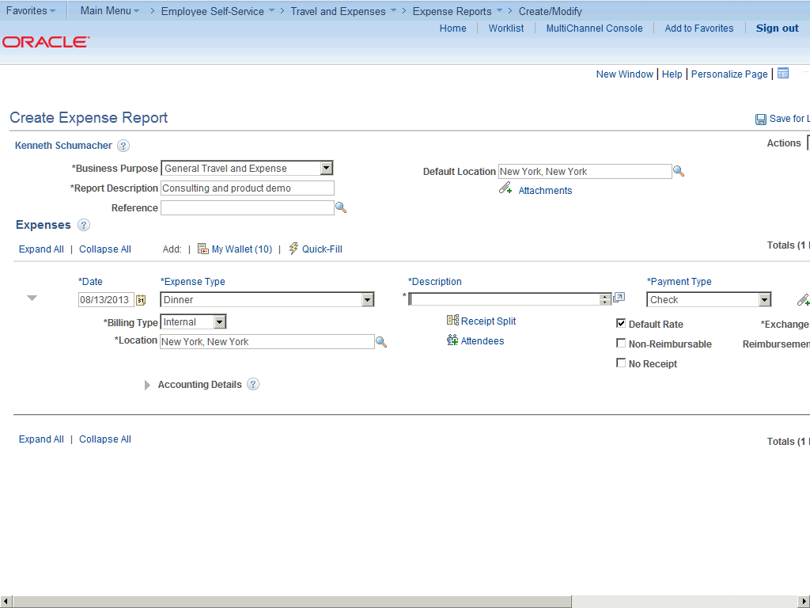

Step | Action
 | Click in the Description field.

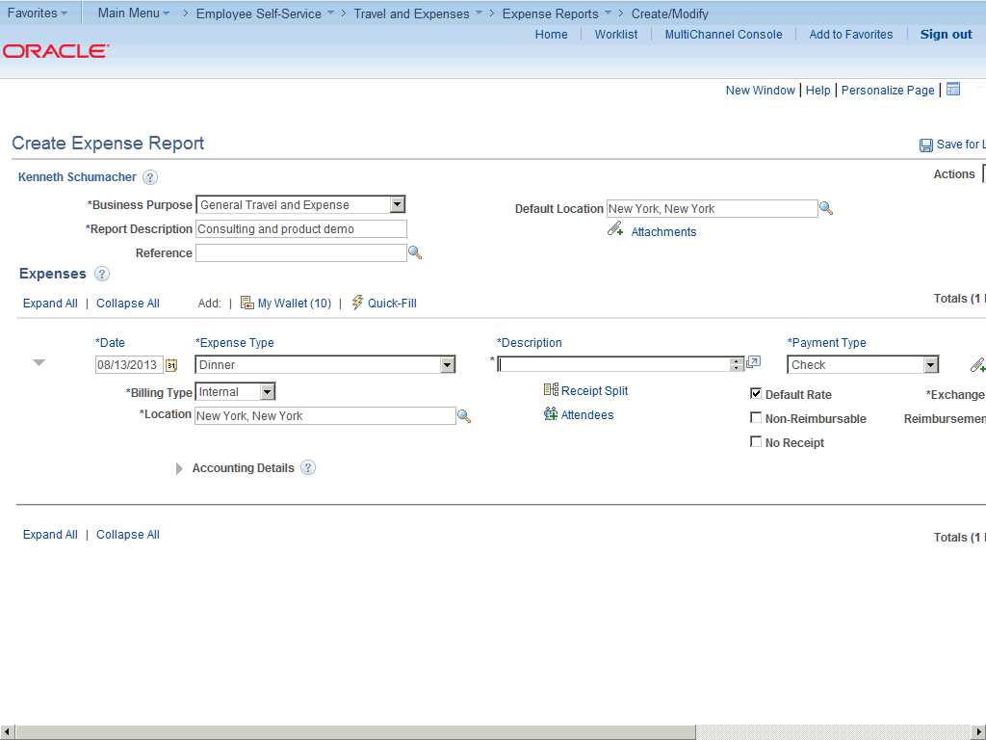

Step | Action
 | Enter the desired information into the Description field. Enter "Dinner at Bills Grill".

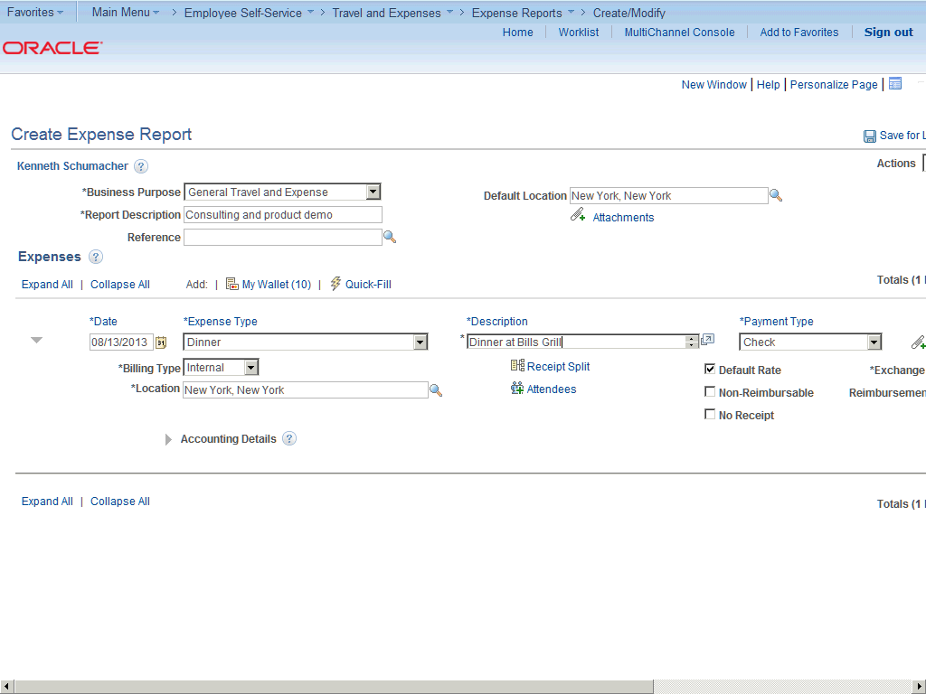

Step | Action
 | Click the Payment Type list.

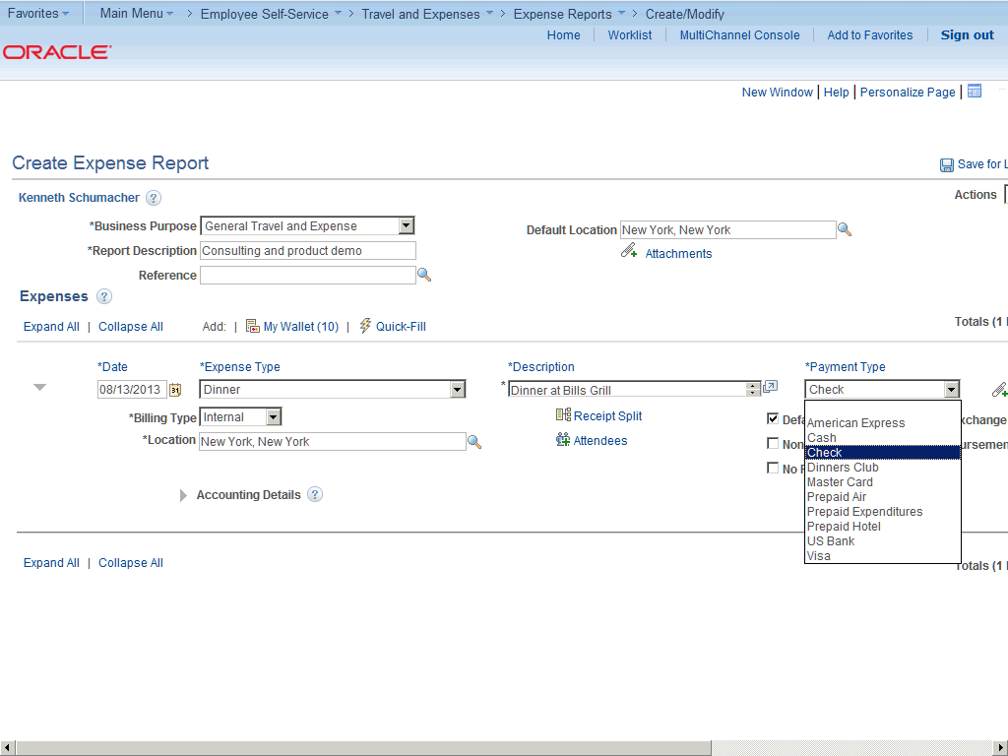

Step | Action
 | Click the American Express list item.

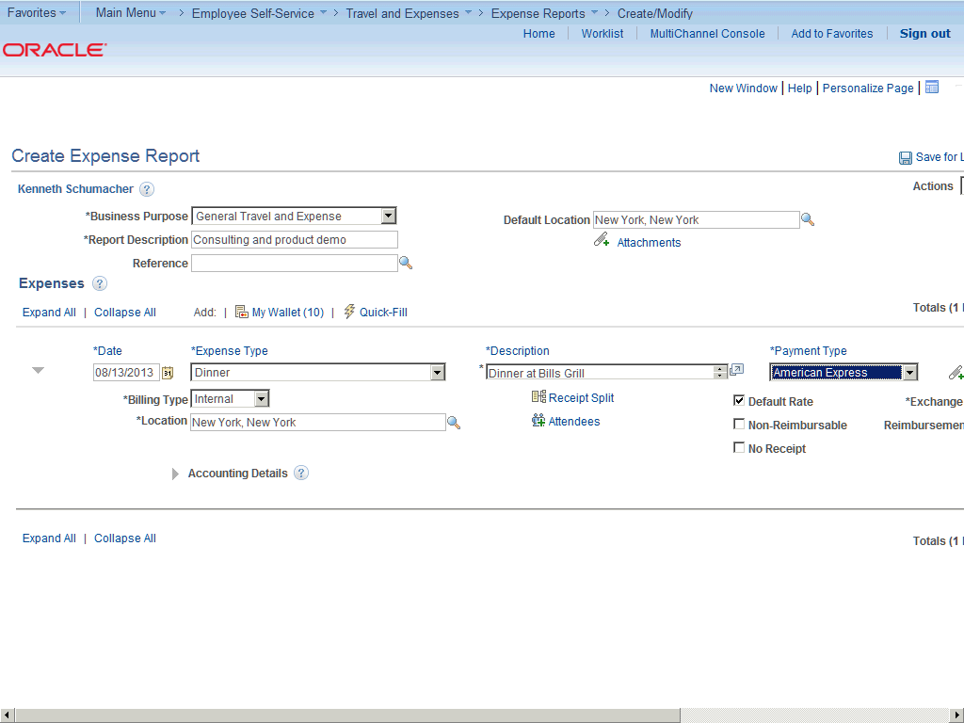

Step | Action
 | Click the horizontal scrollbar.

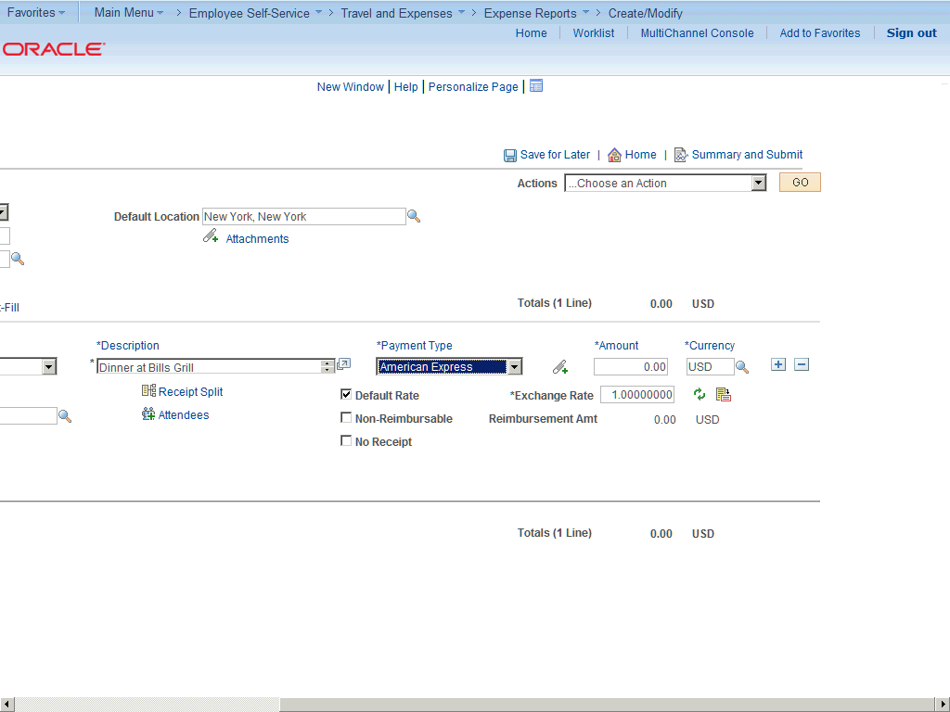

Step | Action
 | Click in the Amount field.

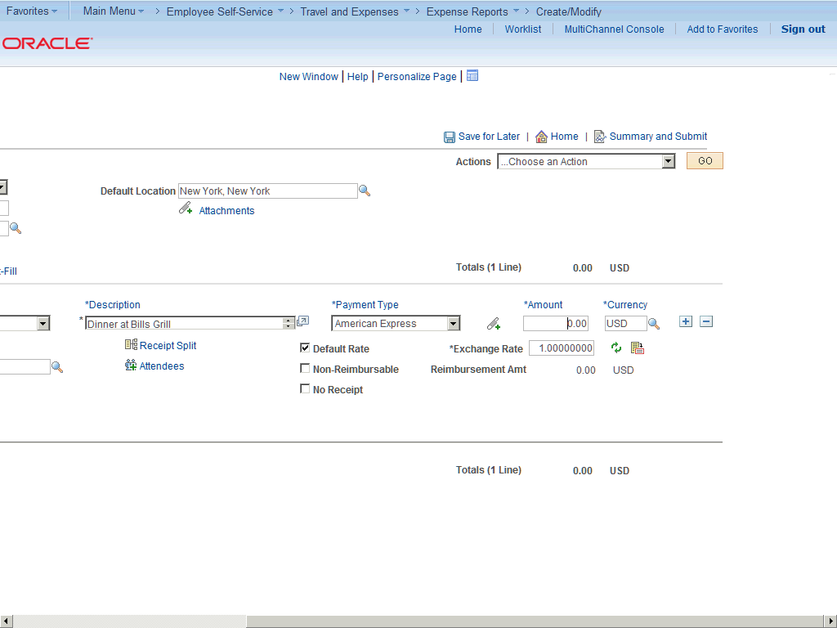

Step | Action
 | Enter the desired information into the Amount field. Enter "85.93".

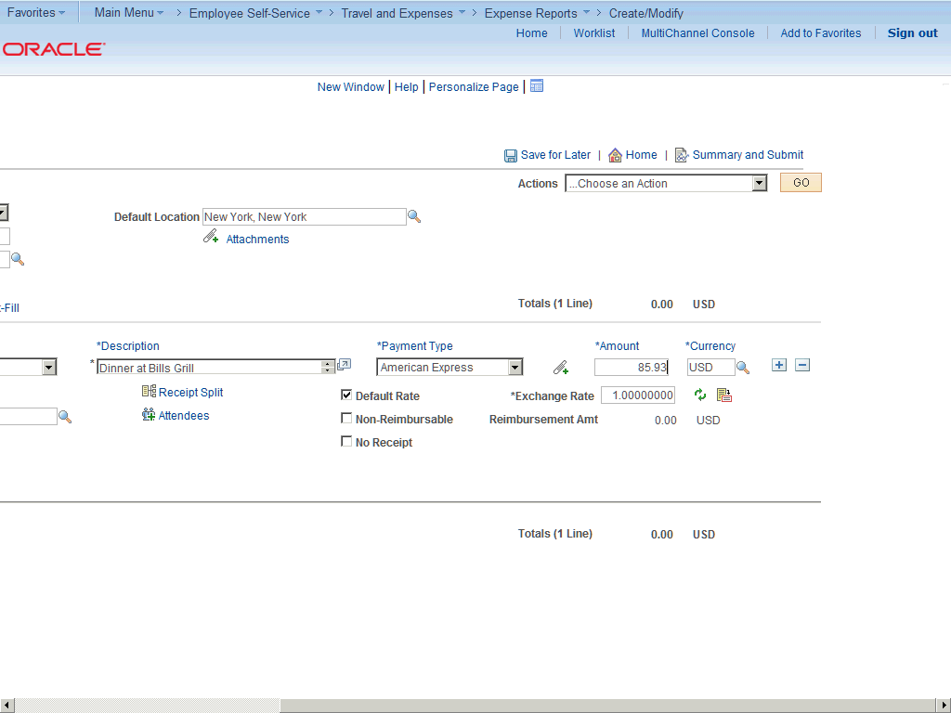

Step | Action
 | Click the horizontal scrollbar.

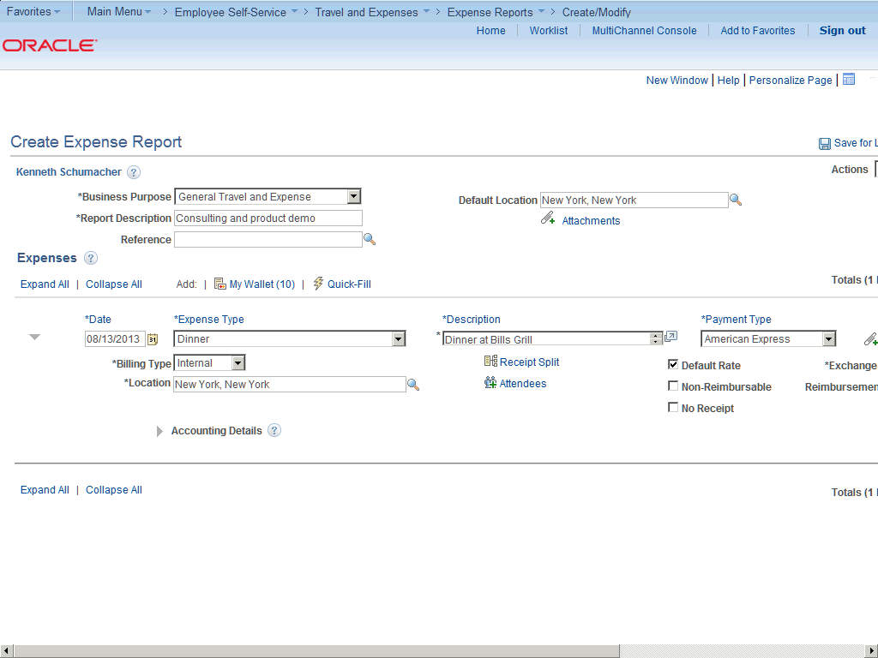

Step | Action
 | Click the Billing Type list.

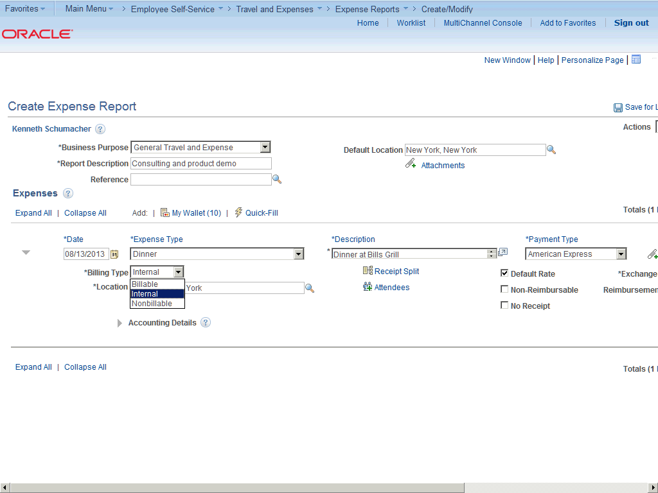

Step | Action
 | Click the Billable list item.

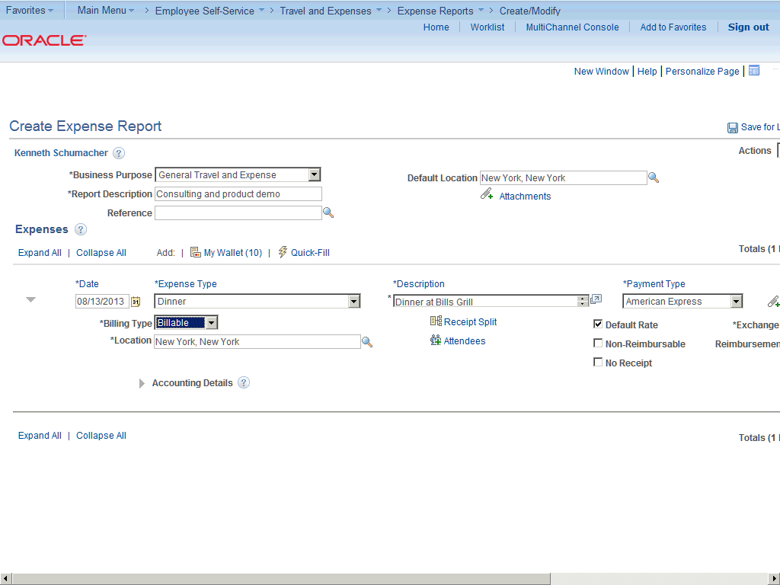

Step | Action
 | Click the Add Additional Attendees button to access the Attendees page and enter names (lastname,firstname), companies, and titles for an expense type that requires a list of attendees on your expense report.

Step | Action
 | Click the Receipt Split link.

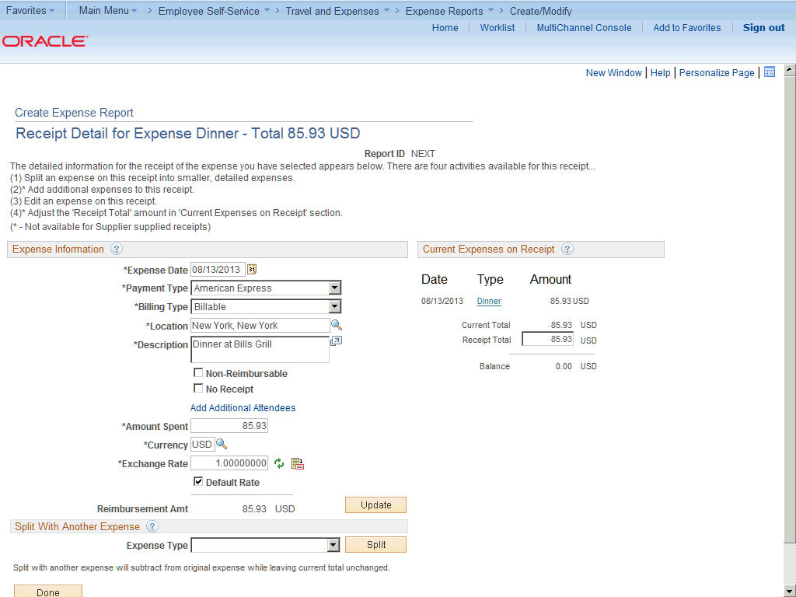

Step | Action
Use the Receipt Detail for <expense type> page to itemize receipts into multiple expense lines.

Notice the instructions at the top of the page that describe the actions you can do with this feature.

Step | Action
The Current Expenses on Receipt section displays each item that is associated with the receipt with the transaction date, expense type, and amount.

Click the Type link to edit the information for that receipt item.

This section is automatically updated when you perform an add or split action.

Step | Action
 | Current Total displays the total of all receipt items, including those that you add to the original receipt total.

Step | Action
 | Receipt Total displays the total of the original receipt amount. The expense system does not change this field when you add new items, but you can enter a new total if the transaction did not originate from a credit card feed.

Step | Action
 | Balance displays the Current Total minus Receipt Total.

Step | Action
To split an item with another expense, select an expense type and click the Split button.

Click the Expense Type list.

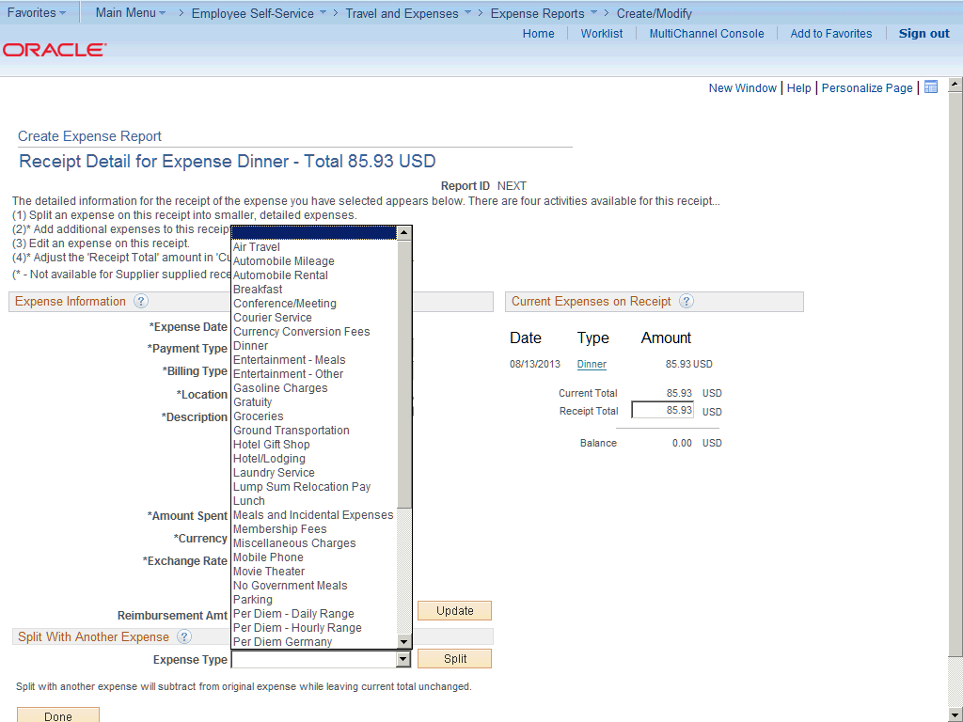

Step | Action
 | Click the Dinner list item.

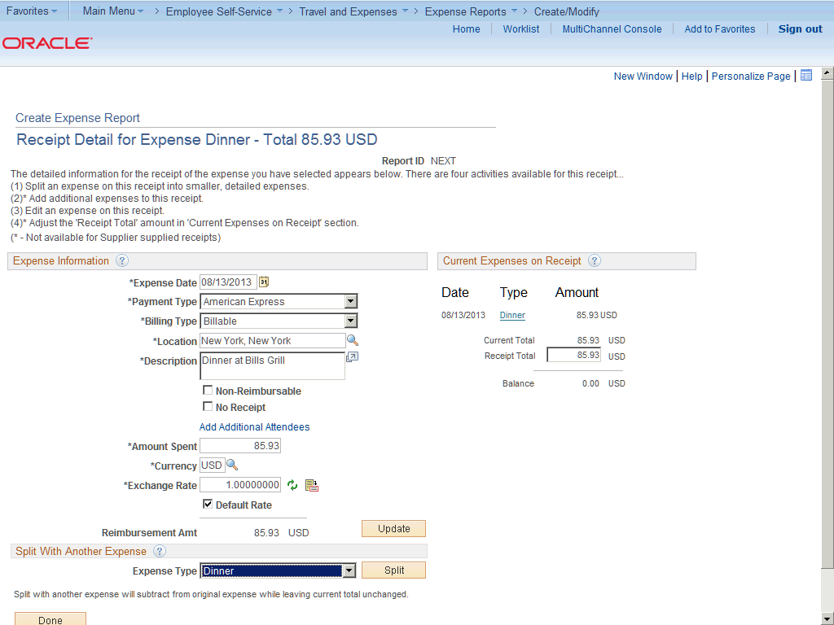

Step | Action
 | Click the Split button.

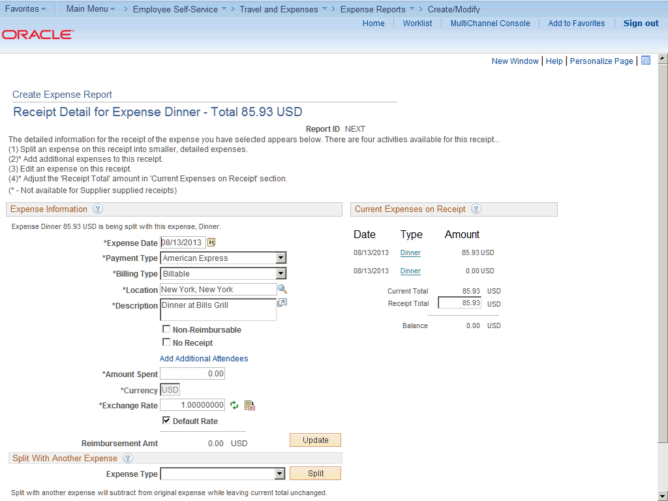

Step | Action
 | Expenses refreshes the page, clears the expense information fields, and adds the selected expense type to the Current Expenses on Receipt section.

Step | Action
Edit the new receipt item to enter an amount and modify any information that is different.

Click the Billing Type list.

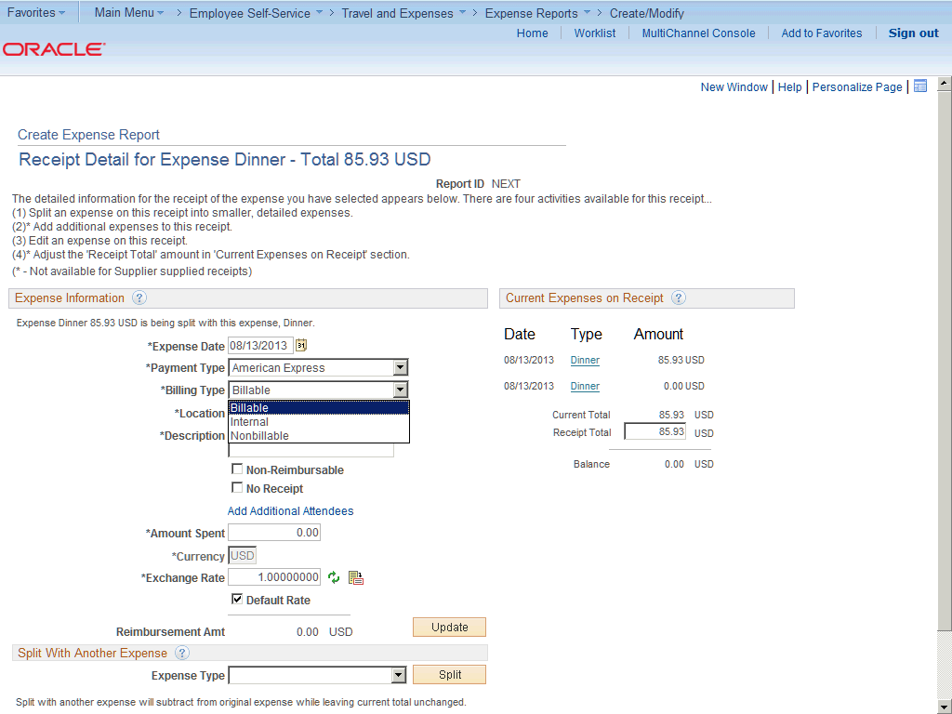

Step | Action
 | Click the Nonbillable list item.

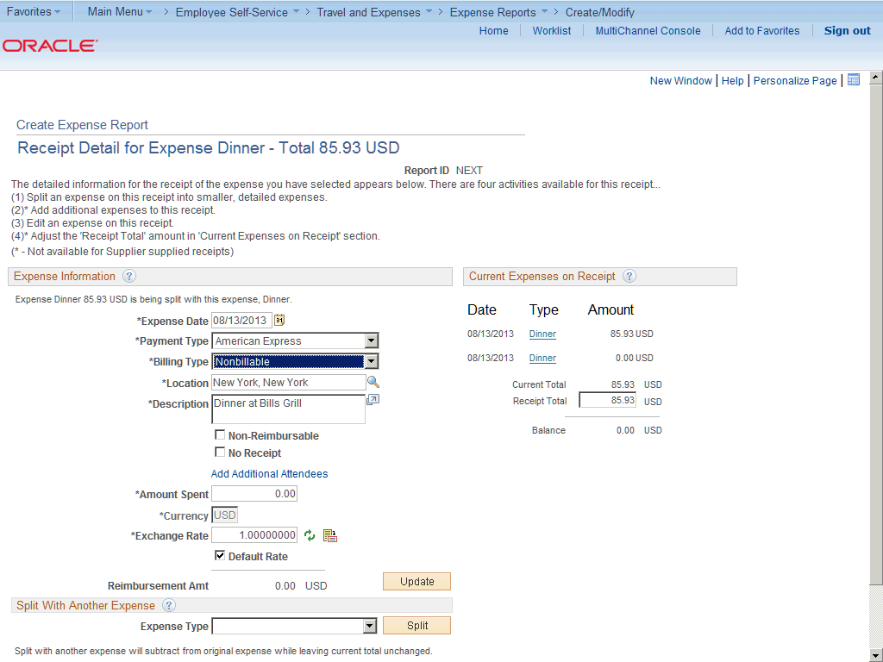

Step | Action
Click in the Description field.
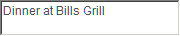

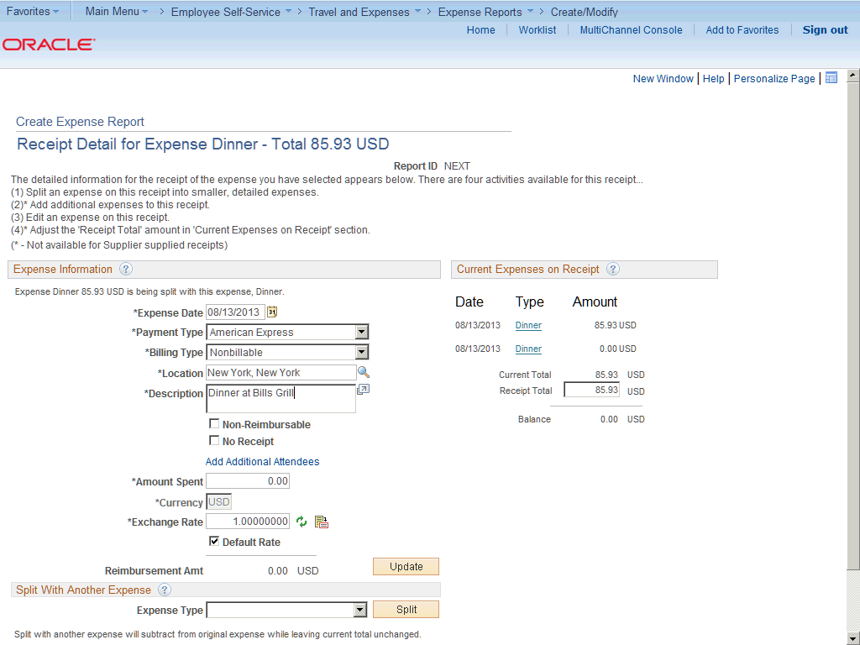

Step | Action
 | Enter the desired information into the Description field. Enter "Friend's dinner".

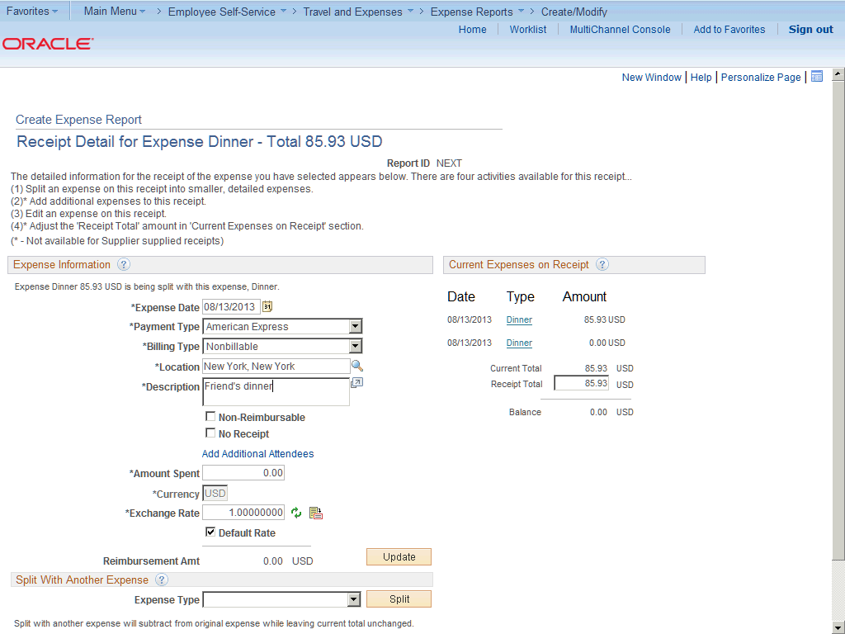

Step | Action
 | Click the Non-Reimbursable option.

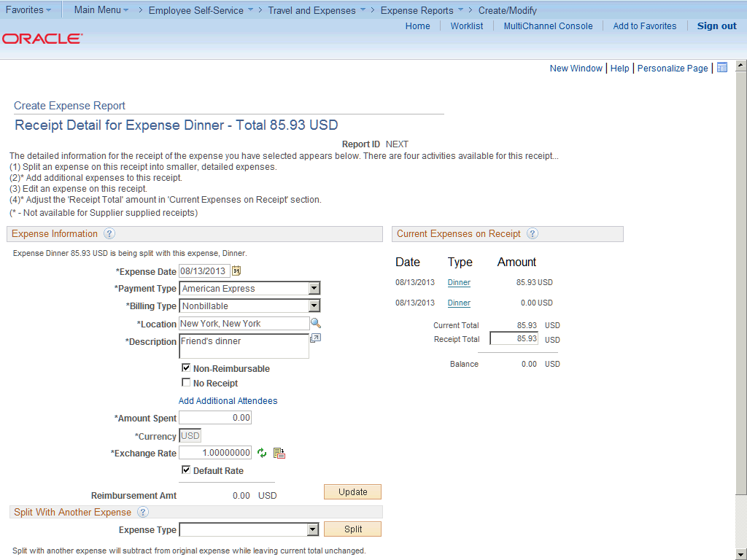

Step | Action
 | Click in the Amount Spent field.

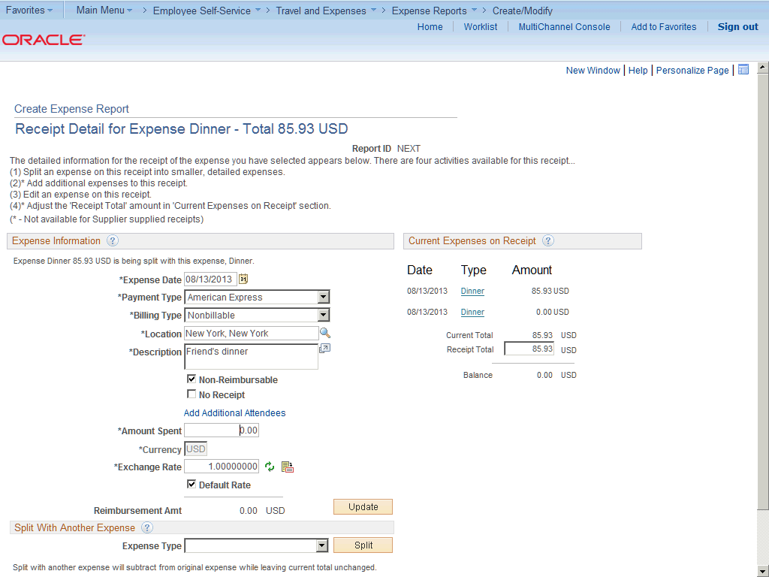

Step | Action
 | Enter the desired information into the Amount Spent field. Enter "42.23".

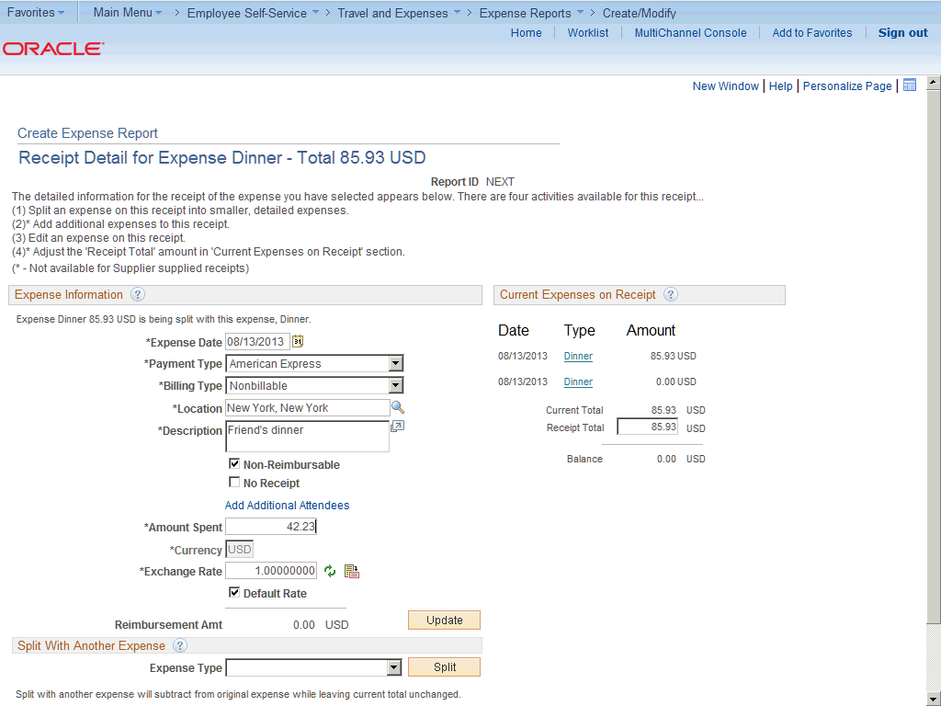

Step | Action
 | Click the Update button.

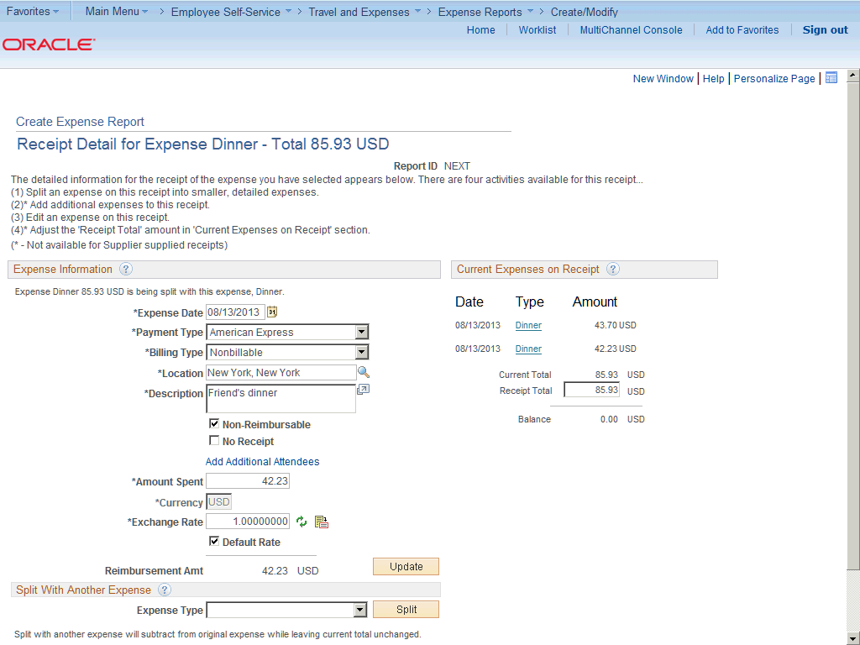

Step | Action
 | Expenses subtracts the amount from the expense item in the Expense Information section, but the receipt total remains the same.

Step | Action
Note: you can split a receipt into more than two expense types.

Expenses displays a message directly under the Expense Information section title that advises you which expense item that you are splitting.

Step | Action
 | An Add Additional Attendees link is available on this page.

Step | Action
When adding or splitting expenses, it may result in an out of balance receipt total. To correct the out of balance situation, you can adjust the receipt total or adjust one of the expense line entries for the receipt.

If you do not adjust the out of balance total and click Done, Expenses displays a message stating that the total of the items entered exceed the receipt amount and asks if you want to update the receipt total amount.

Step | Action
 | Click the vertical scrollbar.

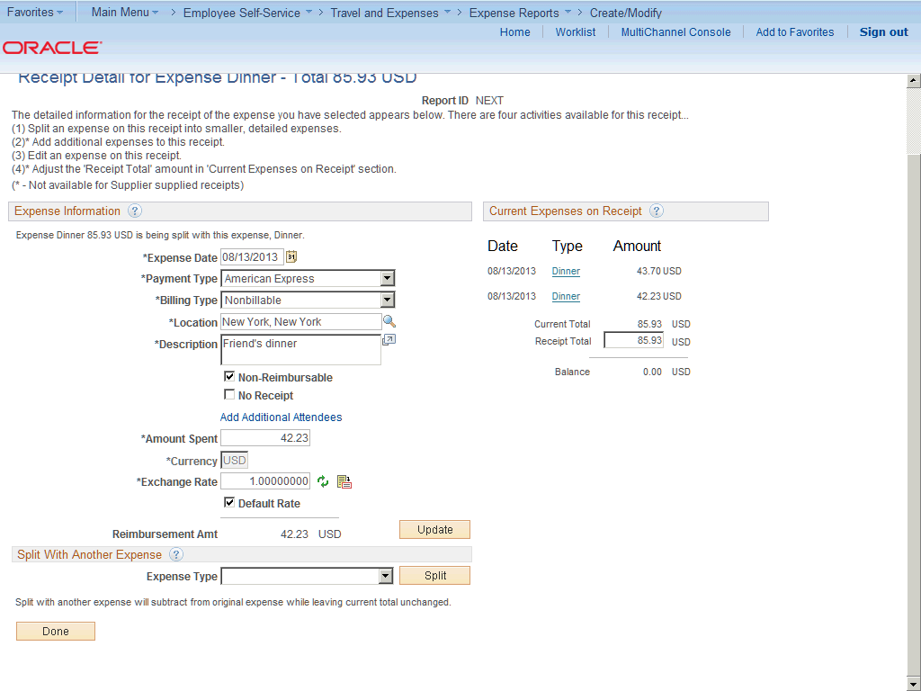

Step | Action
 | Click the Done button.

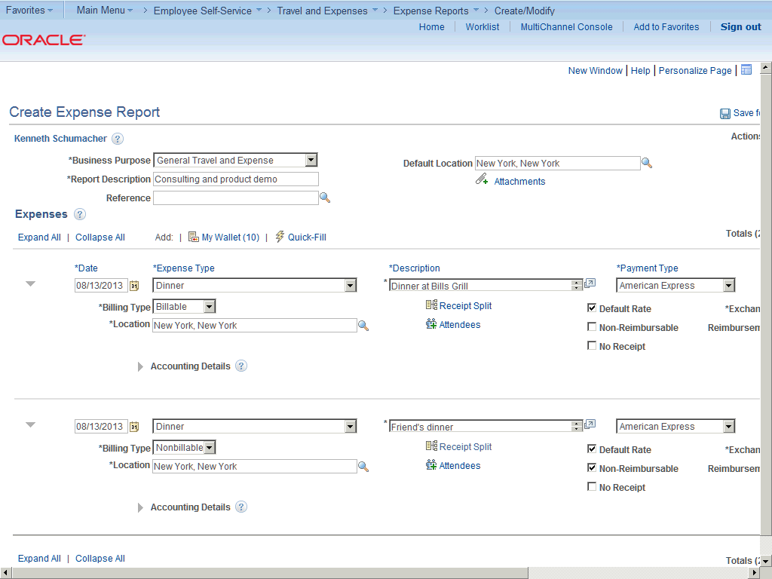

Step | Action
 | The split item appears as separate line items.

Step | Action
 | Click the horizontal scrollbar.

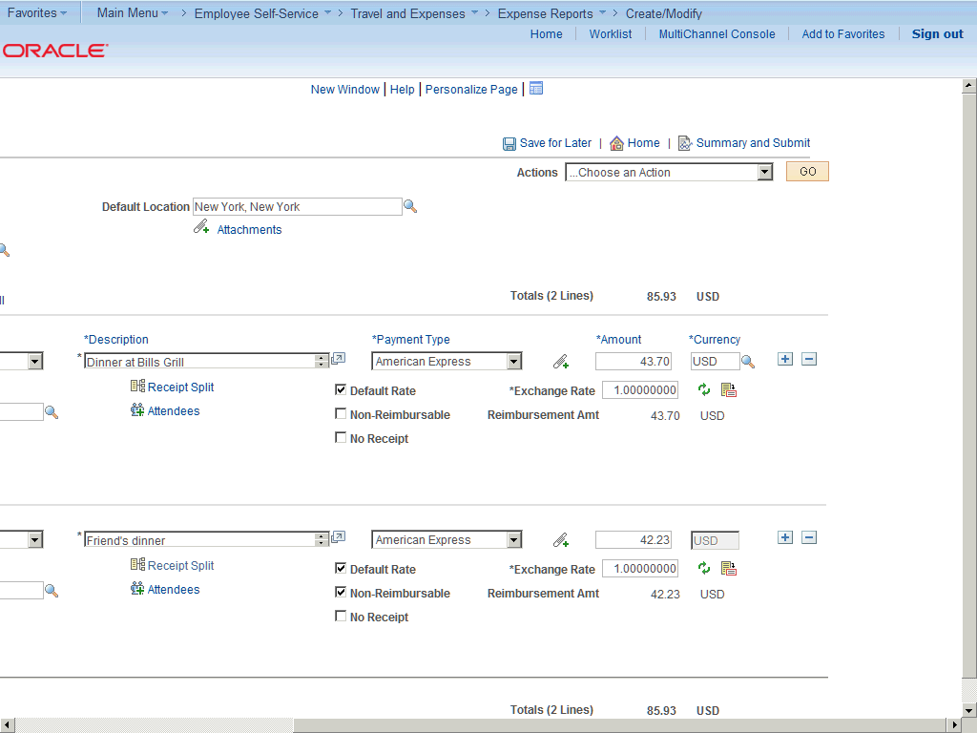

Step | Action
 | The amount displayed in the Totals field reflects the Total amount of the expense report.

Step | Action
 | Click the Save for Later link.

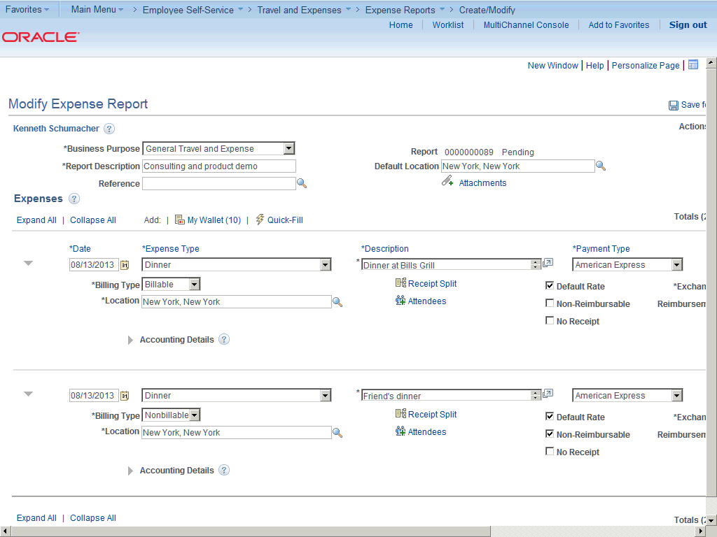

Step | Action
In this topic you have learned the following:

- How to Split Receipts.

You have successfully completed this training session.
End of Procedure.

Itemizing Hotel Bills Using The Hotel Wizard
Itemizing Hotel Bills Using Hotel Wizard

Expenses provides Hotel Wizard for you to split a Hotel/Lodging expense type into multiple expense lines. For example, a hotel bill may enter your expenses system through a credit card feed as one expense transaction. Use Hotel Wizard to create expense lines for room charges for each day of a business trip and to separate charges for telephone calls, laundry service, room service, parking, and so on. You can itemize these items individually and daily. If you must make any adjustments after you complete Hotel Wizard, you may use the receipt split functionality to reconcile the bill later.

In this topic, you will use the Hotel Wizard to enter an itemized hotel bill.
Procedure

In this topic you will learn the following:

- How to itemize hotel bills using the Hotel Wizard.
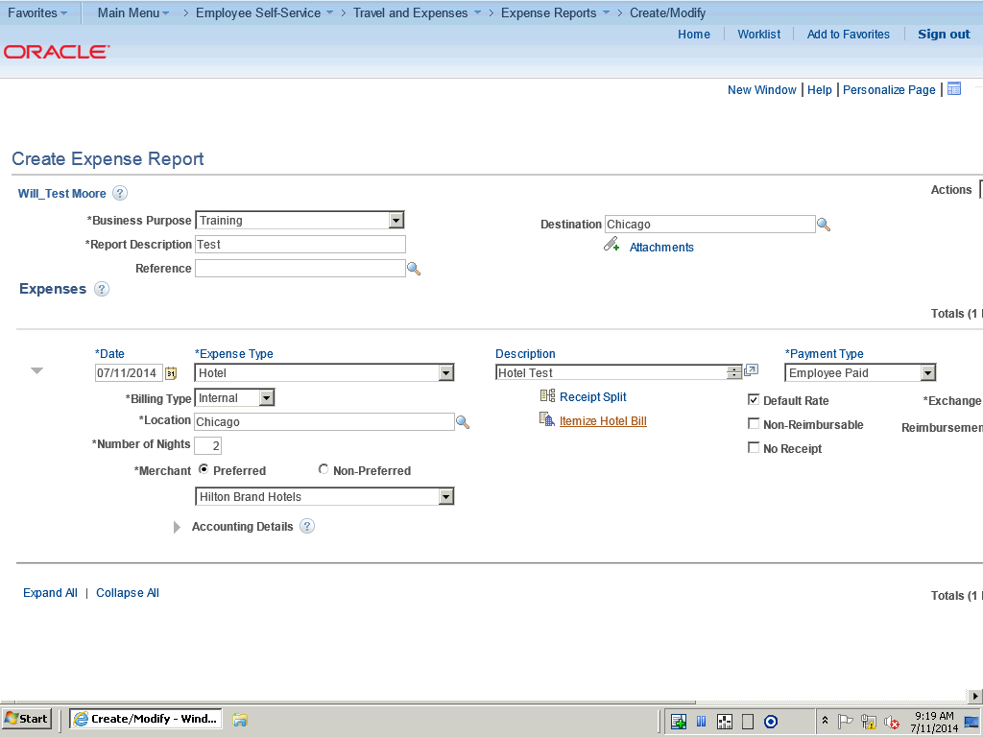

Step | Action
 | Begin by clicking on the Itemize Hotel Bill link on the Expense Report.

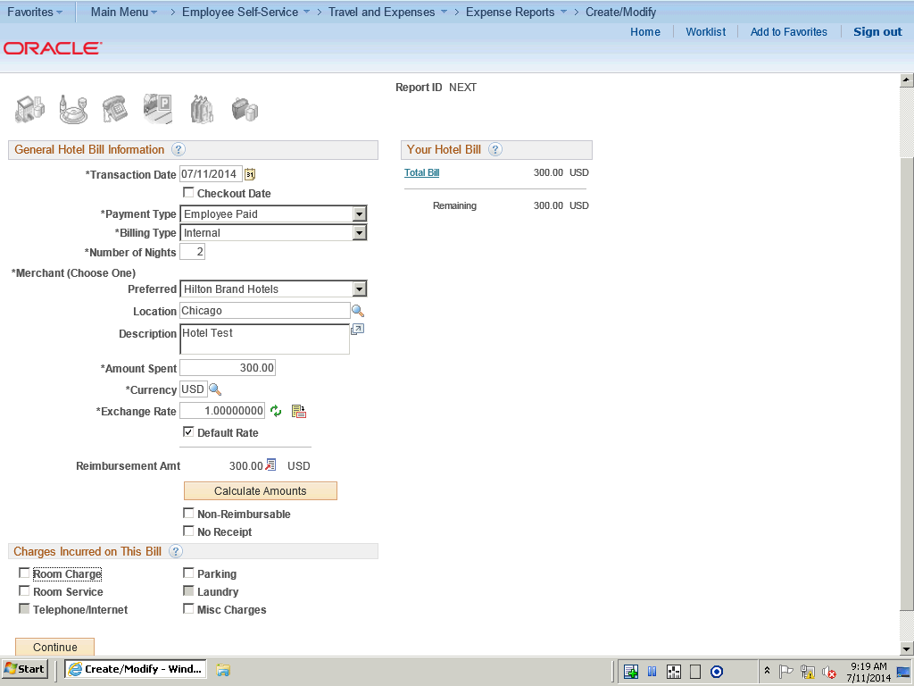

Step | Action
 | Use the Itemize Hotel Bill page to break down individual expenses in a hotel bill.

Step | Action
The data in the General Hotel Bill Information section comes from the information that you entered on the Create Expense Report page.

You can modify the fields just as you did when you originally added the expense item.

Step | Action
Select the Checkout Date option to indicate that the value in the Transaction Date field is the last day of the hotel stay. If selected, Expenses starts from the transaction date and creates expense lines moving backwards in time.

Clear the option to indicate that the value in the Transaction Date field is the first day of the hotel stay. If not selected, Expenses starts from the transaction date and creates expense lines moving forward in time.

Step | Action
 | In this example, we we select hotel charges to itemize.

Step | Action
 | Click the Room Service option.

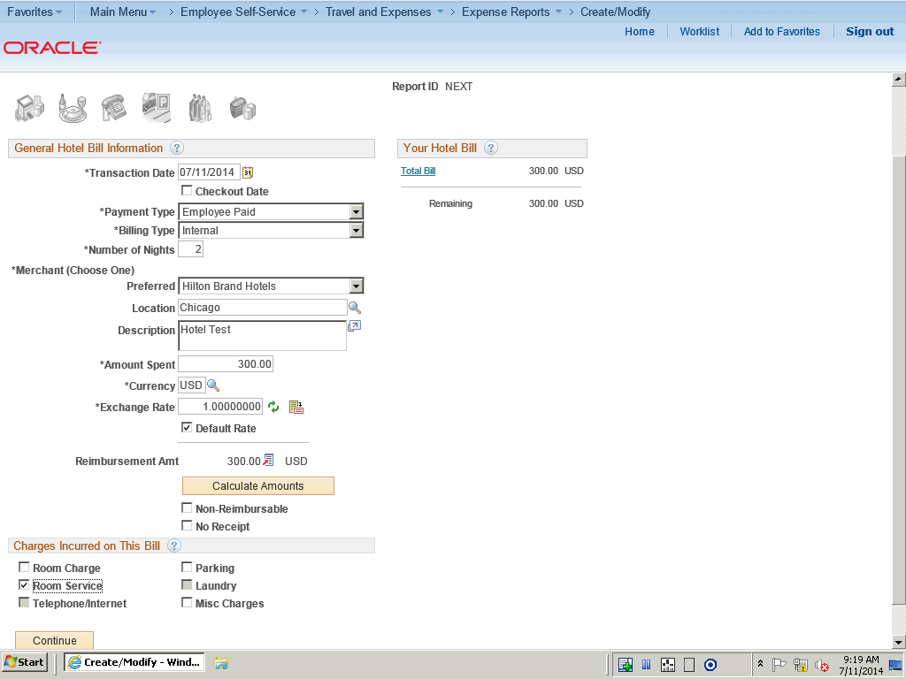

Step | Action
 | Click the Parking option.

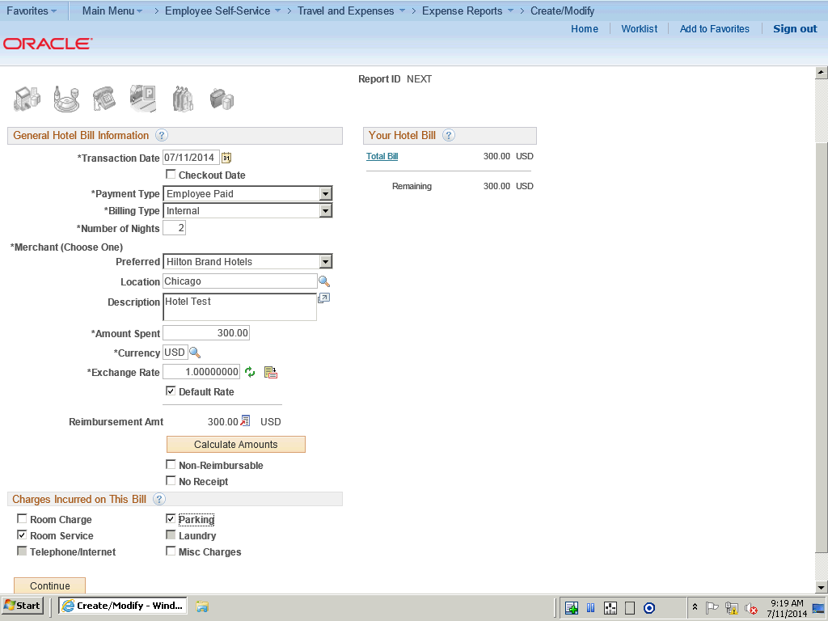

Step | Action
 | Click the Continue button.

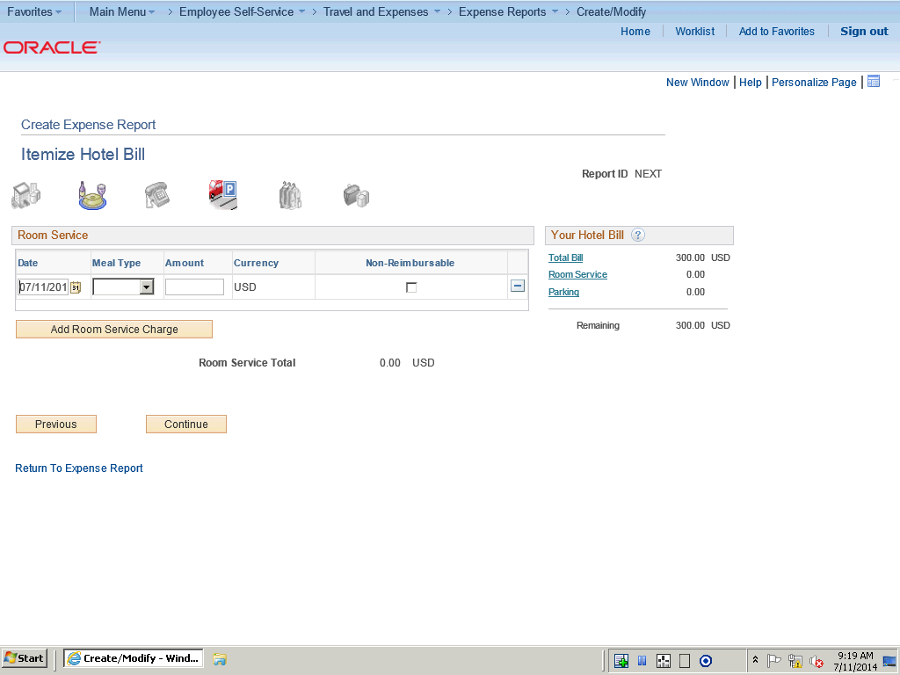

Step | Action
 | Click the Meal Type list.

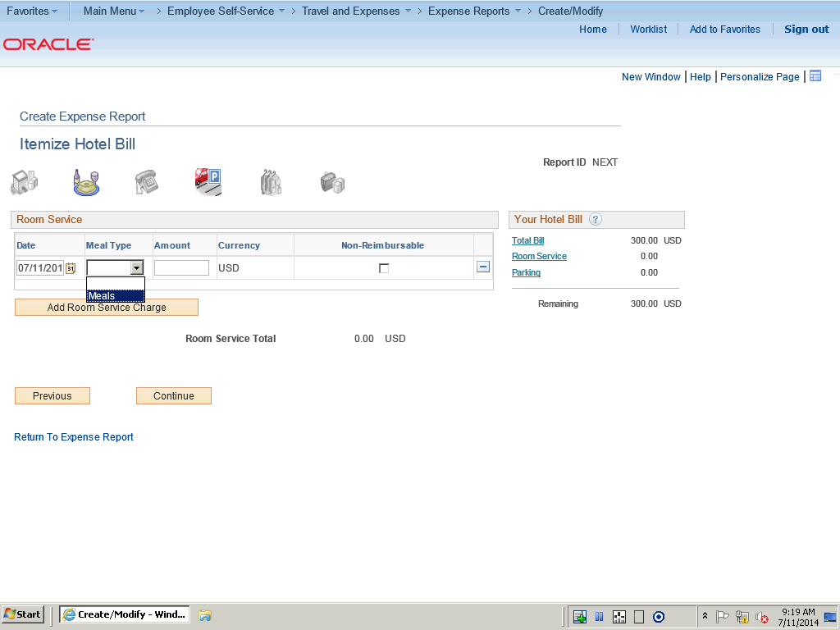

Step | Action
 | Click the Meals list item.

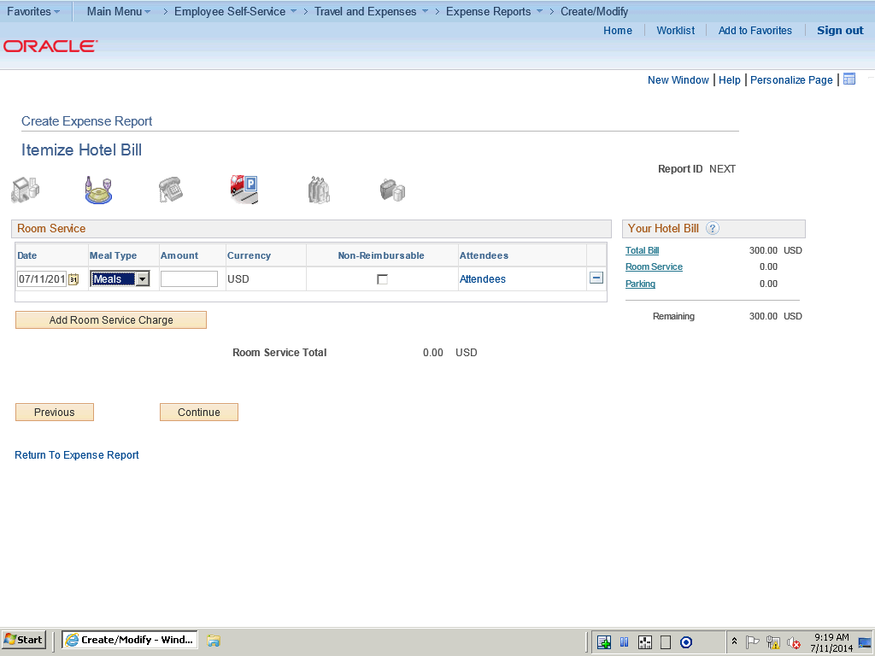

Step | Action
 | Click in the Amount field.

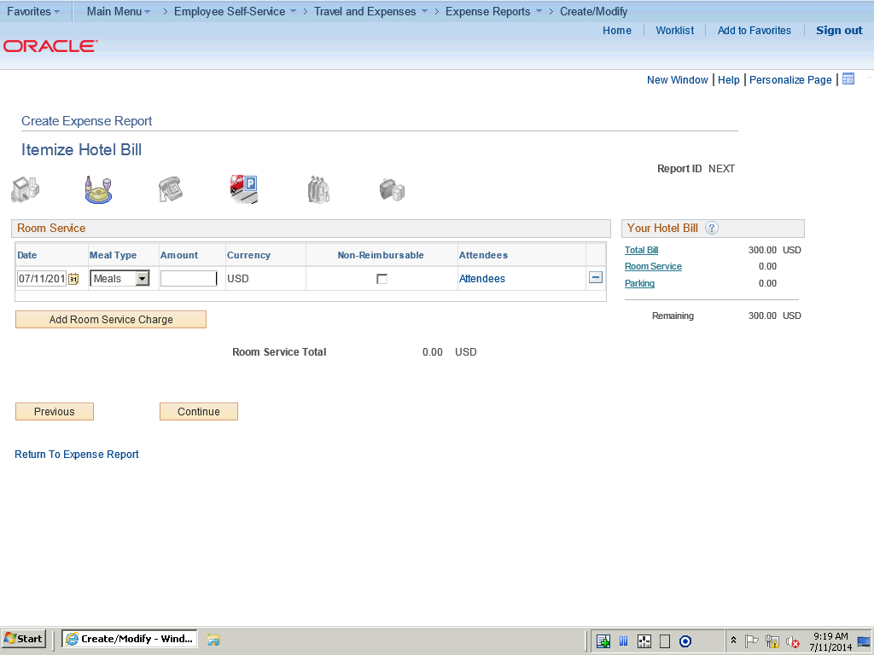

Step | Action
 | Enter the desired information into the Amount field. Enter "150.00".

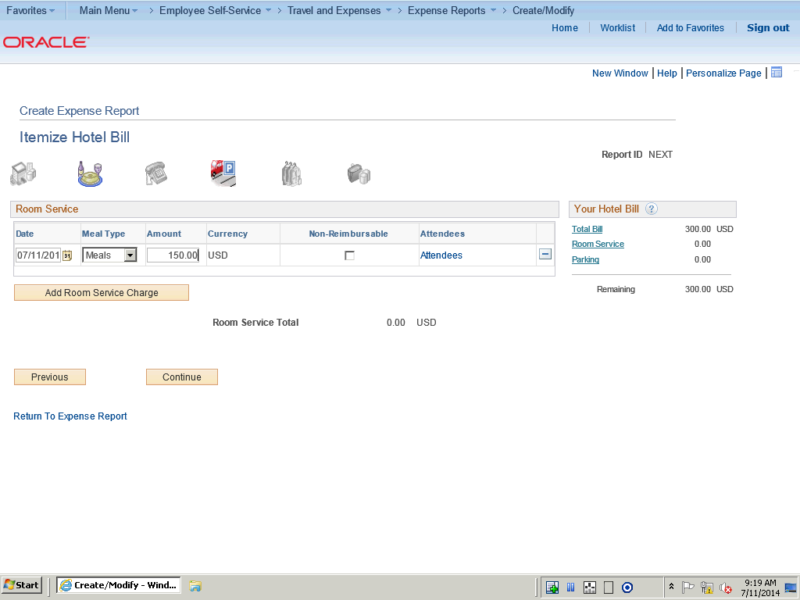

Step | Action
 | Click the Add Room Service Charge button.

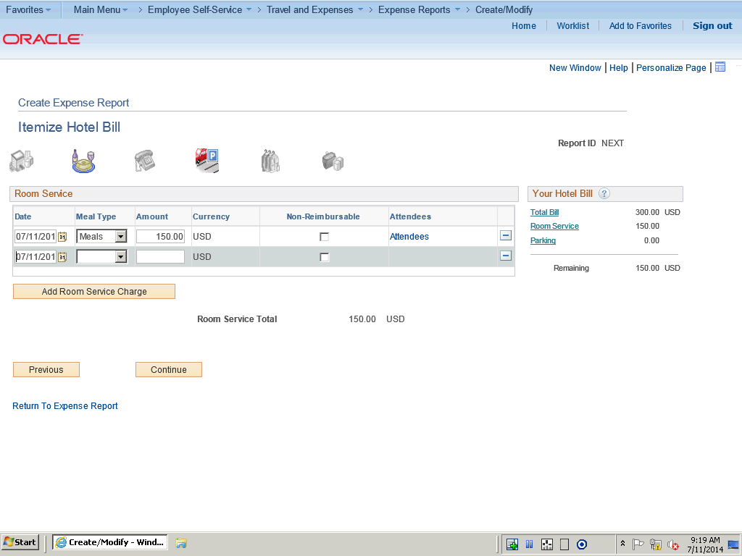

Step | Action
 | Note that the Hotel Wizrad keeps count and seperates the expenses.

Step | Action
 | You can navigate to the different itemized pages by using the icons at the top of the page.

Step | Action
 | Click the Continue button to move to the next expense type.

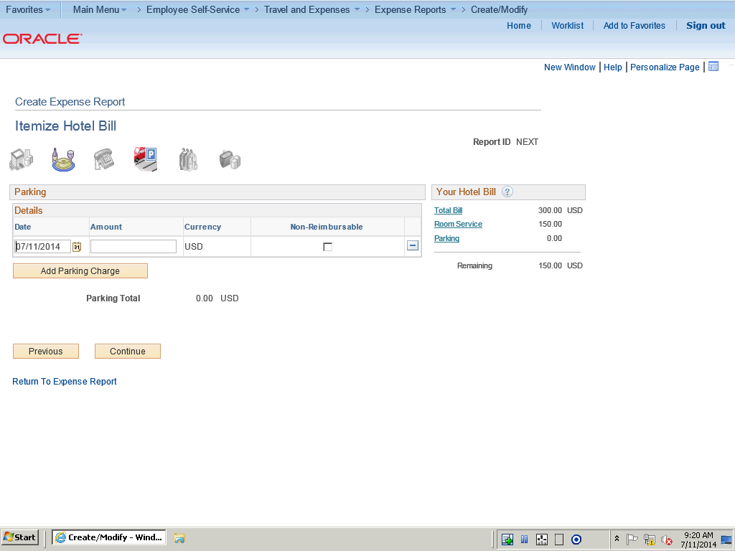

Step | Action
 | Click in the Amount field.

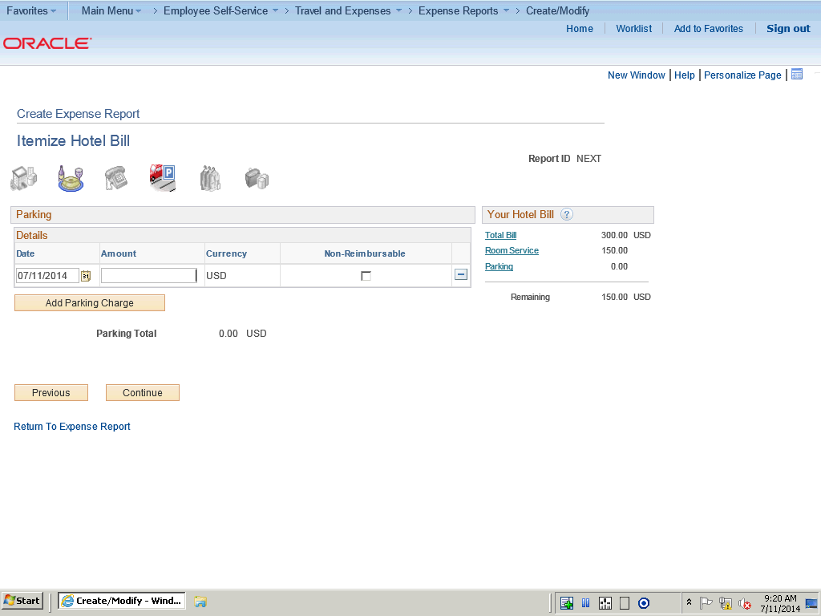

Step | Action
 | Enter the desired information into the Amount field. Enter "150.00".

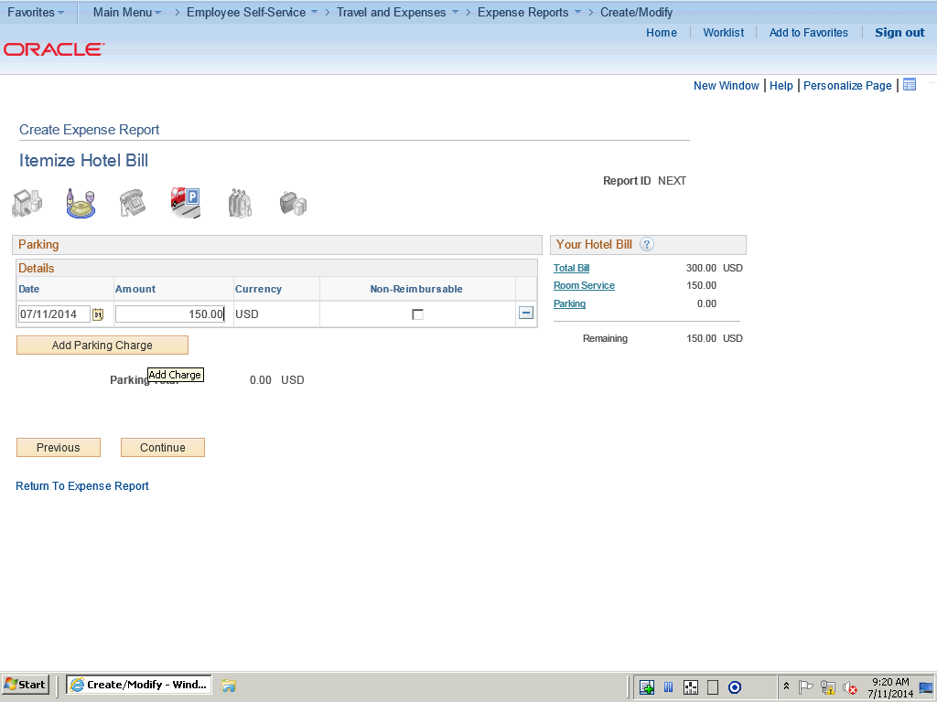

Step | Action
 | Click the Add Parking Charge button.

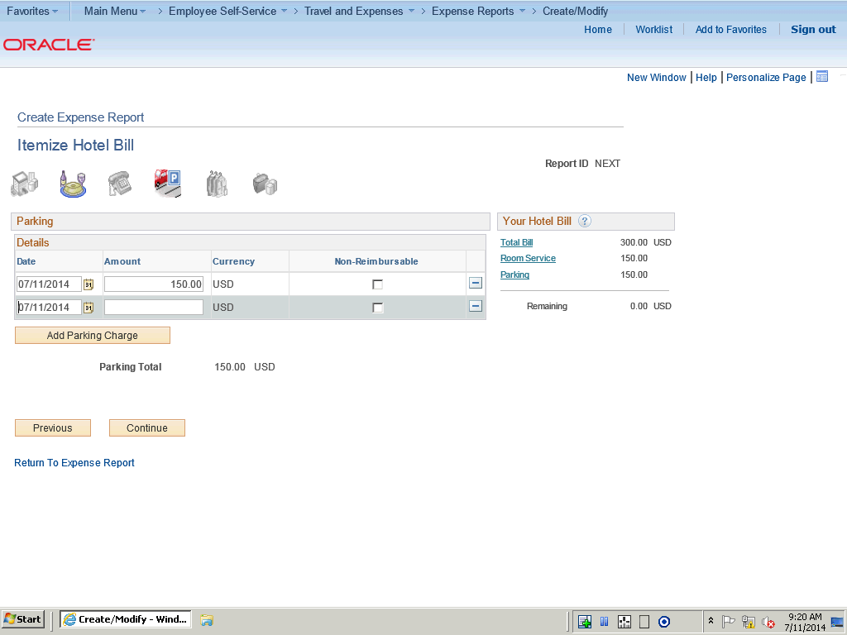

Step | Action
 | Click the button.

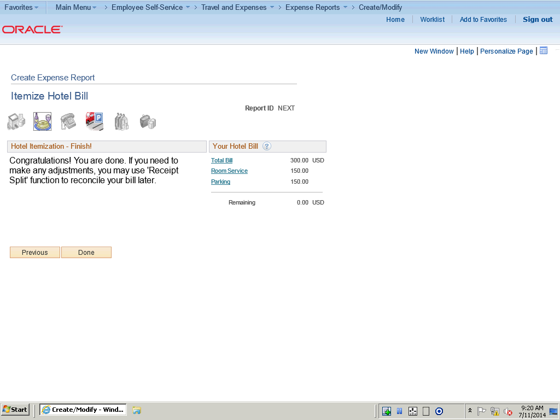

Step | Action
Click the Done button to return to the Create Expense Report page, which displays all the itemized expense items as individual lines.

IMPORTANT! If you return to the main expense report grid without clicking Done, you will lose your itemized expenses.

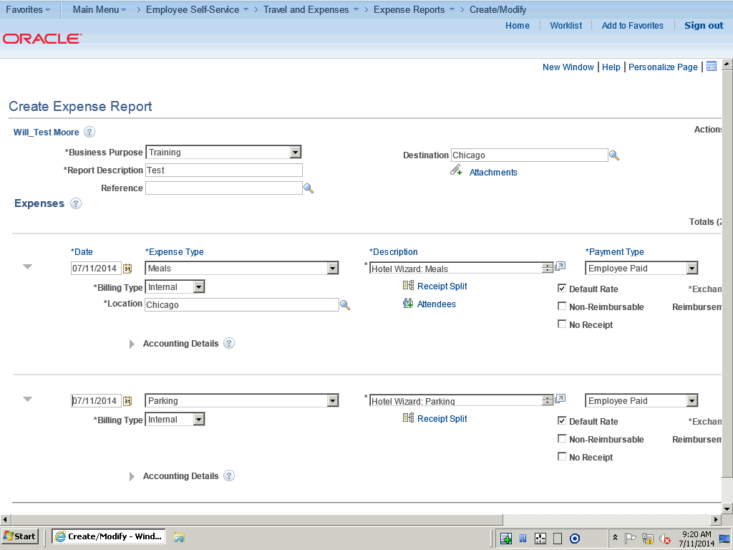

Step | Action
 | Click the scrollbar to navigate to the top of the page.

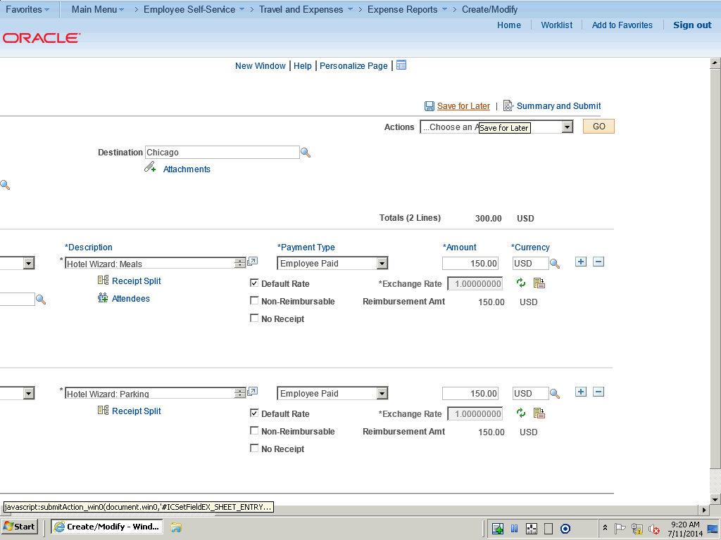

Step | Action
 | Click the Save for Later link.

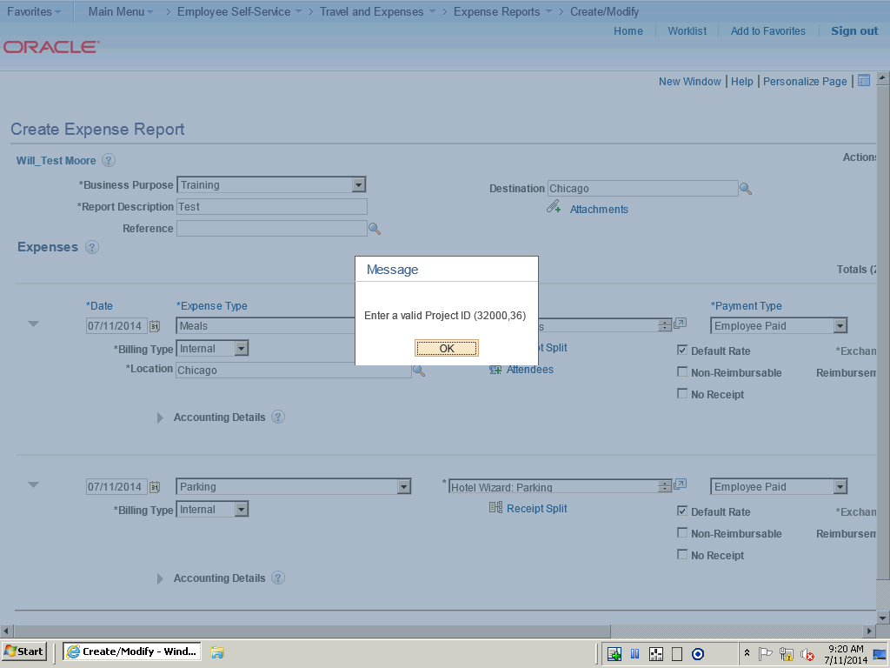

Step | Action
In this topic you will learn the following:

- How to itemize hotel bills using the Hotel Wizard.

You have successfully completed this training session.
End of Procedure.

Withdrawing an Expense Report
Withdrawing an Expense Report
Procedure

In this topic you will learn the following:

- How to withdraw an Expense Report.
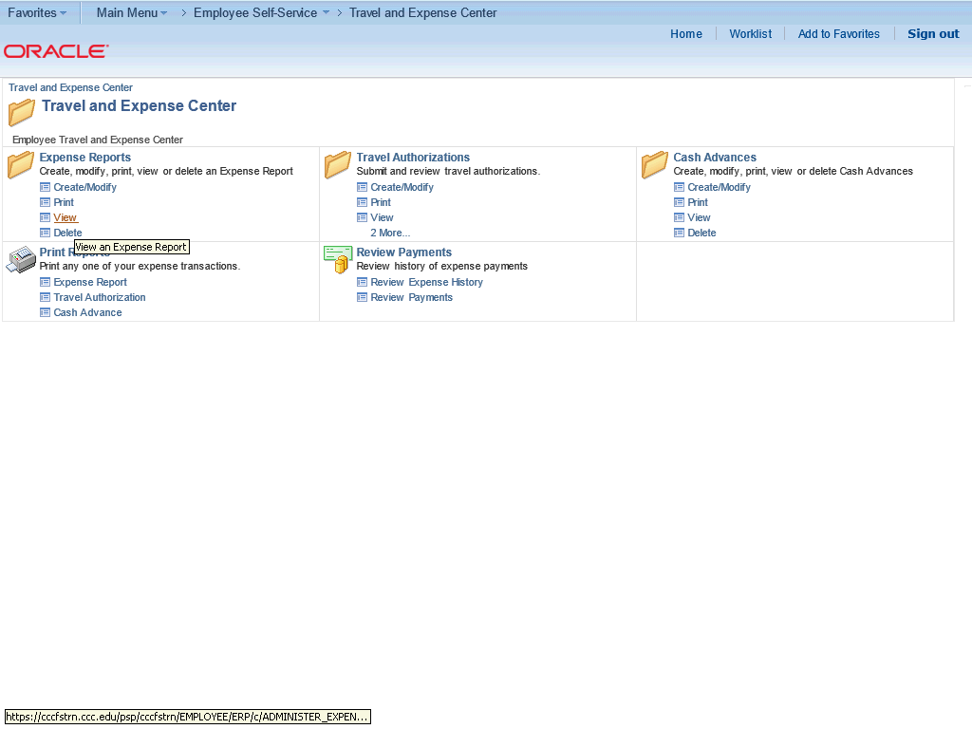

Step | Action
 | Click the Expense Reports View link on the Travel and Expense Center.

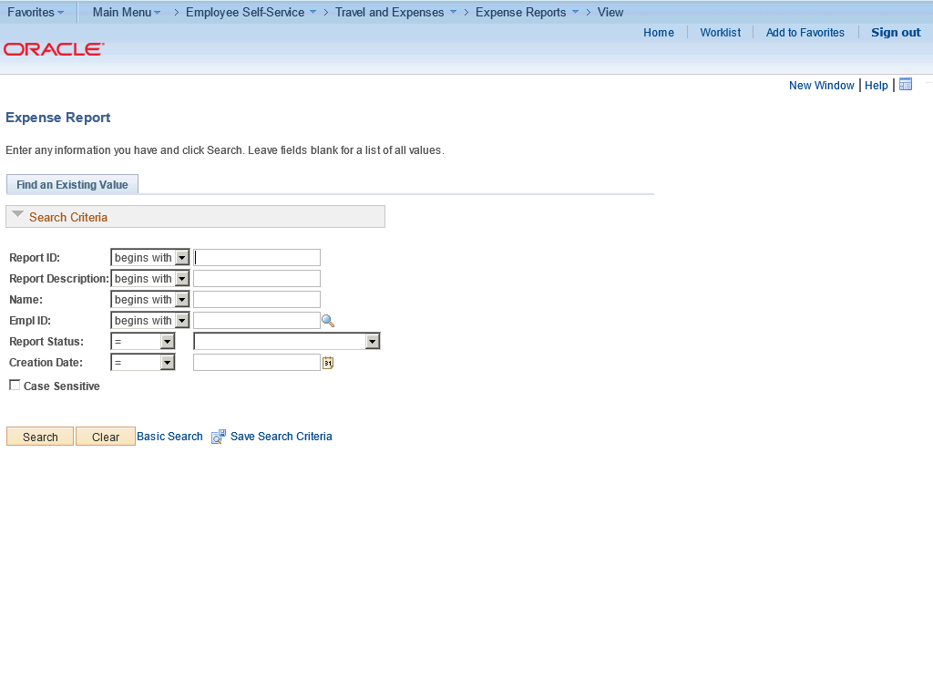

Step | Action
 | Click the Search button.

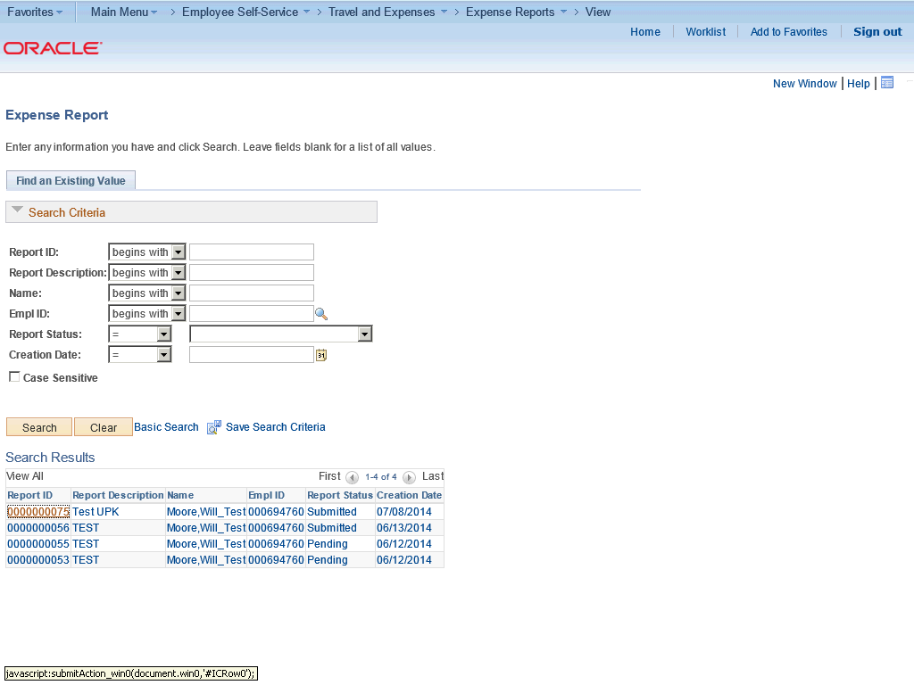

Step | Action
 | Click the 0000000075 link.

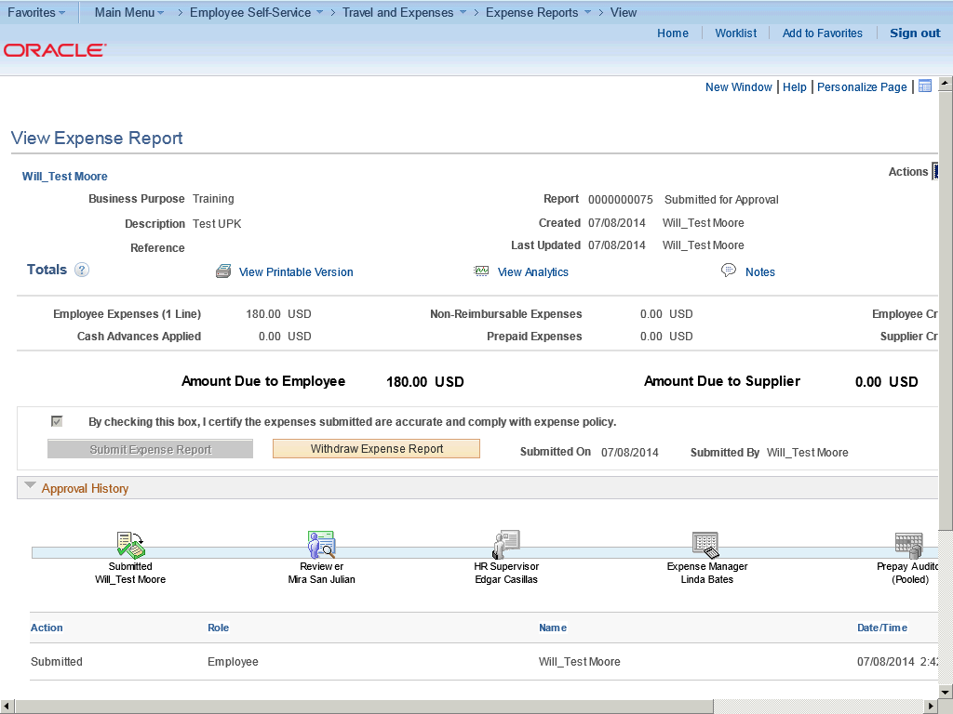

Step | Action
 | Use the View Expense Report page to view an expense report in read-only mode.

Step | Action
 | When an Expense Report is in pending status, you can withdraw it.

Step | Action
 | Click the Withdraw Expense Report button.

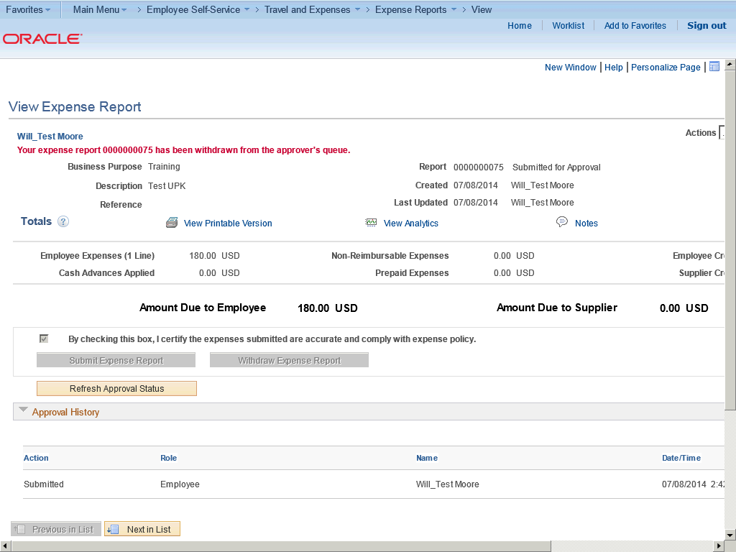

Step | Action
 | You will get a message that confirms that the expense report has been withdrawn from the approver's queue.

Step | Action
In this topic you will learn the following:

- How to withdraw an Expense Report.

You have successfully completed this training session.
End of Procedure.

Deleting Expense Reports
Deleting Expense Reports

You can delete an expense report if you have not submitted it for approval. If it has been submitted, you can still delete it if the approver returns it for modifications or if the status is Denied.

In this topic, you will delete an expense report that was entered incorrectly.
Procedure

In this topic you will learn the following:

- How to delete an expense report.
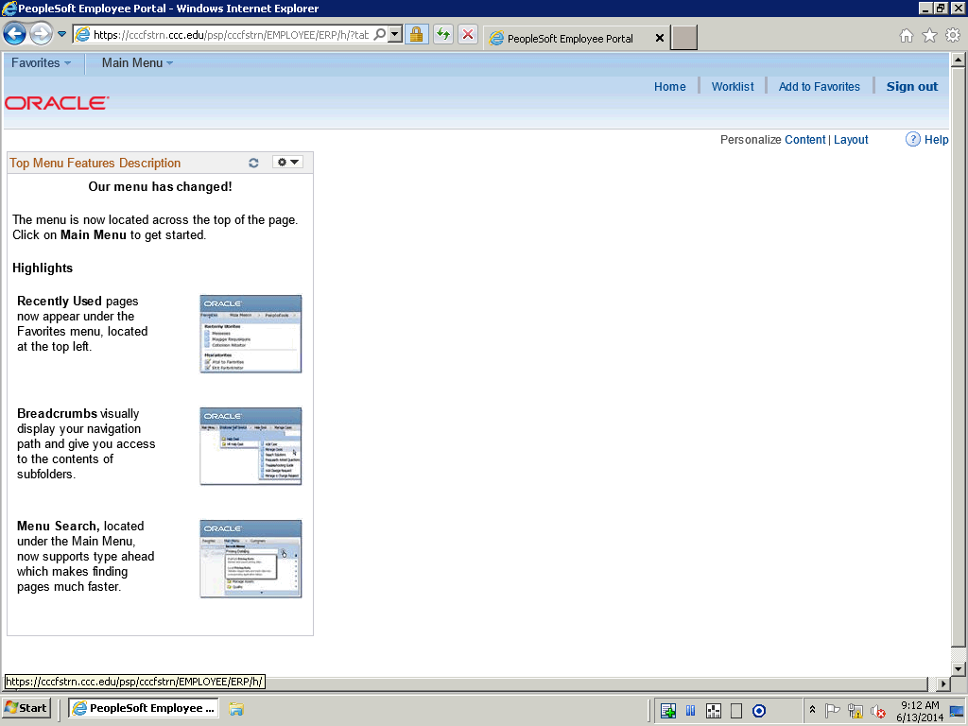

Step | Action
Begin by navigating to the Delete Expense Reports Page.

Click the Main Menu button.

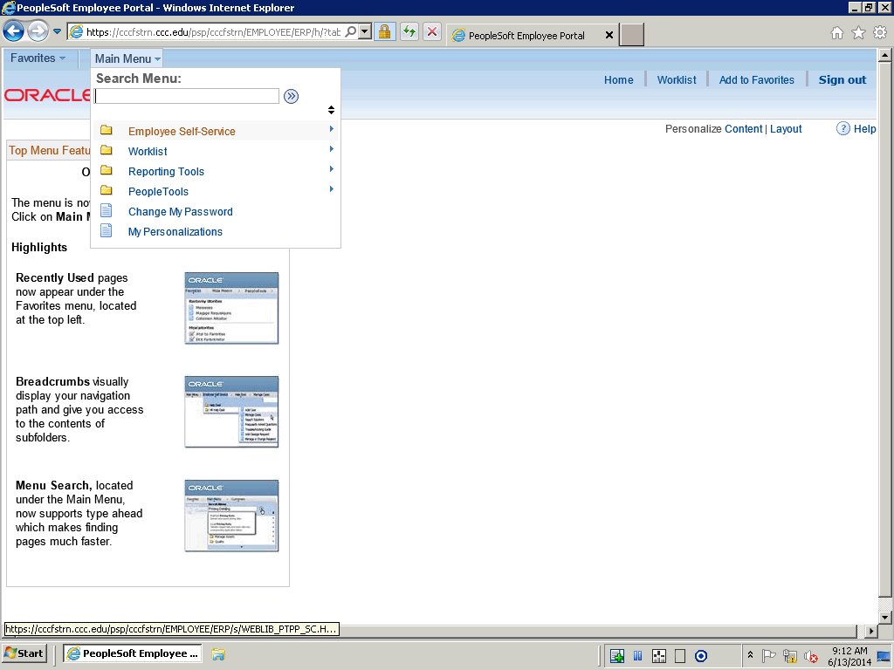

Step | Action
 | Click Employee Self-Service.

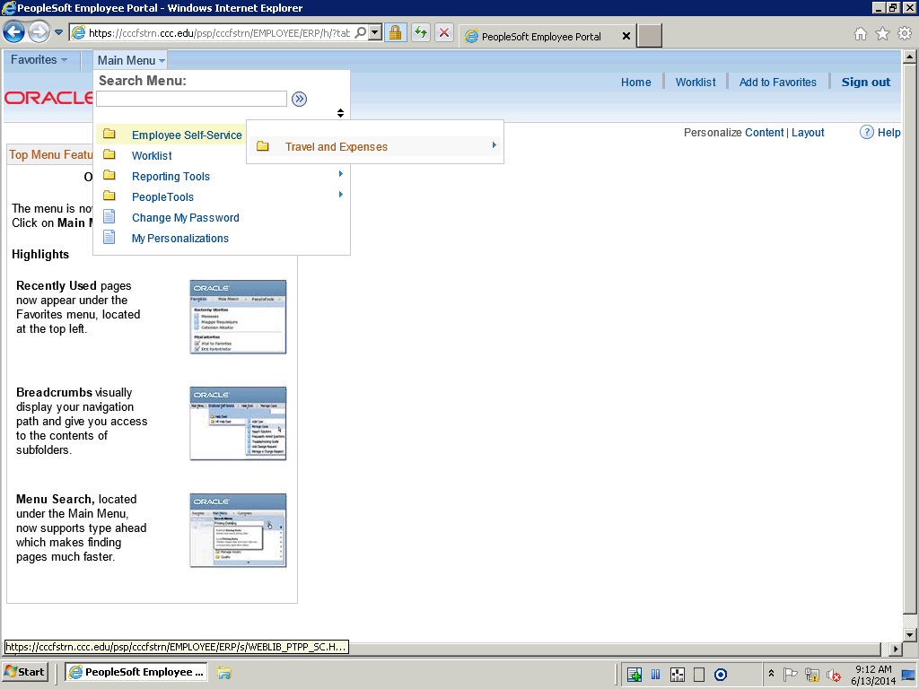

Step | Action
 | Click Travel and Expenses.

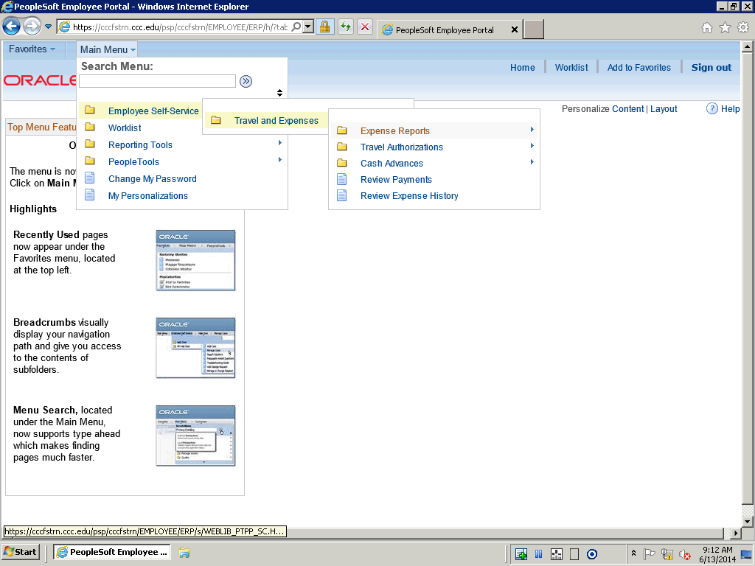

Step | Action
 | Click Expense Reports.

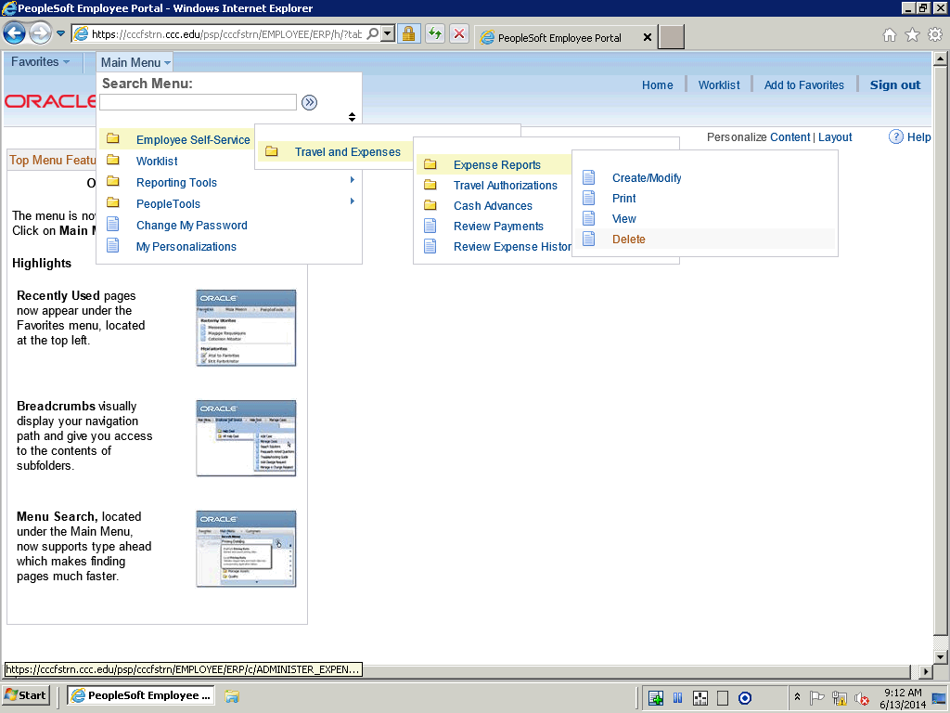

Step | Action
 | Click Delete.

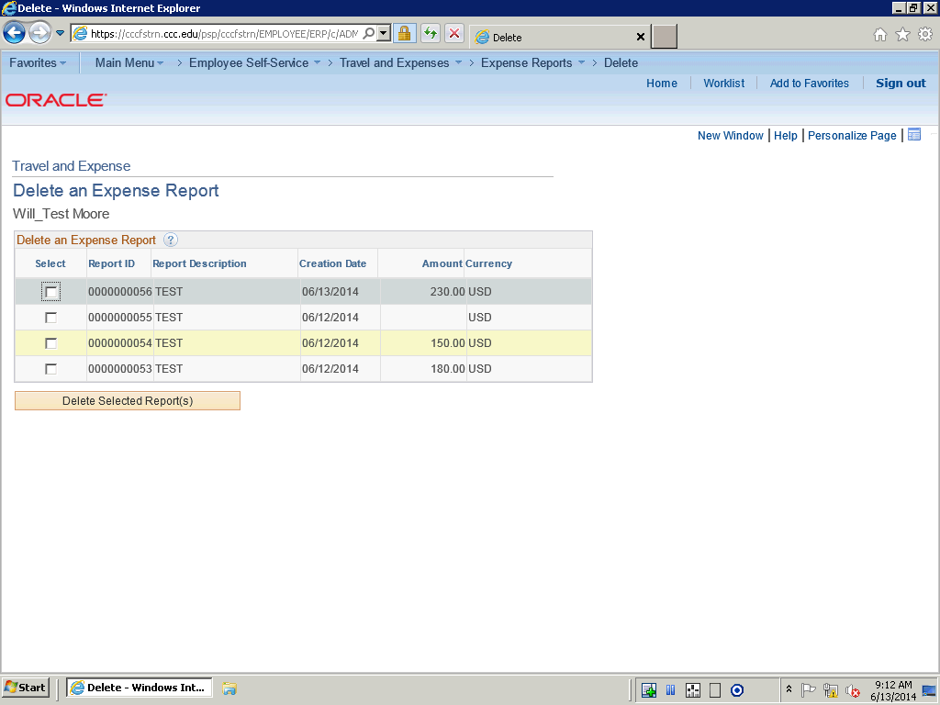

Step | Action
 | Click the Select option next to the expense report you would like to delete.

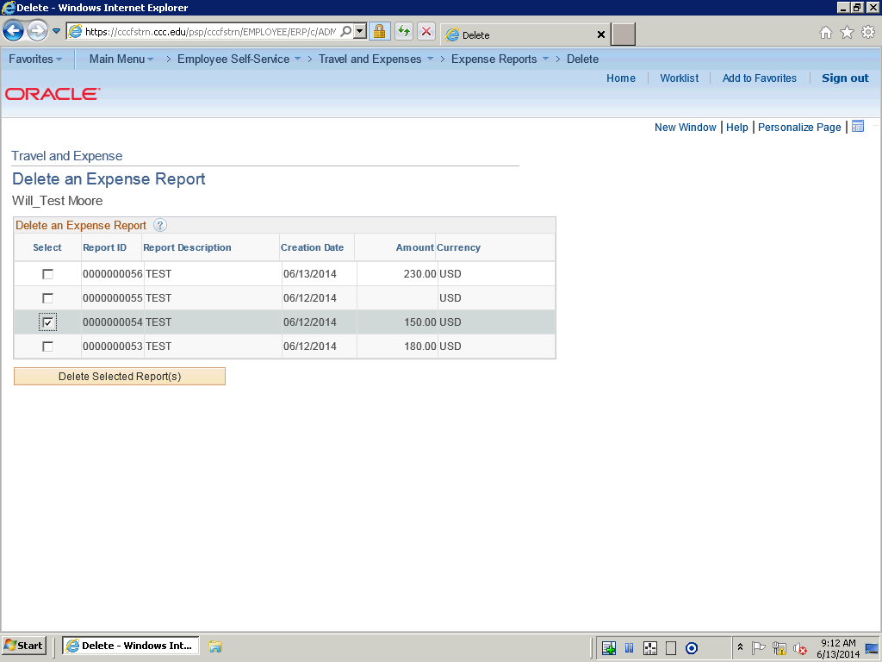

Step | Action
 | Click the Delete Selected Report(s) button.

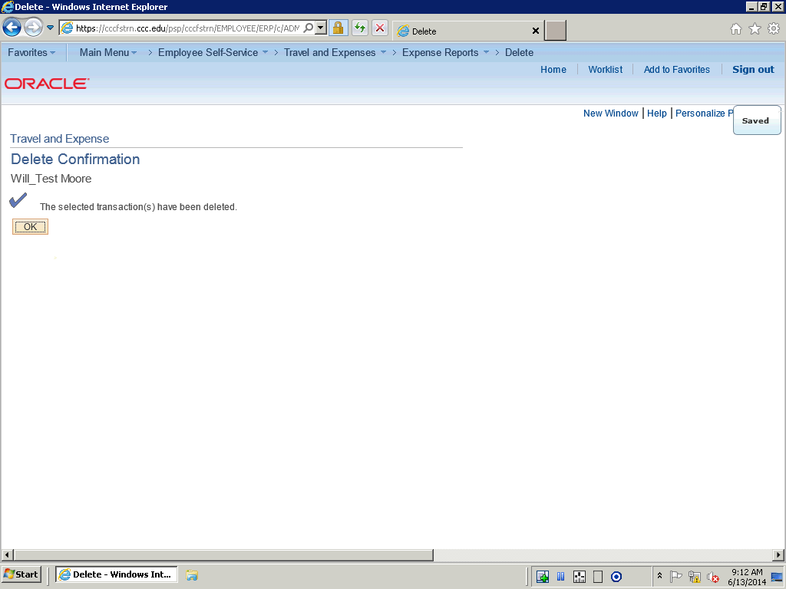

Step | Action
 | Click the OK button.

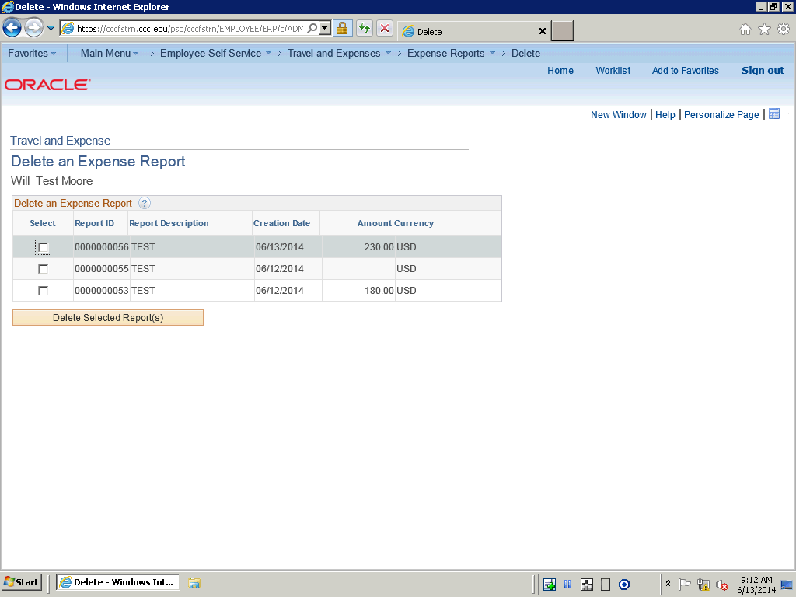

Step | Action
In this topic you have learned the following:

- How to delete an expense report.

You have successfully completed this training sesion.
End of Procedure.

