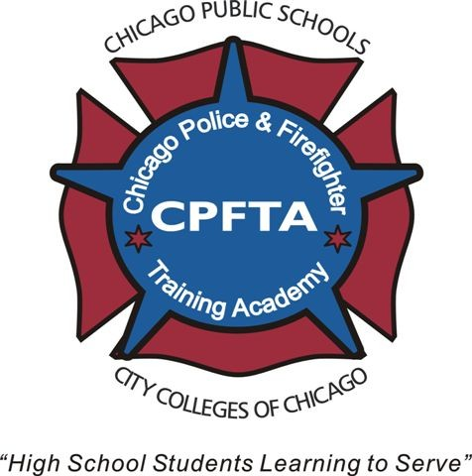
Chicago Police and Firefighter Training Academy (CPFTA)
2015-2016 Academic Year
Program Highlights/Fact Sheet

- The CPFTA Program was developed twelve years ago and is a partnership between the Chicago Public Schools (CPS), City Colleges of Chicago (CCC), Chicago Fire Department, and the Chicago Police Department serving high school students enrolled in CPS and Non-CPS schools.
  - The program recruits and trains up to 250 students each year
  - The CPFTA is a two-year program that starts in the student’s (called cadets) junior year in high school.
  - Additional program highlights can be found in the CPFTA brochure or online at www.cpfta.com
- CCC is proud to offer “scholarships” to qualifying graduates who enroll in a CCC college following graduation. The scholarships are tuition waivers, which attempt to cover the student’s “unmet financial need”. Unmet need is the difference between the student’s financial aid award and total tuition cost. This type of award can be referred to as a “last chance scholarship”. The scholarship is available ONLY to NON-CPS CPFTA Graduates. CPS Graduates are encouraged to apply to the STAR scholarship.

- The CCC personnel listed below are available to assist and advise cadets, their families and advocates or CPFTA partners regarding college preparation activities, i.e. how to secure financial aid, how to determine a major, how to survive in college etc. In some cases, you may be referred to another staff member for more detailed information. Be prepared to schedule an appointment for a later date to talk by phone or meet with the college contact.

CCC College Contact List for CPFTA Cadets/Graduates

Daley Harold Washington Kennedy-King
7500 S. Pulaski Rd 60652 30 E. Lake Street 60601 6301 S. Halsted Street 60621
773.838.7729 Kim Bowens Shannice Berry
earlycollegeda@ccc.edu 312.553.5666 773.602.5037
kbowens3@ccc.edu sberry43@ccc.edu

Malcolm X Olive-Harvey Truman
1900 W. Jackson 60612 10001 S. Woodlawn Ave 60628 1145 W. Wilson Ave 60640
LaKisha Hillard Holly Thrash Nicole Blotnick
312.850.7446 773.291.6478 773.907.4344
lhillard5@ccc.edu hthrash@ccc.edu nblotnick@ccc.edu

Wright Officer Paul Chester
4300 N. Narragansett St. 60634 Chicago Police Academy
Mila Simeonovska 312-745-5837
773.481.8234 paul.chester@chicagopolice.org
msimeonovska@ccc.edu

Cpt. Frank Brim General Info about CPFTA
Chicago Fire Academy Sandra Irizarry, Chicago Public Schools
312-747-7245 773.553.2486
Frank.brim@cityofchicago.org sacastillo@cps.edu

